Earth Science Field Trip to Hill Country

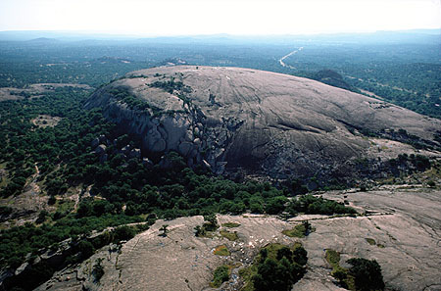November 2-4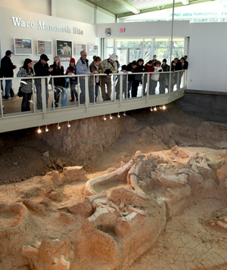

* **Visit the remains of a mammoth herd, preserved in Waco, Tx**
* **Tour a working rock quarry in Spicewood, Tx**
* **Observe astronomy of the hill country night skies**
* **See first-hand the rocks that originally formed Texas**
* **Make your own geologic map**
* **Climb beautiful Enchanted Rock near Fredericksburg, Tx**

Waco Mammoth Site

Enchanted Rock