Six Flags Alternative Assignment - Conceptual Classes
(Don’t do struck through problems – these are for advanced classes)
ROLLERCOASTER #1

GREASED LIGHTNING
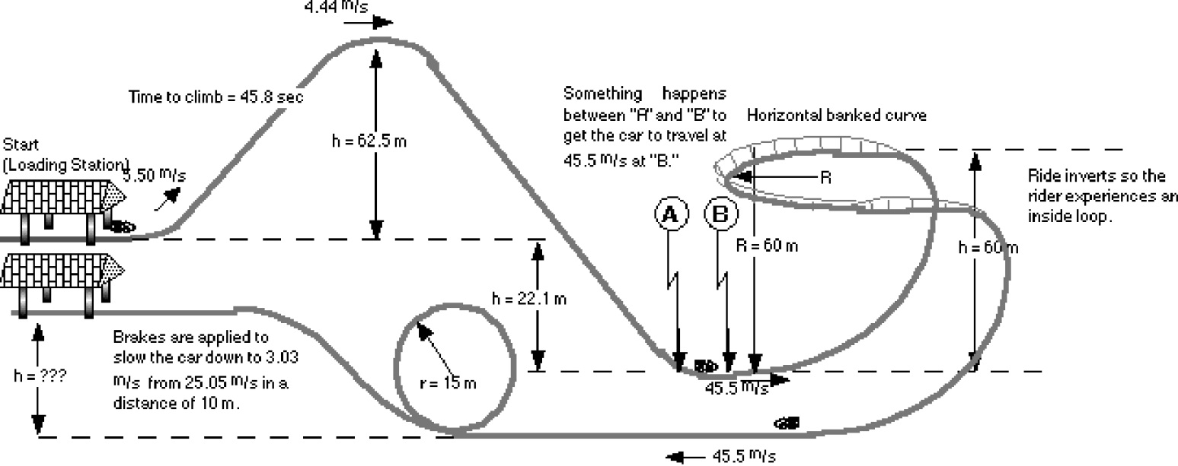

Mass = 6500 kg

Using the information shown on the rollercoaster diagram above, determine the correct answers to the following questions. Show all work on a separate sheet of paper.

  - How much power was used to pull the coaster car up the first hill? (in watts and horsepower.)
- How fast is the car traveling at location A if it coasted down the back side of the first hill? Don’t do this, but you’ll need the answer for Question 3: Answer = 41.0 m/sec
- How many g's does the rider feel as he enters the bottom of the next element if its radius is 60.0 m, at location B?
- How fast is the car traveling when it reaches the banked curve?
- If the banked curve is at a 52.3° angle with the horizontal, then what is the radius of the banked curve?
- How many g's does the rider feel in the banked curve?
- How many g's does a rider feel as he enters the bottom of the loop?
- How fast is the rider traveling at the top of the loop?
- How many g's does the rider feel at the top of the loop?
- As the car enters the station at the end of the ride, its brakes are applied. How much power do the brakes exert on the car? (in watts and horsepower.) t = 0.712 sec.

ROLLERCOASTER #2

LICKETY SPLIT
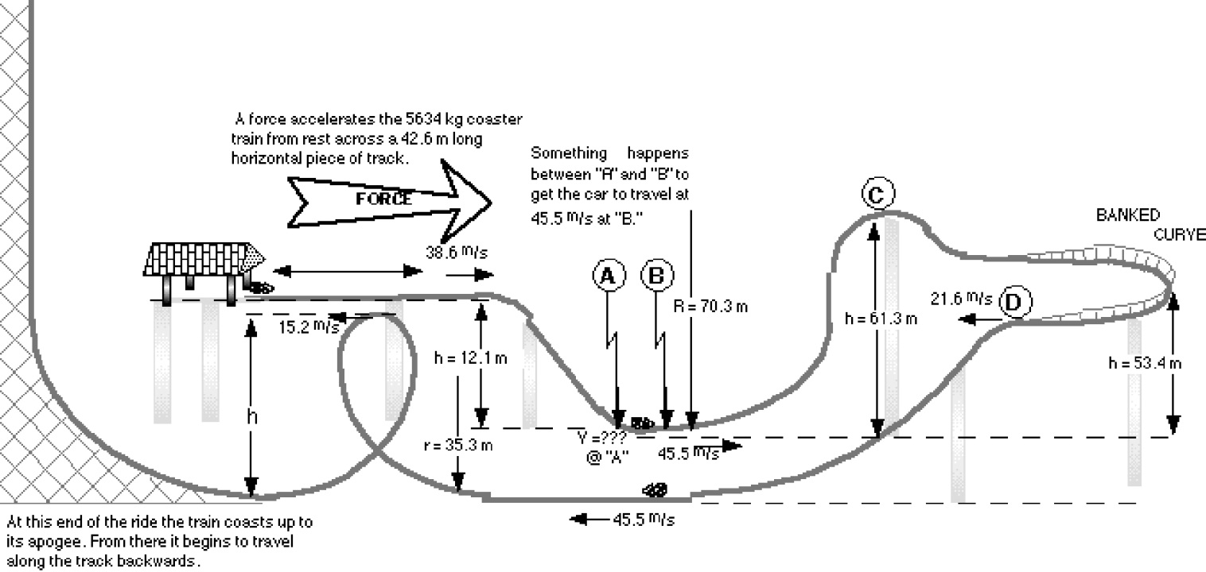

r = 42.3 m

Using the information shown on the rollercoaster diagram above, determine the correct answers to the following questions. Show all work on a separate sheet of paper.

- How much force is used to accelerate the train across the first 42.6 m? t = 2.21 sec.

- How many g's does the rider feel as he is pushed by the initial accelerating force?

- How fast is the car traveling at location A if it coasted down the back side of the first hill?

- At location B the incline is 90° of a circle. How many g's does the rider feel as he enters the loop at location "B?"

- How fast is the car traveling when it reaches location "C"?

- In the banked turn the rider is traveling 21.6 m/s. What is the optimum angle of the banked curve?

- How many g's does the rider feel as he enters the loop?

- What is the height of the loop?

- If the radius at the top of the loop is 7.45 m, then how many g's does the rider feel at this location?
- How high does the coaster train coast at the end of the track?

