**Phys 2425**

**University Physics Workbook Vol. I**

**Tyler Junior College, Summer I 2013**

by Gene Branum, Tom Hooten, & Jim Sizemore, Tyler Junior College

|  |  |
| --- | --- |
| 2013_04_05_170521_IMG_8803_aps_aapt_t2i.jpg | Acknowledgements: This workbook has been developed over a number of years by numerous collaborators whose names have been lost and forgotten. Our thanks go to those unsung heroes who have contributed to this work. Portions of this work are used by permission and/or fair use of Dr. Bob Abel (Olympic College), The Science Source, Cenco Physics, Vernier, and AAPT.  Tareleton State College in Stephenville, TX, Rocket Launch on 4/5/2013. Photo by Jim Sizemore.  [Creative Commons License](http://creativecommons.org/licenses/by-nc-sa/3.0/)This work is licensed under a [Creative Commons Attribution-NonCommercial-ShareAlike 3.0 Unported License](http://creativecommons.org/licenses/by-nc-sa/3.0/). |

Hyperlinks work, primary web site at <http://iteach.org/funphysicist/>. Offsite files at:

**PDF:** <http://funphysicist.weebly.com/uploads/2/0/3/8/20383539/calc_physics_workbook_v1.pdf>

**Word:** <http://funphysicist.weebly.com/uploads/2/0/3/8/20383539/calc_physics_workbook_v1.docx>

Table of Contents

[Lab Report Guidelines 5](#_Toc331608533)

[Density and Archimedes’ Principle 13](#_Toc331608534)

[Specific Heat of Substances 17](#_Toc331608535)

[Coulomb’s Law 19](#_Toc331608536)

[Electric Field Mapping 21](#_Toc331608537)

[Ohm’s Law 29](#_Toc331608538)

[Series and Parallel Circuits 33](#_Toc331608539)

[The Magnetic Field in a Coil 37](#_Toc331608540)

[RC Time Constant 43](#_Toc331608541)

[Physical Pendulum 47](#_Toc331608542)

[Waves and Wave Characteristics 49](#_Toc331608543)

[Velocity of Sound 53](#_Toc331608544)

[Light, Brightness and Distance 57](#_Toc331608545)

[Reflection and Refraction 61](#_Toc331608546)

[Focal Length of Lenses (Optics) 67](#_Toc331608547)

[Light Production 73](#_Toc331608548)

[Calculating Radioactive Decay Products 77](#_Toc331608549)

[Appendix A: Periodic Table of the Elements 82](#_Toc331608550)

[Appendix B: Lecture Activities 83](#_Toc331608551)

[**Planning for College** 85](#_Toc331608552)

[**Roadrunner** 89](#_Toc331608553)

[**Fluids** 91](#_Toc331608554)

[**Moon’s Motion** 93](#_Toc331608555)

[**Project** 97](#_Toc331608556)

[**Heat** 99](#_Toc331608557)

[**Entropy** 101](#_Toc331608558)

[**Electricity** 103](#_Toc331608559)

[**Electrical Energy** 105](#_Toc331608560)

[**Resistance** 109](#_Toc331608561)

[**Magnetism** 113](#_Toc331608562)

[**Electrical Oscillation** 115](#_Toc331608563)

[**Slinky Wave** 119](#_Toc331608564)

[**Doppler** 121](#_Toc331608565)

[**AM Radio Antenna** 123](#_Toc331608566)

[**Optics** 125](#_Toc331608567)

[**Interference** 127](#_Toc331608568)

[**Relativity** 131](#_Toc331608569)

[**Supergirl's Photons** 133](#_Toc331608570)

[**Sun’s Energy** 135](#_Toc331608571)

[Appendix C: SOLVE Method 137](#_Toc331608572)

[Appendix D: Geometry, Trigonometry, & Vector Summary 139](#_Toc331608573)

[Appendix E: Exponentials & Logarithms Summary 151](#_Toc331608574)

[Appendix F: Instructions for Coulomb’s Law 155](#_Toc331608575)

Profits from the sale of this lab manual will go toward student activities and professional development.

**University Physics Workbook Vol. I**

# Lab Report Guidelines

**Lab Supplies**

1. Ruler with centimeter scale
2. Protractor
3. Pencil
4. CALCULATOR
5. Graph Paper

**Student’s Lab Responsibility**

1. Be on time!
2. Study lab before class – PRE-LAB ASSIGNMENTS WILL BE REQUIRED! For example, your instructor may need to approve your data collection prior to class.
3. Actively participate as an individual in a group.
4. Be careful with equipment.
5. Feel free to move around and talk in lab, but DO NOT DISTURB OTHERS!
6. When you leave the lab, *return equipment precisely where you got it from*, place chairs under tables, and clean your work area.

**Links to expanded discussion:**

The following is about 24 pages worth of how-to for scientific writing with links to additional resources. I’ve attempted to condense this and more to 8 pages, however this is a good discussion – a little light reading.

IMPORTANT NOTE: Links are active in the online version of this lab manual.

*pdf version:*

<http://writingcenter.unc.edu/resources/handouts-demos/pdfs/Scientific%20Reports.pdf>

*html version:*

<http://writingcenter.unc.edu/resources/handouts-demos/specific-writing-assignments/scientific-reports>

**Guidelines for Lab Reports**

*At a very basic level a lab report expresses clear thinking about a topic under investigation. Your goal is to think, investigate, and express your investigation clearly!*

We are practicing writing a research report to prepare you for your future work. No matter what you do in the future you will be called upon to write reports, unless you’re content to flip burgers for the rest of your life or something equally mundane. Our practice contributes to the knowledge and skills your future will require. Classroom thinking is, “I’m doing this because the teacher requires it.” Broader thinking is, “I’m practicing writing skills that my future endeavors will require.”

Think of your audience. People who read research reports are interested in two things, (1) what is the information contained in the report, and (2) are the findings valid and legitimate. Write your report to answer these two basic questions.

A lab report generally follows the scientific method, that is, (1) research, (2) make a hypothesis, (3) design an experiment, (4) perform the experiment, (5) analyze the experiment to determine if it confirms or contradicts the original hypothesis, and (6) report your findings. Your goal is to clearly, completely, and yet concisely explain how you followed the scientific method in performing your experiment.

A key prerequisite to a good report is to know and understand the scientific principles underlying your experiment and why and how the experiment tests those principles. IT IS, therefore, IMPERATIVE TO READ AND UNDERSTAND THE LAB INSTRUCTIONS BEFORE COMING TO LAB. Understand the following:

1. What you are going to do, that is, what’s the procedure?
2. Why are we going to do it that way?
3. What are we hoping to learn from this experiment?
4. Why would we benefit from this knowledge?

Answering these questions lead you to a more complete understanding of the experiment think about the “big picture” leading to a better lab report.

Ask questions of the lab instructor. If you don’t know an answer the instructor can help explain it or, at least, help you figure it out.

**Before the Lab**

1. READ AND UNDERSTAND THE LAB INSTRUCTIONS!
2. Plan the steps of the experiment carefully with your lab partners.
3. Design a table to record your data.
4. Assign each member of the lab group a “job” and rotate that job each lab. Don’t have somebody doing the same thing all semester.
5. EVERYBODY does the experiment. Have one person do one measurement, a second person do the second measurement, a third person the third measurement, etc.

**During the Lab**

1. All members record the data in your personal lab book.
2. Record data carefully.
3. Consult with your lab partners as you are performing work.

**Lab Reports**

1. DO YOUR OWN WORK! You may discuss this with your lab partners, however copying will result in a zero grade, or worse, for all persons in the lab group. Copying is a violation of academic ethics and punishment may be severe. Students should adhere to high ethical standards.
2. The instructor may, optionally, require reports to be submitted as a lab group. Consult your instructor or their syllabus regarding this.
3. Lab reports are due *at the beginning* of the next scheduled lab, however write a first draft prior to leaving. If you have forgotten something then you can acquire what you need. YOUR INSTRUCTOR MAY REQUIRE A REVIEW OF DATA AND CALCULATIONS PRIOR TO LEAVING LAB!
4. The prose and tables of your report must be typed. Graphs and drawings may be done using pencil and straight edge (be sure to include them in the proper order though). In fact, YOUR INSTRUCTOR MAY REQUIRE HAND DRAWN GRAPHS – at this level, your mathematical skills may be insufficient to properly draw graphs using a computer. Neatness, readability, and a well organized report is the primary requirement whether done by hand or by computer.
5. Use the following outline format and **do not deviate from this order** when writing your lab report. You may mix typed and hand written information, however DO NOT, for example, staple raw data to the end of the report.

|  |  |  |
| --- | --- | --- |
| Course Name and Section  Experiment Name  Date experiment was performed  Lab Partner’s Names and Duties  Title | | |
|  | Purpose | A couple sentences |
|  | Theory/Introduction | Discuss key equations |
|  | Procedure  Title Procedure Step  Use subtopic headings as an aid to organizing  your information  Next Procedure Step  etc. | USE DIAGRAMS! |
|  | Data | ORGANIZE IN TABLES! |
|  | Graphs | Hand drawn using a straight edge. |
|  | Sample Calculations | Provide a sample or all calculations used in the lab |
|  | Results | 1. These are calculations on the data. 2. ORGANIZE IN TABLES! 3. ALWAYS REPORT THEORETICAL EXPECTATIONS! 4. ALWAYS REPORT A %ERR OR %DIFF! |
|  | Conclusions | Discuss your experiment |
|  | Questions | Answer any questions posed in the lab instructions |

DO NOT DISMANTLE THE APPARATUS UNTIL AFTER YOUR INSTRUCTOR HAS REVIEWED (SIGNED OFF) ON YOUR DATA AND CALCULATIONS. It may be necessary to repeat portions of your experiment.

1. Be consistent with your outline *format* throughout the entire report.
2. Do not write on the back of your paper.
3. Organize your report so that there are no large gaps between topic headings.
4. **General Guidelines:**
5. Use **correct spelling, grammer** and complete sentences to express your ideas. Word processors are very good at this.
6. **Be complete and clear, yet concise.** Hack writers typically bloat their bloat their narratives with excessive and repetitious wordiness. Unfortunately in school you are required to write an n-page report which encourages this. It’s time to break that habit and write with meaning and clarity – not merely write to fill space.
7. Avoid repetition.
8. Be consistent with your terminology. If a word or phrase was used in one part of your report, use the same word or phrase for the entire report.
9. Carefully prepare your report.
10. Make your report easy to follow.
11. Be specific.
12. Explain your terms – even if they were in the lab instructions.
13. Avoid jargon.
14. Pretend you’re writing for a student in another section of this course and write in a way that student may understand your work.
15. **Title:**
16. Is the title brief yet clear enough to identify the experiment?
17. Does it express all the features of interest?
18. **Purpose:**
19. What is your testable hypothesis?
    1. *Not a hypothesis:* There is significant relationship between the temperature of a solvent and the rate at which a solute dissolves.
    2. *Hypothesis:* As temperature increases the rate at which a solute dissolves increases.
20. A purpose goes one step further; for example, determine the mathematical relationship between the temperature of the solvent and rate of solute dissolution.
21. What leads you to believe your hypothesis is supported by evidence? Even outside-the-lab experience may be used. For example, you note that sugar seems to dissolve faster in hot water than in cold.
22. Justify the experimental approach to test your hypothesis.
23. What is the rationale of the experiment as it relates to your hypothesis?
24. In a short paragraph list with short discussion (phrase or sentence) the theories you intend to confirm – do not list equations.
25. Insure your list of theories or questions investigated are complete.
26. What is the experimental objective? Why is it important to do this experiment?
27. Think about what the experiment is testing and list the theories being tested *even if not mentioned in the lab manual.*
28. Indicate the main topics to be tested.
29. Outline the purpose, scope, and approach of the experiment.
30. Discuss skills you will be acquiring by doing this lab.
31. Brevity is important. Mention or list items – don’t thoroughly discuss them. You’ll discuss them completely in the next section.
32. Are there details which could be reduced, put in an appendix, or omitted?
33. **Theory/Introduction:**
34. Demonstrate that you understand the context for this experiment. Using the dissolution rate of a solute as has been our example, you may recall lecture discussions about polar molecules that motivate your hypothesis.
35. List equations pertaining to theories being tested, the theories mentioned in the purpose, and thoroughly (yet concisely and clearly) discuss those theories and equations.
36. Discuss how your experiments will confirm or deny those theories and what error analysis you will perform.
37. Define symbols and abbreviations the first time they are used.
38. Discuss the applicability of prior work with adequate references.
39. Your experimental approach needs to be adequate. In general, attempt experiments at the extremes of the capabilities of the instrument and at least one attempt in the middle. In general this will require at least three measurements and spread measurements out evenly.
40. **Procedure:**
41. You must describe your procedure in sufficient detail that your experiment may be reproduced.
42. Be precise, but stay relevant. Ask yourself, “Would it make a difference if a part were a different size or different material?”
43. Provide enough details to prevent the experiment from going awry if someone else tries to perform it.
44. Explain your rationale. If you capped a test tube after adding solute, why did you do that?
45. What is your control experiment? Did other researchers obtain specific results performing the experiment under specific conditions? You may repeat this as a control. Or, are you comparing your results to an existing theory?
46. Describe the steps like a story in chronological order. Especially if order is important to the procedure, present the steps in order.
47. Don’t use the recipe approach. Don’t, for example, specify amounts such as 50 ml. Instead state, “Measure the water used in the experiment, record this in the data table, and add it to the beaker.”
48. Usually we want to use past tense and third person reporting. Since first person is usually more readable, at this stage, we won’t be particular about this. Remember, however, in the future this distinction may be important.
49. **Diagrams:**
50. Draw diagrams neatly using a straightedge.
51. Identify the equipment used and label the parts. Include them in your report in the correct order.
52. **Data Tables:**
53. ALWAYS USE TABLES! The strength of a table is the ability to supply large amounts of exact data.
54. NEVER REPORT DATA IN PARAGRAPH FORM!
55. Use data tables to identify and organize your data and information.
56. Choose a good clear descriptive title for your table.
57. Number your table.
58. Arrange the table so readers read vertically, not horizontally. Have a header row and then data in columns.
59. Center numbers in a column or line up on the decimal point.
60. Be sure to identify the data collected with the appropriate units of measurement in these tables.
61. Use clear descriptive captions that are easily identifiable.
62. Round to 3 sig. figs. or more such that the final result is accurate to 3 sig. figs.
63. Avoid vertical lines.
64. If you have few measurements and few calculations, sometimes it makes more sense to report data and results together. This is acceptable, however if neatness, organization, and clarity are improved, report data and results separately.
65. **Graphs:**
66. Most of the time data is in the form of a response variable as a function of the independent variable. Data in this form is plotted in a graph. Always graph data if it is in this form.
67. The strength of a graph is the ability to dramatically illustrate trends. Note the strength of tables is presentation of exact information. A graph trades exactness for illustrative ability. A graph helps readers better understand your results.
68. A beginner problem is not making graphs big enough. Use an entire page for your graphs AND make sure your data consumes most of the page.
69. What is the message the graph is attempting to convey?
70. Identify the graph with a clear descriptive title.
71. Number your graph.
72. Use Graph Paper.
73. Use a French curve or ruler to connect the dots or mark the best fit line.
74. Identify the quantity being graphed along each axis (force, mass, distance, etc.)
75. Identify the unit of measurement of each quantity graphed.
76. The independent variable (what you set) goes on the horizontal axis and the dependent variable (what your measure) goes on the vertical axis.
77. Clearly mark the scale of measurement along the x- and y- axes.
78. Insure the scale is uniform.
79. Start the scale from (0,0). Choose scales of 1, 2, 5, 10, 20, 50, 100, 500, or 1000 units per division. Do not, for example, use units of 3, 7, 11, etc. units per division.
80. Write the title, quantity, and measurement information in the white margin - NOT INSIDE THE GRAPH GRID.
81. Denote the experimentally obtained data on the graph by small, precise dots.
82. Keep it simple. Draw three separate graphs, for example, rather than three overlying and confusing lines on a solitary graph.
83. Ask yourself if the best-fit line must go through the origin or not?
84. If more than one graph is placed on a grid, be sure to CLEARLY identify each curve along with the scale of measurement that applies to that curve, e.g. color code and key.
85. **Sample Calculations:**
86. Write all the general formulae you are applying, and then give an example calculation for each formula using experimental data. Show only a single example for each formula.
87. Indicate the units on your calculations
88. Calculate percent difference or error.
89. Use lined paper and show only one calculation per line.
90. ALLOW ADEQUATE SPACE BETWEEN CALCULATIONS SO THAT THEY CAN BE EASILY READ!
91. **Results:**
92. **Summarize** data with calculated averages, slope of line, % Err, % Dev, etc.
93. **ALWAYS TABULATE** if possible. Don’t write, for example, “R1 was 50 , R2 was 50 , measured Rs was 101 , the calculated Rs was 100 , and the % Err was 1.00%. For the second experiment, R1 was 40 , R2 was 60 , measured Rs was 98 , the calculated Rs was 100 , and the % Err was 2.00%, …” Use tables instead as shown in the following example:

|  |  |  |  |  |
| --- | --- | --- | --- | --- |
| R1 () | R2 () | Theory  Rs = R1 + R2 () | Measured  Rs () | % Err |
| 50 | 50 | 100 | 101 | 1% |
| 40 | 60 | 100 | 98 | 2% |
| .  .  . | .  .  . | .  .  . | .  .  . | .  .  . |

1. Create your own well organized tables. This is the art form of learning to better report scientific information and you only learn by doing.
2. Graph your tabulated information. Some reviewers demand that you do not replicate tabulated information in a graph and vice-versa. That is not the case for our college’s labs and especially at the student’s level of math skills. Tabulate the information you are graphing.
3. Write a clear descriptive summary for each table and graph.
4. **Always** report % Err or % Diff (whichever is applicable)
5. **Always** compare experiment to any and all applicable theories even if not specified in the objective or purpose statement.
6. Be clear and complete, yet concise.
7. **Most important:** How do your results confirm or contradict your original hypotheses?
8. Do you observe trends?
9. Do not make conclusions.
10. **Conclusion/Discussion:**
11. This is the most important part of the report. In this section you will summarize your purpose, the hypothesis tested, argue the validity of the methods used to confirm or contradict the hypothesis, and the implications of your findings.
12. Use your best communication skills to convey your message. If reasoning is difficult to follow it detracts from the report.
13. Write in paragraph form using complete sentences.
14. Review the purpose of the experiment to help you formulate your conclusions. Paraphrase a restatement of the purpose.
15. Explain whether the data supports or contradicts the hypotheses and support this with your evidence.
16. Be clear and complete, yet concise. The extremes of too much brevity and excessive verbosity are to be avoided.
17. Facts, arguments, and conclusions need to be technically valid and accurate.
18. Avoid bias and guesswork.
19. Acknowledge anomalous data, or deviation, from expectations.
20. If you should have done a better experiment, be honest, however since your results are reviewed before completion of the lab we should not encounter this. You will be penalized for incomplete labs and doubly penalized for dishonesty.
21. If your experiment had a weakness, be precise about that weakness, why and how that weakness affected your data, and what you would do to eliminate that weakness. Avoid lame excuses like human error, it was the second Tuesday of the month, etc.
22. Indicate the main topics, measurements, formulas, relationships, and results.
23. What was this experiment about, what are the findings and implications, and why do they matter.
24. Derive conclusions about the topic under investigation.
25. Relate your findings to previous work including lecture discussions. Present your work in context.
26. Do your results support or not support your expectations (theory)?
27. Include possible reasons for any percent difference or error obtained in the experiment.
28. Lastly, what are the implications of this work.
29. **Questions:**
30. Answer ALL the questions raised in the purpose, introduction, and theory/introduction sections.
31. Restate the question.
32. THIS IS NOT A SUBSTITUTE FOR A CONCLUSION!
33. Explain your reasoning thoroughly including using the SOLVE Method (Appendix B).
34. Use your best communication skills to convey your message. If reasoning is difficult to follow it detracts from the report.
35. Write in paragraph form using complete sentences.
36. Be clear and complete, yet concise. The extremes of too much brevity and excessive verbosity are to be avoided.
37. Facts, arguments, and conclusions need to be technically valid and accurate.

**Lab Grades**

1. Lab reports are evaluated on content, technical validity, organization, and presentation of information and neatness. This reflects the quality of your work!
2. I will end with the statement I started with: **At a very basic level a lab report expresses clear thinking about a topic under investigation. Your goal is to think, investigate, and express your investigation clearly!**

**University Physics Workbook Vol. I**

# Density and Archimedes’ Principle

**Purpose**

The purpose of this lab is to learn how to find the density of materials, and to investigate Archimedes’ principle and the buoyant force. The procedure is outlined in very general terms below. You must use your own knowledge and skills to decide how to make many of these measurements.

**Materials**

|  |  |  |
| --- | --- | --- |
| 1. Wood block | 1. Metal block | 1. Graduated Cylinder |
| 1. Ruler | 1. Mass Balance | 1. Overflow Beaker |
| 1. Catch Beaker | 1. Lab Stand |  |

**Theory**

Density is defined as the amount of mass in a unit of volume. You will find density in four ways and compare your results to the accepted value. First, you will directly measure the volume and mass. Second, you will measure volume by how much water overflows. Finally you will use Archimedes’ Principle using two different procedures. You will perform this on both an object denser than water and an object less dense than water.

Archimedes’ principle states that *the buoyant force on an object immersed in a fluid is equal to the weight of the fluid that the object displaces*. You will weigh the displaced water for a direct measurement and you will compare this to a measurement of the buoyant force as follows:

Fill a beaker partly full of water and measure its mass. Call this *mbw* for mass of only the *beaker* and *water* and calculate the force the scale is exerting upward, *Wbw = mbwg*. Then dip the unknown in and measure the mass. Call this *min* for mass with unknown *in* the beaker and water and calculate the force the scale is exerting upward, *Win = ming*. See the following figure to understand the force diagrams:

Forces acting on beaker

–

by Newton’s 3rd Law, if the water is pushing up and the sample, the sample must push down with equal and opposite force.

*FB*

mass balance

*Wbw*

Forces acting

on sample

*Wwe*t

*FB*

*Wdry*

⇒

*Win*

Therefore, *FB* is: *FB = Win – Wbw*.

Note that this also works for a sinker hanging under the unknown. *Wbw*, in this case, is the weight of the beaker and water with ONLY the sinker in. Submerge the unknown, measure *Win*, and calculate the buoyant for per the previous equation.

By Archimedes’ Principle you may also obtain the specific gravity of a substance. Specific gravity (usually abbreviated as S.G.) is the ratio of the density of a substance to the density of water. Also note that Archimedes’ Principle states that the buoyant force equals the weight of the water displaced which means the volume of the water displaced and the volume of the substance are the same. Finally recall  (density) times V is mass, Wsubstance is the weight of the substance, and therefore:

$$S.G.= \frac{ρ_{substance}}{ρ_{water}}= \frac{ρ_{substance}Vg}{ρ_{water}Vg} = \frac{W_{substance}}{F_{b}}$$

**Procedure**

* + 1. Find the mass of the metal sample in air and the mass of the empty beaker and record these masses as *mmetal* and *mbeaker,* respectively, in Data Table 1 (you will need to read this lab before *doing the experiment* and decide how to organize this data table). Data Table 1 will contain the information related to buoyant force and Data Table 2 will contain the information related to density.
    2. Using a ruler, Vernier caliper, or other instrument, directly measure the metal’s volume, calculate density, and enter this in the appropriate table. You may refer to this as density calculation by Method 1.
    3. **Measurement of Water Displaced:** Fill the overflow can with water so that the overflow spout is full. (Clean up any water that spills).
    4. Place the beaker under the spout to catch the overflow.
    5. Lower the metal sample into the overflow can until the sample is completely submerged. Be sure that no bubbles adhere to the sample.
    6. The overflow from the can when the metal sample is submerged is caught in the beaker. Record the mass of the beaker and displaced water as *mw+b* in Data Table 1.
    7. Remove and dry the sample.
    8. Calculate the weight and volume of the water displaced by the metal sample and enter the data in the appropriate tables.
    9. From the volume of water displaced and mass, calculate the density (Method 2) and enter the data in the appropriate tables.
    10. Calculate the direct measurements of buoyant force and, from the previous equation for S.G. above, calculate the density (Method 3) and enter the data in the appropriate tables.
    11. **Measurement of Buoyant Force:** Using string, hang the metal mass from a lab stand. Set the height of the mass under the water in the beaker, but above the bottom. If the unknown is wood, you will need to hang a sinker under the wood.
    12. Measure the weight of a beaker with water (mass of beaker with water, *mbw* , times acceleration of gravity, *g* [9.8 m/sec2] = weight of beaker with water, *Wbw*) and record the data in the appropriate tables. If the unknown is wood (or something less dense than water), measure the weight of the beaker and water *with the sinker only in the water*. Record this information in the appropriate data tables.
    13. Allow the unknown to go beneath the surface of the water, but not touching the bottom, measure the force exerted by the mass balance now (*Win*), and record this in the appropriate tables.
    14. Calculate the buoyant force from the second procedure and enter this in the appropriate tables.
    15. Calculate the density from this second procedure (Method 4) and enter this in the appropriate tables.
    16. Find the accepted value of density and enter this in the appropriate tables.
    17. Find the percent difference for buoyant force, the percent errors for the four methods of finding density, and enter this in the appropriate tables.
    18. Repeat Steps 1 to 17 for an unknown wooden block.

**Questions** — Answer the following questions in your lab report as part of your conclusion.

* + 1. Discuss your results, including possible sources of error. Were you successful in demonstrating Archimedes’ Principle? **Explain** why or why not.
    2. Is the buoyant force on a block of wood greater than its weight? How is this possible? Explain thoroughly.
    3. Suppose there were an air bubble on the bottom of the metal sample immersed in water. How would this affect the calculations of the density of the metal (by methods 2, 3, or 4)?
    4. Suppose we lower a lead block into a beaker of water suspended from a spring scale. Does the scale reading change when a lead block is lowered into the water where it is held submerged without touching the bottom or sides of the bucket? Explain your answer. (Remember Newton’s Third Law)!!!

Page left intentionally blank

**University Physics Workbook Vol. I**

# Specific Heat of Substances

**Purpose:**

To determine the specific heat of various substances, understand the first law of thermodynamics, energy conversation, and compare this to accepted values.

**Factors to be Related**

|  |  |
| --- | --- |
| *Cs* | Specific heat of substance |
| *Cc* | Specific heat of calorimeter cup |
| *Cw* | Specific heat of water |
| *Ms* | Mass of substance |
| *Mc* | Mass of calorimeter cup |
| *Mw* | Mass of water |
| *Ts* | Original temperature of substance |
| *Tw* | Original temperature of water |
| *Tf* | Final temperature of water and substance |

**Theory**

The specific heat of a substance is the amount of heat necessary to raise the temperature of one gram of the substance one degree Celsius. The heat capacity of a substance is the amount of heat necessary to raise the temperature of a given mass of the substance one degree Celsius. The heat capacity of a substance is *MsCs*. The amount of heat lost by a mass of substance in dropping from one temperature to another is the mass of the substance multiplied by its specific heat and that result multiplied by the difference in temperatures.

To determine the specific heat of a substance, suspend a mass of the substance at a high temperature into a mass of water at a lower temperature. Then determine the final temperature of the water. Applying the law of conservation of energy, the heat lost by the substance is equal to the heat gained by its environment.

The amount of heat lost by the substance is *MsCs(Ts - Tf)*

The heat gained by the water is *MwCw(Tf - Tw)*

The amount of heat gained by the calorimeter cup is *McCc(Tf - Tw)*

The total measurable heat gained by the environment is *MwCw(Tf - Tw) + McCc(Tf - Tw)*

From the law of conservation of energy the following equation is found:

*MsCs(Ts - Tf) = MwCw(Tf - Tw) + McCc(Tf - Tw)*

**Apparatus**

Calorimeter

Pot of boiling water

Substances of unknown specific heat

Thermometer

Bunsen burner & stand

**Procedure:**

1. Start water boiling in pot and bring to vigorous boil. Each lab group may have its own pot and burner OR your lab instructor may set up only one boiling pot for all groups.
2. Find the mass of the substance to be tested (*Ms*).
3. Suspend substance in boiling water for *5* minutes. Measure the temperature, *Ts*.
4. Find the mass of the calorimeter cup (*Mc*).
5. Fill the calorimeter cup half full with water and find the mass again (*Mc + Mw*). Mix cold and warm water to make it a few degrees lower than room temperature.
6. Determine the temperature of the water in the calorimeter (*Tw*).
7. Quickly remove substance from boiling water and put it into the calorimeter.
8. Find highest temperature to which calorimeter water rises (*Tf*).
9. Repeat procedure with two or more other substances.

**University Physics Workbook Vol. I**

# Coulomb’s Law

**Background Information**

The electrical interaction between two *charge* particles is described in terms of the forces exerted between them. Augustin de Coulomb conducted the *first* quantitative investigation of these forces in 1784. Coulomb used a very sensitive torsion balance to measure the force between two “point charges”, that is, charged bodies whose dimensions are small compared to the distance between them. Coulomb found that the force grows weaker as the distance between the charges increase, and that it also depends on the amount of charge on each body. More specifically, Coulomb’s force law states that:

*The Force of attraction or repulsion between two point charges is directly proportional to the charges and inversely proportional to the square of the distance between them.*

**Purpose**

This experiment will seek to verify whether the force of attraction or repulsion between two point charges is truly inversely proportional to the square of the distance between them.

**Procedure**

***Note: Use mks units to record all values in the Data Tables.***

1. Refer to Appendix for detailed instructions (Instructions for Coulomb’s Law).
2. Determine the vertical length, *L*, of the suspension supporting point charge B. Since there is only one reading, provide a solitary space for this information above your data table. NOTE: You must remove the lid from the apparatus to make the measurement, but be sure to replace it once finished.
3. Determine the horizontal equilibrium position, *Xo*, of point charge B. Record this value in your data table. Since there is only one reading, provide a solitary space for this information above your data table.
4. Carefully align balls A and B so they are the same height and, as you slide ball A in and out, that ball B is along the same line.
5. Create a data table for about 10 readings of the position of charge A, XA, and the position of charge B, XB. Be very consistent, that is, left-to-right is the positive direction if your experiment is like Figure 1. However if your experiment is the mirror image (ball B, the ball on the pendulum, is to the left), then right-to-left is the positive direction. *Anticipate and accommodate this or other details that potentially influence the outcome!*
6. Add charge to point charge A by first rubbing a glass rod with animal fur then physically touching the rod to point charge A. You may also charge by induction or other methods.
7. Slide point charge A into the box from one side. Allow point charge A to come into contact with point charge B. After this step both point charges should be equal and the two point charges should repel. Repeat this process until enough charge is deposited that charge B deflects a reasonably large amount.
8. Quickly position charge A to achieve maximum deflection of charge B, but don’t allow charge A to touch charge B. Record XA and XB in your data table.
9. Quickly move charge A 1 mm from charge B and record XA and XB.
10. Repeat the previous step for as many readings as you can. Stop when you cannot observe any change in the position of charge B.
11. Create a table for your results for *r*, *d*, $\frac{1}{r^{2}}$, and $\frac{gd}{L}$. *r* equals *XB* – *XA*, *d* equals *XB – Xo* (Refer to Figure 1), and *g* = 9.8 m/sec2. Note that $\frac{gd}{L}$ is the gravitational force per mass.
12. Compute values for for *r*, *d*, $\frac{1}{r^{2}}$, and $\frac{gd}{L}$ and record in your results table.
13. Create a scatter plot of $\frac{gd}{L}$ vs. $\frac{1}{r^{2}}$ and draw a best fit line. Estimate error by drawing two more best fit lines with larger and smaller slopes that appear reasonable and calculate percent difference of the slopes.
14. (Optional) Your instructor may prefer you plot using a computer program such as Excel. Using a computer plot the same data as the previous step. In addition, calculate the correlation coefficient, R2, for a linear lit to the data. The R2 value is a measure of the goodness—or—fit for a theoretical curve (or line) to experimental data points. A value of 1.0 for R2 indicated a perfect linear correlation between theoretical and experiment results. An R2 value of -1.0 indicates a perfect correlation with negative slope. Values of R2 between plus and minus 1.0 will indicate to a knowledgeable researcher the goodness-of- fit between theoretical and experimental values. In particular, R2 of 0.0 indicates uncorrelated data – the same as if values were chosen randomly. If plotted on graph paper, draw a best fit line. Comment if data was close to this line or scattered.
15. Write a strong conclusion explaining whether and how the purpose of this lab was accomplished.

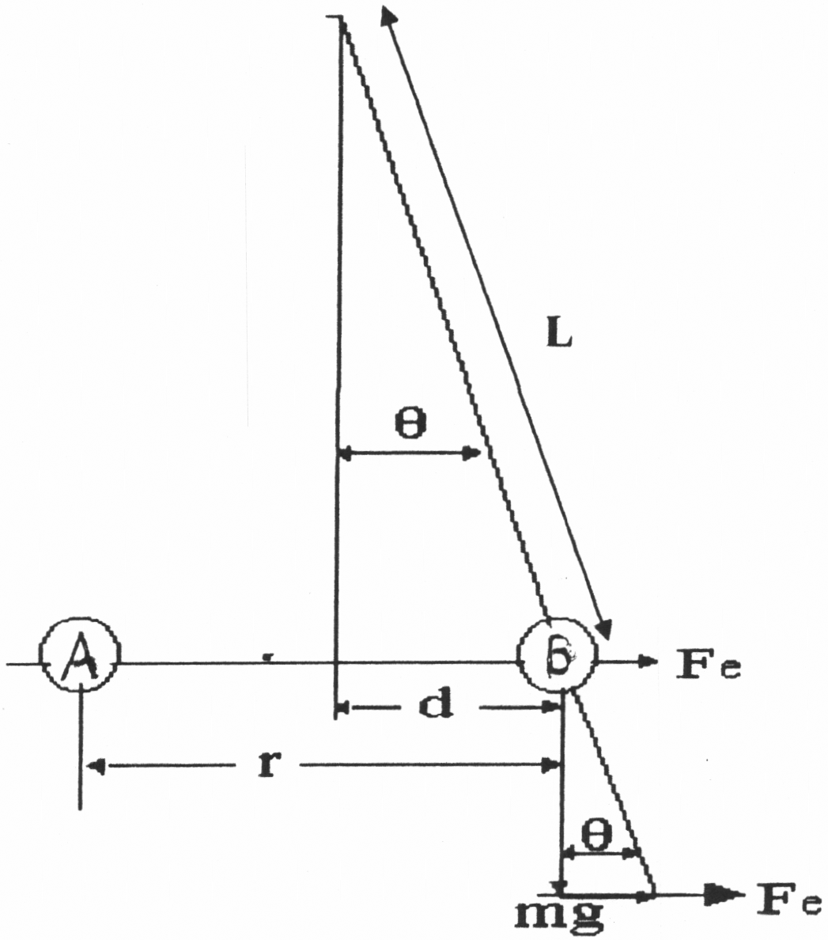

**Figure 1: Coulomb’s Law Apparatus**

**University Physics Workbook Vol. I**

# Electric Field Mapping

The following is revised from the Operating Instructions of the Overbeck Electric Field Mapping Apparatus CP79587-00 by Cenco Physics, P.O. Box 369, Franklin Park, IL 60131, (800) 262-3626.

**Introduction**

The Overbeck Electric Field Mapping Apparatus (CP79587-00) is used to map equipotential lines of an electric field and locate the electric lines of force.

**Purpose**

To examine the properties of electric fields, map equipotential lines of an electric field, and determine the electric lines of force.

**Theory**

Coulomb’s Law: The first quantitative investigation of the law of force between electrically charged bodies was carried out by C. A. Coulomb in 1784-1785. His measurements showed that the force of attraction for unlike charges or of repulsion for like charges followed an inverse square law of distance of separation. It was later shown that for a given distance of separation r the force is proportional to the product of the individual charges, Q and Q’, and is a function of the nature of the medium surrounding the charges. Expressed mathematically, Coulomb’s Law is:

F = k QQ’ / Kr2 (1)

where the factor K, called the dielectric constant is introduced to take care of the nature of the medium and k = 9\*109 N m2/Coul2 = 1/4o = c2\*10-7. The factor K is arbitrarily assigned a value of 1 for empty space. Coulomb’s Law is restricted to point charges, that is, the charged body must have dimensions that are small compared to the separation distance.

System of Units: Several systems of units, each with its particular advantages, have been used. The modern metric system is the S.I. system where forces are expressed in Newtons, distances are expressed in meters, the unit of charge is the Coulomb (Coul or C), and the proportionality constant, k, as listed above. Note that k is closely related to the permittivity of free space and the speed of light.

Unit Quantity of Electricity or Charge: When all quantities in equation (1) are unity, the equation expresses the definition of the unit of charge (Coul or C) or Coulomb — The Coulomb is a charge of such magnitude that it is repelled by a force of 9\*109 N when placed 1 m from an equal charge in a vacuum. The charge of one electron is a natural basic unit of quantity of electricity. Its charge is -1.602\*10-19 Coulomb. Thus -1 Coulomb represents a charge of 6.25\*1018 electrons.

Dielectric Constant: The factor K in Coulomb’s Law, called the dielectric constant of the medium, is assigned a value of 1 for a vacuum. When the medium separating the charges is not empty space, the force between the charged bodies is altered because charges are induced in the molecules of the medium. Air at one atmosphere pressure has a dielectric constant of 1.00059. Thus as a practical matter, equation (1) using K = 1 is acceptable to one part in two thousand for Coulomb’s Law experiments in air. The common dielectrics have “constants” K from 1 to 10 in value. The dielectric constant of glass ranges from 5 to 10, mica from 3 to 6, and oil from 2 to 2.5. The specific value of the “constant” for a given medium may vary with a change in temperature, pressure, frequency of current, etc. K is a pure number in the S.I. system, however has dimensions dependent on the system of units used.

Electric Field: An electric field, often called field of force, is a region in which forces act on any electric charges present. If a force F acts on a charge q at a point in the field, the field strength E, by definition the force per unit charge, is:

E=F/q (2)

that is, the magnitude of electric field strength is the force per unit charge. Force is a vector quantity having direction as well as magnitude. The direction of on electric field at any point is the direction of the force on a positive test charge placed at the point in the field.

Lines of Force: Faraday introduced the concept of lines of force to visualize the strength and direction of an electric field. A line of force is the path that a positive, free, massless test charge would follow in traversing the electric field. The path is tangent to the field direction at every point. As an illustration, consider the isolated positive charge Q placed at A in Figure 1. A small positive test charge q at any point in the Field experiences a radial force of repulsion from A. The lines of force are drawn with arrows to point this direction. When Q is a negative charge, that is an excess of electrons, these lines would be directed towards A to indicate an attraction of the positive test charge q.

|  |  |
| --- | --- |
| **Figure 1** Electric field around on isolated positive charge. | **Figure 2** Electric field near two equal charges of opposite sign. |

The magnitude of the force per unit charge may also be graphically shown using the concept of lines of force. By convention, the number of lines of force drawn through a unit area placed normal to the field at a point is made numerically equal to the field strength at that point. For example, if the field strength at a point is 5 N/Coul, five lines of force per square centimeter are shown at that position in the field.

The diagram of Figure 2 shows a plane section near a pair of equal charges of opposite sign. Each charge exerts a force on a unit test charge placed in the field. The resultant force is the vector sum of these forces. Thus, at the point b, f1 is the repulsion force on the unit test charge due to the positive charge on A, and f2 is the force of attraction to the negative charge on B. The resultant R is tangent to the line of force at the point b.

It is evident that a uniform field is represented by a set of parallel lines of force. A converging set of lines of force indicates a field of increasing strength; while a field of decreasing strength would be represented by a diverging set of these lines.

Potential Difference: Two points in on electric field have a difference of potential if work is required to carry a charge from the one point to the other. This work is independent of the path between the two points. Consider the simple electric field illustrated in Figure 3.

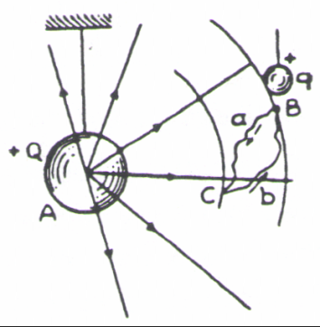

**Figure 3** Potential difference between points in an electric field.

Since the charge +Q produces an electric field, a test charge +q at any point in the field will be acted upon by a force. It will be necessary to do work to move the test charge between any such points as B and C at different distances from the charge Q. The potential difference between two points in an electric field is defined as the ratio between the work done in moving a small positive charge between the two points and the magnitude of the charge moved — symbolically stated:

V=W/q (3)

where V is the potential difference, W is the work done, and q is the charge moved. In the S.I. system B is expressed in volts when W is in Joules and q in Coulombs.

The conservation of energy principle requires that the work done must be independent of the path over which the charge is transported. Otherwise energy could be created or destroyed by moving a charge from one point such as B in Figure 3 to C by path a, involving a certain energy, and returning by path b of different energy.

Absolute Potential: If point B in Figure 3 is taken very far from A, the force on the test charge q at this point would be practically zero — see equation (1). The potential difference between C and this point at on infinitely large distance away is called the absolute potential of point C. The absolute potential of point in on electric field may, therefore, be defined numerically as the work per unit charge required to bring a small positive charge from a point outside the field to the point considered.

Since both work and charge are scalar quantities, it follows that potential is a scalar quantity. The potential near on isolated positive charge is positive, while that near on isolated negative charge is negative. (What is the physical significance of negative work?)

Equipotential Surfaces: It is possible to find a large number of points in on electric field, all of which have the some potential. If a line or a surface is so drawn that it includes all such points, the line or surface is known as an equipotential line or surface. The line C’C’ in Figure 4 is an equipotential line. A test charge may be moved along an equipotential line or over an equipotential surface without doing any work.

Lines of Force Perpendicular to Equipotential Surfaces: Since no work is done in moving a charge over an equipotential surface it follows that there can be no component of the electric field along an equipotential surface.

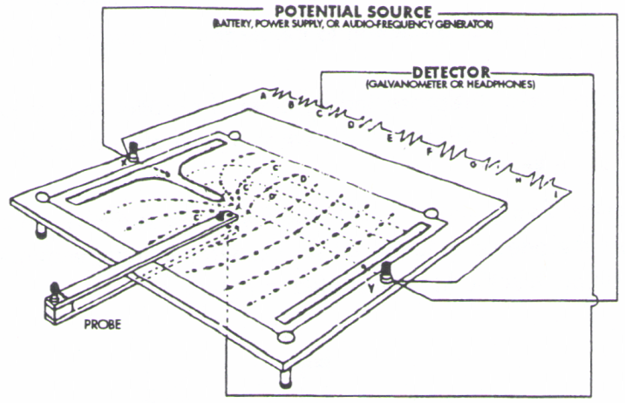

**Figure 4** Sketch of the Electric Field Apparatus with Equipotential Diagram.

Thus the electric field or lines of force must be everywhere perpendicular to the equipotential surface. Equipotential lines or surfaces in an electric field are more readily located experimentally than lines of force, but if either is known the other may be constructed as shown in Figure 5. The two sets of lines must everywhere be normal to one another.

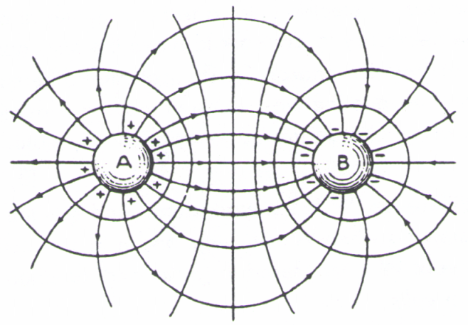

**Figure 5** Lines of force and equipotential lines near two charges of equal magnitude and opposite sign.

The field in Figure 4 is a reproduction of an actual test made in designing a part for a high voltage generator. The solid lines are the equipotential lines and the dash lines are the lines of force for a field existing between a pin and a plane.

Potential of a Conductor: Electrons in a conductor can move under the action of an electric field. Thus, if an electrical conductor is placed in an electric field, this electron flow, which constitutes an electric current, will take place until all points in the conductor reach the same potential. There will be no net electric field inside the conductor whether solid or hollow provided it contains no insulated charge. Thus, to screen a region of space from an electric field it need only be enclosed within a conducting container since all parts of the conductor are at the same potential, the electric lines of force always leave or enter the conductor at right angles to its surface.

Lines of Flow: When charged bodies of different potentials are located in a medium in which some flow of charge can occur, the field of force will cause these charges to be transported from one body to the other. To maintain the difference of potential the bodies must then be connected to a source of electromotive force. The flow lines of the charge follow the paths of the lines of force, that is, they are also at all points perpendicular to the equipotential surfaces.

**Description**

The apparatus consists of a field-mapping board, a U-shaped probe, six field plates (pictured in Figure 6), and two plastic templates. The patterns on the two templates are a composite of the patterns on the six field plates. Any one of the six field plate patterns can be reproduced with the templates. Eight similar resistors are connected in series between the two binding posts on the field-mapping board to eight points separated by the same difference of potential (see Figure 4).

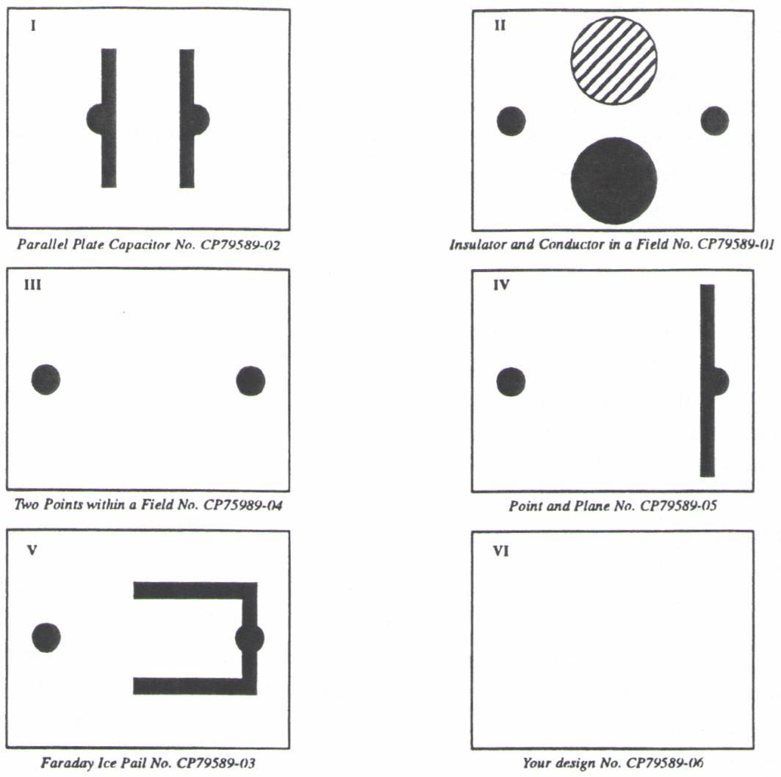

**Figure 6** The Overbeck Electric Field Mapping Apparatus’ six field plates

**Setup**

The following equipment is required for operation:

1. A source of potential, such as a 2V or 6V battery or a signal generator.
2. A null-point detector, such as a galvanometer (CPB210l-01) used in conjunction with the battery, or a pair of headphones used in conjunction with the signal generator.

Turn the field mapping board over and notice the two metal bars. Each bar has two threaded holes. Two of these holes hold plastic-headed thumb screws with knurled lock nuts. Remove the thumb screws and center any one of the field plates so the holes in the plate coincide with holes in the metal bars. Insert a thumb screw into each hole and turn it until it touches the board below. Turn the knurled lock nut to hold the field plate securely in place.

Binding posts marked “Bat.” and “Osc.” are located on the upper side of the board. Connect the potential source to the appropriate binding post. Fasten a sheet of 8.5 x 11-inch graph paper to the upper side of the board. Secure the paper by depressing the board on either side and slipping the paper under the four rubber bumpers. Select the design template containing the field plate configuration you have chosen. Place the design template on the two metal projections (template guides) above the paper edge and let the two holes on top of the template slide over the projections. Trace the design corresponding to the field plate pattern in place on the underside of the mapping board and remove the template.

**Operation**

Place the Field Mapping Board and the U-shaped probe on a lecture table or laboratory bench. Carefully slide the U-shaped probe onto the mapping board with the ball end facing the underside of the filed mapping board. Connect one lead of the null-point detector (galvanometer or headphones) to the U- shaped probe and one to one of the banana jacks, numbered E1 through E7.

Notice the knurled knob on top of the probe (next to the spotting hole) and the screw below the probe that acts as a support leg. To make tracings, guide the probe with one finger of one hand resting lightly on the knurled knob, and a finger on the other hand lightly touching the nut of the leg. The leg slides on the table top and stabilizes the probe. Do not apply pressure to the probe, and avoid squeezing its jaws. This causes unnecessary wear on the plates. Although some wear is inevitable, the plates will last longer if proper care is taken.

Using the selected banana jack, move the U-shaped probe over the paper to a zero reading or a no-sound position. The circular hole in the top arm of the probe is directly above the contact point that touches the graphite-coated paper. Record the location of the equipotential point directly on the paper. Move the probe to another null-point position and record it. Continue this procedure until you have generated a series of these points across the paper. Connect the equipotentiol points with a smooth curve to show the equipotential line of the banana jack.

Connect the detector to a new banana jack and plot its equipotential line. Repeat until equipotential lines are plotted for all banana jacks El through E7. Since the potential difference is the same across each similar resistor, the equipotential lines will be spaced to show an equal potential drop between successive lines.

The lines of force are perpendicular to these equipotential lines at every point. Using dashed lines, draw in the lines of force of the electric field being studied. After completion, select a different field plate and repeat the above procedure until all electric fields from field plates I, III, IV, and V (shown in Figure 6) are drawn. You may optionally include additional field plates.

**Questions**

1. Why are the equipotential lines near conductor surfaces parallel to the surface and why are they perpendicular to the insulator surface mapped?
2. Is it possible for two different equipotential lines or two lines of force to cross? Explain.
3. Explain, with the aid of a diagram, why lines of force must be at right angles to equipotential lines.
4. Under what conditions will the field between the plates of a parallel plate capacitor be uniform?
5. How does the electric field strength vary with distance from an isolated charged particle?
6. Sketch the equipotential lines for an isolated negatively charged particle, spacing the lines to show equal difference of potential between lines.
7. Compare the sketch in answer to Question 6 with the mapped field of the “Parallel Plate Capacitor.” Account for the difference.
8. Show that the electric field strength is equal to the potential gradient.
9. How much work is done in transferring a Coulomb of charge from the one terminal to the other terminal in this experiment?
10. Explain the lack of symmetry in the field of sheet I, Figure 6.
11. Sketch the field pattern of two positively charged small spheres placed a short distance from each other.
12. Explain the pattern of the field found inside a Faraday “Ice Pail.”

**Maintenance**

After many hours of operation, the silvered surface of the field plates can rub off. This surface can be renewed with any high-quality conductive silver paint, such as the paint sold by radio parts dealers for repairing printed circuits. Occasionally buff the tip of the ball probe with a very fine grade of emery paper to ensure good electrical contact.

If difficulties arise with this apparatus that cannot be eliminated by the above steps, please contact Cenco Physics, giving details of the problem. To ensure better service, please do not return any item until we have sent you authorization.

**Accessories**

The following is a list of equipment suitable for use with the Overbeck Electric Field Mapping Apparatus (CP79587-00):

DESCRIPTION CAT. No.

Sine/Square Wave Generator CP33048-00

Student Galvanometer CP82108-01

Rectangular Graph Paper, 8.5 x 11 inches

5 lines/cm, 100 sheets CP72711-55

10 lines/inch, 100 sheets CP88119-00

**Copyright Notice**

The Overbeck Electric Field Mapping Apparatus operating instructions are copyrighted and all rights reserved. Permission is granted to all non-profit educational institutions to make as many copies of these instructions as they like as long as it is for the sole purpose of teaching students. Reproduction by anyone for any other reason is prohibited.

Page left intentionally blank

**University Physics Workbook Vol. I**

# Ohm’s Law

**Purpose**

Study Ohm’s Law, the variation of current with positive and negative voltage, and the variation of resistance with wire type, length, and area.

**Required**

Resistance Board, a dc power supply (5V) or three dry cells, a dc voltmeter (5V), a dc ammeter 1A and connecting cords are also required for operation.

**Introduction**

According to Ohm’s Law, the voltage drop across a resistor is proportional to the current as follows:

$V=IR$ (1)

where *V* is the voltage drop, *I* is the electrical current, and *R* the resistance. You already know *V* is measured in volts, *I* in amps, however you may not yet be familiar with the fact that the unit of resistance is an Ohm or  (capital Greek letter omega). From Equation (1) it’s easy to see:  = volt/amp.

Ideally resistance is inversely proportional to the area and proportional to length. If area is doubled it’s like two wires each carrying the same current, therefore the resistance is halved. If length is doubled, it’s like two wires connected in series each with a the same voltage drop so the total drop across both wires is doubled for the same current. Therefore resistance doubles.

Conductance is a useful concept and equals the reciprocal of resistance. Therefore, by the same reasoning as the previous paragraph, conductance is proportional to area and inversely proportional to length.

Resistance also depends on the material with silver being a very good conductor, followed by copper and aluminum. A nickel-chromium alloy is the worst conductor of all known metals, however other materials, such as graphite, have even higher resistance. For electronic devices to operate at low power, high resistance is useful to reduce current and, consequently, power. Insulators have the highest resistance of all and are useful to effectively prevent current flow. Insulators cover wires to prevent unwanted conduction from one wire to another.

To accommodate the effect of differing materials we employ the material specific constant referred to as resistivity. You may also come across conductivity – it is simply the reciprocal of resistivity. Resistivity may be useful for one type of electrical application while conductivity may be more convenient for other applications. Using resistivity, the total resistance is given by:

$R= ρ\frac{l}{A}$ (2)

Where *R* is resistance,  is resistivity, *l* is length, and *A* is area. There are two common units of resistivity used by scientists and engineers, either  cm or  m. In our experiment, to keep power used low, we use metals (constantan, a copper/nickel alloy, and steel) with relatively high resistivity.

**Procedure**

Study the base of the unit. You will see that there are four binding posts on each end of the base. Orient the base so that the number labels that mark the position of the binding post is to your left. If oriented correctly, the number 1 should be closest to you, and the number 4 should be furthest from you (see diagram).

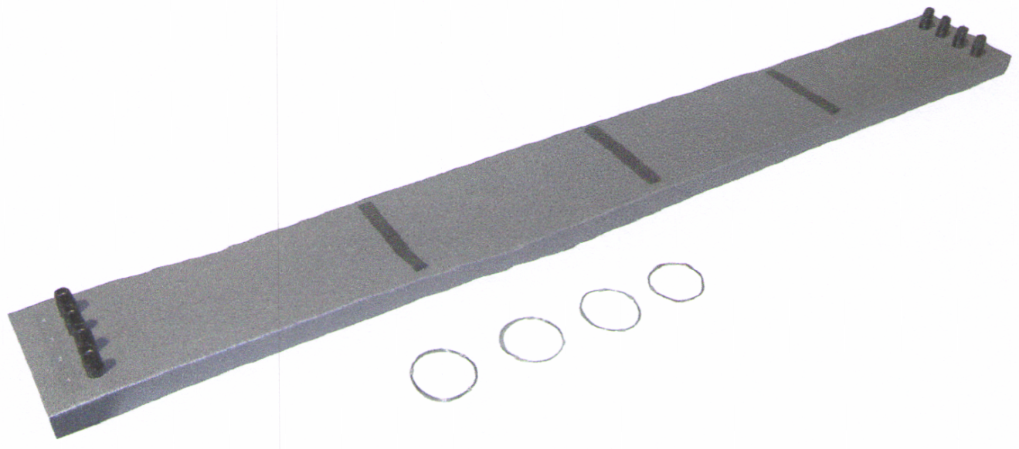

**LAWS OF RESISTANCE BOARD**

The Resistance Board is used for studying the physical laws that describe electrical resistance phenomenon in metal conductors. It is also used to investigate ohm’s law and the effects of length, cross section and material on a conductor’s electrical resistance.

It consists of a metal base, 110 cm long and 12.5 cm wide, 4 parallel wires, each 100 cm long, terminating in insulated binding posts at each end are mounted on the board. Three nos. of insulating blocks are present on the base which prevent the wires from contacting the metal base during experiment. All wires are 1.035 m long and the numbering for wire is also given and characteristics for wires are as given below:

|  |  |  |  |  |  |
| --- | --- | --- | --- | --- | --- |
| Terminal | AWG Wire Diameter (mm) | Measured Wire Diameter (mm) | Wire Gauge | Material | Resistivity (n m) |
| 1 | 0.255 | 0.33 | 30 | Constantan | 490 |
| 2 | 0.511 | 0.52 | 24 | Constantan | 490 |
| 3 | 0.218 | 0.33 | 32 | Steel (Music Wire) | 100 to 600, likely ~ 500 |
| 4 | 0.255 | 0.32 | 30 | Copper | 16.4 |

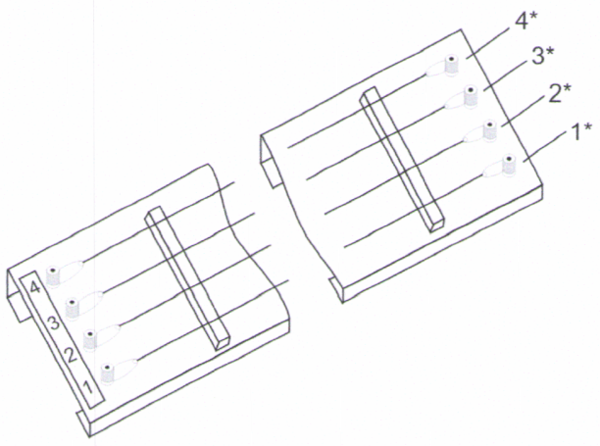

To demonstrate the characteristics of electrical resistance in metal wires, different combinations of the wires on the board are connected to a constant voltage DC source and the voltage across various segments of the wires is measured using a voltmeter and test leads.

The following examples of experiments will aid in using the board. To simplify the descriptions, the terminal at the opposite end of each wire from the number label is designated by an asterisk, as illustrated in the previous diagram.

**Ohm’s Law**

The resistance *R* of a conductor is equals to the voltage *V* across the conductor divided by the current *I* through the conductor. To verify this relationship, connect a dry cell between terminals 1 and 2. If using a power supply, set it to 1.5 V. Connect an ammeter with a 1 A range between terminals 1\* and 2\*. Record the current reading. Repeat this procedure, first using two dry cells connected in series or a power supply setting of 3 V, then with three dry cells in series or a power supply setting of 4.5 V.

Next remove the meter from the circuit and connect the 1\* and 2\* terminals together. Using the 5 V range of the voltmeter, verify the voltage of the current source and then measure the voltage of the current source and then measure the voltage between 1 and 2 for each of the preceding arrangements. It will be found that the ratio between the applied voltage (in volts) and the current (in ampere) is numerically equal to the resistance (in ohms).

Repeat this experiment for wires 3 and 4. Organize your data and results well, plot V vs. I, calculate slope and error of the slope, and discuss in the conclusion whether or not Ohm’s Law is confirmed or not.

**Law of Lengths**

Connect terminals 1\* and 2\* together, then connect three dry cells (4.5 V) across terminals 1 and 2. If using a power supply, set it to 4.5 V. Using the 5 V range of the voltmeter measure the voltage drop between 1 and a point midway between 1 and 1\*. Now measure the voltage across the entire length of this wire (from 1 to 1\*). It will be found that, within the accuracy limits of the measurements, the second reading should be twice the first. Finally, measure current by breaking the circuit between terminals 1\* and 2\*, insert the ammeter, and read the amperage. Be sure to set the ammeter to a high scale, use the hole marked “A” if the power supply reads greater than 0.2 A, and move scale downward until the reading is in range.

Repeat the experiment for all four wires. Organize your data and results well, plot resistance vs. length, calculate slope and error of slope, and discuss in the conclusion whether or not you confirm resistance is proportional to length and this proportionality does not depend on the material.

**Law of Areas**

Note that wires 1 and 2 are the same material with different diameters. Using the same setup as in the previous experiment (power supply or batteries between 1 and 2 and connect 1\* and 2\* together), measure the voltage across terminals 1 and 1\* and across 2 and2\*. Observe that the voltage drop across 2 and 2\* is approximately four times greater than that across 1 and 1\*. Finally, measure current by breaking the circuit between terminals 1\* and 2\*, insert the ammeter, and read the amperage. Be sure to set the ammeter to a high scale, use the hole marked “A” if the power supply reads greater than 0.2 A, and move scale downward until the reading is in range.

Since both conductors have the same length and are made of the same material, you should observe that the resistance of a conductor is inversely proportional to its cross-sectional area. Show this by plotting resistance vs. 1/area, calculate slope and error of slope, organize your data and results well, and discuss in the conclusion whether or not you confirm resistance is inversely proportional to area.

**Law of Material**

Connect together terminals 1\* and 2\*, 2 and 3, and 3\* and 4\*. Connect three dry cells across terminals 1 and 4. If using a power supply, set it to 4.5 V. Using the 5 V range of the meter, measure the voltages across the terminals pairs 1 and 1\*, 2 and 2\*, 3 and 3\*, and 4 and 4\*. Different meter readings will result. Finally, measure current by breaking the circuit between terminals 1\* and 2\*, insert the ammeter, and read the amperage. Be sure to set the ammeter to a high scale, use the hole marked “A” if the power supply reads greater than 0.2 A, and move scale downward until the reading is in range.

Wires 1 and 4 have the same length and diameter, but are made of different materials. It follows that the resistance of a conductor depends on its material. Using the wire lengths and diameters, calculate the resistivities of the four wires and compare this with accepted values including reporting % err.

**University Physics Workbook Vol. I**

# Series and Parallel Circuits

**Purpose:** To verify Kirchoff’s current and voltage laws, calculate effective resistance in series and parallel, and compare to measured values. Also become acquainted with instruments used for electrical measurements, circuit diagrams, and elements of the circuit.

**Currents and voltages in series circuits**

* + 1. Set the battery at 5 volts or less. Do not change this setting, once made, during this part of the experiment. NOTE: The voltmeter is always placed in parallel (looks like a bypass) to the element of the circuit across which the voltage is being measured. The positive pole of the voltmeter goes toward the positive pole of the battery as in the diagram.

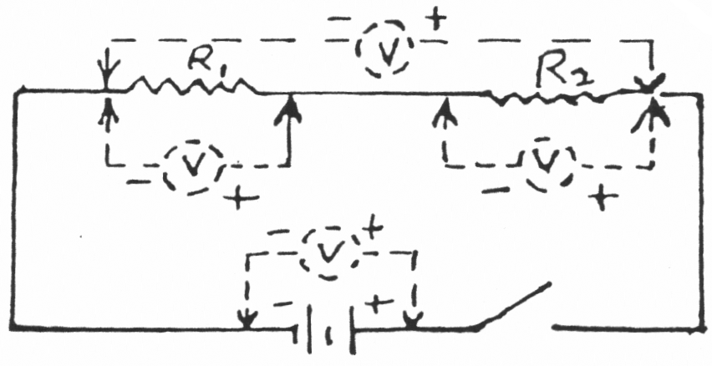

**Figure 1**

* + 1. Use the following pairs of values for R1 and R2: (25  & 75 ), (20  & 80 ), (33  & 67 ), (50  & 50 ), and (100  & 100 ). Also use pairs of resistors that sum to 300  and 400 . Due to availability of resistor pairs, it may be necessary to adjust the values of the pairs of resistors measured. Optional using Vernier Circuit Board use the pairs (10  & 51 ), (10  & 68 ), (51  & 68 ), (22 k & 47 k), and (22 k & 100 k)
    2. Set up your data table to measure voltage drop across each resistor, voltage drop across the resistor pair, the battery voltage, and the current through three points (X, Y, and Z in Figure 2). Measure the battery voltage with the switch closed.
    3. From your measurements, calculate R1, R2, and Rs (the effective series resistance of R1 and R2), tabulate in a new well organized table in the results section, compare to listed values including reporting % err or %diff, and compare your calculated resistance to other methods of calculating resistance including calculating % err or %diff.
    4. Are Kirchoff’s voltage and current laws confirmed or contradicted? Tabulate expected currents and voltages in a new well organized table and report % err or %diff to show if Kirchoff’s voltage and current laws are confirmed or contradicted.
    5. With the circuit of Figure 2, R1 = 25 ohms, and R2 = 75 ohms (or corresponding Vernier Circuit Board pair 51  & 68 ) read the ammeter at each position noted. Record in your report’s data table

NOTE: The ammeter is always placed in the circuit at the point where a knowledge of the amperage is desired. The positive pole of the ammeter goes toward the positive pole of the battery. Unlike a voltmeter there is potential for damage to an ammeter. TO AVOID DAMAGE set the ammeter to a large scale and gradually reduce the scale.

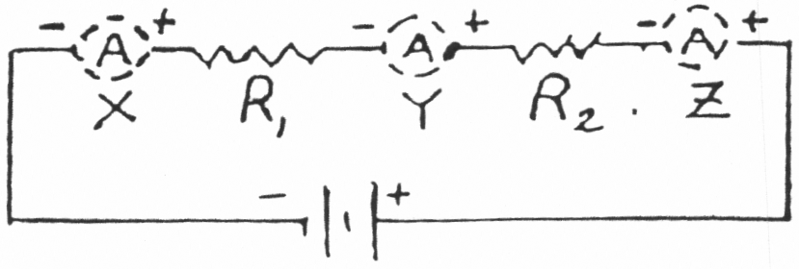

**Figure 2**

* + 1. For the other resistances indicated in Step 2, record the voltages and currents as shown in Figures 1 and 2. For the remainder of resistances in Step 2 you only need to measure current at one point, X for example. Discuss why this procedure is valid (this is an end-of-report question).

**Currents and voltages in parallel circuits**

1. With R1 = 40 ohms, R2 = 33 ohms, and R3 = 62 ohms (Vernier Circuit Board 10 , 51 , & 68 ) set the battery or power supply in the circuit of Figure 3 to 3.0 V. Move the ammeter and measure the current at the other indicated positions.

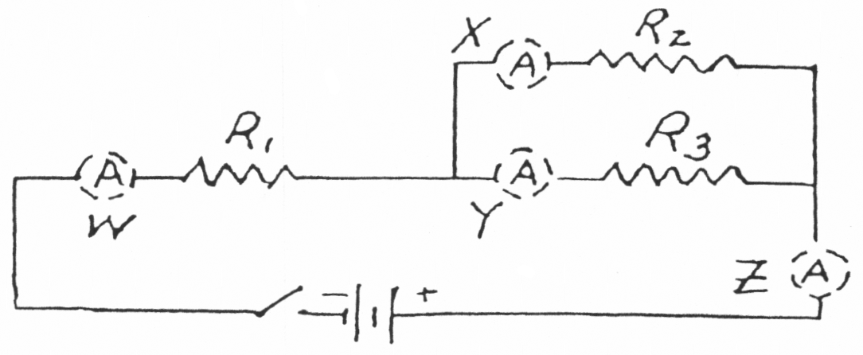

**Figure 3**

1. Take voltages as indicated in Figure 4 and record. Record the data appropriately in your lab report. Take voltage across the battery with the switch closed. Set battery or power supply to 3.0 volts.

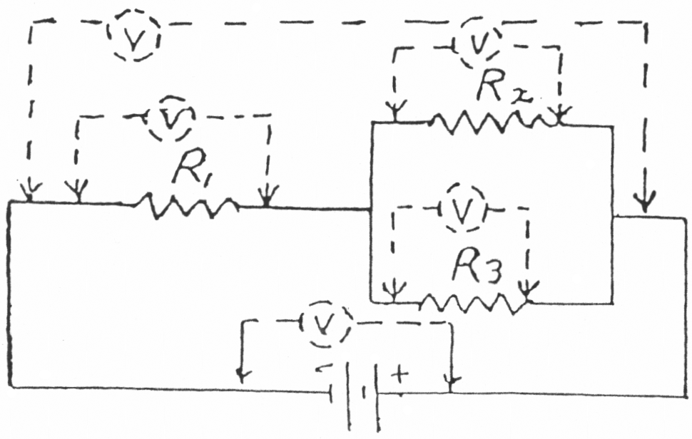

**Figure 4**

1. Organize your data collection to record battery voltage; voltage drop across the entire network; voltage drop across R1, R2, and R3; Measure currents at Points W, X, Y, and Z.
2. Consider current ratio and resistance ratios in the parallel portion of the circuit. How does the current through R2 and R3, together, compare with that through R1? Record your observations in your lab report.
3. From your measurements, calculate R1, R2, Rp (the effective parallel resistance of R2 & R3), and Rps (the effective resistance of the series/parallel network of R1, R2, & R3), tabulate in a new well organized table in the results section, compare to listed values including reporting % err or %diff, and compare your calculated resistance to other methods of calculating resistance including calculating % err or %diff.
4. Are Kirchoff’s voltage and current laws confirmed or contradicted? Tabulate expected currents and voltages in a new well organized table and report % err or %diff to show if Kirchoff’s voltage and current laws are confirmed or contradicted.

Page left intentionally blank

**University Physics Workbook Vol. I**

# The Magnetic Field in a Coil

**Purpose**

When an electric current flows through a wire, a magnetic field is produced around the wire. The magnitude and direction of the field depends on the shape of the wire and the direction and magnitude of the current through the wire. If the wire is wrapped into a loop, the field near the center of the loop is perpendicular to the plane of the loop. When the wire is looped a number of times to form a coil, the magnetic field at the center increases.

In this activity, you will examine how the magnetic field is related to both the number of turns in a coil and the current through the coil. A Magnetic Field Sensor will be used to detect the field at the center of the coil. A complication that must be considered is that the sensor will also detect the Earth’s field and any local fields due to electric currents or some metals in the vicinity of the sensor.

**Theory**

According to Maxwell’s Equations and Ampere’s Law, an infinite wire carrying current of I produces a magnetic field at a distance R from the wire of:

$B= \frac{{\text{μ}}_{o} I}{2 π R}$ (Magnetic Field Around Wire) (1)

Note that o = 4\*10-7 Tesla m / Amp. The theory concerning wires wrapped in various arrangements requires knowledge of calculus and is beyond the scope of this course. Simply listed here are a few equations for some simple configurations.

$B= \frac{{\text{μ}}_{o} R^{2} N I}{2 {\left(z^{2}+ R^{2}\right)}^{3/2}}$ (Magnetic Field on Center Axis of Coil) (2)

Note that, unlike Equation (1), R is the radius of the coil and z is the distance from the center of the coil along the center axis. When z = 0 Equation (2) simplifies to:

$B= \frac{{\text{μ}}_{o} N I}{2 R}$ (Magnetic Field at Center of Coil) (3)

For a long coil with a length much greater than the radius, also known as a solenoid, the magnetic field for a solenoid of length L and N number of loops is:

$B= \frac{{\text{μ}}_{o} N I}{L}$ (Magnetic Field at Center of Long Coil – Solenoid) (4)

**Objectives**

* Use a Magnetic Field Sensor to measure the field at the center of a coil.
* Determine the relationship between magnetic field and the number of turns in a coil.
* Determine the relationship between magnetic field and the current in a coil.
* Explore the Earth’s magnetic field in your room.
* Explore the relationship of magnetic field to the radius of a coil.
* Explore the relationship of magnetic field to the length of a coil.
* Explore the magnetic field around a wire.
* Explore the magnetic field to the distance from the center of a short coil.
* Compare results to theory.

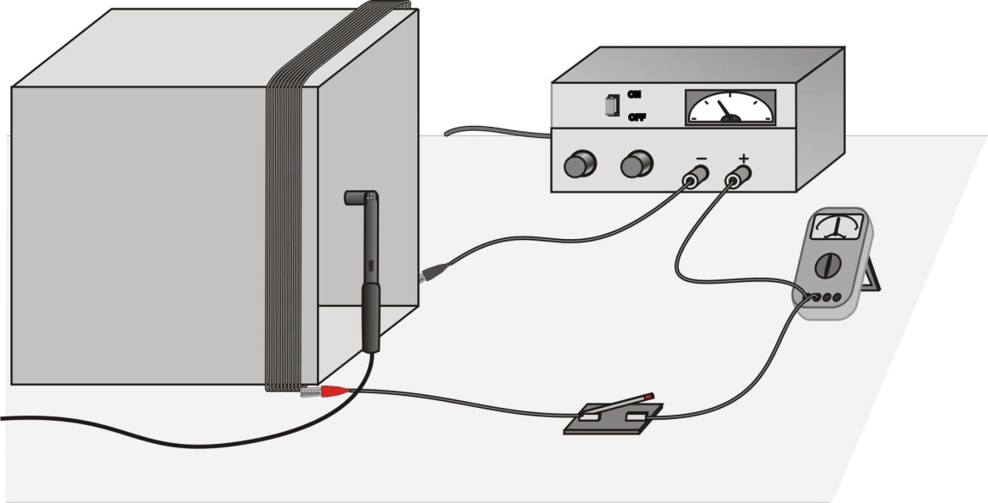

Figure 1

**Materials**

|  |  |
| --- | --- |
| * Computer | * Square or circular frame |
| * Vernier computer interface | * Ammeter |
| * Logger *Pro* | * Momentary-contact switch |
| * Vernier Magnetic Field Sensor | * Magnetic compass |
| * Adjustable power supply | * Insulated wire (at least 12 m) |

**Initial Setup**

* + 1. Connect the Vernier Magnetic Field Sensor to Channel 1 of the interface. Set the switch on the sensor to 0.3 mT (high amplification), however if necessary switch it to 6.4 mT (low amplification).
    2. Using the long spool of wire, loop the wire ten times around a frame or box creating a coil of ten turns. Optionally pre-prepared coils may be used. Consult your instructor regarding this.
    3. Connect the coil, switch, ammeter, and power supply, as shown in Figure 1. Use an external ammeter (DMM) unless you are certain the power supply’s ammeter is accurate. Usually it is not.
    4. Optionally open the file “25 Magnetic Field in a Coil” in the *Physics with Vernier* folder. Most people have better results NOT using the previously prepared experiment.
    5. Several different coils are located around the lab. It will be necessary for lab groups to trade coils for the various parts of this experiment. Your lab instructor will assign groups to work on different portions of this experiment at different times so all lab groups can accomplish this experiment.

**Preliminary Questions and Additional Setup**

1. Hold the plastic rod containing the Magnetic Field Sensor vertically and move it completely away from the coil. Click CollectNew to begin data collection. Rotate the rod around a vertical axis. Look at the graph. What do you observe? What is causing the variation of field reading?

2. Determine the orientation of the sensor when the magnetic field is at a maximum, and compare the direction that the dot on the sensor is pointing with the direction that the magnetic compass needle points. What did you discover? How much does the reading change in one rotation?

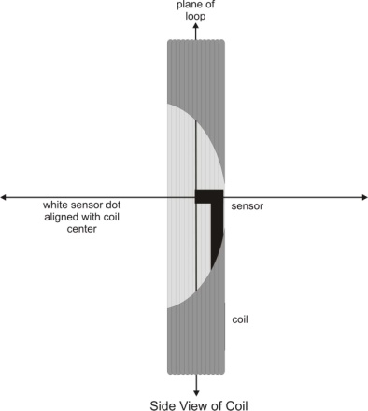3. Set the power supply so that the current will be 3 A when the switch is closed. Place the sensor in a vertical position at the center of the coil, with the white dot facing along the axis of the coil as shown here (figure at left). Click CollectNew. Wait 2 to 3 seconds and then close the switch. What did you observe? **Warning:** This lab requires fairly large currents to flow through the wires. **Do not leave the switch on except when taking measurements.** The wire and possibly the power supply may get hot if you leave current flowing continuously.

4. Repeat Step 3, but this time, rotate the Magnetic Field Sensor while you are holding the switch closed. Determine the orientation of the sensor that gives the maximum reading. How much does the reading change in one rotation of the sensor?

**Procedure**

*Part I How Is The Magnetic Field In A Coil Related To The Current?*

For the first part of the experiment you will determine the relationship between the magnetic field in the center of a coil and the current through the coil. Use the loop with all ten turns for all of Part I. As before, leave the current off except when making a measurement.

1. Set the power supply so that the current will be 3 A when the switch is closed.

2. Place the Magnetic Field Sensor in a vertical position so that the flat end is at the center of the coil (see figure). With the switch closed, rotate the sensor about a vertical axis and observe the magnetic field values in the meter. Find the position that indicates a maximum positive magnetic field. The flat end of the sensor should be in the plane of the coil. Keep the sensor in the same position for the remainder of the experiment.

3. We will first zero the sensor when no current is flowing; that is, we will remove the effect of the Earth’s magnetic field and any local magnetism. With the switch open, click ZeroNew.

4. Close the switch and take a magnetic field reading. Optional Vernier Procedure: Click CollectNew to begin data collection. Wait a few seconds and then close the switch until data collection ends.

5. Optional Vernier Procedure: View the field *vs*. time graph and determine when the current was flowing in the wire. Select this region on the graph, by dragging over it. Determine the average field while the current was on by clicking on the Statistics button, StatsNew. Record the average field and the current through the coil in the data table.

6. Briefly close the switch and decrease the current by 0.5 A and repeat Steps 4 and 5.

7. Repeat Step 6 down to a minimum of 0.5 A.

8. Record all your measurements a well organized data table.

*Part II How Is The Magnetic Field In A Coil Related To The Number Of Turns?*

For the second part of the experiment you will determine the relationship between the magnetic field at the center of a coil and the number of turns in the coil. The Magnetic Field Sensor should be oriented as before. Use a current of 3.0 A for all of *Part II*. Leave the current off except when making a measurement.

9. We will first zero the sensor when no current is flowing. That is, we will remove the effect of the Earth’s magnetic field and local magnetism. With the switch open, click on ZeroNew.

10. Set the power supply so that the current will be 3 A when the switch is closed. Take a magnetic field reading. Optional Vernier Procedure: Click CollectNew. After a few seconds, close and hold the switch for at least 10 s during the data collection.

11. Optional Vernier Procedure: View the field *vs*. time graph and determine where the current was flowing in the wire. Select this region of the graph by dragging over it with the mouse cursor. Determine the average field while the current was on by clicking on the Statistics button, StatsNew. Record the average field and the number of turns on the coil (10) in the data table.

12. Remove one loop of wire from the frame to reduce the number of turns by one and repeat Steps 9–10. If you move the frame or the sensor, make sure that you get it back to the same orientation as the previous measurement. Optionally pre-prepared coils may be used. Consult your instructor regarding this.

13. Repeat Step 12 until you have only one turn of wire on the frame or have completed the experiment with pre-prepared coils. Keep the current at 3.0 A.

14. Record your data in a well organized table.

**Analysis**

*Part I*

* + 1. Plot a graph of magnetic field *vs.* current through the coil. Optional Vernier Procedure (consult instructor): You may use Logger *Pro* or another graphing tool. Page 2 of the experiment file is set up for this graph. What is the relationship between the current in a coil and the resulting magnetic field at the center of the coil?
    2. Determine the equation of the best-fit line through the data points. DO NOT DO THIS ON COMPUTER! Should your best-fit-line go through the origin? Why or why not? Explain the significance of the constants in your equation. What are the units of the constants?
    3. Compare your data to the theory for a short coil and find percent error.

*Part II*

* + 1. Plot a graph of magnetic field *vs*. the number of turns on the coil. Page 3 of the experiment file is set up for this graph. How is magnetic field related to the number of turns?
    2. Determine the best-fit line through the data points. DO NOT DO THIS ON COMPUTER! Should your best-fit-line go through the origin? Why or why not? Remember that you (should have) zeroed the sensor before taking data in this lab. Explain the significance of the constants in your equation. What are the units of the constants?
    3. Compare your data to the theory for a short coil and find percent error.

**Extensions (required)**

* + 1. How does the diameter of the coil loop affect the magnetic field? Design and conduct an experiment to answer this question. Compare this to your other experiments and theory for a short coil and discuss errors (including finding percent error).
    2. Remove the coil and hold the Magnetic Field Sensor horizontally. Collect data while rotating it smoothly about a horizontal axis. Explain where the maximum and minimum readings occur and where zero or near-zero readings occur. Compare your pattern to the data you collect while rotating about a vertical axis. From this information find and estimate error of Earth’s magnetic field vector at your location.
    3. Conduct a magnetic field reading at the center of a long solenoid. Compare this to your experiments for a short coil, theories for short and long coils, and discuss errors.
    4. Conduct a magnetic field reading around a current carrying wire. Compare this to your experiments for a short coil, theories for coils and wires, and discuss errors.
    5. Conduct magnetic field readings at varying distances from the center of your short coil. Compare this to your other experiments and theory for a short coil and discuss errors.

Page left intentionally blank

**University Physics Workbook Vol. I**

# RC Time Constant

**Objective**

Study the charging and discharging of a capacitor, determine the time constant from experiment, and compare to theory including error estimation.

|  |  |
| --- | --- |
| **Theory**  Starting with a discharged capacitor, when Switch 1 is closed per the figure at right, the capacitor starts charging. A first a lot of current flows at first, *I = Vo/R*. But as voltage across the capacitor increases the current decreases to *I = (Vo – Vc)/R = VR/R* where *Vc* is the voltage across the capacitor and *VR* the voltage across the resistor. | **Figure 1** – RC Circuit Schematic  S1  .  .  Vo  .  S2  R  C |

Once charged if Switch 1 is opened and Switch 2 is closed, the capacitor begins discharging. If the voltage across the capacitor starts at *Vo*, then the current flowing is *I = Vo/R* (just like charging). As the capacitor loses charge, the voltage drops so that *I = Vc/R*.

This is very much like nuclear decay. The rate of decay is *n*/*t* is proportional to the number of available particles, *n*. If you start with *no* particles with half-life *th*, then the number of particles at some time t is given by:

$n=n_{o}{\left(\frac{1}{2}\right)}^{\frac{t}{t_{h}}}$ (1)

This is much like discharging of a capacitor where the equation is:

$V_{c}=V_{o}{\left(\frac{1}{2}\right)}^{\frac{t}{t_{h}}}$ (2)

When we write the equation for discharging a capacitor we use a slightly different form. You may need to review Appendix D regarding logarithms and exponentials to understand the connection.

$V_{c}=V_{o}e^{{-t}/{RC}}$ (3)

Recall *e* is a special number called Euler’s Number, *e* ≈ 2.71828, and is the base of natural logarithms. To fully understand *e* requires calculus. For now understand that, raised to a power, it increases exponentially like 2x or 10x and just use it on your calculator. R is the resistor value and C is the capacitance value and, multiplied together, they are a time which we call the “RC time constant.” Note that comparing Equations 2 and 3 lead to *th = RCln(2)*.

When charging, instead of going from Vo V to 0 V, the capacitor is going from 0 V to Vo V, in other words, upside down from discharging. The equation is:

$V_{c}=V_{o}\left(1- e^{{-t}/{RC}}\right)$ (4)

Graphs of charging and discharging are shown in the following figure.

|  |  |
| --- | --- |
|  |  |
| **Figure 2** – Plots of capacitor charging and discharging. | |

There’s one more thing. When measuring charging and discharging, we don’t start at 0 V or battery (power supply) voltage and don’t start at *t* = 0. Therefore we need to make adjustments to the previous equations. Let *Vmin* be the minimum voltage, *Vmax* be the maximum voltage and *to* be the starting time. The adjustments to Equation 4 (charging) lead to the following equation:

$\frac{V_{c}-V_{min}}{V_{max}-V_{min}}=1- e^{{-\left(t-t_{o}\right)}/{RC}}$ (5)

The adjustments to Equation 3 (discharging) lead to the following equation:

$\frac{V_{c}-V_{min}}{V_{max}-V_{min}}=e^{{-\left(t-t_{o}\right)}/{RC}}$ (6)

Finally, we wish to find the RC time constant from our measurements. If we slightly rearrange Equation 5 and take the natural log of both sides of the modified Equation 5 and Equation 6 we obtain Equation 7 for charging and Equation 8 for discharging.

$ln\left(1- \frac{V_{c}-V_{min}}{V_{max}-V_{min}}\right)= ln\left( \frac{V_{max}-V_{c}}{V_{max}-V_{min}}\right) ={-\left(t-t_{o}\right)}/{RC}=f_{c}$ (7)

$ln\left( \frac{V_{c}-V_{min}}{V_{max}-V_{min}}\right) ={-\left(t-t_{o}\right)}/{RC}=f_{d}$ (8)

When doing your experiment, be sure to record *Vmin*, *Vmax*, and *to* in addition to taking about 10 readings of *Vc* and *t*. Take your measurements on the curved portion of the plot, not at the flat top or bottom. To make life a little easier the complicated logarithm function is named fc (charging) or fd (discharging) in Equations 7 and 8. Plot these functions on the y axis and time on the x axis. Plot by hand using a ruler – DO NOT DO COMPUTER PLOTS! Do the calculations and find the slope of the line of the function (fc or fd) vs. t. That slope will be ‑1/RC.

**Procedure**

1. Connect the computer and NI Elvis together as shown by the instructor. Optionally, and for reference, read [Introduction to NI ELVIS](http://www.funphysicist.net/physics_1402/labs/Intro_to_NIELVIS_Multisim_LV.pdf) Exercise 3-3, Page 3-7. Also, optionally, an ordinary oscilloscope and frequency generator can be used.
2. We will be studying four combinations of resistances 10 k, and 100 k and capacitances 0.01 F, and 0.001 F. Pick a resistor and capacitor, such as 10 k and 0.01 F, and connect them per Figure 1. The function generator will substitute for the battery and the oscilloscope for the voltmeter (close or short out the switches).
3. Turn the function generator to manual and square wave. Select a frequency appropriate to the RC time constant (f ≈ 1/RC) and it may be necessary to fine tune it.
4. Some of the following instruction may apply only to NI Elvis. Make adjustments as necessary to use an ordinary oscilloscope and function generator. Your instructor may have a demonstration set up at the front of the lab to assist with your set up.
5. Connect the “Func\_out” terminal to the resistor (where Switch 1 connects).4
6. Connect “Ch A+” of the oscilloscope between the resistor and capacitor.
7. Connect “Ch A-“ of the oscilloscope AND ground to the other end of the capacitor.
8. Start NI Elvis or function generator.
9. Start Oscilloscope.
10. Click “Single” and turn logging off.
11. Set Channel A on and Channel B off.
12. Set source to “BNC/Board Ch A.”
13. Set vertical position to zero, scale 1 V.
14. Set trigger to Channel A, type analog and slope rising ().
15. Set level to zero.
16. Adjust time base so you may see a full charge and discharge cycle on the screen.
17. Set the cursors “on” to measure voltage and time.
18. Measure *Vmin*, *Vmax*, and *to*. Be careful, the times on the left side of the screen are negative values.
19. Take several readings of *Vc* and *t* (about 10) for both charging and discharging. Take these readings on the curved portion of the plot – not the flat top or bottom.
20. For charging plot fc vs. t (see Equation 7). Plot by hand using a ruler – DO NOT PLOT BY COMPUTER! The slope is -1/RC. Estimate error of RC and tabulate both in the results section.
21. For discharging plot fd vs. t (see Equation 8). Plot by hand using a ruler – DO NOT PLOT BY COMPUTER! The slope is -1/RC. Estimate error of RC and tabulate both in the results section for discharging.
22. Change resistor and capacitor.
23. Adjust frequency and time base of the oscilloscope so you may see a full charge and discharge cycle on the screen.
24. Repeat steps 17 through 22 for all resistor/capacitor combinations.

Reporting

1. You will have 8 plots total – a plot for charging and discharging for each of the four resistor/capacitor combinations.
2. Plot the functions, fc & fd, vs. t, that is, the functions are on the y axis and time is on the x axis.
3. Make hand plots using a ruler, DO NOT USE A COMPUTER!
4. Estimate the best-fit-line (using a straight edge) through your data points.
5. From those plots determine your measured RC time constant value and report an estimate of error. One method to do this is to calculate the percent deviation between the RC values calculated charging and discharging..
6. Compare the results of Step 2 to the theoretical values and calculate percent error.
7. Report data and errors well including well organized tables.
8. Discuss sources of error and discuss if the theory (Equations 3 & 4) is confirmed or contradicted.

Page left intentionally blank

**University Physics Workbook Vol. I**

# Physical Pendulum

**Purpose**

To determine the relationship between the period of a square physical pendulum and the length of its sides and compare to the theory of this type of pendulum.

**Theory**

A physical pendulum is defined as a rigid body mounted so that it can swing in a vertical plane about an axis passing perpendicularly through it. It differs from a simple pendulum in that it cannot be approximated by a point mass.

The theory of harmonic oscillation predicts that when there is a restoring “force-like” quantity causes an “acceleration-like” quantity proportional to and in the opposite direction as a “displacement-like” quantity then the system will oscillate. Furthermore, the angular frequency of oscillation is equal to the square root of the constant of proportionality. For a spring the “force-like” quantity IS the force and the “displacement-like” quantity IS the displacement. However, even for a simple pendulum, the “force-like” quantity is torque and the “displacement-like” quantity the angle. In electricity the “force-like” quantity is voltage, the “acceleration-like” quantity is change of current divided by change of time, and the “displacement-like” quantity is charge.

Using your knowledge of rotational mechanics from lecture include a discussion of the theory of the physical pendulum and predict the period versus side length in your lab report. For reference, the formula for the moment of inertia around the center of a rectangular plate of dimensions x and y is:

$$I=\frac{M}{12}\left(x^{2}+y^{2}\right)$$

When applying this formula do not forget the parallel-axis theorem.

**Procedure**

You will be provided with several square sheets of metal which will have pins through one corner so that the sheets can oscillate about the pin as shown.

The period of a pendulum is defined as the time it takes the pendulum to make one complete oscillation. The accuracy of measurement of the period can be increased by finding the average time per oscillation. While keeping the angle of oscillation small (less than *15°),* determine the period of each pendulum after allowing it to complete 20 oscillations.

Graphically determine what relationship exists between the period of the pendulum and the length of its side (Period vs. Length). Plot by hand using a ruler – DO NOT USE A COMPUTER! To confirm the relationship between period and length you may need to make a second graph and/or transform the data.

**Diagram Physical Pendulum Holder 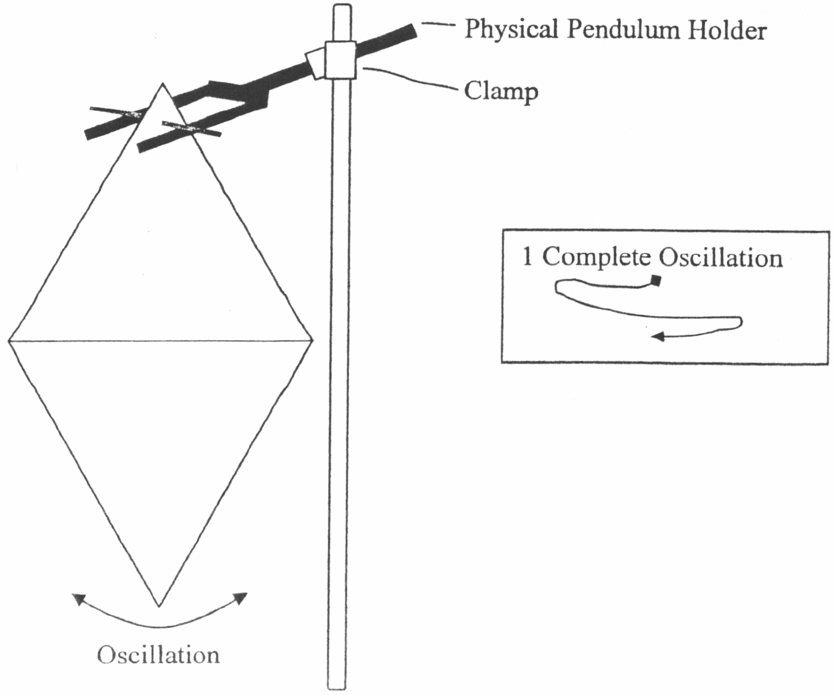**

**University Physics Workbook Vol. I**

# Waves and Wave Characteristics

**Purpose**

To study behavior and characteristics of waves and confirm if the equation, *v = f*, is confirmed or contradicted.

**Introduction**

A *wave* is a traveling disturbance that transfers energy from one place to another without transferring matter. When the disturbance is rhythmic (or repetitive), it is called a *periodic wave.* For a *longitudinal* wave (e.g., sound) the disturbance is in the same direction as the energy transfer. For that reason there is no preferred direction perpendicular to the direction of energy transfer and, thus, a longitudinal wave cannot be polarized. For a *transverse* wave (e.g., light) the disturbance is perpendicular to the energy transfer direction and, since there is a preferred direction perpendicular to the direction of energy transfer (the direction of the disturbance), a transverse wave may be polarized.

In this laboratory you will investigate four properties of a transverse periodic wave on a rope. Before starting, it is necessary to clarify some terms that are used in discussing periodic waves. This will be done in the context of a wave traveling along a rope. Figures 1 and 2 will help you to understand these terms.

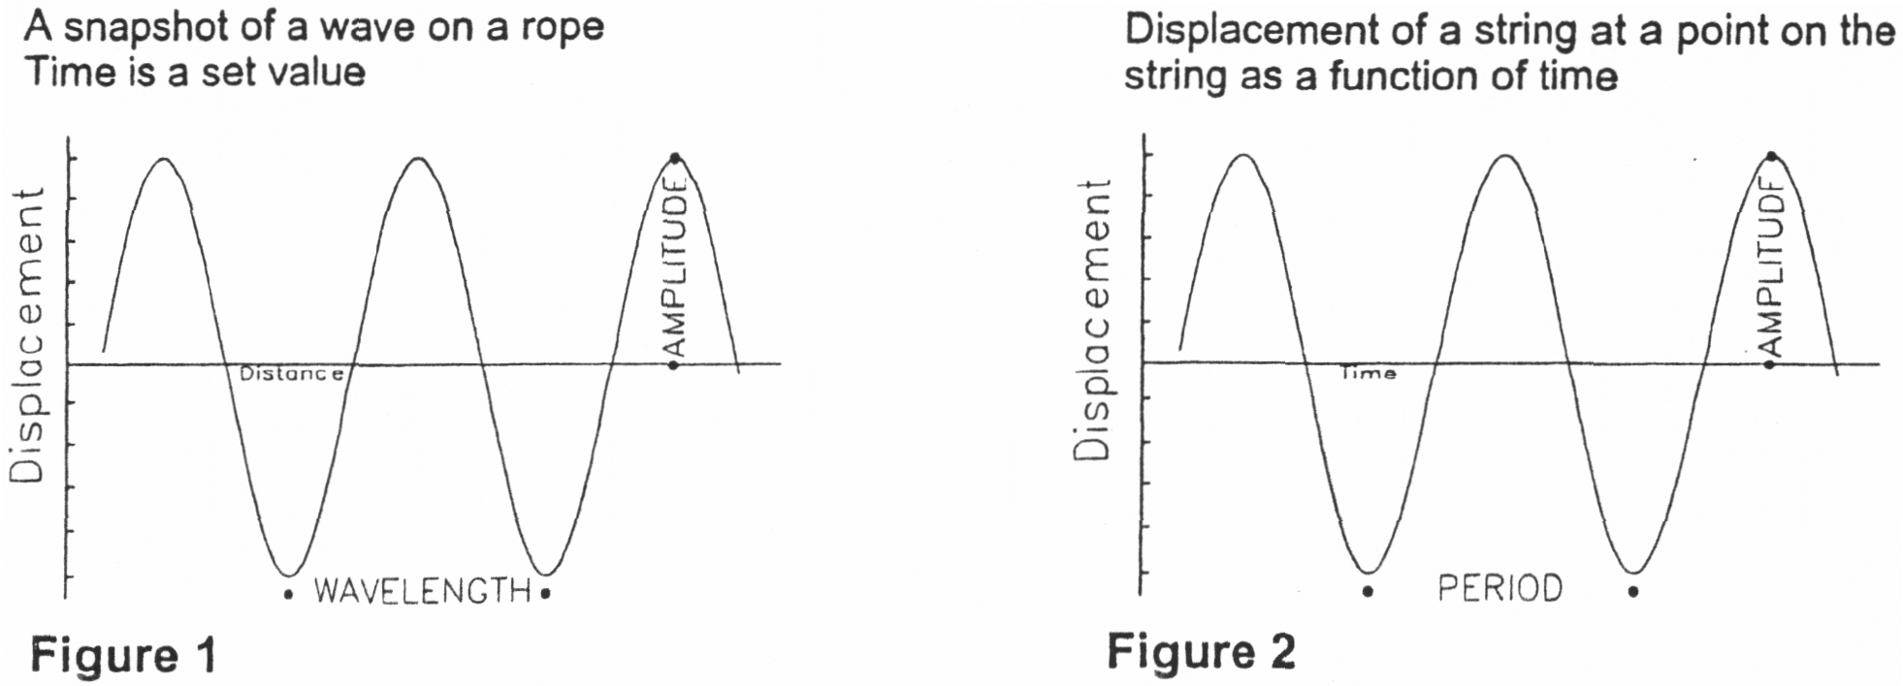

Note that Figure 2, but not Figure 1, applies to oscillations. While closely related, a major distinction between an oscillator and a wave is that a wave moves through space while an oscillator is at a fixed location.

**DISTURBANCE:** The *disturbance* is the occurrence that is repeated. If the rope is disturbed by moving it repeatedly up and down, the disturbance will consist of the motion upward from the initial (equilibrium) position, the motion downward past the initial position, and then the motion upward from the lowest position to the initial position again. At this point, the disturbance will be repeated.

**AMPLITUDE:** The *amplitude* is the maximum distance the rope moves from its initial position,

**WAVELENGTH:** The *wavelength* is the distance along the rope between the beginning of one disturbance and the adjacent repetition at some point in time. It is also the distance along the rope between the maximum displacement in one direction and the adjacent maximum displacement in the same direction (or between any two successive positions that have identical displacements and slopes).

**PERIOD:** The *period* is the time required for a single complete disturbance pattern to pass a given point. Equivalently, it is the shortest time in which the motion of one point on the rope will repeat itself.

**FREQUENCY:** The *frequency* is the number of disturbances that pass a point along the rope per time interval. For example, if you move the rope up and down to produce 5 repetitions of the disturbance in 2 seconds, the frequency will be *5* repetitions/2 seconds 2.5 repetitions/seconds (frequently called cycles/second). Rather than writing the units as repetitions/second, a standard name is defined: 1 repetition/second = 1 hertz (Hz). (Note that frequency is the reciprocal of period, which is the time/repetition).

**SPEED:** The *speed* of the wave is the distance some feature of the disturbance (e.g., a peak or a valley) moves along the rope per time interval. Note you can calculate the speed if you know the wavelength and the period. Since the wave travels one wavelength in one period, the speed is just wavelengthlperiod. This can also be written as wavelength x frequency.

**SUPPLIES:** Meterstick, tape, timer, 6-rn-long rope.

**PROCEDURE AND QUESTIONS:**

* + 1. Tie one end of the rope to some stationary object near the floor.
    2. Stretch the rope out in a straight line and mark this line on the floor. This line is the initial position (or equilibrium line) of the rope.
    3. Produce a wave by moving the free end of the rope rhythmically back and forth horizontally across the floor.
  1. Are you producing a longitudinal or transverse wave? Justify your answer from the definitions given at the beginning of this lab.
     1. Try to increase the amplitude.

1. Does it feel like you are doing more or less work? What are you doing differently to produce the increased amplitude?
2. You are doing work on the rope because you are exerting a force in the direction of the rope’s motion. When you do work on the rope, you transfer energy to it. Where does this energy go?
3. When you move your hand farther back and forth on the floor (i.e., increase the amplitude of the wave), are you doing more or less work on the rope? How do you know?
   * 1. While one lab partner keeps time, count the number of repetitions you produce in 15 seconds. When the 15seconds is up, drop the free end of the rope and let the rope’s wave formation remain on the floor.

The number of repetitions in 15 seconds is \_\_\_\_\_\_\_\_\_\_\_\_\_\_

The frequency = number of repetitions/15 seconds = \_\_\_\_\_\_\_\_\_\_\_\_\_\_ Hz.

* + 1. You can find the wavelength by measuring the distance between the same points on two adjacent repetitions on the floor. When you let the free end go, the disturbances should still be exhibited on the rope.

The wavelength is \_\_\_\_\_\_\_\_\_\_\_\_\_\_\_\_ cm.

* + 1. The speed can be calculated by multiplying the wavelength and frequency together.

The speed of the wave is \_\_\_\_\_\_\_\_\_\_\_\_\_\_\_\_\_ cm/s.

* + 1. Wave speed may also be calculated directly, that is, measure the time it takes the crest to move a given distance. Measure distance, time, and calculate the wave speed using this second method.
    2. Compare the two methods and calculate a %diff.

**GLOBAL QUESTIONS:**

1. Would the speed of the wave increase, decrease, or remain the same if you increased the repetitions/time at your end of the rope? Why?
2. Would the speed increase, decrease, or remain the same if, leaving the repetitions/time the same, you increased the amplitude? Why?
3. Write down three types of waves that you know about. For each, describe how you could measure one of the characteristics defined at the beginning of this lab.

Page left intentionally blank

**University Physics Workbook Vol. I**

# Velocity of Sound

**Purpose:** To study the phenomenon of resonance, measure the velocity of sound in air, and compare to theory.

**Apparatus:**

* Glass or plastic resonance tube about 1 in. in diameter and 48 in. long (may come are pre-assembled apparatus)
  + One-hole rubber stopper to fit tube
  + Laboratory stand and water reservoir with rubber tubing for connection to resonance tube
* Three tuning forks (suggested frequencies, 384, 420, and 512)
* Kundt’s tube apparatus with metal rods, cork dust, rosin, and chamois or woolen cloth
* meter stick, or steel rule
* thermometer.

**Introduction**

Obviously, the most direct method of measuring the velocity of sound in air would be to station two experimental groups at some distance apart (one mile or more) with visual contact between the groups, and actually determine the time required by sound waves to traverse a measured distance. This can be done with considerable accuracy using present-day electronic timing methods. Air temperature and wind effects must, of course, be taken into account, and appropriate correction factors applied to the measured results.

The same methods could be used to determine the velocity of sound in metals or in water, but these methods are understandably not well-suited to the space limitations of the standard physics laboratory. This experiment will therefore make use of less direct methods.

The fundamental equation of wave motion is

$v=f\text{λ}$ (1)

where *v* = velocity of propagation of the wave

*f* = number of complete waves per second (frequency)

● = wavelength

In this experiment the phenomenon of *resonance* will be used in two different investigations — the first, to determine the velocity of sound in air, and the second, to determine the velocity of sound in metal rods.

PART 1. VELOCITY OF SOUND IN AIR

If a vibrating source (such as a tuning fork) is held over an air column in a closed tube, compressions and rare- factions will travel down the tube and be reflected. If the tube length is adjusted until it is equal to exactly one-fourth the wavelength of the tone from the fork, the returning wave will arrive back at the top of the tube precisely in phase with the next vibration of the fork, and a tone of unusually loud volume will be heard. This phenomenon is known as *resonance,* and it occurs when standing waves are set up in the tube with a node at the closed end and a loop very near the open end. This situation can occur when the length of the tube is any *odd number of quarter wavelengths* of the sound waves being emitted by the fork (see Fig. 1) Resonance will occur when

$L= \frac{\text{λ}}{4}, \frac{\text{3}\text{λ}}{4}, \frac{\text{5}\text{λ}}{4}, etc.$

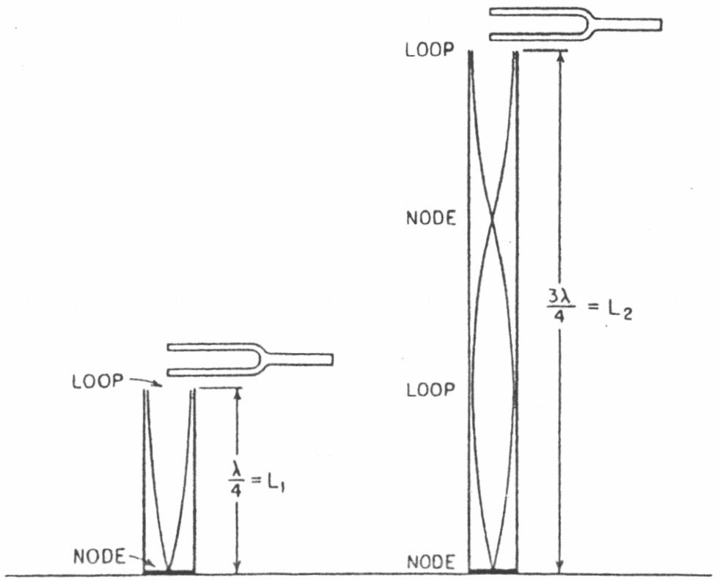

**Fig. 1** – Diagrams showing relationship between wavelength of sound and distance to the first and second points of resonance. The *waves* are diagrammed as if they were transverse, for convenience; actually, sound waves axe longitudinal waves.

The apparatus used in the experiment consists of a glass tube about 4 ft long and 1 in, inside diameter, fitted with a rubber stopper and tubing connection to a water reservoir whose level can be changed to make water rise or fall in the resonance tube itself. The apparatus is shown in Fig. 2.

Since the frequency of the fork is known (specified by the manufacturer) and A can be calculated from measurements taken at points of resonance, the velocity of sound in air may be calculated from Eq. (1).

The accepted velocity of sound in air (in m/s) may be calculated from

$V_{a}=330 + 0.6×T_{c}$ (2)

in m/s where Tc is the air temperature in °C. The velocity increases with rising temperature.

**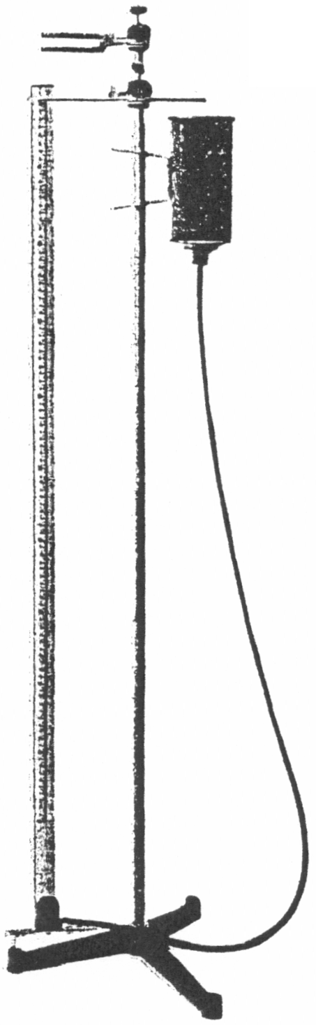Fig. 2 –** Apparatus for determining the velocity of sound in air, by resonance methods. (Central Scientific Company)

**Measurements**

Raise the water level in the glass tube until it is near the top. Position the tuning fork at the top of the glass tube so that it will barely clear the glass while vibrating. Make sure it will not strike the glass while vibrating. Strike it with a rubber hammer. While it is vibrating, lower the water level slowly until the first resonance point is reached. (The sound will be quite loud at this point, even though the sound of the fork itself may be barely audible.) By approaching the resonance point *carefully* from above and below, determine its position accurately.

Measure *L1* – the distance from the bottom bar of the fork to the first point of resonance.

In like manner determine *L2* and *L3,* the distance to the second and third points of resonance, if the tube is long enough. Repeat the entire process with two other forks of different frequencies.

Record the frequencies of the forks used and the temperature of the air in the resonance tube.

**Calculations**

From the measurements taken with the resonance tube, calculate values for the velocity of sound in air for each of the three tuning forks used. Determine the mean value for the velocity of sound in the room. Compare your experimental value (per cent error) with the correct value for air at the recorded temperature, calculated from Eq. (2).

**Analysis and Interpretation**

* + 1. Give a complete analysis of the sources of error in the experiment.
    2. Based on collateral reading, write a brief discussion of sonar, and explain how variations in the velocity of sound in ocean water are taken into account.
    3. Write a paragraph explaining your interpretation of the phenomenon of resonance. What are the necessary and sufficient conditions for resonance?
    4. The famous tenor Caruso was supposed to be able to shatter a wineglass by holding a sustained note at a certain pitch. Explain how this might be theoretically possible. Would the same note (pitch) suffice for any wineglass?

Page left intentionally blank

**University Physics Workbook Vol. I**

# Light, Brightness and Distance

You probably have noticed that a light appears to be brighter when you are close to it, and dimmer when you are farther away. If you are reading this page illuminated by a single light bulb, the amount of the light that strikes this page will increase as the page is brought closer to the light source. Using a Light Sensor, you can determine how the brightness of light varies with distance from the source and compare that result to a mathematical model.

There are several ways to measure the brightness of light. Since this experiment can be performed with any of several different light sensors, each of which measure slightly different quantities, we will just use the word intensity to describe the relative brightness of the light, although the term may not be strictly appropriate for your sensor. Regardless of the way light is measured, the same relative changes with distance are observed, and that is what you will study today. In this experiment you will measure light intensity at a variety of distances from a small source of light, and see how the intensity varies with distance.

*Figure 1*

**OBJECTIVE**

• Determine the mathematical relationship between intensity and the distance from the light source.

**MATERIALS**

|  |  |
| --- | --- |
| Computer | meter stick |
| Vernier computer interface | **or** Vernier Dynamics System and Optics Expansion Kit |
| Logger *Pro* | clear glass light bulb (1.5 V penlight type) |
| Light Sensor | battery (1.5 V) |

**PRELIMINARY QUESTIONS**

1. Suppose a small light source is placed at the center of two transparent spheres (see next page). One sphere has a radius R, and the other a radius 2R. Energy in the form of light leaves the source at a rate P. That same power P passes through the surface of the inner sphere and reaches the outer sphere. Intensity is the power per unit area. What is the intensity at each sphere? Solve this problem by considering the following:

• How does the power passing through the inner sphere compare to the power reaching the outer sphere?

• How do the surface areas of the two spheres compare?

• In general, then, how will the intensity vary with distance from the source?

2. Since most light bulbs that you use are not true point sources of light, how do you think the answer to Question 1 would change if a typical light bulb were used?



Figure 2

**INITIAL SETUP**

1. Connect the Light Sensor to Channel 1 of the interface. If your sensor has a range switch, initially set it to the 600 lux range and adjust to bring your reading as high as possible, but within range.

2. Make sure that the filament axis of the light bulb is horizontal and pointing directly at the Light Sensor. This makes the light bulb look more like a point source of light as seen by the Light Sensor.

3. The filament and Light Sensor should be at the same vertical height (Figure 1).

4. Place the end of the filament (not the glass) at the 0.0 cm mark of the meter stick.

5. (Optional) Open the file “29 Light Brightness Dist” in the Physics with Vernier folder. The meter window will display light intensity.

6. Turn down the lights to darken the room. A dark room is critical to obtaining good results. There must be no reflective surfaces behind or beside the bulb.

**PROCEDURE**

1. Place the Light Sensor 2 cm from the light bulb filament and note the value of intensity in the Meter window. Make sure that the intensity changes as you move the sensor, otherwise you may need to switch to a less sensitive scale or use a less intense light source. Move the sensor away from the bulb and watch the displayed intensity values. What is your prediction for the relationship between intensity and the distance to a light source?

2. Click CollectNew to begin data collection. Place the Light Sensor 2 cm from the light bulb filament. Important: The distance must be measured carefully. Be sure you measure from the filament of the lamp to the sensor on the Light Sensor.

3. Wait for the intensity value displayed on the screen stops changing in a single direction. Click KeepNew2, then type the distance between the Light Sensor and the light source and click  to record the value of intensity. A point will be plotted on the graph.

4. To improve accuracy, turn off the light and repeat the measurement (Steps 1-3). This measures ambient light. The difference between this reading and the reading from Step 3 with be the light intensity from the light bulb.

5. Move the Light Sensor 1 cm farther away from the light source and repeat Step 3.

6. Repeat Step 3 moving the sensor in 1 cm increments until the Light Sensor is 10 cm from the light source.

7. Click StopNew2 when you have finished collecting data. In your data table, record the intensity, ambient intensity, and distance. What result will you need to calculate?

**ANALYSIS**

1. Examine the graph of light intensity vs. distance. Does it appear to be consistent with the model you predicted in the Preliminary Questions? How can you tell?

2. Fit a model to your data. It is optional to use Vernier software for this purpose, however instructions follow:

a. Click the Curve Fit button, CurveFitNew4. Select inverse square from the list of curve fits displayed, then click .

b. A best-fit curve will be displayed on the graph. The curve should closely match the data.

3. Fit a model to your data (required). Calculate 1/d2 can call it “Distance^–2” – this is your x-axis data and intensity is your y-axis data. Plot and find best fit line. Should it go through the origin? Does it fit your data well or not? Try other plots, for example, intensity vs. d; intensity vs. d2; and intensity vs. 1/d. Are these superior to intensity vs. “Distance^–2”?

4. How well does the power regression fit your experimental data? Do your data approximately follow an inverse square function? Does the equation agree with your model of light intensity using the concentric spheres?

5. List some reasons why your experimental setup might not match the relationship you predicted in the Preliminary Questions between intensity and distance.

**EXTENSIONS**

1. If you have a window facing the sun, it may be interesting to try an experiment to measure the intensity of the sun. If your sensor has a range switch set it to the 150,000 lux range and load the calibration for that setting. Place the Light Sensor 10 cm from a 150 W clear light bulb and measure the intensity. Point the Light Sensor at the sun and measure the intensity of the sun relative to the light bulb. How many light bulbs would you have to place 10 cm from the Light Sensor to be equal to the intensity of the sun? Use the mathematical relationship found in this lab to calculate the intensity of the sun if it was placed 10 cm from the Light Sensor. Determine how many of these light bulbs would be equivalent to this value.

2. (Optional with instructor’s assistance) Use the Light Sensor to measure the intensity of the sun over the period of an entire school day.

3. Use the Light Sensor to examine sunglasses. By what percentage is the sun’s intensity reduced when sunlight passes through the lens of sunglasses?

4. Use the sensor to compare other light sources to the light source that you used in the lab. For instance, how does intensity vary as you move away from a long fluorescent bulb or a circular fluorescent bulb?

Page left intentionally blank

**University Physics Workbook Vol. I**

# Reflection and Refraction

**Equipment**

* Pencil
* Pins
* Cork Board
* Mirrors
* Glass Plates
* Paper

**Purpose** – To explore reflection and refraction relationships, what they mean to observations of reflected and refracted images, test the law of reflection, and test Snell’s law.

**Procedure**

Part I: Reflection

1. Hold a pencil vertically at arm’s length. In your other hand, hold a second pencil about 15 cm closer than the first. Without moving the pencils, look at them while you move your head from side to side.
   1. *Question:* Which way does the nearer pencil appear to move with respect to the one behind it when you move your head to the left?
2. Now move the pencils closer together and observe the apparent relative motion between them as you, move your head.
   1. *Question:* Where must the pencils be if there is to be no apparent relative motion, that is, no parallax, between them?
3. Now we shall use parallax to locate the image of a nail (pin) seen in a plane mirror. Place a blank paper on the cork board and support a plane mirror vertically about half way down the paper by fastening it to a wood block with rubber bands or using straight pins to hold it upright. Stand a pin on its head about 10 cm in front of the mirror. Draw the line B-B’ indicating the reflecting surface AND recall reflection occurs on the rear of the mirror. Refer to the following Figure.
   1. *Question:* Where do you think the image of the nail or pin is?
4. Move your head from side to side while looking at the nail and the image.
   1. *Question:* Where is the nail’s (pin’s) image? Describe this location. Behind the mirror or in front of the mirror, the same distance or more or less than the object, etc.
5. We can also locate the position of an object by drawing rays which show the direction in which light travels from it to our eye. Stick a pin vertically into a piece of paper resting on a sheet of soft cardboard. This will be the object pin. Establish the direction in which light comes to your eye from the pin by sighting along a ruler as shown in the following figure. Look at the object pin from several widely different directions and mark the new lines of sight to the object pin. *Questions:*
   1. Where do these lines intersect?
   2. How do the distances of the image and object from the reflecting surface compare?

|  |
| --- |
| **Figure Reflection and Refraction 1** – Diagram of experimental arrangement studying reflection. |

1. Measure the angle of incidence and angle of reflection for each of your three or more rays. Remember the “normal” is at 90° to the surface of the mirror.
2. In the results section, but sure to estimate errors. For example, what is the %diff between all measurements of the distance of the image behind the mirror? Or, what is the %diff between angle of incidence and angle of reflection?
3. Draw rays showing the path of the light from the object pin to the points on the mirror where the light was reflected to your eye.
   1. *Question:* What do you conclude about the angles formed between the mirror surface and the light paths?
4. Arrange two mirrors at right angles with an object somewhere between them. Comment on the images you observe. *Questions:*
   1. How is this like and how is this unlike a single plane mirror?
   2. Is this expected or unexpected?

Part II – Refraction

1. We can perform the same experiments observing the location of a pin looking through a piece of glass instead of observing a reflection in a mirror. Take a piece of rectangular glass and lay it down flat on the cork and paper. You will be observing edge on. Refer to the following figure.
2. Perform one measurement at a moderate angle inserting pins at a couple locations O and O’ looking at the image through the glass instead of the reflection in the mirror and sight along the ruler until there is no parallax in the image of the two pins. *Questions:*
   1. Do you expect the rays on either side of the glass to be parallel or not? Explain.
   2. Determine if your rays found experimentally are parallel or not?
   3. Does the answer to Question (b) fit your expectations or not.
3. You can measure the angle in air *on both sides of the glass* and angle in glass on both sides. Compare these results and find %diff.
4. Find the index of refraction of the glass and compare this to the accepted value of n = 1.5 including error estimation.
5. *Do not move the rear pin* and do two more measurements at a high and low angle.
6. You now have three (3) ruler lines. Extend these lines finding the point of intersection. This is the location of the *image* of the rear pin.

|  |
| --- |
| C:\Users\Owner\AppData\Local\Microsoft\Windows\Temporary Internet Files\Content.IE5\D92I7VP0\MP900316433[1].jpg  A  A’  Glass  r  i  P  B  B’  N  O’  P’  r’  i’  N’  O  R  C:\Users\Owner\AppData\Local\Microsoft\Windows\Temporary Internet Files\Content.IE5\D92I7VP0\MP900316433[1].jpg  C:\Users\Owner\AppData\Local\Microsoft\Windows\Temporary Internet Files\Content.IE5\MFW9FWSL\MC900290924[1].wmf  **Figure Reflection and Refraction 2** – Diagram of experimental arrangement studying refraction. |

1. Instead of testing refraction using a rectangular prism we can test refraction using a half circle, however, for this procedure to work properly, the light rays must go through the center of the circle as illustrated next.

|  |
| --- |
| O  C:\Users\Owner\AppData\Local\Microsoft\Windows\Temporary Internet Files\Content.IE5\MFW9FWSL\MC900290924[1].wmf**Fi**C:\Users\Owner\AppData\Local\Microsoft\Windows\Temporary Internet Files\Content.IE5\D92I7VP0\MP900316433[1].jpg**gure**C:\Users\Owner\AppData\Local\Microsoft\Windows\Temporary Internet Files\Content.IE5\D92I7VP0\MP900316433[1].jpg **Reflection and Refraction 3** – Refraction experiment using semicircle.  N  r  i  P  A  A’ |

1. Observe from the previous figure that it is necessary for the refracted ray to go straight when it encounters the circular interface. Sight along the ruler until there is no parallax between the two pins. After doing a measurement, extend the line from the ruler. It should go through Point P just as the line through the pins should intersect Point P. *If this is not true then adjust the apparatus and try again.*
2. Perform the experiment similar to previous instructions.
3. Attempt to observe from at least six (6) widely varying incident angles. Attempt i angles between 5° and 85°.
4. Find the index of refraction for each of the attempted angles.
5. We use water in this experiment and the accepted value for n is 1.33.
6. Experimentally determine the critical angle using the semicircle. How is this performed? (Remove the rear pin, find the sight line where the front pin is on the verge of appearing and disappearing, and mark this line of sight using the ruler.)
7. Answer the same questions from Steps 3 to 8 except for refraction instead of reflection. In addition *answer the following:*
   1. Is the Law of Reflection confirmed or disproved? Why or why not? Use your results to support your conclusion. Recall, *i* = angle of incidence (angle of light ray from object from normal to mirror), and *r* = angle of reflection (angle of light ray to eye from normal to mirror).
   2. Is Snell’s Law confirmed or disproved? Why or why not? Use the results of both methods we employed to support your conclusion. Recall, *n1* = index of refraction of substance 1, *n2* = index of refraction of substance 2, *1* = angle in substance 1 (angle of light ray from normal), *2* = angle in substance 2 (angle of light ray from normal), *v1* = speed of light in substance 1, *v2* = speed of light in substance 2 and c = speed of light in vacuum, Snell’s Law states:

where:

* 1. What is the position of the image compared to the position of the object? How is this position similar or different in reflection and refraction? Explain how to correct for this if your eyes are above the water and you’re trying to catch fish in the water.
  2. Calculate the critical angle for total internal reflection in water (n = 1.33). How does this compare to your experimental measurement?

**University Physics Workbook Vol. I**

# Focal Length of Lenses (Optics)

**Introduction**

The formation of images by lenses is one of the most important studies in the field of optics. The purpose of this experiment is to observe the real images formed by various lenses and to verify the lens equation. In particular, we will measure the focal length of some positive (converging) and negative (diverging) lenses and the equivalent focal length of a combination of thin lenses.

**Theory**

When a beam of rays parallel to the principal axis of a lens impinges upon a converging lens, it is brought together at a point called the principal focus of the lens. For a diverging lens, parallel rays spread apart, however the rays projected backward meet at the focus. The distance from the principal focus to the center of the lens is the focal length of the lens and, by convention, the focal length is positive for a converging lens and negative for a diverging lens.

A ray through the center of a lens is not deflected. Applying geometry (that’s why we call this geometric optics) with these two facts, parallel rays meeting at the focus and rays through the center are un-deflected, we derive the thin lens equation. Consider the following figure for a converging lens (also refer to the online simulation <http://phet.colorado.edu/sims/geometric-optics/geometric-optics_en.html>).

**Fig. 1** – Ray diagram of converging convex (outward bulge) lens where *ho* is the object height, *do* is the object distance from the lens, *f* is the focal length of the lens, *di* is the image distance from the lens, and *hi* is the image height. If you fold this ray diagram along the dotted line, you obtain the ray diagram for a concave (inward bulge) mirror.

object

*do*

*ho*

*f*

*di*

*hi*

image

From geometry we observe,

$\frac{h_{o}}{f}= \frac{h_{i}}{d_{i}- f}$ (1)

Also using geometry we may instantly define and observe a formula for magnification M,

$\frac{h_{i}}{h_{o}}= \frac{d_{i}}{d_{o}} ≡M$ (2)

Multiply both sides of Eq. (1) by (*di* – *f*)*/ho* and combine with Eq. (2) to obtain,

$\frac{h_{i}}{h_{o}}= \frac{d_{i}}{d_{o}}= \frac{d_{i}- f}{f}$

Divide both sides by *di*,

And add 1/*di* to both sides to obtain the thin lens equation,

$\frac{1}{f}= \frac{1}{d_{o}}+ \frac{1}{d_{i}}$ (3)

You will note in Eq. 3 that if *do* < *f* then *di* < 0. When we consider the ray diagram (following figure) we see that rays do not converge, but when projected back intersect.

**Fig. 2** – Ray diagram for situation where object is closer than the focal length of a converging lens or mirror (for a mirror this ray diagram is folded along the dotted vertical line). This is the ray diagram for a magnifying glass or makeup mirror.

object

*do*

*ho*

*f*

*di*

*hi*

image

The situation where rays, in reality, converge we refer to as a *real* image. Where rays *appear* to come from a particular point we refer to as a *virtual* image. An image in a plane mirror, from the previous lab, is a good example of a virtual image.

The equations for a virtual image work out identically as before except *di – f* in Eq. 1 is replaced by *di + f*. Following the previous mathematical steps we would arrive at a different equation OR we can simply use a mathematically convenient convention and consider *di* to be a negative number. Most people use the convenience of letting *di* be negative. You will note this implies magnification is also negative. We interpret to mean the image is a virtual image, is upright compared to the object, and is on the same side of the lens as the object or the opposite side of the mirror as the object.

These conventions can be confusing, however drawing a ray diagram helps clear them up and leads to the same results.

There are a couple special cases to consider. The first special case is if the object is infinitely far away then all rays emanating from it are parallel by the time they reach the lens and, therefore, the image is at the focal length of a lens. We observe that Equation (3) accommodates this situation if we consider 1/*do* = 0.

The second special case is where *di = do = 2f.* We observe that Equation (3) is solved using these values. For real images as formed shown in Figure 1, if we find focus with the projection screen at *di*, we will also find a focus with the projection screen at *do* and the object distance at *di*. In other words, we get a second focus if we switch the values for *di* and *do*. For example, if *f* = 100 mm, *di* = 500 mm, and *do* = 125 mm, then we also get a second focus if *di* = 125 mm, and *do* = 500 mm. However in the special case of *di = do = 2f* there is only one position of the lens where we get focus. In Procedure 3 (as follows) there are two positions of the lens where the image is in focus, but Procedure 4 as follows finds the special condition where there in only one position that is in focus, *di = do = 2f* AND D = *di + do = 4f.*

The following figure illustrates the ray diagram for a diverging lens.

**Fig. 3** – Ray diagram of a diverging concave lens. If you fold this ray diagram along the dotted line, you obtain the ray diagram for a convex mirror.

object

*do*

*ho*

*f*

*di*

image

The equations work out identically as before except *di – f* in Eq. 1 is replaced by *f ‑ di*. It is mathematically convenient to keep Eq. 3 and consider *M*, *f*, and *di* to be negative with the same interpretation as previously. A diverging lens is commonly used to correct for near-sightedness and a convex mirror as the rear view mirror of a vehicle. Note the image is smaller than the object which is why car mirrors state that “objects are larger than they appear”. The advantage of a diverging mirror is you have a larger field of view.

While we may use a distant object to determine the focal length of a converging lens, note in Eq. 3 that the equation is satisfied if *di* = *do* = 2*f*. Experimentally we can set up an object and move a viewing screen and the lens until the image is in focus. If the lens is precisely between the view screen and object then the focal length is a fourth of the distance between the image and the object. If the object to image distance is less than four times the focal length it is not possible to obtain focus, and if the object to image distance is greater than four times the focal length then there are two positions where focus is obtained – one where M > 1 and one where M < 1.

When two thin converging lenses are in contact, the equivalent focal length of the combination may be measured experimentally by one of the above methods. It may also be calculated in terms of the individual focal lengths. To derive the formula when two lenses are in contact we apply Eq. 3 twice and observe that the image of the first lens is the object of the next and with the proviso that the second lens acts like the situation in Fig. 2. Thus,

$\frac{1}{f_{1}}= \frac{1}{d_{o}}+ \frac{1}{d_{i1}}$, and $\frac{1}{f_{2}}= \frac{1}{{-d}_{i1}}+ \frac{1}{d_{i}}$

Adding these two equations together and since

$\frac{1}{f}= \frac{1}{d_{o}}+ \frac{1}{d_{i}}$, then $\frac{1}{f_{1}}+ \frac{1}{f_{2}}= \frac{1}{f}$ (4)

where *f* is the equivalent focal length of the lens combination, *f1* is the focal length of the first lens, and *f2* is the focal length of the second lens.

Eq. 4 is very convenient in optometry. Optometrists define a unit called a diopter which is 1/*f* where *f* is measured in meters. Therefore, to find the diopters of a lens combination, you simply add the diopters of the lenses that comprise the combination.

A concave lens by itself cannot form a real image, since it is a diverging lens, hence a different method must be used for measuring its focal length. This is done by placing the diverging lens in contact with a positive lens of shorter and known focal length, measuring the equivalent focal length of the combination experimentally, and then using the Eq. 4 to solve for the focal length of the diverging lens. We may also discover the focal length of a diverging lens using the methods of finding the image in a mirror, however combining a diverging and converging lens together and observing real images is more convenient.

**Purpose:** To confirm or disprove Equations (2), (3), and (4). That is, to confirm or disprove the Thin Lens Equation, Magnification Equation, and formula for lens combinations.

**Apparatus**

|  |  |
| --- | --- |
| 1. Optical bench | 1. Two convex lenses A (f ≈ 20 cm) and B (f ≈ 10 cm) |
| 1. Screen | 1. One concave lens, C (of about -20 cm focal length) |
| 1. Illuminated object | 1. Metric ruler |
| 1. Lens holders |  |

**Procedure**

1. Measure the focal length of lens A directly by obtaining the image of a very distant object on the screen and measuring the image distance. The object may be a tree or a house about a block away. If you are indoors, go to a nearby window.
2. Repeat Procedure 1 for lens B.
3. Determine the focal length of lens A by the use of the Equation (3).
   1. Place the illuminated object at one end of the optical bench and place the screen at a distance of about five times the focal length of the lens.
   2. With the object and screen fixed, find the position of the lens for which a sharp, enlarged image is produced on the screen. Make sure that the object, lens, and screen all lie along the same straight line (the principal axis of the lens) and that they are all perpendicular to the axis.
   3. Record the position of the object, the lens, and the screen; record the measurements to 1 millimeter.
   4. Measure the size (height or width – dimension) of the object and the size of the image; record these measurements to 0.5 millimeter.
   5. Find a second focus (see Theory Section). If the lens is close to the object, then the second focus is nearer to the image.
   6. In any experiment attempt to gather data at the extremes of the instrument and from Equation (3) we note that the screen at five (5) times the focal length is the smaller extreme. Therefore, move the screen a few cm away from the object and repeat Steps 3.a to 3.e. Also see how far away you can move the screen and still obtain measurements.
   7. Record the data for each screen distance (at least three).
4. Using the arrangement of Procedure 3, continue to move the screen closer to the object and observe that there are two lens positions that give a focused image. Keep moving the screen closer and closer until these two positions coincide atthe midpoint between the object and the screen. Measure and record the value of the object-screen distance *D* corresponding to this condition.
5. Repeat Procedure 3 using lens B.
6. Repeat Procedure 4 using lens B.
7. Repeat Procedure 3 using the combination of lenses A and B in contact.
8. Repeat Procedure 4 using the combination of lenses A and B in contact.
9. Repeat Procedure 3 using the combination of lenses B and C in contact.
10. Repeat Procedure 4 using the combination of lenses B and C in contact.

**DATA & Results** – The suggested organization is to make the first table a data table. You will be doing four tests: Lens A (steps 1, 3, & 4 above), Lens B (steps 2, 5, & 6 above), Lens A & B in combination (step 7), and Lens B & C in combination (steps 7 & 8). Column 1 is the lens, Column 2 is f per Procedure 1 or 2, Column 3 is object distance, Column 4 is image distance, Column 5 is D (distance from view screen to object), Column 6 is the object dimension, and Column 7 is the image dimension.

The second table’s Column 1 will repeat the list of lens, however will include lens C; Column 2 repeats f per Procedure 1 or 2; Column 3 is f per Procedure 3 Equation 3; Column 4 is f per Equation 4; Column 5 is f per Procedure 4; Column 6 is the percent difference; Column 7 is magnification by the ratio of image to object size; Column 8 is magnification by the ratio of image to object distance; and Column 9 is the percent difference of magnifications.

Page left intentionally blank

**University Physics Workbook Vol. I**

# Light Production

Big Idea: Continuous and emission line spectra are produced in different ways. The wavelengths of emission lines give information about the chemical composition of the substance producing the light.

Goal: Students will conduct a series of inquiries about light and atomic spectra using spectroscopes and analyze results to find the relationships between emission lines and composition.

Background:

In 1860, Gustav Kirchoff discovered that the spectra produced by the light emanating from objects could be placed in one of three categories.

*Continuous Spectrum*—A solid or liquid when heated to luminescence (for example the tungsten filament in a light bulb) will produce a spectrum with all the colors of a rainbow when the light is passed through a prism.

*Emission Spectrum*—A hot thin gas (for example a flame) will produce a spectrum consisting of a number of discrete lines of various colors when passed through a prism. The number and color of these lines will depend upon the chemical composition of the gas.

*Absorption Spectrum*—When a source of continuous spectrum is viewed through a thin gas (such as viewing the Sun through the Sun’s outer atmosphere) a continuous spectrum with a series of dark lines superimposed upon it is produced. The number and placement of these “absorption” lines depends upon the chemical composition of the thin gas.

The wavelengths of light that are emitted by atoms in excited states are exactly the same wavelengths of light that those atoms will absorb.

**Part 1: Exploration**

SPECTROMETER CALIBRATION

* Obtain a spectrometer and follow the instructions on the top to make sure the spectrometer is properly calibrated.

CONTINUOUS SPECTRA

* Get some colored pencils.
* Observe the bright incandescent bulb through the spectrometer and sketch the spectrum in the space below. Be careful to match up the colors you see with the correct wavelengths.
* Look at the dim incandescent bulb through the spectrometer.

INCANDESCENT BULB



1. **How does the spectrum of the dim light differ from the spectrum of the bright light?**
2. **Is the wavelength of orange light the same as it was before?**
3. **Is the wavelength of green light the same as it was before?**
4. **Is the color of light determined by its wavelength? Explain using your observations so far.**

EMISSION SPECTRA

* Observe the gas discharge tubes through the spectrometer and sketch the spectra in the spaces below. Be careful to match up the colors you see with the correct wavelengths.

HYDROGEN



HELIUM



NEON



MERCURY



ARGON



OXYGEN



1. **Do any of the elements have identical spectra? If so, which ones?**
2. **Describe the differences in the spectrum of the incandescent light and the spectra of the discharge tubes.**
3. **Look closely at a discharge tube that is not on and an incandescent light. What makes the light for each of these: a gas, a liquid, or a solid?**

**Part 2: Does the Evidence Match the Conclusion?**

Consider the research question, “What is inside fluorescent light bulbs?” Use your spectrometer to examine the light emitted from a fluorescent light bulb. Compare what you see to the spectra you’ve observed so far and determine what is inside fluorescent light bulbs: both the phase (gas, liquid, or solid) and the composition.

If a student proposed a generalization that “fluorescent light bulbs are filled with helium gas,” would you agree or disagree based on the evidence you’ve collected? Explain your reasoning and provide specific evidence.

**Part 3: What Conclusions Can You Draw From This Evidence?**

Someone poses the research question, **“What elements are in the Sun?”** What conclusions and generalizations can you make from the following data collected by professional astronomers in terms of the question posed? You do not need to identify every element present on the Sun but you should be able to identify at least one based on the observations you have made so far in this lab. Explain your reasoning and provide specific evidence, either from the graph or from previous work in this lab, with sketches if necessary, to support your reasoning.

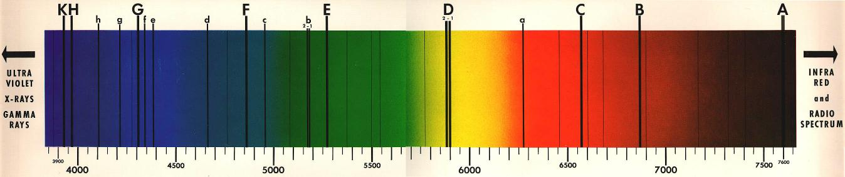

**Part 4: What Evidence Do You Need To Pursue?**

You are posed with the research question **“Are halogen lights incandescent or fluorescent?”**

Create a detailed, step-by-step description of evidence that needs to be collected to answer this question and a complete explanation of how this could be done—not just “look at the graph,” but exactly what someone would need to do, step-by-step, to accomplish this. You might include a table of data to be collected and/or sketches of experimental setup. The goal is to be precise and detailed enough that someone else could follow your procedure.

You do not need to carry out the procedure you’ve written.

**Part 5: Formulate a Question, Pursue Evidence, and Justify Your Conclusion**

Your task is to come up with an answerable research question about spectroscopy, propose a plan to pursue evidence, collect data, and create an evidence-based conclusion to your question that you have not completed in another part of this lab.

Steps of Research Report:

1. Specific research question:
2. Step-by-step procedure, with sketches if needed, to collect evidence:
3. Data tables and/or results:
4. Evidence-based conclusion statement:

**Part 6: Summary**

Create a 50-word summary, in your own words, that describes what information can be discerned from an object’s spectrum and how. Your description should cite specific evidence you have collected in this lab exercise, not describe what you have learned in class or elsewhere. Feel free to use sketches in your response as well.

**University Physics Workbook Vol. I**

# Calculating Radioactive Decay Products

Names of Lab Partners:

This lab, the last lab of the semester, is a fill-in-the-blank lab. You’re getting a slight break by not having to write a traditional lab report. Submit one handout per group and, if everybody wishes to keep a copy, you may make a copy of this lab to fill out and turn in.

**Objective:** Simulate the process by which Uranium-238 eventually decays to Lead-206

**Overview**

Each element is defined by the number of protons in its nucleus. Hydrogen, for example, always contains one proton, while carbon always contains six. Each element also has different **isotopes;** that is, they can contain different numbers of neutrons. Hydrogen nuclei usually contain one proton and no neutrons (1H1), but occasionally there may be a neutron in the nucleus (1H2), and on still rarer occasions, we may find two neutrons (1H3), but there is **always** one proton. Protons and neutrons are the only inhabitants of atomic nuclei, which is why both they are also known as nucleons. Neutrons seem to assist in keeping the positively charged protons together in the tightly bound nucleus. More protons in a nucleus require even more neutrons. The most common isotope of Carbon, Carbon-12 (6C12), has 6 protons and 6 neutrons, while Uranium-238 (92U238) has 92 protons and 146 neutrons (more than one and a half times as many neutrons as protons).

The different isotopes of each element have different levels of stability. Some have half-lives of billions of years, while others have half-lives on the order of a few millionths of a second. They decay via **radioactive** processes, a few of which we will study today. Nuclei can absorb and emit electrons, neutrons, protons, alpha particles (helium nuclei), and positrons (“positive electrons”). They also emit gamma radiation, which removes energy from the nucleus without changing the isotopic structure. (Incidentally, the beta decay process also emits a particle known as a **neutrino,** an extremely small mass particle with no charge. Although they are very important in the make-up of the universe, they don’t interact with your body, so we won’t be discussing them.) The decay process conserves the **atomic number** (Z, the total number of protons) and the **nucleon number** (A, the total number of protons and neutrons. that is, the total number of **nucleons**).

The nucleon number was formerly and is still commonly referred to as the mass number since it *approximates* the mass, however it does not equal the mass due to nuclear binding energy. For example, two protons and two neutrons make up 2He4. The proton mass is 1.6726217\*10-27 kg and neutron mass is 1.6749273\*10-27 kg and, thus, two protons plus two neutrons should have mass of 6.695098\*10-27 kg. However the mass of a 2He4 nucleus is 6.644656\*10-27 kg – a loss of 0.753%. The difference in mass is converted to energy by E = mc2 and is the energy released by a hydrogen bomb or, hopefully in the future, controlled fusion. We often use atomic mass units to refer to nuclei masses. An atomic mass unit, u, equals 1.6605388\*10-27 kg and, therefore, a proton has a mass of 1.0072765 u, the neutron 1.0086649 u, and the 2He4 nucleus 4.0015061791 u. A, the nucleon number, approximates the mass in u of a nucleus, but there is a small difference and it ALWAYS exactly equals the number of protons plus the number of neutrons. To improve the precision of our terminology is the reason A is now referred to as the nucleon number.

Isotopes are written as ZXA or ${}_{Z}^{A}X$, however since X is unique for a given Z it is also written as X‑A. In other words, 92U238 is also written as ${}_{92}^{238}U$ or U-238 since the atomic number of U, Uranium, is 92. Similarly, 2He4 is or He-4, 6C12 is or C-12, etc. ZXA or X-A is more common now since ${}_{Z}^{A}X$ is harder to write using word processors, but since it was almost as easy to write using a typewriter you still see the ${}_{Z}^{A}X$ form in older textbooks.

In this lab, we’ll simulate the decay ofUranium-238 (92U238) into Lead-206 (82Pb206), a common process on our planet. Radon-222 (86Rn222)is an intermediate stage of the decay process - you may have heard about homes being checked for Radon. As you’ll find out, inhaled Radon winds up as lead in your lungs, and along the way itemits alpha particles (helium nuclei), beta particles (electrons) and gamma rays, none of which are particularly good for your health. Unfortunately, protons and neutrons are difficult to work with in a hands-on experiment, so our protons will be black (or pinto – p for pinto, p for protons, get it?) beans, our neutrons will be white beans, and our nucleus will be a glass jar. We’re going to be nuclear bean counters.

**Procedure**

Empty the jar’s contents onto the desk and count the beans. This should be a Uranium-238 nucleus, so the jar should contain 92 protons (black beans) and 146 neutrons (white beans). Put them in groups often while counting to ensure accuracy. If you need more beans, tell the lab tech or your instructor. After you’ve made sure you have the right number of nucleons, put them back in the nucleus (jar). Keep in mind that these decay processes have widely varying half-lives. The half-life of U-238, for example, is 4.5 billion years, while the half-life for Polonium-214 is 0.00015 seconds.

**1) First Reaction:**

The first reaction for U-238 is **alpha decay**, which is the loss of a helium nucleus (also known as an alpha particle) from the “parent” nucleus. The half-life of U-238 is 4.46 billion years. The half-lives of each product are given in parentheses. A helium nucleus contains 2 protons and 2 neutrons. Remove one helium nucleus (alpha particle) from the jar. To simulate this remove two white beans (representing neutrons) and two black (darker or pinto bean representing a proton) beans. What isotope is left? The nuclear reaction equation will tell you, because you know that atomic number and nucleon number are conserved:

92U238 →90Th234 + 2He4 Isotope Name: **Thorium-234** (24.1 days)

The nucleus now has 90 protons (= 92 **—**2), 144 neutrons (= 146 — 2), and 234 nucleons (= 238 – 4). Looking at the periodic table in your text (end of this lab), you’ll find that the isotope must be Thorium-234 since Thorium has an atomic number of 90.

Let’s discuss conservation of nucleon number and atomic number for a moment. This works much like chemistry. In chemistry the number of atoms of the same element on one side of a chemical equation must equal the number of atoms of the same element on the other side. In the nucleus, the number of nucleons on one side of the equation must equal the number of nucleons on the other side. Note the arrow divides the left side of the nuclear reaction from the right side. The upper number (either left or right of the element symbol or, in the case of the X-A notation, A) is the number of nucleons. Therefore the sum of the upper numbers on the left side of the equation must equal the sum of the upper numbers on the right side of the equation. Since 238 = 234 + 4, the conservation of nucleons is satisfied in the previous equation.

Conservation of the atomic number is actually conservation of charge. The charge on the proton is, to a very close approximation, equal to 1.602\*10-19 Coul and the lower right number counts the how many there are. By the way, the lower right is reserved for chemical equations – that position denotes the number of atoms as we are used to in working with chemical equations. For example, an atomic number of 92 in the previous nuclear reaction means the charge on the nucleus is 92\*1.602\*10-19 Coul = 1.47384\*10-17 Coul. Since it’s easier to write 92 rather than 1.47384\*10-17 Coul, this is how we note the charge on the nucleus. Similar to the nucleon number, the sum of atomic numbers on one side of a nuclear reaction is equal to the sum of atomic numbers on the other side. Since 92 = 90 + 2, the conservation of atomic number is satisfied in the previous equation. There is, however, one trick in working with charge – the charge on an electron is equal in magnitude, but opposite charge (negative instead of positive), to the proton or ‑1.602\*10-19 Coul. So, using our convention, an electron is noted as ‑1e0, that is, it has an atomic number of *negative* one. Also since an electron doesn’t exist inside the nucleus its nucleon number (upper number) is zero. We will see how this works in the next reaction.

**2) Second Reaction:**

Thorium-234 decays via **beta decay,** that is, by ejecting an electron from the nucleus. The beta decay process also emits a gamma ray. What actually happens is that a neutron is converted to a proton and an electron, and the electron is ejected. You can simulate this by removing a neutron (white bean) and inserting a proton (black, darker, or pinto bean) – do a swap, a black (pinto or darker) bean for a white bean. The reaction equation tells us what’s left. An electron is listed as having an atomic number of -1 and a nucleon number of zero. Making sure that atomic number and mass number are conserved, we can figure out what is left after beta decay:

90Th234 → 91Pa234 + ‑1e0 +  Isotope Name: **Proactinium-234** (1.17 min.)

The product of beta decay of Thorium-234 is Proactinium-234; 91 protons, 143 neutrons (one less neutron than Thorium-234, but one more proton), for a total of 234 nucleons (the same as Thorium since the electron is not a nucleon).

**The Rest of the Reactions**

For the remaining reactions, we’ll tell you what particle is lost and you’ll adjust the nucleons in your jar accordingly. Remember, alpha decay means you remove two protons and two neutrons, beta decay means you replace a neutron with a proton, and gamma decay doesn’t change the number of protons and neutrons. Fill in the blanks in the equation for each step and include the name of the isotope, as we did in steps 1 and 2. In the end you should wind up with a jar of 82Pb206 (also known as Lead-206) a stable (but chemically toxic) isotope of lead. **When you’re finished, count the beans to check your results.**

**3) Beta Decay:**

91Pa234 → \_\_\_\_\_\_\_ + ‑1e0 +  Isotope Name: \_\_\_\_\_\_\_\_\_\_\_\_\_\_\_ (245,000 yrs)

**4) Alpha Decay:**

\_\_\_\_\_\_\_ → \_\_\_\_\_\_\_ + 2He4 Isotope Name: \_\_\_\_\_\_\_\_\_\_\_\_\_\_\_ (75,400 yrs)

**5) Alpha Decay:**

\_\_\_\_\_\_\_ → \_\_\_\_\_\_\_ + 2He4 +  Isotope Name: \_\_\_\_\_\_\_\_\_\_\_\_\_\_\_ (1,600 yrs)

**6) Alpha Decay:**

\_\_\_\_\_\_\_ → \_\_\_\_\_\_\_ + 2He4 +  Isotope Name: \_\_\_\_\_\_\_\_\_\_\_\_\_\_\_ (3.82 days)

**7) Alpha Decay:**

\_\_\_\_\_\_\_ → \_\_\_\_\_\_\_ + 2He4 Isotope Name: \_\_\_\_\_\_\_\_\_\_\_\_\_\_\_ (3.11 min.)

**8) Alpha Decay:**

\_\_\_\_\_\_\_ → \_\_\_\_\_\_\_ + 2He4 Isotope Name: \_\_\_\_\_\_\_\_\_\_\_\_\_\_\_ (26.8 min.)

**9) Beta Decay:**

\_\_\_\_\_\_\_ → \_\_\_\_\_\_\_ + ‑1e0 +  Isotope Name: \_\_\_\_\_\_\_\_\_\_\_\_\_\_\_ (19.9 min.)

**10) Beta Decay: (This step and the next are often reversed)**

\_\_\_\_\_\_\_ → \_\_\_\_\_\_\_ + ‑1e0 +  Isotope Name: \_\_\_\_\_\_\_\_\_\_\_\_\_\_\_ (1.63\*10-4 sec)

**11) Alpha Decay:**

\_\_\_\_\_\_\_ → \_\_\_\_\_\_\_ + 2He4 Isotope Name: \_\_\_\_\_\_\_\_\_\_\_\_\_\_\_ (22.3 yrs)

***12)* Beta Decay:**

\_\_\_\_\_\_\_ → \_\_\_\_\_\_\_ + ‑1e0 Isotope Name: \_\_\_\_\_\_\_\_\_\_\_\_\_\_\_ (5.01 days)

**13) Beta Decay:**

\_\_\_\_\_\_\_ → \_\_\_\_\_\_\_ + ‑1e0 Isotope Name: \_\_\_\_\_\_\_\_\_\_\_\_\_\_\_ (138 days)

**14)Alpha Decay:**

\_\_\_\_\_\_\_ → \_\_\_\_\_\_\_ + 2He4 Isotope Name: \_\_\_\_\_\_\_\_\_\_\_\_\_\_\_ (relatively stable)

**15) Count your beans to check your results.**

**ANALYSIS**

1) How many alpha particles were emitted in the 14 decay processes?

2) How many electrons were emitted?

3) How many gamma ray photons were emitted?

4) If a person inhales Radon-222 and it stays in their lungs until it becomes Lead-206, how many alpha particles are emitted into your lungs for each Radon-222 atom?

5) How many electrons are emitted into your lungs?

6) How many gamma ray photons?

# Appendix A: Periodic Table of the Elements

**University Physics Workbook Vol. I**

# Appendix B: Lecture Activities

Page left intentionally blank

|  |  |  |  |
| --- | --- | --- | --- |
| **Planning for College** | <http://www.funphysicist.net/icha/planning_for_college.htm> | Now=6/25/2012 | Mod=06/22/2012 |

What are you going to do with the rest of your life?  How is college going to help you get there?  How are you going to finish college?  What degree are you going to get?  How will that degree help you get to the next step - finding a job or advanced degrees? 

Most of you doing this assignment are just starting your career path and now is the time to think about these questions.  Figure out what you enjoy doing, what you're good at, and what you can be paid for.  The intersection of these three things (see figure at right) is where you should be.

Steps To Get There

**GRADUATE!**

**Get your two year diploma!!**

**And be specific!!**

Even if you plan to transfer, four year colleges recognize the course you take at a two year college **ONLY if you get your diploma and NOT a general studies diploma.**This means aim for a specific goal and get THAT diploma.

Assignment:  Plan Your Course to Achieve Your Degree Plan

Hopefully you understand the need for that diploma and how it benefits you.  Your mission is to map out, semester-by-semester, the courses you will need to get there.

* If you have partially completed your program, starting with this semester, show how you will finish it.
* If you have not decided yet, make your best guess now.

Why make a best guess now if you're undecided.  If you plan, now, to travel from Tyler, TX to Los Angeles, CA, and you change your mind deciding to go to Phoenix, AZ it's easier to change your destination half-way there than it is to start from Tyler.  Just be sure you're not taking the Hasting's Cutoff (it was the "shortcut" the Donner Party took which delayed them about a month, left them snowbound & trapped for the winter without enough food, and lead to some resorting to cannibalism).  That's a joke - in higher education the Hasting's Cutoff is going to an unaccredited school.  Stay with accredited schools and, no matter what your major is, when you change majors, at least some of your college is transferrable.

So **PLAN YOUR WORK AND WORK YOUR PLAN** - no matter what your future holds, you'll better off than doing nothing.  Right now we're making the plan - it's up to in this course and future coursed to execute it, that is, to "work your plan."  A few more things:

* If your plan requires more than four years, show how you will finish your two year degree.  This may, in fact, require more than two years AND most students take longer than ideal - you're not alone.
* Add pages if needed.
* If you feel there is something unusual in your plans, write a note about it.
* But be as specific as possible and, if you haven't decided, take your best guess and decide on something in order to complete this assignment.  You can change your mind at a later date.
* You have one week to complete this assignment - it is **due the first meeting of the second week of class.**
* Bug advisors and instructors AND here's some links to assist you:  <http://www.tjc.edu/degreeplans/>, <http://www.tjc.edu/degreeplans/Engineering.pdf>, <http://www.tjc.edu/degreeplans/Engineering_Mechanical_Compact_2011-2012.pdf>, <http://www.tjc.edu/degreeplans/PHYSICS_2011-2012.pdf>, <http://www.tjc.edu/degreeplans/BIOLOGY_2011-2012.pdf>, <http://www.tjc.edu/degreeplans/CHEMISTRY_2011-2012.pdf>.
* **Research your four year college** - the previous links are generic and your four year college of choice may have some deviations from the requirements in the above documents.  Wouldn't it be better to do a little work now to find out what you need rather than spending a lot of work and effort taking a course that won't transfer?  Do your homework now - it will save you time, energy, and money.

|  |  |  |  |  |  |  |  |  |  |  |
| --- | --- | --- | --- | --- | --- | --- | --- | --- | --- | --- |
| Year 1 Fall Semester | | | | |  | Year 1 Spring Semester | | | | |
| Course |  | Credits |  | Degree Requirement? (list) |  | Course |  | Credits |  | Degree Requirement? (list) |
|  |  |  |  |  |  |  |  |  |  |  |
|  |  |  |  |  |  |  |  |  |  |  |
|  |  |  |  |  |  |  |  |  |  |  |
|  |  |  |  |  |  |  |  |  |  |  |
|  |  |  |  |  |  |  |  |  |  |  |
|  |  |  |  |  |  |  |  |  |  |  |
|  |  |  |  |  |  |  |  |  |  |  |
| Year 2 Fall Semester | | | | |  | Year 2 Spring Semester | | | | |
| Course |  | Credits |  | Degree Requirement? (list) |  | Course |  | Credits |  | Degree Requirement? (list) |
|  |  |  |  |  |  |  |  |  |  |  |
|  |  |  |  |  |  |  |  |  |  |  |
|  |  |  |  |  |  |  |  |  |  |  |
|  |  |  |  |  |  |  |  |  |  |  |
|  |  |  |  |  |  |  |  |  |  |  |
|  |  |  |  |  |  |  |  |  |  |  |
|  |  |  |  |  |  |  |  |  |  |  |
| Year 3 Fall Semester | | | | |  | Year 3 Spring Semester | | | | |
| Course |  | Credits |  | Degree Requirement? (list) |  | Course |  | Credits |  | Degree Requirement? (list) |
|  |  |  |  |  |  |  |  |  |  |  |
|  |  |  |  |  |  |  |  |  |  |  |
|  |  |  |  |  |  |  |  |  |  |  |
|  |  |  |  |  |  |  |  |  |  |  |
|  |  |  |  |  |  |  |  |  |  |  |
|  |  |  |  |  |  |  |  |  |  |  |
|  |  |  |  |  |  |  |  |  |  |  |
| Year 4 Fall Semester | | | | |  | Year 4 Spring Semester | | | | |
| Course |  | Credits |  | Degree Requirement? (list) |  | Course |  | Credits |  | Degree Requirement? (list) |
|  |  |  |  |  |  |  |  |  |  |  |
|  |  |  |  |  |  |  |  |  |  |  |
|  |  |  |  |  |  |  |  |  |  |  |
|  |  |  |  |  |  |  |  |  |  |  |
|  |  |  |  |  |  |  |  |  |  |  |
|  |  |  |  |  |  |  |  |  |  |  |
|  |  |  |  |  |  |  |  |  |  |  |

Page left intentionally blank

|  |  |  |  |
| --- | --- | --- | --- |
| **Roadrunner** | <http://www.funphysicist.net/icha/icha_roadrunner.htm> | Now=6/27/2012 | Mod=01/28/2012 |

|  |  |
| --- | --- |
| Name\_\_\_\_\_\_\_\_\_\_\_\_\_\_\_\_\_\_\_\_    Name\_\_\_\_\_\_\_\_\_\_\_\_\_\_\_\_\_\_\_\_    Name\_\_\_\_\_\_\_\_\_\_\_\_\_\_\_\_\_\_\_\_ | Roadrunner from http://www.freeclipartnow.com/cartoons-comics/road-runner/roadrunner.gif.html |

Frequently we will watch a Roadrunner cartoon to find physical law violations in those cartoons.  When we do, get with your ICA group, watch the cartoon with the rest of the class, then discuss and list the physical law violations observed.  You may use this form or a separate piece of paper.

|  |  |  |
| --- | --- | --- |
| Description of Scene | Name the Law Violated | How was the Law Violated? |
|  |  |  |
|  |  |  |
|  |  |  |
|  |  |  |
|  |  |  |
|  |  |  |
|  |  |  |
|  |  |  |
|  |  |  |
|  |  |  |
|  |  |  |
|  |  |  |
|  |  |  |
|  |  |  |
|  |  |  |
|  |  |  |
|  |  |  |
|  |  |  |
|  |  |  |
|  |  |  |
|  |  |  |

|  |  |  |
| --- | --- | --- |
| Description of Scene | Name the Law Violated | How was the Law Violated? |
|  |  |  |
|  |  |  |
|  |  |  |
|  |  |  |
|  |  |  |
|  |  |  |
|  |  |  |
|  |  |  |
|  |  |  |
|  |  |  |
|  |  |  |
|  |  |  |
|  |  |  |
|  |  |  |
|  |  |  |
|  |  |  |
|  |  |  |
|  |  |  |
|  |  |  |
|  |  |  |
|  |  |  |
|  |  |  |
|  |  |  |
|  |  |  |
|  |  |  |
|  |  |  |
|  |  |  |
|  |  |  |
|  |  |  |

|  |  |  |  |
| --- | --- | --- | --- |
| **Fluids** | <http://www.funphysicist.net/icha/icha_fluids.htm> | Now=6/3/2012 | Mod=01/27/2012 |

|  |  |
| --- | --- |
| Name\_\_\_\_\_\_\_\_\_\_\_\_\_\_\_\_\_\_\_\_    Name\_\_\_\_\_\_\_\_\_\_\_\_\_\_\_\_\_\_\_\_    Name\_\_\_\_\_\_\_\_\_\_\_\_\_\_\_\_\_\_\_\_ | sailing |

|  |  |
| --- | --- |
| 1. Take two pieces of ordinary paper and hold them hanging down and loose.  Then blow between them as shown.  Do they attract, repel, or do nothing?  Explain what is happening.  What you are observing is called the Bernoulli effect. | Bernoulli Effect |

1. Observe a water faucet (or pouring water out of a bottle).  First, turn it on slowly so it comes out smooth (this is called laminar flow).  What happens to the flow as it speeds up from gravity?  Does it narrow or expand?  As fluids move faster they become turbulent (turbulent flow).  What changes happen as you look down the stream?  Describe and sketch this stream of water.

|  |  |
| --- | --- |
| 1. The Bernoulli effect you observe in Part 1 ignores drag, however drag is important in some fluid dynamics problems.  Due to high drag,  baseballs behave just the opposite of what the Bernoulli effect predicts as shown at right.  The curve of a baseball is due to a drag effect - the Magnus effect.   The influence of drag can be observed with eggs since raw eggs are a hard shell filled with a viscous fluid while a hard boiled egg is completely solid.  The viscous fluid interior should slow the spin of the raw egg.  Spin the two eggs, observe, and record your observations below.  At the end we will reveal which egg is hard boiled and which is raw.  Did you predict this correctly?  How did the raw egg behave?  The hard boiled egg? | Magnus & Bernoulli |

At the end of this ICA you instructor will choose the hard boiled egg and a student may break it on his or her forehead to prove it is hard boiled.  While your instructor will object to breaking the raw egg on his or her forehead, you may break the raw egg in a sink to prove it is, indeed, raw.

PS - a large number of physics textbooks erroneously state the curve of a baseball is due to the Bernoulli effect.

|  |  |  |  |
| --- | --- | --- | --- |
| **Moon’s Motion** | <http://www.funphysicist.net/icha/icha_moon.htm> | Now=6/3/2012 | Mod=01/27/2012 |

Name\_\_\_\_\_\_\_\_\_\_\_\_\_\_\_\_\_\_\_\_

Name\_\_\_\_\_\_\_\_\_\_\_\_\_\_\_\_\_\_\_\_

Name\_\_\_\_\_\_\_\_\_\_\_\_\_\_\_\_\_\_\_\_

The Sun and the Moon are the two astronomical objects that are most evident to us.  In this ICA we seek to understand on a basic level how the Moon moves around the Earth.

Equipment:  Your eyes and brains and your teammates

Procedure:  Over the period of this class, observe the moon nightly (or daily).  Work as a team - if one person forgets to observe, another teammate can pick up the slack.  Also for analysis you'll need to discuss this with each other.  Sketch the image of the moon - be sure to label North, South, East, and West.  The four most common phases follow:

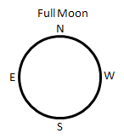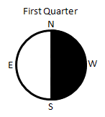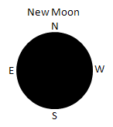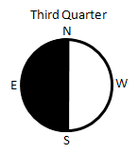

Note that North, South, East, and West are the direction you would observe when laying on your back with your head to the North and looking UP into the sky.  In this case East is to the left.  If you look DOWN at a map, East is to the right.  When I was a small child I was confused about this.  I asked which way was North.  Dad said it was on my right.  Then I turned 180°, and Dad said North was too my left.  I got it cleared up and the same sort of thing is happening when observing the sky.  We are flipped 180° from what we were used to.

Also report Moon rise or Moon set.  You may estimate this.  For example, if at 8 pm the moon is halfway through the sky, Moon rise was about 6 hr before that or 2 pm and Moon set is about 6 hr after that or 2 am.  Fill in the table at the end for at least one full cycle.  A few days before the New Moon, the Moon sets shortly before the Sun and is difficult to see near sunset, but can be seen shortly before sunrise.  After the New Moon it is easy to see after sunset, but after the First Quarter it rises past midnight.  Do the best you can, but skip days if inclement weather prohibits observation.

**Very Important Analysis**:  This assignment is incomplete until you can successfully explain, based on your observations, to a 5th grader, how and why the Moon moves around the Earth.  In particular, connect your observations with the actual motion of the Moon. Sketch the relationship of the Sun, Earth and Moon in for the four major phases of the Moon.  Show the view looking down at the North Pole, show the direction the Earth is rotating, and the direction the Moon is moving.  Make a model of the Sun, Earth, Moon system and view it from the perspective of a person on Earth. EXPLAIN your reasoning on separate pages and include diagrams.

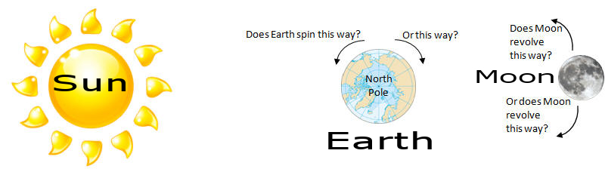

|  |  |  |  |  |  |  |
| --- | --- | --- | --- | --- | --- | --- |
| Sunday | Monday | Tuesday | Wednesday | Thursday | Friday | Saturday |
| |  |  | | --- | --- | | Sketch | | | Moon rise: |  | | Moon set: |  | | |  |  | | --- | --- | | Sketch | | | Moon rise: |  | | Moon set: |  | | |  |  | | --- | --- | | Sketch | | | Moon rise: |  | | Moon set: |  | | |  |  | | --- | --- | | Sketch | | | Moon rise: |  | | Moon set: |  | | |  |  | | --- | --- | | Sketch | | | Moon rise: |  | | Moon set: |  | | |  |  | | --- | --- | | Sketch | | | Moon rise: |  | | Moon set: |  | | |  |  | | --- | --- | | Sketch | | | Moon rise: |  | | Moon set: |  | |
| |  |  | | --- | --- | | Sketch | | | Moon rise: |  | | Moon set: |  | | |  |  | | --- | --- | | Sketch | | | Moon rise: |  | | Moon set: |  | | |  |  | | --- | --- | | Sketch | | | Moon rise: |  | | Moon set: |  | | |  |  | | --- | --- | | Sketch | | | Moon rise: |  | | Moon set: |  | | |  |  | | --- | --- | | Sketch | | | Moon rise: |  | | Moon set: |  | | |  |  | | --- | --- | | Sketch | | | Moon rise: |  | | Moon set: |  | | |  |  | | --- | --- | | Sketch | | | Moon rise: |  | | Moon set: |  | |
| |  |  | | --- | --- | | Sketch | | | Moon rise: |  | | Moon set: |  | | |  |  | | --- | --- | | Sketch | | | Moon rise: |  | | Moon set: |  | | |  |  | | --- | --- | | Sketch | | | Moon rise: |  | | Moon set: |  | | |  |  | | --- | --- | | Sketch | | | Moon rise: |  | | Moon set: |  | | |  |  | | --- | --- | | Sketch | | | Moon rise: |  | | Moon set: |  | | |  |  | | --- | --- | | Sketch | | | Moon rise: |  | | Moon set: |  | | |  |  | | --- | --- | | Sketch | | | Moon rise: |  | | Moon set: |  | |
| |  |  | | --- | --- | | Sketch | | | Moon rise: |  | | Moon set: |  | | |  |  | | --- | --- | | Sketch | | | Moon rise: |  | | Moon set: |  | | |  |  | | --- | --- | | Sketch | | | Moon rise: |  | | Moon set: |  | | |  |  | | --- | --- | | Sketch | | | Moon rise: |  | | Moon set: |  | | |  |  | | --- | --- | | Sketch | | | Moon rise: |  | | Moon set: |  | | |  |  | | --- | --- | | Sketch | | | Moon rise: |  | | Moon set: |  | | |  |  | | --- | --- | | Sketch | | | Moon rise: |  | | Moon set: |  | |
| |  |  | | --- | --- | | Sketch | | | Moon rise: |  | | Moon set: |  | | |  |  | | --- | --- | | Sketch | | | Moon rise: |  | | Moon set: |  | | |  |  | | --- | --- | | Sketch | | | Moon rise: |  | | Moon set: |  | | |  |  | | --- | --- | | Sketch | | | Moon rise: |  | | Moon set: |  | | |  |  | | --- | --- | | Sketch | | | Moon rise: |  | | Moon set: |  | | |  |  | | --- | --- | | Sketch | | | Moon rise: |  | | Moon set: |  | | |  |  | | --- | --- | | Sketch | | | Moon rise: |  | | Moon set: |  | |

Page left intentionally blank

|  |  |  |  |
| --- | --- | --- | --- |
| **Project** | <http://www.funphysicist.net/icha/icha_project.htm> | Now=6/3/2012 | Mod=01/27/2012 |

|  |  |
| --- | --- |
| Name\_\_\_\_\_\_\_\_\_\_\_\_\_\_\_\_\_\_\_\_      Name\_\_\_\_\_\_\_\_\_\_\_\_\_\_\_\_\_\_\_\_      Name\_\_\_\_\_\_\_\_\_\_\_\_\_\_\_\_\_\_\_\_ | [Project Plan](http://www.funphysicist.net/icha/excel_project_planner.xlsx)http://www.funphysicist.net/icha/images/ICA_Project_02.jpg |

In-class groups will participate in a project and present a tri-fold display at the end of the semester.  This is very much like a K-12 high school science fair project.  Research science fair guidelines, and compare to this, to get ideas, but you will be held accountable to meet the following guidelines.

**Tri-fold Required** (see photo above right) at or prior to end of semester.  See below for [guidelines](http://www.funphysicist.net/icha/icha_project.htm#Poster_Guidelines).  Also refer to [the science poster](http://www.monash.edu.au/lls/llonline/writing/science/8.xml), [writing in science](http://www.monash.edu.au/lls/llonline/writing/science/index.xml), and [writing in engineering](http://www.monash.edu.au/lls/llonline/writing/engineering/index.xml).

**Project ideas**:  Archimede's screw (water pump), how a musical instrument works, Foucault's pendulum (no model - difficult to build), magnetic levitation, marshmellow shooter, electric motor, Curie effect heat engine, Franklin's Bells, Van de Graff generator, Barkhausen effect, solar cooker, electrochemical cell, solar cell, fuel cell, radio, crystal radio (not from a kit), Hero's steam engine, or CHOOSE YOUR OWN.

You may have an idea.  If you have an idea, discuss it me, your other professors, and/or contact [me](mailto:JTSizemore@tjc.edu).  I am looking for a step up from the baking soda and vinegar volcano.  But can you design a project to use baking soda and vinegar to weigh air?

Potential opportunity every semester:

* Some semesters we have disabled students who need **notetakers**.  Being a notetaker satisfies project requirement, however a tri-fold poster is still required and must have science content.

**Project requirements**:

1. **Progress Reports:**
   1. Plan:  Due about 1/3 way through semester (see syllabus).  This spreadsheet is provided as an example: [spreadsheet.](http://www.funphysicist.net/icha/excel_project_planner.xlsx)
   2. Progress Report:  Due about 2/3 way through semester (see syllabus).  Be honest - are you on track to finish.  You're grade won't depend on how your adherence to the plan, but on the honesty and accuracy of this report.
2. **Working model** if project is amenable to a working model.  Check with [me](mailto:JTSizemore@tjc.edu) if in doubt.
3. **Tri-fold Poster Guidelines**:  A Tri-fold poster is required at last day of class.  The [library](http://www.tjc.edu/Library/) or [writing lab](http://www.tjc.edu/Tutoring/Labs.php) can help AND you get ICA credit for utilizing the writing center.  Organization:
   1. **Title** (include names of group members)
   2. **Brief description** (~1 paragraphs)
   3. **Introduction** - more thorough discussion of background, history, & theory.  For trifold make these bullet points.
   4. **Experiment** - Describe equipment and procedure.  Vary factors and test the outcomes.  View labs as examples.  Ask similar questions relating to your project.  What did it do?  For example, if you build a battery, what was the voltage and how long did it run a light bulb.
   5. **Results** - Take the data, analyze it, and try to draw conclusions.  In general we report results and not raw data.
   6. **Discuss Results** - What to the results mean or imply?  Discuss cause and effect.  Did your project meet expectations or not?  What would you do differently in the future?
   7. **Brief, Key Conclusions**
   8. Cite all non-original sources using **MLA or APA style**.  Pick one or the other (MLA or APA), but be consistent.  The [library](http://www.tjc/library/) or [writing lab](http://www.tjc.edu/Tutoring/Labs.php) can help.  Remember, if you cite the source it's research, if you don't it's plagiarism.
   9. Think for yourself.  Gather research sources, however contribute your own thoughts and conclusions.  If too much of your tri-fold is citations you won't be accused of plagiarism, but the grade may suffer from lack of originality.
   10. Edit ruthlessly.  The emphasis of a tri-fold poster is on visual information & completeness yet very concise
   11. Email me an electronic version of your poster text and photos.
   12. NO FLIPPING PAGES.  Everything must be visible from the front including group member names & citations.

**Grading**:  Your grade will depend on how well you comply with these requirements.

Sometimes things don't work out as we plan.  Your grade, therefore, will not depend on whether the project works.  If it doesn't work I'll be looking for a good explanation of what went wrong; a good attempt to make a working model; a clear explanation of your project, construction, and procedures; valid testing; results and conclusions; and good tri-fold presentation.

|  |  |  |  |
| --- | --- | --- | --- |
| **Heat** | <http://www.funphysicist.net/icha/icha_heat.htm> | Now=6/3/2012 | Mod=01/27/2012 |

|  |  |
| --- | --- |
| Name\_\_\_\_\_\_\_\_\_\_\_\_\_\_\_\_\_\_\_\_    Name\_\_\_\_\_\_\_\_\_\_\_\_\_\_\_\_\_\_\_\_    Name\_\_\_\_\_\_\_\_\_\_\_\_\_\_\_\_\_\_\_\_ | toaster |

Mechanical energy is easily converted to heat, but the reverse is harder.  Today we're going to use thermal probes to understand how mechanical energy is turned into heat.

1. Without touching the probe to anything, what is the temperature in °F? In °C?
2. Hold it in your hand.  What is your temperature in °F? In °C?
3. Don't put this under your tongue, however, why do doctors put the thermometer under your tongue (or elsewhere) to measure body temperature?
4. Rub your hands together then hold the thermal probe in your hand.  What is the new temperature in °F? In °C?
5. Is your hand hotter now?  Why?  Or why not?  Explain.
6. Measure and record the temperature of several things around the room.  The window, the computer, etc.  Record your observations.  Explain why one thing is warmer than another.
7. What is heat?  Why can energy be converted to heat, but not all heat can be converted back to useful energy?  Does this mean energy isn't conserved?  Why or why not?  Explain.

|  |  |  |  |
| --- | --- | --- | --- |
| **Entropy** | <http://www.funphysicist.net/icha/icha_entropy.htm> | Now=6/3/2012 | Mod=01/27/2012 |

|  |  |  |
| --- | --- | --- |
| Name\_\_\_\_\_\_\_\_\_\_\_\_\_\_\_\_\_\_\_\_    Name\_\_\_\_\_\_\_\_\_\_\_\_\_\_\_\_\_\_\_\_    Name\_\_\_\_\_\_\_\_\_\_\_\_\_\_\_\_\_\_\_\_ | ice melting |  |
| When something gains heat it becomes more disordered and it's hard to get that order back.  The ice cube above, for example, gains heat and becomes a disordered puddle of water.  Going back to become an ice cube is more difficult.    Watch the video at right. | |

|  |  |
| --- | --- |
| 1. | Can you tell when the film switches from running forward to running backward?  What finally informs you that the film was running backward?. |

|  |  |  |
| --- | --- | --- |
| 2. | Let's solve an entropy problem.  If 1 cal of heat enters the hot side of a copper heat conductor at 400°K and leaves cold side at 300°K, calculate the change in entropy.  First, how much entropy does the hot side lose? | Entropy change |
|  | |

|  |  |
| --- | --- |
| 3. | How much entropy does the cold side gain? |

|  |  |
| --- | --- |
| 4. | Add the answers from Parts 2 and 3 - What is the total entropy change? |

|  |  |
| --- | --- |
| 5. | The second law of thermodynamics says entropy increases.  Did this happen? |

Page left intentionally blank

|  |  |  |  |
| --- | --- | --- | --- |
| **Electricity** | <http://www.funphysicist.net/icha/icha_electricity.htm> | Now=6/3/2012 | Mod=01/27/2012 |

|  |  |
| --- | --- |
| Name\_\_\_\_\_\_\_\_\_\_\_\_\_\_\_\_\_\_\_\_    Name\_\_\_\_\_\_\_\_\_\_\_\_\_\_\_\_\_\_\_\_    Name\_\_\_\_\_\_\_\_\_\_\_\_\_\_\_\_\_\_\_\_ | Electricity |

Rub a balloon on your hair (or wool) and attempt to stick it to the wall.  Does it?  Even if it doesn't (it might not due to humidity and other factors), do you feel a force of attraction?  Why or why not?

Observe the Wimshurst machine or Van de Graff generator.  Why do they spark?  What is happening?

Tape a couple strips of paper close together on one electrode.  Do they attract or repel each other?  Why?

Hold your hand close to the paper strips. Are they attracted to or repelled by your hand? Explain.

If you have a charged object and uncharged object, how can you use this to put the opposite charge on the uncharged object? It's called electrostatic induction - [see this site](http://regentsprep.org/Regents/physics/phys03/aeleclab/induct.htm).

We will have foil leaf electroscopes with a charge on them - the instructor will inform you if it is positive or negative. Using the rods, fur, cloth, etc. place a charge on the object (the rubber, glass, or plastic rod, etc.) and determine the polarity. The place the opposite polarity on the electroscope and explain how you did it?

|  |  |  |  |
| --- | --- | --- | --- |
| **Electrical Energy** | <http://www.funphysicist.net/icha/icha_capacitor.htm> | Now=6/3/2012 | Mod=01/27/2012 |

|  |  |
| --- | --- |
| Name\_\_\_\_\_\_\_\_\_\_\_\_\_\_\_\_\_\_\_\_    Name\_\_\_\_\_\_\_\_\_\_\_\_\_\_\_\_\_\_\_\_    Name\_\_\_\_\_\_\_\_\_\_\_\_\_\_\_\_\_\_\_\_ | capacitors (public domain royalty free clip art from www.clker.com) |

A capacitor works a lot like a water reservoir.  Instead of storing water molecules, it stores electrical charges to be released whenever we want them.  We're going to compare a real capacitor to the tornado tube.

Equipment:  Tornado tube, battery or power supply, light (consistent with capacitor voltage), wires & alligator clips, ~1 F capacitor, stopwatch (a cell phone or wristwatch stopwatch works well), DMM

Turn the tornado tube over.  You can spin it if you want, or let the water glug, glug down.  Observe it and answer the questions:

1. What is the source of energy?

1. How is the energy consumed?

1. What happens, or does not happen, when the energy is entirely consumed?

1. Now we'll charge the capacitor.  When you charge a capacitor, what are you doing?

1. How is this similar to starting the tornado tube?

1. Now connect the capacitor to the light.  Sketch the circuit (first step in [SOLVE](http://www.funphysicist.net/help/solve.htm) method) and observe and describe what happens.

|  |  |
| --- | --- |
|  |  |

1. How is the behavior of the light/capacitor similar to or different than the tornado tube?

1. Measure the time it takes for the light to be about half the brightness and record it here as an equation.

1. What is the equation for this time in terms of resistance and capacitance.  Write it down, solve it symbolically for resistance of the light, and finally numerically calculate the resistance of the light.  Use [SOLVE](http://www.funphysicist.net/help/solve.htm).

1. Measure the resistance of the light, record the data (as an equation) below and calculate the percent error using the [SOLVE](http://www.funphysicist.net/help/solve.htm) method.

1. What do you conclude?  How does a capacitor work?  Compare and contrast it to the tornado tube.

1. If a 1 F capacitor is charged to -2.1 V, how much energy is it storing?

1. How much charge does this capacitor store?

1. If the spacing between plates is 10-8 m, what must the area of a 1 F capacitor be?

1. What is the electric field between the plates?

1. Pretend the charge on the capacitor is a point charge. What is voltage 1 cm from the charge?

1. Still pretending the charge is a point charge, what is the electric field 1 cm from the charge?

Page left intentionally blank

|  |  |  |  |
| --- | --- | --- | --- |
| **Resistance** | <http://www.funphysicist.net/icha/icha_resistor.htm> | Now=6/3/2012 | Mod=01/27/2012 |

|  |  |
| --- | --- |
| Name\_\_\_\_\_\_\_\_\_\_\_\_\_\_\_\_\_\_\_\_    Name\_\_\_\_\_\_\_\_\_\_\_\_\_\_\_\_\_\_\_\_    Name\_\_\_\_\_\_\_\_\_\_\_\_\_\_\_\_\_\_\_\_ | battery & flashlight |

Think of a battery (or any electrical power source) like a water pump taking water from low to high.  A battery takes electrons from low to high energy.  A resistor is like a pipe.  A large resistor is like a long garden hose and a small resistor is like a short firehouse.  The hydraulic analog to electricity is so useful that hydraulics engineers make electrical models of rivers to understand when flooding will occur, how fast the river is moving, how much water is flowing, etc.

Equipment:  batteries (9 V are great, things with terminals that alligator clips attach to are great; AA, C, D, etc. are not so great unless wires are soldered to them), lights, electrical breadboard, wires & alligator clips, DMM

|  |  |
| --- | --- |
| 1. Take two batteries WITH DIFFERENT VOLTAGES and measure the voltages of each.  Draw the circuit to the right and write down the voltages below as equations. |  |

1. Connect the positive of one battery to the negative of the other.  Measure and write as an equation the total voltage.

1. What is your conjecture (hypothesis) about finding the total voltage if you know individual voltages?  Write your conjecture below as a symbolic equation and evaluate it.

|  |  |
| --- | --- |
| 1. Connect the positive of one battery to the POSITIVE of the other.  Draw the circuit to the right and measure and write as an equation the total voltage. |  |

1. What is your conjecture (hypothesis) about finding this new total voltage (called reverse polarity) if you know individual voltages?  Write your conjecture below as a symbolic equation, solve it symbolically using the [SOLVE](http://www.funphysicist.net/help/solve.htm) method and evaluate it.

|  |  |
| --- | --- |
| 1. Take one of the batteries matching the light bulb voltage.  Your instructor will help you pick.  Connect two lights bulbs in series to the battery.  Draw the circuit to the right and WITH THE BATTERY CONNECTED, measure the total voltage and the voltage across each light as equations.  Observe the brightness of the bulbs. |  |

|  |  |
| --- | --- |
| 1. Using the same batteries and lights, connect the lights in parallel.  Draw the circuit to the right and WITH THE BATTERY CONNECTED, measure the total voltage and the voltage across each light as equations.  Observe the brightness of the bulbs this time and compare them to Step 6. |  |

1. The bulb brightness is approximately proportional to power which is current times voltage.  How do the currents compare between Steps 6 and 7? How does the power compare?

1. What is your conjecture about how to find total voltage given individual voltages across the lights in both the series and parallel configuration.  Express values as equations and use the [SOLVE](http://www.funphysicist.net/help/solve.htm) method.  How close are the theoretical values compared to measured values?

1. Write a conclusion comparing and contrasting currents for light bulbs in the series vs. parallel configurations.

1. Provide a summary (headline) conclusions for this experiment.  How do battery voltages add?  How do you combine voltages in circuits?  How do you combine currents in circuits?

|  |  |  |  |
| --- | --- | --- | --- |
| **Magnetism** | <http://www.funphysicist.net/icha/icha_magnetism.htm> | Now=6/3/2012 | Mod=01/27/2012 |

|  |  |
| --- | --- |
| Name\_\_\_\_\_\_\_\_\_\_\_\_\_\_\_\_\_\_\_\_    Name\_\_\_\_\_\_\_\_\_\_\_\_\_\_\_\_\_\_\_\_    Name\_\_\_\_\_\_\_\_\_\_\_\_\_\_\_\_\_\_\_\_ | magnet |

Look at the pattern of iron filings over a bar magnet.  How many concentrations are there?  These are called magnetic poles.  How is this different from electricity?  Explain.

Does a permanent magnet pick up nails?  How about an electromagnet?  What are the similarities between a permanent and electromagnet?

What causes the CRT-TV picture to get messed up by magnets?

Explain what causes magnetism.

Page left intentionally blank

|  |  |  |  |
| --- | --- | --- | --- |
| **Electrical Oscillation** | <http://www.funphysicist.net/icha/icha_oscillator.htm> | Now=6/3/2012 | Mod=01/27/2012 |

Name\_\_\_\_\_\_\_\_\_\_\_\_\_\_\_\_\_\_\_\_

Name\_\_\_\_\_\_\_\_\_\_\_\_\_\_\_\_\_\_\_\_

Name\_\_\_\_\_\_\_\_\_\_\_\_\_\_\_\_\_\_\_\_

Radios, TV, cell phones, blackberries, etc. all use a tuner and ALL have to work with alternating current signals.  A crystal radio is the easiest to understand.

Inductor

Antenna

Variable capacitor to tune radio (arrow tells you it’s variable)

•

•

•

•

•

•

Diode – only lets current flow one way

Capacitor to smooth out signal and let through only signals you can hear

High impedance, high efficiency earphone

The inductor has lots of energy when the capacitor is empty and vice versa.  Charges slosh back and forth like a swing and the radio signal from the antenna "pumps" the swing.  Only the exact right frequency, which is tuned using the variable capacitor, will pump this circuit.

The diode takes some of the AC current and, along with the capacitor, smoothes it out.  So we hear the AMPLITUDE of the AC signal and the amplitude changes in a way we can hear it.  That's why this type of radio is called AM - Amplitude Modulation.  Adding transistors to the circuit amplifies the signal from the earphone on, however we start with the inductor/capacitor "tank" circuit - like a tank of water where the water sloshes back and forth.  Here are a couple good sites (<http://www.transistor.org/FAQ/two-transistor.html> & <http://sound.westhost.com/articles/am-radio.htm>).  Here's an interesting [link](http://www.funphysicist.net/icha/icha_oscillator.pdf) - Texas Instrument's/Regency 4 transistor radio patent.  But, they all have the initial stage inductor/capacitor "tank" circuit.

Equipment:  Old style (transistorized) portable radio, for example, National Panasonic R-104A or crystal radio; variable resistor, DMM

Open the back of the radio.  Draw a sketch of the major components:  Antenna, variable tuning capacitor, variable volume resistor, circuit board, battery pack, and speaker.

1. Turn it on and tune in a few stations.  Observe how it is tuned.  What does the tuning?  Draw a sketch and explain how this device works.

1. What device changes the volume?  What is it called?  Draw a sketch and explain how this device might work.  You can't actually see it working so you may need the instructor to help you.  Or a larger version of a variable resistor may be set up.

1. It is not necessary to use a variable capacitor for tuning - you may use a variable inductor.  A variable inductor has a sliding conductor moving across wire much like a variable resistor.  Why do you think the variable capacitor is the component of choice for tuning?  Why is a variable resistor acceptable for volume?

1. What is the formula for the frequency of an LC circuit?  A typical value of C is 10-9 F and frequency of an AM signal is 1 MHz.  Using the [SOLVE](http://www.funphysicist.net/help/solve.htm) method, determine the value of L.

1. Explain what AC (Alternating Current) is and draw a sketch of voltage (or current) vs. time.

Page left intentionally blank

|  |  |  |  |
| --- | --- | --- | --- |
| **Slinky Wave** | <http://www.funphysicist.net/icha/icha_slinky_wave.htm> | Now=6/3/2012 | Mod=01/27/2012 |

|  |  |
| --- | --- |
| Name\_\_\_\_\_\_\_\_\_\_\_\_\_\_\_\_\_\_\_\_    Name\_\_\_\_\_\_\_\_\_\_\_\_\_\_\_\_\_\_\_\_    Name\_\_\_\_\_\_\_\_\_\_\_\_\_\_\_\_\_\_\_\_    Also refer to [slinky waves for conceptual classes](http://www.funphysicist.net/icha/icha_slinky_wave_concept.htm) | Surfer (waves) |

|  |  |
| --- | --- |
| 1. | Use a slinky to make a transverse standing wave.  Measure the wavelength of the slinky wave.  What is it? |

|  |  |
| --- | --- |
| 2. | Use a timer to find the period of a slinky wave.  This often works well by timing 10 oscillations and then dividing by 10.  What is the period? |

|  |  |
| --- | --- |
| 3. | What formula do you use to find the wave speed? |

|  |  |
| --- | --- |
| 4. | Evaluate the wave speed. |

|  |  |
| --- | --- |
| 5. | Your instructor will provide the total mass of the slinky.  What is it? |

|  |  |
| --- | --- |
| 6. | What is the length of the slinky? |

|  |  |
| --- | --- |
| 7. | Combining Parts 5 and 6, what is μ, the mass per unit length? |

|  |  |
| --- | --- |
| 8. | You instructor is going to put a mass on the slinky or use a spring scale to stretch the slinky to find the spring constant.  What is the mass or force reading on the spring scale? |

|  |  |
| --- | --- |
| 9. | How much did the slinky elongate? |

|  |  |
| --- | --- |
| 10. | Combining Parts 8 and 9, what is the spring constant k? |

|  |  |
| --- | --- |
| 11. | How are you going to get the tension, FT, of the slinky?  Find FT. |

|  |  |
| --- | --- |
| 12. | What is the formula for wave speed? |

|  |  |
| --- | --- |
| 13. | Evaluate wave speed using the formula in Question 12. |

|  |  |
| --- | --- |
| 14. | How does the answer to Part 13 compare to the answer to Part 4? |

|  |  |  |  |
| --- | --- | --- | --- |
| **Doppler** | <http://www.funphysicist.net/icha/icha_doppler.htm> | Now=6/3/2012 | Mod=01/27/2012 |

|  |  |  |
| --- | --- | --- |
| Name\_\_\_\_\_\_\_\_\_\_\_\_\_\_\_\_\_\_\_\_    Name\_\_\_\_\_\_\_\_\_\_\_\_\_\_\_\_\_\_\_\_    Name\_\_\_\_\_\_\_\_\_\_\_\_\_\_\_\_\_\_\_\_ | [Society of Physics Students](http://www.spsnational.org/) |  |

The Doppler effect is so intimately connected to physics that the [Society of Physics Students](http://www.spsnational.org/) uses it in their logo.

We're all familiar with the fact that when a fire truck or police car goes by it starts with a high pitch sound as it approaches, then it becomes lower pitched after it passes.  This is the Doppler effect.

We're going to swing a cell phone with a pure 440 Hz A note.  Notice the change in pitch as it's swinging.  This was done in a video (above).  In that video we recorded 3 frequencies, 441 Hz without motion, 419 Hz as phone moved away, and 452 Hz as phone moved toward camera.

|  |  |
| --- | --- |
| 1. | We have both a wind speed and source (cell phone) speed.  Draw two sketches - one for the phone moving toward the camera and one for moving away. |

|  |  |
| --- | --- |
| 2. | We want to find several things:  wind speed (vs), cell phone speed (vo), and wavelengths (λo - no motion, λt - cell phone moving toward camera, λa - cell phone moving away from camera) at all 3 frequencies.  What do we know?. |

|  |  |
| --- | --- |
| 3. | What formulas do we need? |

|  |  |
| --- | --- |
| 4. | Derive formulas expressing our unknowns in terms of known quantities. |

|  |  |
| --- | --- |
| 5. | Plug in numbers and calculate.  What is: |

vs =

vo =

λo =

λt =

λa =

|  |  |
| --- | --- |
| 6. | Explain these results.  Explain why wind speed effects pitch and why the pitch moves up or down.  Explain why moving toward and away from the camera effects pitch and which direction the pitch changes. |

|  |  |  |  |
| --- | --- | --- | --- |
| **AM Radio Antenna** | <http://www.funphysicist.net/icha/icha_antenna.htm> | Now=6/3/2012 | Mod=01/27/2012 |

|  |  |
| --- | --- |
| Name\_\_\_\_\_\_\_\_\_\_\_\_\_\_\_\_\_\_\_\_    Name\_\_\_\_\_\_\_\_\_\_\_\_\_\_\_\_\_\_\_\_    Name\_\_\_\_\_\_\_\_\_\_\_\_\_\_\_\_\_\_\_\_ | inductor |

Radio antennas can sense either electrical or magnetic fields.  TV and FM antennas sense electrical field while AM radios typically (not always) use an inductor coil as an antenna.

Equipment:  Old style (transistorized) portable radio, for example, National Panasonic R-104A.

Open the back of the radio.  Draw a sketch of the major components:  Antenna, variable tuning capacitor, variable volume resistor, circuit board, battery pack, and speaker.

1. Tune in a station.  What do you think the orientation of the antenna must be to the transmitting station?  Draw a sketch.

1. Change the orientation of the radio to determine the orientation when the radio best receives the signal.  In AM radio this is when volume is loudest.  FM and TV is different and you can't figure out the strongest signal from volume.  Sketch the orientation when the signal is best.

1. Did this match your original expected orientation?  From the actual orientation, do you have a conjecture about why the signal is strongest?  Sketch the EM wave and how it interacts with the radio, elaborate and explain.

|  |  |  |  |
| --- | --- | --- | --- |
| **Optics** | <http://www.funphysicist.net/icha/icha_optics.htm> | Now=6/3/2012 | Mod=01/27/2012 |

|  |  |
| --- | --- |
| Name\_\_\_\_\_\_\_\_\_\_\_\_\_\_\_\_\_\_\_\_    Name\_\_\_\_\_\_\_\_\_\_\_\_\_\_\_\_\_\_\_\_    Name\_\_\_\_\_\_\_\_\_\_\_\_\_\_\_\_\_\_\_\_ | Magnifying Glass |

Look through the lens close up (like the picture above).  How do objects appear?  Larger?  Smaller?  Normal?  Inverted?

Hold the lens far from you.  How do objects appear now?  Larger?  Smaller?  Normal?  Inverted?

Can you explain this from the laws of refraction?

Observe the ray diagrams below.  Which one do you believe shows the situation when objects are close?  Which one shows when objects are far away?  Which one would be used in a camera?

FYI - Rays always go straight through the center of a lens and parallel rays converge at the focal length.

Ray Diagram A

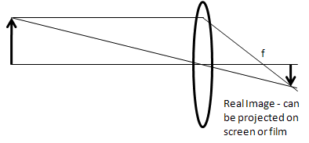

Ray Diagram B

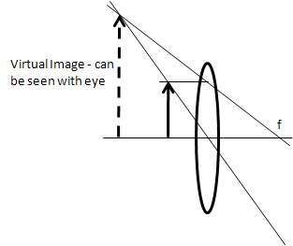

|  |  |  |  |
| --- | --- | --- | --- |
| **Interference** | <http://www.funphysicist.net/icha/icha_interference.htm> | Now=6/3/2012 | Mod=01/27/2012 |

|  |  |
| --- | --- |
| Name\_\_\_\_\_\_\_\_\_\_\_\_\_\_\_\_\_\_\_\_    Name\_\_\_\_\_\_\_\_\_\_\_\_\_\_\_\_\_\_\_\_    Name\_\_\_\_\_\_\_\_\_\_\_\_\_\_\_\_\_\_\_\_ | Diffraction pattern slit spacing 1.5 wavelengthsDiffraction pattern 180 deg out of phase, emitters two wavelengths apart |

In this activity we will bounce a laser beam (670 nm) at a blank CD and determine the spacing of tracks on a CD.

The two images above are like a snapshot of a ripple tank where two wave emitters are two wavelengths apart (the emitters are horizontal).  This is like a CD with a spacing of twice the wavelength of the light.  Each stripe acts like the wave generator in a ripple tank.  Unlike the above image a CD has thousands in a row.  But the angle where light waves are reinforced are the same.  The light areas are crests of the wave and these are where the wave is reinforced.  Your instructor may show what happens with a laser striking a CD, but let's look at the wave pattern first and try to decide what we expect before we measure the CD.

The first thing to notice is that the right and left pattern above appear identical, but they are not.  The waves are 180° out of phase.  In the image at left the center is a crest.  In the image at right the center is a trough.  But reinforcement occurs at the same angles either way.

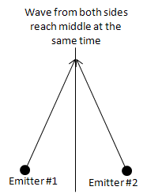Why reinforcement occurs in the center should be obvious (see figure at right).  At any point on a vertical line halfway between the two emitters the wave emanating from each emitter is going to reach that middle line at the same time.  So the perpendicular from the line connecting the emitters is going to be where constructive interference occurs.

It's the other angles that are a little bit more difficult to figure out, but not really that hard.  The first angle (other than straight ahead) where constructive interference occurs is where there is exactly one wavelength difference between the path lengths as sh 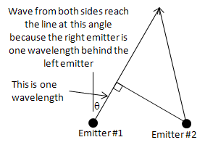own in the next figure.  The other, larger, angles occur where the path length difference is 2, 3, 4, etc. wavelength difference.  The figure at right shows the angle for the first order (1 wavelength difference).  The angle, θ, from the center is found from simple trigonometry.

On the last page the left hand top figure is expanded.  We'll analyze the first order.

|  |  |
| --- | --- |
| 1. | Using a protractor (or ruler and trigonometry), find the angle of the first order.  What is it? |

|  |  |
| --- | --- |
| 2. | Use d to represent the distance between emitters and use trigonometry to solve for this angle (first order).  What is the formula? |

|  |  |
| --- | --- |
| 3. | If d is two wavelengths, evaluate this formula.  What is θ? |

|  |  |
| --- | --- |
| 4. | Compare the results of Part 1 and 3.  Are they close to each other? |

|  |  |
| --- | --- |
| 5. | Now consider the CD.  How far from the screen was the CD? |

|  |  |
| --- | --- |
| 6. | How far from the central spot was the first order spot? |

|  |  |
| --- | --- |
| 7. | Using trigonometry, what is the formula for θ given the results of Parts 5 and 6? |

|  |  |
| --- | --- |
| 8. | Evaluate θ.  What is it? |

|  |  |
| --- | --- |
| 9. | The formula is the same as the formula for Part 2, but you need to solve for d this time.  Symbolically solve the formula in Part 2 for d and write it here. |

|  |  |
| --- | --- |
| 10. | Evaluate the formula in Part 9.   This is the spacing of tracks in a CD. |

Blow up of interference pattern follows:

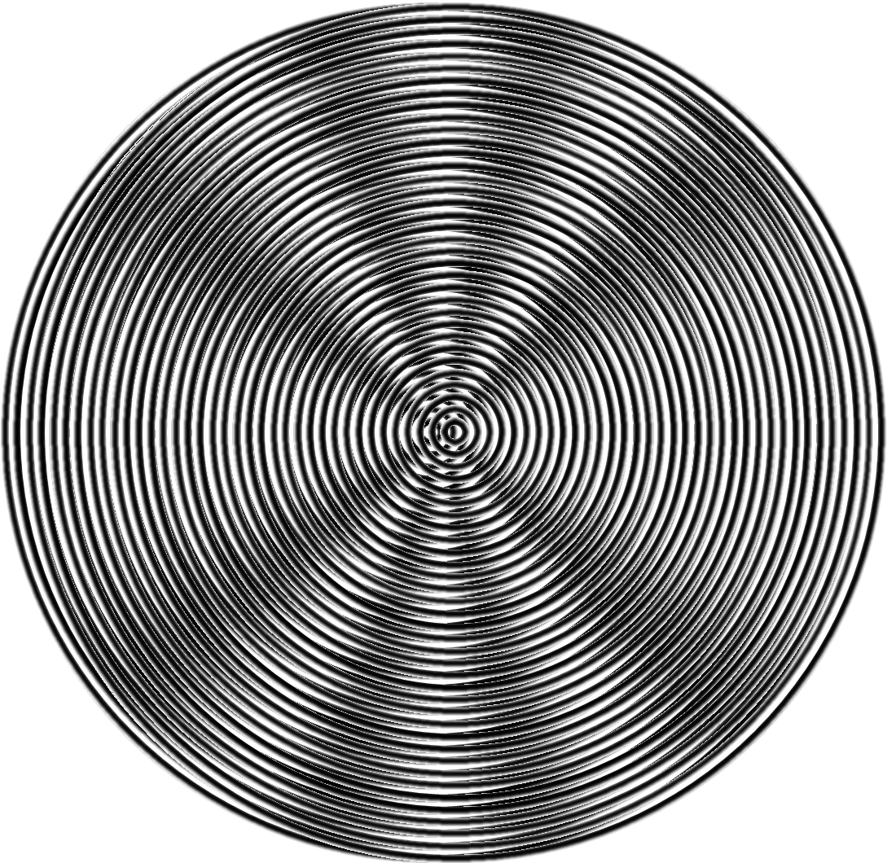

Page left intentionally blank

|  |  |  |  |
| --- | --- | --- | --- |
| **Relativity** | <http://www.funphysicist.net/icha/icha_relativity.htm> | Now=6/3/2012 | Mod=01/27/2012 |

|  |  |
| --- | --- |
| Name\_\_\_\_\_\_\_\_\_\_\_\_\_\_\_\_\_\_\_\_    Name\_\_\_\_\_\_\_\_\_\_\_\_\_\_\_\_\_\_\_\_    Name\_\_\_\_\_\_\_\_\_\_\_\_\_\_\_\_\_\_\_\_ | Pythagorean Theorem |

We can start to understand relativity by thinking about a speed boat crossing a river compared to going downstream and back.  The boat is like a light beam and the speed of the river is like the speed Earth is traveling through space.  The river is 1500 m wide (must be the Amazon), the boat's speed is 30 m/sec, and the river's current is 3 m/sec.

First consider how long it takes the boat to travel to a point exactly across the river and back.  The answer is not 100 sec.  The boat has to aim upstream a bit both directions.

1. What is the equation for the boat's upstream speed (relative to the water) need to be to exactly cancel the current so the boat's upstream speed relative to shore is zero?

1. Draw a picture and label the components of the boat's velocity relative to the water.

1. What is the equation for the boat's speed perpendicular to the shore (relative to the shore)?  Use the variables v for the speed of the river's current, c for the speed of the boat, x for the distance across the river and back, and t for the time it takes to cross the river and come back.

1. What is the equation for the time it takes for the boat to go across the river and back?  Express this in terms of 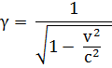.

1. Now plug in numbers - how long does it take to go back and forth?  Keep 6 sig figs.

1. We're going to compare the answer to Part 5 to the time it takes to go 1500 m downstream and back.  Derive the equation for the time it takes to go 1500 m downstream?

1. Now derive the equation for the time it takes to go 1500 m back upstream?

1. Derive the equation for the total time it takes to go 1500 m downstream and back?  Express this in terms of γ per Part 4 and call this total time t'.

1. Compare the equation of Part 8 to Part 4.  Are they the same?  By what multiplying factor are they different?

1. Plug in numbers and calculate t' keeping 6 sig figs.

1. Compare t to t'.  Are they the same?

1. Instead of a boat let's say you had a light beam and instead of a river let's be on a rocket ship traveling through space.  Do you expect your equations of Part 8 and Part 4 to vary?  Why or why not?

1. In publications between 1861 and 1873 discussing the theory of electromagnetism, James Maxwell predicted the equations in Parts 4 & 8 would be the same.  This surprised physicists because, as you just got done figuring out, it should be different.  What would you propose to settle this?

As good scientists do when there is an apparent contradiction, they perform an experiment.  American scientists Albert Michelson and Edward Morley tested this in 1887 proving Maxwell correct.   t and t' WERE the same.   Hendrik Lorentz introduced the fudge factor, γ, in 1904 without really understanding the physical significance.  It was just a mathematical convenience.  The next year Albert Einstein published his work on special relativity explaining why t and t' should be the same.

What is weird and amazing about Albert Einstein's explanation is that for the speed of light to be a constant, time itself will be different.  Even if we made perfect clocks, they would run at different rates depending on their frame of reference.  We will discuss this in detail in class.

|  |  |  |  |
| --- | --- | --- | --- |
| **Supergirl's Photons** | <http://www.funphysicist.net/icha/icha_supergirl_photons.htm> | Now=6/3/2012 | Mod=01/27/2012 |

|  |  |
| --- | --- |
| Name\_\_\_\_\_\_\_\_\_\_\_\_\_\_\_\_\_\_\_\_    Name\_\_\_\_\_\_\_\_\_\_\_\_\_\_\_\_\_\_\_\_    Name\_\_\_\_\_\_\_\_\_\_\_\_\_\_\_\_\_\_\_\_ | Supergirl |

According to DC comics, Kryptonians (former inhabitants of Krypton) gained their super powers from our yellow sun.  Earlier you calculated how much energy, 11113 J, it took for Supergirl to leap over the 21.0 m TJC chapel steeple.  Now lets figure out how many photons she needs from our sun to accomplish this.  Since solar radiation is about 1000 W/m2 (watts per meter squared are units of irradiance) on a sunny day we can also calculate how long it would require for her to gain this energy and how much mass in the sun is converted to energy.

|  |  |
| --- | --- |
| 1. | Lets figure out how long it takes first.  What is the formula relating power, energy and time? |

|  |  |
| --- | --- |
| 2. | Solve this formula for time and write the working equation here. |

|  |  |
| --- | --- |
| 3. | Let's assume the super cape is 100% efficient capturing the solar radiation, channeling it to the Kryptonians, and the cape area is 2 m2.  Power per area is called irradiance and is a common way to specify how "bright" a beam of light is.  The formula is I = P/A.  Solve this formula for power and write it here: |

|  |  |
| --- | --- |
| 4. | Substitute the expression for power in Part 3 into the equation of Part 2 to get the formula for time in terms of I, A, and E. |

|  |  |
| --- | --- |
| 5. | Now plug in numbers and calculate the time. |

|  |  |
| --- | --- |
| 6. | Next we'll figure out how many photons are in 11113 J of light.  Nature is truly strange.  Remember how we discussed why light is a wave?  Both Max Plank and Albert Einstein showed light comes in units of energy called quanta.  In other words, light is BOTH a particle AND a wave.  The "wave-icle" of light is called a photon.  This photon is like a piece of vibrating string thus making it act like both a wave and particle.  Later we'll learn ordinary matter behaves similarily.  The energy of each photon is given by the formula Ep = hf where h = 6.63\*10-34 J sec and f is frequency.  But before we can calculate Ep, we need to know f.  Recall for a wave the wavelength, λ, and f are related by λf = c = 3\*108 m/sec.  Yellow light has a wavelength of 600 nm (recall nm = 10-9 m).  Solve the formula λf = c for f and write down the working equation here: |

|  |  |
| --- | --- |
| 7. | Substitute this equation for f into Ep = hf and write that down here: |

|  |  |
| --- | --- |
| 8. | We know total energy, E, is 11113 J and we got a formula for the energy of each photon, Ep, in Part 7.  What is the formula for the number of photons?  Write that here: |

|  |  |
| --- | --- |
| 9. | Substitute the formula for Ep from Part 7 into the equation from Part 8 and write the formula here: |

|  |  |
| --- | --- |
| 10. | Now plug in numbers and calculate the number of photons. |

|  |  |
| --- | --- |
| 11. | Now we'll calculate how much solar mass is consumed doing this using the formula E = mc2.  Rearrange this formula to obtain m and write the new formula here: |

|  |  |
| --- | --- |
| 12. | Now plug in numbers and calculate the mass lost by the Sun. |

|  |  |
| --- | --- |
| 13. | Is this a lot of mass or a little?  Nuclear power comes from a tiny amount of matter converted to energy.  Why do you only need a tiny amount of matter? |

|  |  |
| --- | --- |
| 14. | Think of the time required from Part 5.  If it requires this amount of time to absorb enough energy to leap over the  TJC chapel steeple, how can Supergirl perform her bigger superhuman feats.  Do you have a hypothesis?  Explain. |

|  |  |  |  |
| --- | --- | --- | --- |
| **Sun’s Energy** | <http://www.funphysicist.net/icha/icha_sun.htm> | Now=6/3/2012 | Mod=01/27/2012 |

|  |  |  |
| --- | --- | --- |
| Name\_\_\_\_\_\_\_\_\_\_\_\_\_\_\_\_\_\_\_\_ | Name\_\_\_\_\_\_\_\_\_\_\_\_\_\_\_\_\_\_\_\_    Name\_\_\_\_\_\_\_\_\_\_\_\_\_\_\_\_\_\_\_\_ | sun |

The sun is mostly hydrogen (one proton) with a little deuterium (an isotope of hydrogen with a proton and neutron), helium-3, and helium-4.  In hydrogen fusion it doesn't just jam 4 hydrogens together to get helium-4.  There are a series of process from hydrogen to helium-4 and in this ICHA we will model the process believed to be responsible for solar energy using beans.

Start with a black (or pinto, i.e., colored) bean.  This will be hydrogen-1 or a proton (pinto, get it?) - the most abundant element in stars.  Because the lower right subscript is reserved for chemical formulas, in nuclear physics we write the number of protons (atomic number) as a lower left subscript and the nucleon (or mass) number as a left or right superscript.  Hydrogen-1 would therefore be 1H1 or .  The 1H1 notation works better for web sites since computer tools are not sophisticated enough to make the ${}_{1}^{1}H$ notation.

Let's add a couple of these together.  We can't lose protons or neutrons so we expect to get 2He2.  But we won't get 2He2 because protons repel so greatly.  What we will get is a positron (like an electron except positively charged) which has zero for a nucleon number and 1 for the charge (the same as a proton)?  In our bean model, making a positron changes a black (or pinto) bean to a white bean (neutron).  So we add two black beans (protons) together and get a black (proton) and a white (neutron) stuck together.  What element is this?  Note, we are ignoring neutrinos and gamma rays, however gamma rays in particular are important because that's where the energy comes from.  Complete the following reaction.

1H1 + 1H1 = 1e0 +  \_\_\_\_\_\_\_\_\_\_\_\_\_\_\_\_\_\_\_\_\_\_\_\_\_\_\_\_\_\_\_\_

This is how deuterium (1H2) is formed.  The positron doesn't just disappear, but it does go away in a manner we don't model.  For every two hydrogen nuclei are two electrons.  An electron will combine with the positron to making gamma rays leaving just one electron to match up with the solitary proton in 1H2.  Charge neutrality is maintained.  Now let's add our deuterium to another hydrogen-1.  Complete the following reaction.

1H1 + 1H2 = \_\_\_\_\_\_\_\_\_\_\_\_\_\_\_\_\_\_\_\_\_\_\_\_\_\_\_\_\_\_\_\_

2He3 is stable and some escapes from the sun, but it's not completely happy.  The two proton's repel each other and it would like an extra neutron to balance things out.  Now, where can we get that extra neutron?  Try adding a couple 2He3 together, then we can work something out.  First we need another 2He3 so do the previous two steps again.

How many hydrogen-1 have you used so far? \_\_\_\_\_\_\_\_\_\_\_\_\_\_\_\_\_\_\_\_\_\_\_\_\_\_\_\_\_\_\_\_

Now lets add two 2He3 get together and make two 1H1 and what else?

2He3 + 2He3 = 1H1 + 1H1 + \_\_\_\_\_\_\_\_\_\_\_\_\_\_\_\_\_\_\_\_\_\_\_\_\_\_\_\_\_\_\_\_

Voila!  Combine several hydrogens and get a helium-4 and lots of solar energy (26.7 MeV or 4.23\*10-12 J per helium-4 produced).

How many hydrogen-1 nuclei did it take to do this? \_\_\_\_\_\_\_\_\_\_\_\_\_\_\_\_\_\_\_\_\_\_\_\_\_\_\_\_\_\_\_\_

How many hydrogen-1 nuclei do you have at the end? \_\_\_\_\_\_\_\_\_\_\_\_\_\_\_\_\_\_\_\_\_\_\_\_\_\_\_\_\_\_\_\_

How many net hydrogen-1 nuclei were consumed? \_\_\_\_\_\_\_\_\_\_\_\_\_\_\_\_\_\_\_\_\_\_\_\_\_\_\_\_\_\_\_\_

How many net helium-4 nuclei were created? \_\_\_\_\_\_\_\_\_\_\_\_\_\_\_\_\_\_\_\_\_\_\_\_\_\_\_\_\_\_\_\_

Was charge conserved? \_\_\_\_\_\_\_\_\_\_\_\_\_\_\_\_\_\_\_\_\_\_\_\_\_\_\_\_\_\_\_\_

Was the number of nucleons conserved? \_\_\_\_\_\_\_\_\_\_\_\_\_\_\_\_\_\_\_\_\_\_\_\_\_\_\_\_\_\_\_\_

Mass was not conserved.  Some was lost.  What happened to it?  Remember, Einstein developed a new principle - that the sum of mc2 and energy was conserved?  Does this new principle hold?  Explain.

**University Physics Workbook Vol. I**

# Appendix C: SOLVE Method

|  |  |  |  |
| --- | --- | --- | --- |
| **SOLVE & Teamwork** | <http://www.funphysicist.net/help/solve.htm> | Now=6/1/2012 | Mod=06/01/2012 |

In a modern work environment, we do not work in isolation.  We must interact and get along.  Here are a few pointers.  Also see [7 Habits of Effective Science Students](http://www.funphysicist.net/help/success.htm) and [How to Flunk](http://www.funphysicist.net/4fun/solitaire.htm).

Individual Problem Solving:

For individual problem solving we strongly, strongly encourage the use of the [SOLVE 5-Step Problem Solving method](http://www.funphysicist.net/help/fivestep.htm).  See the [SOLVE](http://www.funphysicist.net/help/fivestep.htm) page, but in summary:

|  |  |  |  |
| --- | --- | --- | --- |
| Picture of Obi wan Kenobi telling Luke to use the 5-Steps | 1. | **S – Sketch** | Sketch, draw a picture, understand the problem |
| 2. | **O – Organize** | Organize, write down known and unknown quantities |
| 3. | **L – List** | List relevant equations, determine which are applicable |
| 4. | **V – Vary** | Vary, rewrite, and transform equations to express unknown quantity in terms of known quantities |
| 5. | **E -- Evaluate** | Evaluate expressions, Plug in Numbers, evaluate to determine if answer makes |

We will be using this throughout the course.

**Group Problem Solving:** This also works for group problems solving.  The same reason the [SOLVE 5-Steps](http://www.funphysicist.net/help/fivestep.htm) help individuals wrap their heads around a problem, it helps communicate your reasoning to others.

**Tolerating Frustration:** Quantitative reasoning can be frustrating.  A large number of steps and if you make a mistake on any one step you will get a wrong result.  That's why we need to tolerate frustration to succeed in quantitative disciplines.

**Working with Others:** There are many classes on working together offered by our college and other colleges.  All of these help defuse emotional tensions and help us work with other, disparate people.  Everybody has a unique and valuable perspective we need to appreciate to come to the best answers.  We need to respect others opinions and interact civilly in order to WORK together.

**Brainstorming:** One (and there are many) technique is brainstorming.  List ideas, any idea.  Don't tease people for bad ideas - bad ideas are OK, we'll eliminate them later.  Get everything on the table so we can sort through them and find the good ideas.  We want the team members to feel comfortable saying something.

**Labs as practice for team building:** We will do labs throughout the quarter.  Research has established that groups of 3 or 4 work best and sometimes it is necessary to make a pragmatic decision.  If we have eight sets of lab equipment and 32 students, it's clear that we will have lab groups of four people.  Part of the purpose of labs is practicing productive, respectful, supportive group interaction.  Here are a few guidelines:

1. Be on time!
2. Study the lab before arriving at class!
3. Have all group members practice doing all portions of the lab.  If you're doing a measurement, have all group members practice doing the measurement.  When assembling equipment, have all group members participate in assembly so everybody understands how the experiment was set up.
4. Avoid one or two people dominating the group.  It's important everybody participates.
5. If your group decides to assign "jobs," rotate those jobs each week.  For example, avoid having the same person always being the data recorder.

**Explain your reasoning:** You really learn something when you can explain it to somebody else.  I expect the stronger students to explain their reasoning to students who don't understand.  And I expect students who don't understand something to ask.  And I expect respect for those questions.  We close the cycle of learning when you can explain your reasoning.

**University Physics Workbook Vol. I**

# Appendix D: Geometry, Trigonometry, & Vector Summary

These three topics, Geometry, Trigonometry, and Vectors, are closely connected. The summary presented is not exhaustive, however it is my opinion that these are the most relevant to a non-calculus physics classes.

There is some really basic stuff that should not be necessary to review, that is, I presume you know this. I’ll say just a few words.

**Point:** An object located in space with no width, height, or depth.

**Line:** A line extends infinitely in both directions and is the set of points such that, if any two points in a line are chosen, all points on the line between those two point are on the shortest path between those two points. A line is pictured as follows:

Note the two arrows at each end. This is an attempt to communicate the idea that a line goes infinitely in both directions. Closely related to the concept of a line are:

* **Ray:** It is part of a line that starts at one point and continues infinitely. To show this ideas the symbol for a ray is:
* **Line segment:** This is the part of the line that starts at one point and stops at a second point. To show this idea a line without arrows is drawn:
* **Parallel Lines:** Lines that never intersect and by “intersecting” we mean that at least one point is common to both lines. If lines are not parallel, they will intersect. Examples:

Non-Parallel Lines – note that they are not shown explicitly intersection, however if one or both are extended (the dashed line) it’s clear they will eventually intersect.

Parallel Lines

* **Transversal:** A third line that intersects two other lines.

transversal

Parallel Lines

Non-Parallel Lines

Transversal

* **Perpendicular:** A line that intersects at 90°, a.k.a., *right angle* or *normal*, to a second line. Note the use of the word “normal.” In physics, “normal” has the same meaning as perpendicular. A more rigorous mathematical definition is required, however we’ll leave this for later when we define angles. Following are symbols used to show right angles – note the square used to imply this meaning.

Perpendicular, 90° angle, right angle, or normal – note the use of a box to show this.

Note that all other angles are also right angles

Finally note the use of arcs to denote general angles.

*Parallel Lines Transversal* – *small angles equal each other and large angles equal each other.*

The key idea to remember in a transversal of parallel lines is small angles equal each other AND big angles equal each other. Angles are labeled using arcs, arcs with hash marks, a symbol, or some combination of methods. Commonly used symbols are Greek letters like  or . Whatever method you use, CLARITY IS MOST IMPORTANT! When working on a geometry problem or physics problem using geometry, USE A RULER & FILL THE ENTIRE SHEET OF PAPER. Here are three different examples of the different notations.

Transversal of two parallel lines with angles shown using symbols

❑

❑

❑

❑









Transversal of two parallel lines with angles shown as single or double arcs

Transversal of two parallel lines with angles shown as arcs or hashed arcs

Note that angles  and  must sum to 180°. Therefore if one angle is known in a transversal of parallel lines, you know all of them. For example, if  is 120° then  must be 60°.

*Angles in Triangle Sum to 180°*

This is actually quite easy to prove using two transversals of parallel lines. Draw the two transversals making sure they both cross the one parallel line at the same point. Then start labeling the angles using the rules of transversals. When we discussed transversals, the angles across from each other have equal measure. We use this fact to assign the symbol  to the angles near the top. This is shown next:

❑

❑

❑

❑





















We finish by noting, viewing the top line, that  +  +  = 180°, however these are also the interior angles of the triangle formed. Q.E.D. (Latin for “quod erat demonstrandum” meaning "what was required to be proved")

*Similar Triangles & Theorem of Pythagoras*

There are many proofs of this theorem – I’ll present the most obvious proof. We start with a right triangle, that is, a triangle with one right angle and refer to the following diagram.

C

b

C2



d

C1

D

A







a

B

c

We label the vertices of the triangle, that is, points where the sides of the triangle intersect, using lowercase letters, the sides of the triangle using uppercase letters, and angles using Greek letters. Note that the vertex opposite the side uses the same letter and the angle at the vertex uses the corresponding Greek letter. Then we drop a perpendicular to the hypotenuse (longest side, line segment ab) and intersecting Point c. Note that “D” refers to the length of the line segment from Point c to Point d. Also note that “C” is the length of the hypotenuse, C1 is the length from Point d to Point a, C2 the length from Point d to Point b, and therefore C = C1 + C2.

Now, to proceed, we must discuss *Similar Triangles*. Any similar figure, including triangles, has the same shape as another, but a different size. For triangles this means angles are preserved, that is, the angles are the same in similar triangles.

Using what we’ve reviewed previously, that is, the sum of all angles in a triangle equals 180°, we assign symbols to all the angles in the previous figure. After doing this, therefore: $∆abc$ is similar to $∆bcd$ and is similar to $∆acd$.

Also *in similar figures, all lengths scale the same*. This is the meaning of “same shape, different size.” This also means that lengths are in proportion in similar figures and, now, we can write a mathematical equation, a proportion, to describe this:

$\frac{A}{C}= \frac{D}{B}= \frac{C_{2}}{A}$ and $\frac{B}{C}= \frac{D}{A}= \frac{C_{1}}{B}$

We will use these equations in just a little bit to derive a second proof of the Pythagorean Theorem. Before we do that, note:

“area of $∆bcd$ ” + “area of $∆acd$ ” = “area of $∆abc$ .”

And areas are proportional to the length of one side squared, therefore the *Pythagorean Theorem* is immediately proven:

$A^{2}+ B^{2}= C^{2}$

Let’s now revisit the equations above applying cross-multiplication:

$A^{2}=C*C_{2}$ and $B^{2}=C*C_{1}$

Noting that C1 + C2 = C we add the prior equations again deriving the Pythagorean Theorem:

$A^{2}+ B^{2}= C^{2}$

The Pythagorean Theorem is one of the most important in math and science and we will have opportunity to apply it shortly.

**Geometric Optics Application**

As the name implies, analysis of optical systems in entirely based on Geometry including similar triangles. There are two basic rules: (1) Rays of light through the center of a lens is undeflected, and (2) parallel rays meet as the focus. Let’s draw the figure:

•

ho

do

hi

di

f

❑

❑





ho is the size of the object, do is the distance of the object from the lens, hi is the size of the image, di is the distance of the image from the lens, f is the focal length of the lens, and angles are labeled to help visualize the similar triangles. Now we can write equations:

$\frac{d_{i}}{d_{o}}= \frac{h_{i}}{h_{o}}=M=$ magnification

And:

$\frac{h_{i}}{d_{i}- f}= \frac{h_{o}}{f}$

Rearranging and noting $\frac{d_{i}}{d_{o}}= \frac{h_{i}}{h_{o}}=M$:

$\frac{h_{i}}{h_{o}}=\frac{d_{i}}{f}- 1= \frac{d_{i}}{d_{o}}$

Now by dividing by *di* we obtain the thin lens equation:

$\frac{1}{f}= \frac{1}{d_{o}}+ \frac{1}{d_{i}}$

Q.E.D.

**Trigonometry –** *Some Old Hippy Caught Another Hippy Tripping On Acid*

A humorous saying, but it helps us to remember our trigonometric functions, sine, cosine, and tangent. They are just ratios – refer to the following figure:

❑

O

H

A

O stands for the length of the side opposite from the angle, , A stands for the side adjacent to the angle, and H is the hypotenuse of this right triangle. Following is how the trigonometric functions are defined and note, the abbreviation for sine is sin, for cosine is cos, and for tangent is tan:

$\sin\left(θ\right)= \frac{O}{H}$

$\cos\left(θ\right)= \frac{A}{H}$

$\tan\left(θ\right)= \frac{O}{A}$

Sin equals opposite over hypotenuse, cos equals adjacent over hypotenuse, and tan equals opposite over adjacent. Now we have a mnemonic device – the underlined letters are there first letters of each word in the phrase: *Some Old Hippy Caught Another Hippy Tripping On Acid*.

Watch out though – take a look at the second non-right angle in the triangle:

❑

O

H

A



The side adjacent to  is NOT the same side that is adjacent to . Note that  = 90°‑‑  and we observe the following relationships:

$\sin\left(ϕ\right)= \cos\left(θ\right)= \cos\left(90°-ϕ\right)$

$\cos\left(ϕ\right)= \sin\left(θ\right)= \sin\left(90°-ϕ\right)$

$\tan\left(ϕ\right)= \frac{1}{\tan\left(θ\right)}= \frac{1}{\tan\left(90°-ϕ\right)}= \cot\left(90°-ϕ\right)$

Note the last equation defines the cotangent function.

If we know the angle, we can calculate the ratios, that is, the sin, cos, or tan of the angle. If we know the angle we can calculate the angle, however insure your calculator is in the proper mode. If you wish to know degrees, insure the calculator is in “degree mode” and if you wish to know radians insure your calculator is in “radian mode.”

We’ve been using angles, but we have not been rigorous about defining angle including units of radians, degrees, and revolutions. We’ll digress to do this and then discuss inverse trigonometric functions. Refer to the following figure:

❑

R

R

c

S is the distance along the arc of the circle

A circle is a set of points a specific distance, R, from a center point, c. Shown are two lines from the center to the circle. S is the distance along the circle from the points where the two lines intersect. The angle, in units of radians, is defined as:

$θ= \frac{S}{R}$

If we go all the way around the circle, the distance traveled is 2R and thus the angle going in a complete circle is 2 rads (rad is an abbreviation for radian). Going in a complete circle is also called a revolution (rev) and also equals 360°. Now we have conversions between these three angular units.

$2π rads=360°=1 rev$

Now back to inverse trigonometric functions. Make sure your calculator is in the mode your desire – degrees or radians. I prefer the notation asin, acos, and atan to refer to the inverse functions, however modern calculators use $\sin^{-1}{}$, $\cos^{-1}{}$, and $\tan^{-1}{}$. Many students become confused erroneously thinking the inverse functions refers to a reciprocal and that’s why I prefer asin, acos, and atan. However both usages are shown next in defining inverse trigonometric functions.

$θ=asin\left(\frac{O}{H}\right)= \sin^{-1}\left(\frac{O}{H}\right)$

$θ=\operatorname{acos}\left(\frac{A}{H}\right)= \cos^{-1}\left(\frac{A}{H}\right)$

$θ=atan\left(\frac{O}{A}\right)= \tan^{-1}\left(\frac{O}{A}\right)$

This is all the trigonometry this course requires, however we’ll do a trigonometry example in conjunction with vectors, thus we’ll discuss vectors first.

**Vectors**

Nature is not one dimensional – it’s at least three or four, including time, or more if the String Hypothesis is confirmed. That’s why we need vectors. Before getting much further, let me refer you to an online resource: Online Vector Resource: <http://comp.uark.edu/~jgeabana/java/VectorCalc.html>.

❑

x

y

A

Ay

Ax

Vectors will be covered in detail by your instructor and, therefore, this is not a review as previous material was. Hopefully this section can serve as a reference to help you.

We represent vectors by arrows and describe the length, units, and direction of the arrow. If the unit is a Newton (if we’re discussing a force), then there is a scale to our arrow, for example, 1 cm length represents 1 N. The direction of the arrow is given by the angle from the x-axis with counter-clockwise being positive angles. Consider the following example:

A vector is symbolized by an arrow over the letter, such as shown above, a line over the letter, e.g., $\overline{A}$, or bold, **A**. Part of the reason we do things is convenience of the tools available, therefore we use bold letters to symbolize vectors because it was easier for typewriters and that practice continued into our computer age. A line over a letter works well for blackboards. We have better word processing tools these days and thus I’ll avoid bold face for vectors, but not all the way to an arrow over to denote vectors. My practice will be the middle – I’ll use a line over.

Ax is the x component of the vector and Ay is the y component. There may also be a z component, $A_{z}$. It’s easy to see, using the Pythagorean Theorem, that the length or *magnitude* of $\overline{A}$ equals:

$\left|\overline{A}\right|=A= \sqrt{A_{x}^{2}+A_{y}^{2}+ A_{z}^{2}}$

Some people use the ordinary capital letter without bold to mean the vector length. I prefer using the absolute value symbol with the overline, that is, the magnitude of $\overline{A}$ is symbolized by $\left|\overline{A}\right|$. Also the term “magnitude” is preferred over “length.” If we restrict our consideration to two dimensions, the angle, , is given by:

$θ=atan\left(\frac{A_{y}}{A_{x}}\right)$

Conversely, in two dimensions, if you know magnitude and angle, you can find the components:

$A_{x}= \left|\overline{A}\right|\cos\left(θ\right)$

$A_{y}= \left|\overline{A}\right|\sin\left(θ\right)$

These formulae for 3 dimensions are more complicated and are usually discussed in more advanced classes.

A very popular method to describe vectors is to use the unit vector notation. A unit vector along the x axis, y axis, or z axis is defined. There are just vectors with magnitude of one. The x axis unit vector has a carrot or hat over the letter, that is, $\hat{x}$, y axis unit vector is $\hat{y}$, and z axis is $\hat{z}$. Some authors use i, j, and k instead of x, y, and z to refer to unit vectors. Therefore, $\hat{x}= \hat{i}$, $\hat{y}= \hat{j}$, and $\hat{z}= \hat{k}$. The connection to components is as follows:

$\overline{A}= A_{x}\hat{x}+ A_{y}\hat{y}+ A_{z}\hat{z}$

*Adding Vectors*

Graphically we use the arrow description and add vectors tip-to-tail, that is, the tip of the first vector touches the tail of the second. The following figure shows this:

A

B

A

B

A + B = C

C

You may use a ruler and protractor to carefully measure and draw to find $\overline{C}$. The component method is extremely popular for this purpose since:

$C_{x}= A_{x}+ B_{x}$

And

$C_{y}= A_{y}+ B_{y}$

And, in three dimensions

$C_{z}= A_{z}+ B_{z}$

Or using unit vectors as we will use in the rest of this book

$\overline{C}= \overline{A}+ \overline{B}= \left(A_{x}+ B_{x}\right)\hat{x}+ \left(A_{y}+ B_{y}\right)\hat{y}+ \left(A_{z}+ B_{z}\right)\hat{z}$

*Subtracting Vectors*

This easiest way to think about this is adding the negative vector, that is, a vector the same magnitude and in the opposite direction. So:

A

B

A

A – B = C

C

–B

The way to negate a vector is simply to negate each of the components. This should be clear from the previous figure. So subtraction using components is also quite simple.

$\overline{C}= \overline{A}- \overline{B}= \left(A_{x}- B_{x}\right)\hat{x}+ \left(A_{y}- B_{y}\right)\hat{y}+ \left(A_{z}- B_{z}\right)\hat{z}$

*Multiplying Vectors by a Scalar*

A *scalar*, unlike a vector, is a quantity without direction. Scalars are the stuff we’ve been used to working with in most of our math. To multiply a vector by a scalar we just multiply the magnitude by the scalar and *direction does not change*. If the scalar is negative, the arrows end flips just like we saw previously when subtracting vectors. Letting the scalar be symbolized by k, then:

$\overline{C}=k\overline{A} =kA_{x}\hat{x}+ kA_{y}\hat{y}+ kA_{z}\hat{z}$

*Vector Scalar Product aka Dot Product*

We first encounter this when discussing work, that is, the force in the direction of motion times distance. If the force is perpendicular to the direction of motion, there is no work. It’s like the weight of a rider on a riding lawn mower. Motion is parallel to the ground, but the person’s force is perpendicular to the ground, therefore the person isn’t working. They may be sipping an ice cold lemonade lazily guiding the lawn mover. The lawn mover’s motor is doing the work – not the rider.

We say that work is force in the direction of motion – a quantity we can easily derive as follows:

❑

F

D

Fx

*Fx* is the force in the direction of the motion, $\overline{D}$, and since $F_{x}= \left|\overline{F}\right|\cos\left(θ\right)$:

$\overline{F}∙\overline{D}= \left|\overline{F}\right|\left|\overline{D}\right|\cos\left(θ\right)$

This is the definition of the dot product (note the “dot” between vectors) or scalar product. The result is a scalar.

The proof of the component version of the dot product is beyond this course and is simply stated below:

$\overline{F}∙\overline{D}= F_{x}*D_{x}+ F_{y}*D_{y}+ F_{z}*D_{z}$

*Vector Cross Product*

We first encounter this discussing torque and rotational motion. Torque is defined as force *perpendicular to the lever arm*, R, times the lever arm. See the next figure:

R

❑

F

Fy

In this case it’s clear that only the *y* component of force will cause rotation. *Fx* will not. Therefore the magnitude of torque is easy to calculate and is:

$\left|\overline{τ}\right|= \left|\overline{R}\right|\left|\overline{F}\right|\sin\left(θ\right)$

Torque is a vector quantity and one finds the direction of the vector using the “Right Hand Rule.” Point the thumb of your right hand in the direction of $\overline{R}$, and fingers in the direction of the force component perpendicular to $\overline{R}$, then your palm will point in the direction of torque. This takes practice and will be covered in class.

The component version of the cross product is beyond the scope of this course and is simply stated below:

$$\left|\overline{τ}\right|= \overline{R}×\overline{F}= \left(R_{y}*F_{z}- R_{z}*F_{y}\right)\hat{x}+ \left(R_{z}*F_{x}- R_{x}*F_{z}\right)\hat{y}+ \left(R_{x}*F_{y}- R_{y}*F_{x}\right)\hat{z}$$

*Application – Force Acting Down Plane*

This is a common problem in physics and illustrates the use of Geometry, Trigonometry, and Vectors. Weight acts downward, but can be resolved into two components – a component acting parallel to the plane and a component acting normal (perpendicular) as shown:

mass m

Weight = F = mg

❑

y

x

Fx

Fy

?

90° – 

First note that we’ve tilted the x and y axes so the component of force acting parallel to the plane is *Fx* and the component acting normal is *Fy*. But we don’t know the angle of the force vector. It’s easy to figure out, however, by noting that two angles ( and a right angle) are known in the lower right triangle making the third angle 90° ‑ . Therefore the angle labeled ? must be .

Using trigonometry, $F_{x}=m\left|\overline{g}\right|\sin\left(θ\right)$ and $F_{y}=-m\left|\overline{g}\right|\cos\left(θ\right)$. This is counterintuitive based on our vector discussion. This highlights the need to carefully think through a problem and don’t just rely on formulae.

The issue is that the angle of the force vector from the x axis is not , it is negative (angle is going clockwise) 90° ‑ . Therefore:

$F_{x}=m\left|\overline{g}\right|\cos\left(θ-90°\right)= m\left|\overline{g}\right|\sin\left(θ\right)$

And

$F_{y}=m\left|\overline{g}\right|\sin\left(θ-90°\right)= -m\left|\overline{g}\right|\cos\left(θ\right)$

*Conclusion*

We’ve summarized Geometry, Trigonometry, and Vectors as they related to Algebra based physics classes. Although we’ve summarized key material, applying this takes practice. Also be careful in analyzing problems. Simply relying on formulae is insufficient – you must think through problems, apply appropriate formulae, know how to correctly apply those formulae, combine knowledge with other knowledge, and do your math carefully step-by-step.

Page left intentionally blank

**University Physics Workbook Vol. I**

# Appendix E: Exponentials & Logarithms Summary

**Laws of Exponents**

To remember laws of exponents, you may expand recalling that exponents mean repeated multiplication.  For example, x3 = x\*x\*x. All of the rules are derived from this basic understanding.

Let i, j, m and n be any Real or Rational (fraction) numbers.  Let a and b be any Real or Rational numbers greater than zero.  When first learning laws of exponents think of i, j, m, n, a and b as integers, however they are quite general and are extended to complex numbers.

For the radical form recall: $\sqrt[n]{a^{m}}= {\left(a\right)}^{\left(\frac{m}{n}\right)}$ and $\sqrt{a}= {\left(a\right)}^{\left(\frac{1}{2}\right)}$

| **Rule Name** | **Summary** | **Radical Form** | **Examples** |
| --- | --- | --- | --- |
| Zero Exponent | $$a^{0}=1$$ | not applicable | 1230 = 1 |
| Exponent of One | $$a^{1}=a$$ | not applicable | 1231 = 123 |
| Exponents and Roots | ${\left(a^{\left(\frac{1}{n}\right)}\right)}^{n}=a$ $${\left(a^{n}\right)}^{\left(\frac{1}{n}\right)}=a$$ | $$\sqrt[n]{a^{n}}= {\left(\sqrt[n]{a}\right)}^{a}=a$$ | $${\left(\sqrt[3]{123}\right)}^{3}=123$$ $$\sqrt{3^{2}}=3$$ |
| Negative Exponent | $$a^{-n}= \frac{1}{a^{n}}$$ | $$\sqrt[-n]{a}= \frac{1}{\sqrt[n]{a}}= \sqrt[n]{\frac{1}{a}}$$ | $$4^{-1}= \frac{1}{4}$$ $$\sqrt[-3]{2}= \frac{1}{\sqrt[3]{2}}$$ $$\sqrt[-3]{2}= \sqrt[3]{\frac{1}{2}}$$ |
| Powers of One |  |  | 1456 = 1 |
| Powers of -1 | n even: $${\left(-1\right)}^{n}=1$$ n odd: $${\left(-1\right)}^{n}=-1$$ | n even: $$\sqrt[m]{{\left(-1\right)}^{n}}=1$$ n & m odd: $$\sqrt[m]{{\left(-1\right)}^{n}}=-1$$ n odd & m even results in imaginary & complex numbers (don’t worry about this yet) | $${\left(-1\right)}^{456}=1$$ $${\left(-1\right)}^{457}=1$$ $$\sqrt[3]{-1}= \sqrt[457]{-1}$$ $$\sqrt[3]{-1}= -1$$ $$\sqrt[4]{{\left(-1\right)}^{2}}= -1$$ $$\sqrt[3]{{\left(-1\right)}^{2}}= -1$$ $\sqrt{-1}=i$ (defines pure imaginary number of magnitude 1) |
| Product of Powers | $$a^{i}a^{j}= a^{\left(i+j\right)}$$ | Note: $\sqrt[n]{a^{m}}= {\left(a\right)}^{\left(\frac{m}{n}\right)}$& $\sqrt[q]{a^{p}}= {\left(a\right)}^{\left(\frac{p}{q}\right)}$ Thus: $$\sqrt[n]{a^{m}} \sqrt[q]{a^{p}}= {\left(a\right)}^{\left(\frac{m}{n} + \frac{p}{q}\right)}$$ | $$2^{3}*2^{5}= 2^{\left(3+5\right)}$$ $$2^{3}*2^{5}= 256$$ |
| Quotient of Powers | $$\frac{a^{i}}{a^{j}}= a^{\left(i-j\right)}$$ | See Product of Powers: $$\frac{\sqrt[n]{a^{m}}}{\sqrt[q]{a^{p}}}= a^{\left(\frac{m}{n} - \frac{p}{q}\right)}$$ | $$\frac{6^{7}}{6^{5}}= 6^{\left(7-5\right)}$$ $$\frac{6^{7}}{6^{5}}= 36$$ $$\frac{\sqrt{6^{7}}}{\sqrt{6^{5}}}= 6^{\left(\frac{7}{2} - \frac{5}{2}\right)}$$ $$\frac{\sqrt{6^{7}}}{\sqrt{6^{5}}}= 6$$ |
| Power of Power | $${\left(a^{m}\right)}^{n}= a^{m*n}$$ | $$\sqrt[n]{a^{m}}= {\left(\sqrt[n]{a}\right)}^{m}$$ $$\sqrt[n]{a^{m}}= a^{\left(\frac{m}{n}\right)}$$ | $${\left(2^{3}\right)}^{-2}= 2^{-6}$$ $${\left(2^{3}\right)}^{-2}= \frac{1}{64}$$ $${\left(\sqrt[3]{5}\right)}^{6}= 5^{2}=25$$ |
| Power of Product | $${\left(a*b\right)}^{m}= a^{m}*b^{m}$$ | $$\sqrt[n]{{\left(a*b\right)}^{m}}= \sqrt[n]{a^{m}}*\sqrt[n]{b^{m}}$$ | $${\left(2*3\right)}^{2}= 6^{2}$$ $${\left(2*3\right)}^{2}= 36$$ $$\sqrt{4*9}= \sqrt{4}*\sqrt{9}$$ $$\sqrt{4*9}= 6$$ |
| Power of Quotient | $${\left(\frac{a}{b}\right)}^{m}= \frac{a^{m}}{b^{m}}$$ | $$\sqrt[m]{\frac{a}{b}}= \frac{\sqrt[m]{a}}{\sqrt[m]{b}}$$ | $${\left(\frac{3}{5}\right)}^{-2}= \frac{3^{-2}}{5^{-2}}$$ $${\left(\frac{3}{5}\right)}^{-2}= \frac{25}{9}$$ $$\sqrt{\frac{25}{9}}= \frac{\sqrt{25}}{\sqrt{9}}$$ $$\sqrt{\frac{25}{9}}= \frac{5}{3}$$ |

**Logarithms**

Remember, the logarithm function is defined as the inverse function to the exponential, that is: $\log_{a}\left(a^{x}\right)=x$ where *a* is the base of the logarithm. And, conversely, $a^{\log_{a}\left(y\right)}=y$.

Note that there are two very common bases, 10 and *e*, for logarithms. Base 10 is rather obvious – we’re used to dealing in base 10. Often the base is left off if referring to base 10. $\log_{10}\left(x\right)= \log\left(x\right)$ mean the same thing. Base *e* is not so obvious and it requires a study to calculus to understand why this is an important base. For right now, before your study of calculus, you will need to accept that *e* is important and learn to work with natural logs, that is, logs of base *e*. Also a common notation for logs of base *e* is ln(x) and *e* is an irrational number ≈ 2.71828.

Since logarithms are the inverse function of exponentials, for every law of exponentials above, there is a corresponding law of logarithms. We repeat the first two columns of the above table, the third column is the corresponding law for logarithms, and the last column shows examples.

| **Rule Name** | **Law of Exponents** | **Law of Logarithms** | | **Examples** |
| --- | --- | --- | --- | --- |
| Inverse Function | $$a^{\log_{a}\left(y\right)}=y$$ | $$\log_{a}\left(a^{x}\right)=x$$ | | $$\log\left({10}^{3}\right)=3$$ $$\ln\left(e^{2}\right)=2$$ $$\log_{2}\left(64\right)=6$$ |
| Zero Exponent | $$a^{0}=1$$ | $$\log_{a}\left(1\right)=0$$ | | $$\log\left(1\right)=0$$ $$\ln\left(1\right)=0$$ $$\log_{2}\left(1\right)=0$$ |
| Exponent of One | $$a^{1}=a$$ | $$\log_{a}\left(a\right)=1$$ | | $$\log\left(10\right)=1$$ $$\ln\left(e\right)=1$$ $$\log_{2}\left(2\right)=1$$ |
| Power of Power | $${\left(a^{m}\right)}^{n}= a^{m*n}$$ | $$\log_{a}\left({\left(a^{m}\right)}^{n}\right)=m*n$$ | | $$\log\left({\left(1000\right)}^{2}\right)=6$$ $$\ln\left({\left(e^{4}\right)}^{5}\right)=20$$ $$\log_{2}\left({\left(8\right)}^{3}\right)=9$$ |
| Change Base | Use Power of Power Rule and fact that $$a^{\log_{a}\left(b\right)}=b$$ therefore (aka $∴$) $$b^{x}= a^{{x*log}_{a}\left(b\right)}$$ | $$\log_{a}\left(b^{x}\right)=x*\log_{a}\left(b\right)$$ | | $$\log\left(8\right)=3*\log\left(2\right)$$ $$\log_{2}\left(100\right)=2*\log_{2}\left(10\right)$$ $$\ln\left({\left(\frac{1}{2}\right)}^{\left(\frac{t}{t_{h}}\right)}\right)= \frac{t}{t_{h}}*\ln\left(\frac{1}{2}\right)$$ If $\frac{V}{V_{o}}= e^{\left(-\frac{t}{RC}\right)}$ then $$\ln\left(\frac{V}{V_{o}}\right)= -\frac{t}{RC}$$ |
| Logs of Different Bases | Use Change Base Rule and let $x= \log_{b}\left(y\right)$ $∴$ $\log_{a}\left(y\right)=\log_{b}\left(y\right)*\log_{a}\left(b\right)$ And $∴$ $\frac{\log_{a}\left(y\right)}{\log_{a}\left(b\right)}= \log_{b}\left(y\right)$ Let y = a $∴$ $\frac{1}{\log_{a}\left(b\right)}= \log_{b}\left(a\right)$ | | | $$\log_{2}\left(14\right)= \frac{\ln\left(14\right)}{\ln{2}}$$ $$\log_{2}\left(14\right)= \frac{\log\left(14\right)}{\log\left(2\right)}$$ $$\ln\left(14\right)= \frac{\log\left(14\right)}{\log\left(e\right)}$$ $$\ln\left(14\right)= \ln\left(10\right)*\log\left(14\right)$$ $$\ln\left(14\right)≈ 2.303*\log\left(14\right)$$ |
| Negative Exponent | $$a^{-n}= \frac{1}{a^{n}}$$ | $$\log_{a}\left(\frac{1}{a^{n}}\right)= -n$$ $$\log_{a}\left(a^{-n}\right)= -n$$ | | $$\ln\left(\frac{1}{e}\right)=-1$$ $$\log\left({10}^{-19}\right)=-19$$ |
| Powers of -1 | n even: $${\left(-1\right)}^{n}=1$$ n odd: $${\left(-1\right)}^{n}=-1$$ | The logarithm of a negative number is undefined | | |
| Product of Powers | This Rule, $a^{i}a^{j}= a^{\left(i+j\right)}$, implies $$\log_{a}\left(x*y\right)= \log_{a}\left(x\right)+\log_{a}\left(y\right)$$ | | | $$\log\left(2*{10}^{4}\right)= 4*\log\left(2\right)$$ |
| Quotient of Powers | This Rule, $\frac{a^{i}}{a^{j}}= a^{\left(i-j\right)}$, implies $$\log_{a}\left(\frac{x}{y}\right)= \log_{a}\left(x\right)-\log_{a}\left(y\right)$$ | | | $$\log\left(\frac{14}{1000}\right)= \log\left(14\right)-3$$ |
| Power of Product | $${\left(a*b\right)}^{m}= a^{m}*b^{m}$$ | | While the law of exponents is simple and important rules, there is no simple corresponding logarithm rule. Apply previous rules in multi-step analysis. Examples: $$\log\left({\left(3*100\right)}^{2}\right)=2*\log\left(3\right)+2*2$$ $$\log\left({\left(\frac{3}{100}\right)}^{2}\right)=2*\log\left(3\right)-2*2$$ | |
| Power of Quotient | $${\left(\frac{a}{b}\right)}^{m}= \frac{a^{m}}{b^{m}}$$ | |

**University Physics Workbook Vol. I**

# Appendix F: Instructions for Coulomb’s Law



**OPERATING INSTRUCTIONS**

**Purpose:**

To investigate Coulomb’s Law of electrostatic attraction and repulsion.

**Contents:**

One (1) Base with grid

One (1) Chamber with mirror, ruler, and glass window

Two (2) Acetate strips (clear)

Two (2) Vinyl strips (colored)

One(1) Hardware package containing:

(1) Hardboard top (square)

(1) Plastic top (clear square)

(2) Guide blocks

(1) Cork stopper

(2) Cotton squares

(2) Wool squares

(6) Graphite coated spheres (average mass .066 g apiece)

(4) Polyethylene insulators

Monofilament

**Required Accessories:**

Glue (white glue or super-glue)

Hobby knife

Graph paper

Electroscope

**Discussion:**

The electrical interaction between two charged particles is described in terms of the forces exerted between them. Augustin de Coulomb conducted the first quantitative investigation of these forces in 1784. Coulomb used a very sensitive torsion balance to measure the forces between two “point charges”, that is, charged bodies whose dimensions are small compared to the distance between them.

Coulomb found that the force grows weaker as the distance between the charges increases, and that it also depends on the amount of charge on each body. More specifically, Coulomb’s force law states that:

The force of attraction or repulsion between two point charges is

**© 2006 The Science Source • P.O. Box 727 • Waldoboro, Maine 04572 • Tel. 1-800-299-5469**

**e-mail us: info@thesciencesource.com visit our web site: www.thesciencesource.com**

Q:\MANUAL FOLDER\MANUAL-PHYSICS\14XX\14480.WPD March 8, 2006

**1**

directly proportional to the product of the charges and inversely

proportional to the square of the distance between them.

The direction of the force on each particle is always along the line joining the two particles; pulling them together when the two charges are opposite, and pushing them apart when the charges are the same.

The force on the “point charges” are measured in this experiment by balancing their electrostatic repulsion against the force of gravity. By suspending a small charged ball with an insulating thread, the electrostatic force can be found by measuring the deflection of the suspended ball from vertical as a second charged ball is brought near. Thus the electric force can be determined from the balls weight and deflection.

**Assembly:**

Carefully insert the bottom ridge of the chamber into the slotted base. The front edge of the chamber should be flush with the edge of the base so that the glass window hangs vertically.

Insert a polyethylene insulator rod into the hole at the end of each guide block. Glue a graphite coated sphere onto the tip of the insulator. Lightly scrape the sides of the insulating rod with a sharp knife to remove any residual conducting film (oils from your hands while handling the insulator).

Cut a length of monofilament approximately one meter in length. Fold it in half and pinch the bend in the middle to make a definite crease. Use a small spot of glue to fasten the creased middle of the monofilament to a graphite coated sphere. Allow the glue to dry thoroughly (be patient - don’t rush this part!).

Lower the ball into the center of the chamber. Pull the monofilament through the precut slits at the top of the chamber. These slits are centered on the top edge of the front and back faces of the chamber. Once the monofilament has been pulled into the slit, the height and position of the ball can be adjusted by pulling on the free ends of the monofilament. The suspended ball’s final position should be the same height as the ball mounted on the guide block and should be centered (front to back) in the chamber.

**© 2006 The Science Source • P.O. Box 727 • Waldoboro, Maine 04572 • Tel. 1-800-299-5469**

**e-mail us: info@thesciencesource.com visit our web site: www.thesciencesource.com**

Q:\MANUAL FOLDER\MANUAL-PHYSICS\14XX\14480.WPD March 8, 2006

**2**

**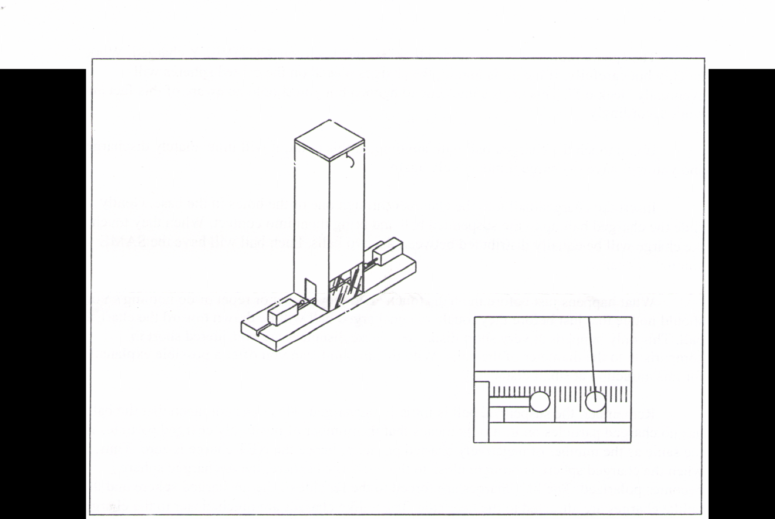**

**Figure 1**

The Coulomb’s Law Apparatus.

A mirror is fastened to the back surface of the chamber to help eliminate measurement errors due to parallax. When making measurements, always make sure the ball’s image in the mirror is completely covered by the ball itself. This insures that your measurements will be consistent.

Cover the top of the chamber with either the clear or hardboard top to help eliminate the effects of air currents and breezes.

**Procedure:**

Begin by inductively charging the sphere fastened to the guide block. Vigorously rub the vinyl strip with the wool square. You may hear the crackle of static discharges as you rub the plastic. Bring the coated sphere mounted on the guide block NEAR the charged plastic strip. DO NOT touch the plastic strip with the sphere! When the sphere is close to the plastic briefly touch the sphere with your finger. After you’ve removed your finger from the sphere, slowly pull the coated sphere away from the charged plastic strip.

**© 2006 The Science Source • P.O. Box 727 • Waldoboro, Maine 04572 • Tel. 1-800-299-5469**

**e-mail us: info@thesciencesource.com visit our web site: www.thesciencesource.com**

Q:\MANUAL FOLDER\MANUAL-PHYSICS\14XX\14480.WPD March 8, 2006

**3**

The sphere mounted on the guide block has just been INDUCTIVELY charged. Work quickly but carefully. If the air is humid, the charges placed on the coated spheres will eventually “leak off’. This takes some time to happen but you should be aware of this fact and work accordingly.

If you touch the charged ball with anything at this point, it will immediately discharge and you will have to charge it inductively again.

Insert the charged ball into the chamber through one of the holes in the base. Gently slide the charged ball up to the suspended ball and bring them into contact. When they touch, the charge will be equally distributed between the two balls. Each ball will have the SAME amount of charge.

What happens just before the balls touch? Did they attract or repel or do nothing? You should notice that just before they touch, the uncharged ball will be drawn toward the charged ball. This only happens at very short distances. These distances are considered short in comparison to the diameter of the balls. With this in mind, can you offer a possible explanation for this attraction at small distances?

Remember, the suspended ball is initially uncharged. This does not mean that the ball has no charged particles on it; it only means that the number of positively charged particles is the same as the number of negatively charged particles, hence the NET charge is zero. Thus, when the charged sphere is brought close to the uncharged sphere, the uncharged sphere becomes polarized. The like charges are forced to the far side of the uncharged sphere and the unlike charges are attracted to the near side. The unlike charges are much closer to the charged sphere than the like charges, so their attractive force is larger than the repelling force of the like charges that are further away, so the two balls are attracted. This is all an example of induction.

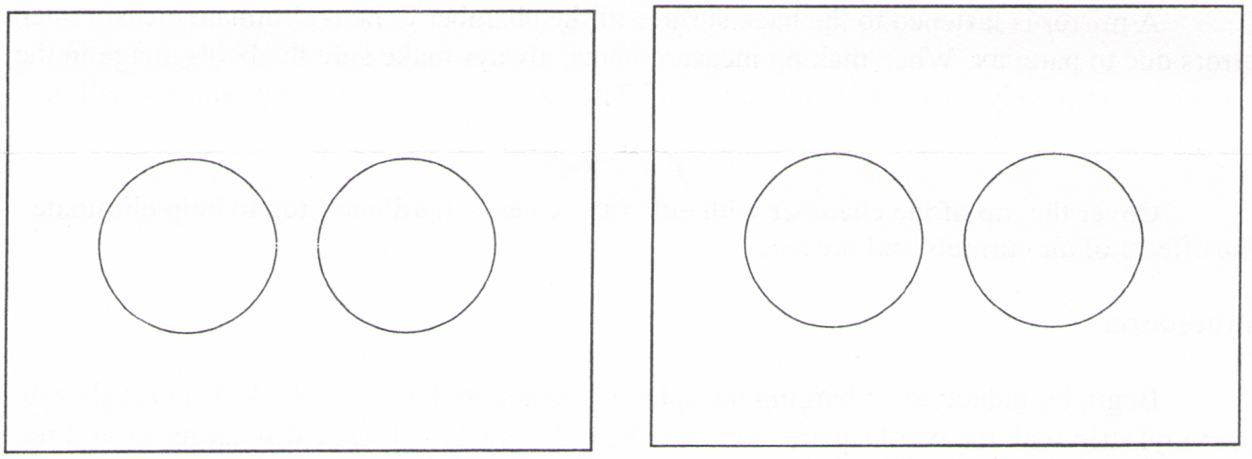

**Figure 2 Figure 3**

Balls just before contact... Balls after contact

**© 2006 The Science Source • P.O. Box 727 • Waldoboro, Maine 04572 • Tel. 1-800-299-5469**

**e-mail us: info@thesciencesource.com visit our web site: www.thesciencesource.com**

Q:\MANUAL FOLDER\MANUAL-PHYSICS\14XX\14480.WPD March 8, 2006

**4**

Once the balls have touched, the charge carried by the sphere glued to the guide block is distributed equally between the two spheres and their like charges cause them to immediately spring apart. How far can you electrically “push” the suspended ball away from center before the two balls are forced together again? What happens to the distance between the two balls as the suspended ball is pushed further and further from center?

It may be necessary to charge the two balls several times to get a sufficient repulsive force. Simply charge the ball on the guide block by induction then bring it into contact with the suspended ball. The more charge you put on the suspended ball, the further it will “run away” before you can contact it with the charged ball. It may take a little practice to get the right amount of charge for your situation. Remember, the greater the charge, the greater the displacement and the better the resolution in your measurements.

The following diagram shows a force diagram for the two balls. We will develop a formula from this diagram to express the electrostatic force between the two balls as a function of the suspended balls weight and displacement from equilibrium.

For small angles Tan() = d/L. Looking at the diagram we can see that Tan() = Fe/mg. Combining these equations results in

Fe/mg = d/L

Fe = mg \* d/L

Where:

Fe is the electrostatic repulsion between the spheres.

mg is the weight of the suspended sphere; for this experiment, mg = 6.5 x 10-4 N

d is the suspended ball’s distance from its equilibrium position (center to center).

L is the length of the suspension.

r is the separation between the two balls (center to center)

Since we are not concerned with particular units of force, we can measure the force in terms of d. Therefore we can study the dependence of Fe on r by plotting d as a function of r. Note that the weight given for the suspended sphere is based on its average mass.

Plot a graph of the force as a function of the separation of the two balls (r). What does your graph look like if you plot the force as a function of 1/r2? If the graph is linear, then it tells us that the force Fe is proportional to l/r2.

To investigate the way in which the force between the two balls depends on the charges of the balls, recharge them and position the guide block ball (A) near the suspended ball (B) so that the suspended ball is displaced a few centimeters. To change the charge on ball (B), touch (B) with an uncharged ball (C) that has been glued to an insulating rod. The charge on (B) will be equally distributed between (B) and (C) thus leaving (B) with one half of its original charge.

**© 2006 The Science Source • P.O. Box 727 • Waldoboro, Maine 04572 • Tel. 1-800-299-5469**

**e-mail us: info@thesciencesource.com visit our web site: www.thesciencesource.com**

Q:\MANUAL FOLDER\MANUAL-PHYSICS\14XX\14480.WPD March 8, 2006

**5**

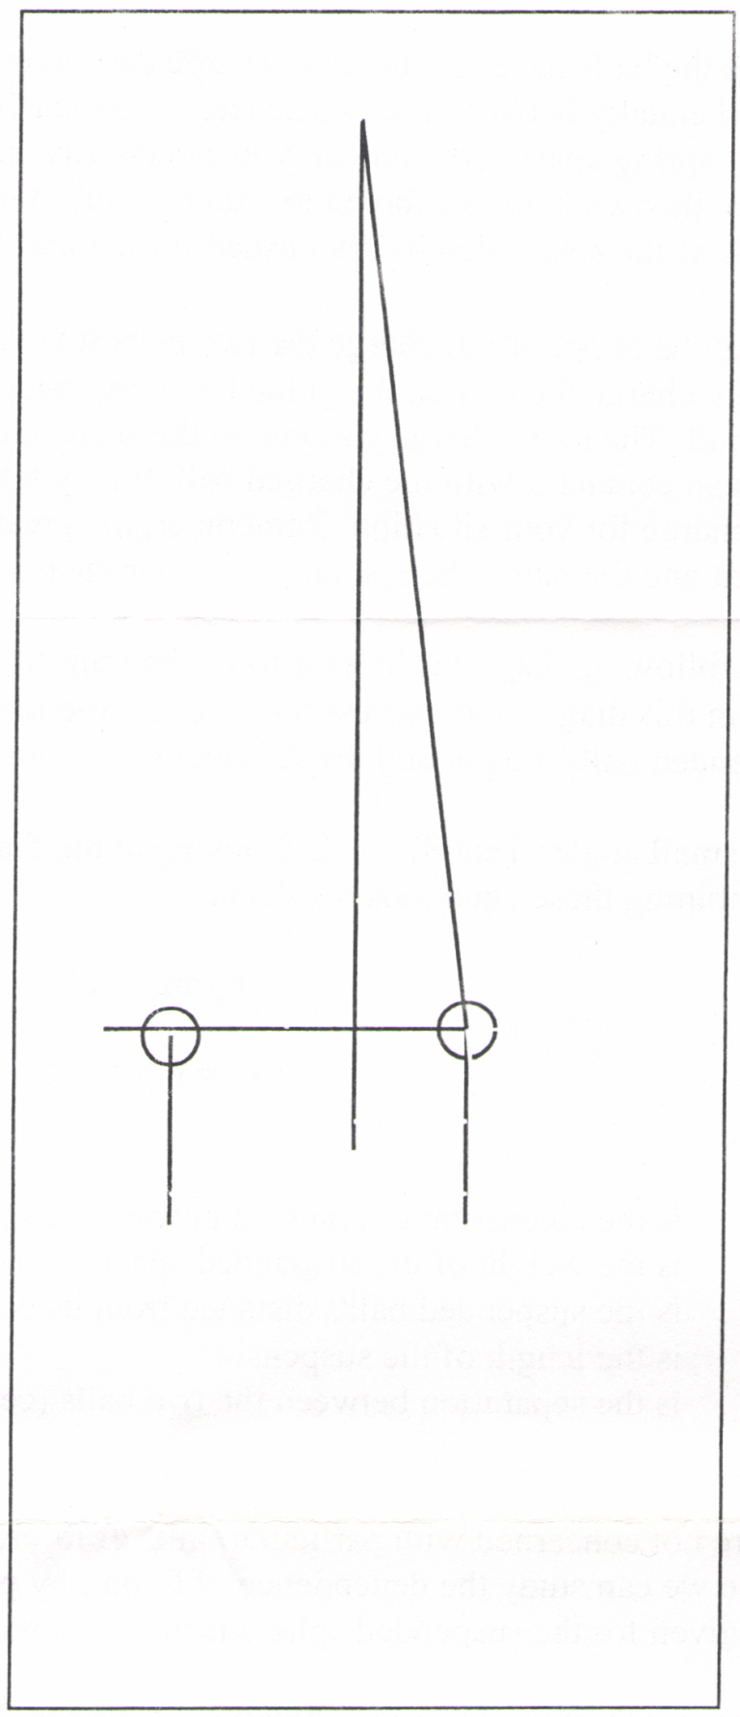Remove ball (C) and note the new distance between the guide block ball (A) and the suspended ball (B).

This process can be repeated to obtain several data points. Plot a graph of the force between the two balls as a function of the product of the charges on the two balls. How does the force depend on the product of the charges?

**Time Allocation:**

To prepare this product for an experimental trial should take less than fifteen minutes. Actual experiments will vary with needs of students and the method of instruction, but most are easily concluded within one class period.

**Feedback:**

If you have a question, a comment, or a suggestion that would improve this product, you may call our toll free number **1-800-299-5469**, or e-mail us: **info@thesciencesource.com**. Our FAX number is: **1-207-832-7281**.

Figure 5

Force diagram for the suspended ball.

**© 2006 The Science Source • P.O. Box 727 • Waldoboro, Maine 04572 • Tel. 1-800-299-5469**

**e-mail us: info@thesciencesource.com visit our web site: www.thesciencesource.com**

Q:\MANUAL FOLDER\MANUAL-PHYSICS\14XX\14480.WPD March 8, 2006

**6**