**Phys 1405**

**Conceptual Physics Workbook**

**Tyler Junior College, Spring 2015**

by Karen Williams & Jim Sizemore, Tyler Junior College

Acknowledgements: These labs have been developed over a number of years by numerous collaborators whose names have been lost and forgotten. Our thanks go to those unsung heroes who have contributed to this work. Portions of this work are used by permission and/or fair use of Doug Parsons & Gene Branum (TJC), Dr. Bob Abel (Olympic College), The Science Source, Cenco Physics, Vernier, and AAPT.

Main site: <http://iteach.org/funphysicist/> with links to this workbook. Actual addresses:

PDF version: <http://funphysicist.weebly.com/uploads/2/0/3/8/20383539/conceptual_physics_workbook.pdf> and

Word version: <http://funphysicist.weebly.com/uploads/2/0/3/8/20383539/conceptual_physics_workbook.docx>

Photo *Good Vibrations* by Thomas Alper, AAPT High School Photo Winner, West Boca Raton High School, Marc Bjorkland Teacher

|  |  |
| --- | --- |
|  | In the photo, the finger is sliding around the rim of the crystal wine glass filled with water. As the finger applies pressure as it circles the rim, the glass vibrates and the vibrating glass causes the water to vibrate. The excited water shoots out of the glass in all directions just as the photo shows. Not only does the water shoot |

out, but the glass creates a high pitched sound because of the natural resonance of the glass being hit as the glass is vibrated. The pitch of the sound can be changed by the amount of water in the glass.

[Creative Commons License](http://creativecommons.org/licenses/by-nc-sa/3.0/)This work is licensed under a [Creative Commons Attribution-NonCommercial-ShareAlike 3.0 Unported License](http://creativecommons.org/licenses/by-nc-sa/3.0/).

**Recommend Printing Instructions**

* Yes to “Front & Back (recommended)” – that is, 2 sided copies
* Collate
* Do not staple
* Do not Hole Punch
* Spiral Binding
* No to Colored Paper – plain white
* No to Color printing
* Deliver to bookstore

Special Instructions

1. **PLEASE MAKE EVERY EFFORT TO DELIVER THIS TO THE BOOKSTORE BY THE FIRST DAY OF CLASS \_\_\_\_\_\_\_\_**

2. **BINDING ON LEFT SIDE LIKE A REGULAR BOOK – NOT ON RIGHT**

3. Print in black & white

4. If possible print all copies from file-don't make Xerox & copy (due to photos/graphics not copying well).

5. **GRAY** cardstock front and back.

6. Print so odd numbered pages are on the right.

7. Deliver one copy to <your name>, <your office> (<your mailroom>)

TJC Bookstore Information

TJC Course Name: Conceptual Physics

TJC Course Number: PHYS 1405

Instructor's Name: <list names of all instructors>

Bookstore Up-Charge (if known): $5.00

**Note to Instructors:**

1. If the number of weeks in a semester is insufficient to do all the labs, then one of the first two labs (Measurements or Density and Archimedes’ Principle), or the Specific Heat lab may be omitted.
2. This lab book is designed to follow Paul Hewitt’s “Conceptual Physics Fundamentals” textbook.
3. Contact Jim Sizemore for quizzes that correspond to this lab book.
4. Instructors may also choose to require preliminary questions be turned in at the beginning of the lab. This document is a work in progress, however, and this may not be appropriate for all labs.
5. The “Momentum, Energy, and Collisions” lab it calls for repeating runs. For the sake of time these repeats may be omitted if the students have good runs.
6. Also in the “Momentum, Energy, and Collisions” the vector nature of momentum is used only once and then mostly ignored. This is intentional to determine if students accommodate this. Various hints are given, such as calling for students to record the direction of motion. There is no column for this – students must record motion from left-to-right as “+” and right-to-left as “-”. Instructors, watch out for this as students perform the experiment.
7. The “Vector Force Table” lab should not be done prior to the third week so that the topic is discussed in lecture prior to the lab.
8. The “Density and Archimedes’ Principle” lab fits with Hewitt’s Chapter 2 (atoms) or Chapter 7 (fluids).
9. The “Free Fall” lab fits with Hewitt’s Chapter 3 (constant acceleration) or Chapter 6 (gravity).

**Table of Contents**

**Lab Page**

[Scientific Method and Measurements 6](#_Toc407916068)

[Density and Archimedes’ Principle 16](#_Toc407916069)

[Density and Specific Gravity 21](#_Toc407916070)

[Graphing Displacement, Velocity, and Acceleration 23](#_Toc407916071)

[Vector Force Table 34](#_Toc407916072)

[Free Fall 41](#_Toc407916073)

[Work, Power, and Conservation of Energy 51](#_Toc407916074)

[Momentum, Energy and Collisions 59](#_Toc407916075)

[Specific Heat of Substances 67](#_Toc407916076)

[Specific heats for various substances at 20 °C 70](#_Toc407916077)

[Batteries, Bulbs, and Circuits 72](#_Toc407916078)

[Electrical & Magnetic Fields 80](#_Toc407916079)

[Measuring the Speed of Sound 91](#_Toc407916080)

[Reflection Laboratory 97](#_Toc407916081)

[Refraction Laboratory 104](#_Toc407916082)

[Spectroscopy Laboratory 115](#_Toc407916083)

[Appendix A: Lecture Activities 129](#_Toc407916084)

[Which Way Does the Moon Move? 130](#_Toc407916085)

[Project 133](#_Toc407916086)

[Planning for College 136](#_Toc407916087)

[Philosophy of Science Debate 140](#_Toc407916088)

[Mass of a penny 143](#_Toc407916089)

[How to Weigh Air 148](#_Toc407916090)

[Roadrunner 151](#_Toc407916091)

[Roadrunner Speed 154](#_Toc407916092)

[How Fast Must Supergirl Jump 157](#_Toc407916093)

[Treasure Hunt 160](#_Toc407916094)

[Supergirl's Force 163](#_Toc407916095)

[Rocket Report 166](#_Toc407916096)

[Supergirls Momentum 168](#_Toc407916097)

[Supergirls Energy 170](#_Toc407916098)

[Supergirls Power 172](#_Toc407916099)

[Rolling Races 174](#_Toc407916100)

[Moon Guns 178](#_Toc407916101)

[Torque on Yo-Yo 180](#_Toc407916102)

[Centripetal Force on Yo-Yo 182](#_Toc407916103)

[Fluids 185](#_Toc407916104)

[Yo-yo Pendulum 188](#_Toc407916105)

[Slinky Wave Conceptual 190](#_Toc407916106)

[Wave Phenomena 193](#_Toc407916107)

[Sound Resonance 197](#_Toc407916108)

[Electricity 200](#_Toc407916109)

[Series Circuits 203](#_Toc407916110)

[Parallel Circuits 208](#_Toc407916111)

[Speed of Light 213](#_Toc407916112)

[Solar Car 217](#_Toc407916113)

[Heat 220](#_Toc407916114)

[Entropy 223](#_Toc407916115)

[Electrical Energy 225](#_Toc407916116)

[Resistance 229](#_Toc407916117)

[Magnetism 234](#_Toc407916118)

[Electrical Oscillation 236](#_Toc407916119)

[AM Radio Antenna 240](#_Toc407916120)

[Optics 243](#_Toc407916121)

[Interference 245](#_Toc407916122)

[X-ray Vision 249](#_Toc407916123)

[Relativity 252](#_Toc407916124)

[Supergirl's Photons 255](#_Toc407916125)

[Sun’s Energy 258](#_Toc407916126)

[Appendix B: SOLVE Method 261](#_Toc407916127)

Profits from the sale of this lab manual will go toward student activities and professional development.

Page left intentionally blank

**Conceptual Physics Workbook**

# Scientific Method and Measurements

\_\_\_\_\_\_\_\_\_\_\_\_\_\_\_\_\_\_/\_\_\_\_\_\_\_\_\_\_\_\_\_\_\_\_\_\_/\_\_\_\_\_\_\_\_\_\_\_\_\_\_\_\_\_\_

**Names – 3 to 5 people per group,**

\_\_\_\_\_\_\_\_\_\_\_\_\_\_\_\_\_\_/\_\_\_\_\_\_\_\_\_\_\_\_\_\_\_\_\_\_**at 6 split into 2 groups**

**Class:\_\_\_\_\_\_\_\_\_\_\_\_\_\_\_\_\_\_\_Section: \_\_\_\_\_\_\_\_\_\_\_\_\_\_Date:\_\_\_\_\_\_\_\_\_\_\_\_\_\_**

**Purpose**

The purpose of this lab exercise is to 1) illustrate that we cannot rely on human intuition and perception as a reliable method of making physical measurements, 2) estimate and measure objects for length, height, depth, volume, area, mass, and density, and 3) familiarize students with the SI System of measurements and unit conversions.

**Materials and Apparatus**

Block of wood, triple beam balance, pencil, metric ruler, meter stick

**Introductory Information**

**Definitions:**

* Intuition – the ability to know without the need for critical reasoning.
* Perception – awareness that comes about through the use of senses.
* Measurement – the magnitude, dimension, quantity, or capacity referenced by a standard.
* Mass – a property of physical objects that measures the amount of matter they contain.
* Weight – a measure of the heaviness of an object taking into account the gravitational pull of the earth.
* SI – abbreviation for Système International, an international system of units of metric measure accepted and used by scientists throughout the world; also known as the “**metric system**”.
* Metric System – a decimal system of units based on the **meter** as the unit of length, the **kilogram** as the unit of mass, and the **second** as the unit of time.
* BE System – the British-English system of units; a system of units based on the **foot** as a unit of length, the **slug** as the unit of mass, and the **second** as the unit of time.
* Density – a measure of an object’s mass per unit volume. The density of an object equals its total mass divided by its total volume.
* Error – an unwanted by-product of **any measurement** that occurs because of physical limitations of any measuring device. Two methods to quantify error are: 1) percent error if a standard value for the measured quantity is known, or 2) percent difference if a standard value for the measured quantity is unknown.
* Percent Error – also known as deviation. Percent error is a measure of the accuracy of any measured value. It is easily determined by comparing the positive difference between an accepted standard value and a measured value to the accepted value itself. In mathematical terms, percent error is an expression of the amount of deviation from the accepted value, expressed as a percentage. Expressed mathematically, percent error is:
$$\% Error= \frac{\left|difference between values\right|}{accepted value}*100\%$$

* Percent Difference – a measure of the accuracy of a measured quantity that is used whenever a standard value is not known. Percent difference is the positive difference between two measurements divided by the average of the two measurements. Percent difference is expressed mathematically as:

$$\% Difference= \frac{\left|difference between values\right|}{average of values}*100\%$$

**Procedure**

**Matters of Perception**

1. A) Look at lines **A** and **B** below. Without measuring either line, estimate which line looks longer. Write your answer in the box to the right.

**A**

**B**

B) Now measure each line. Which line is actually longest? Write your answer in the box to the right.

2. A) Look at lines **a** and **b** below. Without measuring either line, estimate which line looks longest. Write your answer in the box to the right.

**a**

**b**

B) Now measure each line. Which line is actually longest? Write your answer in the box to the right.

**Making Length Measurements**

3. Obtain a wooden block from your instructor. Without actually measuring your wooden block, use only your eyes to estimate (**in centimeters**) the length, width, and height of your wooden block. (Let “length” be the longest side, “width” be the side that is in between the “length” and the “height”.) Record your length, width, and height estimates in the Estimated column of Data Table 1. Be sure to include the units of each measurement.

4. Now actually measure (**in centimeters**) the length, width, and height of the wooden block. Record your measurements in the SI column of Data Table 1. Be sure to include units.

5. Calculate and record in the right-hand-column of Data Table 1 the percent difference between your estimated and measured values for each measurement recorded in Data Table 1.

**Making Mass Measurements**

6. This time, estimate the mass (in kilograms) of the wooden block, without actually making the measurement. Record your estimated mass in Data Table 2.

7. Now actually measure the mass (in kilograms) of the wooden block. Record the mass of the wooden block in Data Table 2.

8. Calculate and record in the right-hand column of Data Table 2 the percent difference between your estimated and measured values for the mass.

**Non-Fundamental Physical Quantities**

9. Using measurements recorded in Data Table 1, calculate the area of the one largest side of your block of wood. Record your finding in Data Table 3. Be sure to record the correct unit.

10. Using measurements recorded in Data Table 1, calculate the volume of your block of wood. Record your finding in Data Table 3. Be sure to record the correct unit.

11. Now, calculate the density of your block of wood, using the mass of the block in **grams**. Record your finding, with the correct unit, in Data Table 3. If you have forgotten the definition of density, refer to the Introductory Information at the beginning of this lab exercise.

12. Once you have filled in the first column of Data Table 3, report your findings on the board for all to see. Once all of the lab groups have reported their findings, you can calculate the class averages. Record the averages in the second column of Data Table 3.

13. Using the class average values for area, volume, and density as the accepted values, calculate the percent error between your measured area, volume, and density and the accepted values. Be careful: percent error is not the same as percent difference.

14. Complete this lab by answering the questions.

**Data Tables**

|  |  |  |  |
| --- | --- | --- | --- |
| **Data Table 1 – Length Measurements** | | | |
|  | **Estimated** | **SI (Metric)** | **% Difference** |
| **Length** |  |  |  |
| **Width** |  |  |  |
| **Height** |  |  |  |

|  |  |  |  |
| --- | --- | --- | --- |
| **Data Table 2 – Mass Measurement** | | | |
|  | **Estimated** | **SI (Metric)** | **% Difference** |
| **Mass** |  |  |  |

|  |  |  |  |
| --- | --- | --- | --- |
| **Data Table 3** | | | |
|  | **Your Measurement** | **Class Average** | **% Error** |
| **Area** |  |  |  |
| **Volume** |  |  |  |
| **Density** |  |  |  |

**Questions**

1. How accurate were your perceptions and estimates in this lab? What could possibly happen if we don’t measure things but only use estimated values?
2. If a block of wood were 6 inches by 4 inches by 2 inches, what would be the block’s volume in SI units (m3)? HINT: 1 inch = 2.54 cm (Show your work!)
3. If a person weighs 150 lbs, what is their mass in kilograms? (Show your work!)
4. By what factor would the area of the largest face of your block change if the length, width, and height of the block were each doubled?
5. By what factor would the volume of your block change if the length, width, and height of the block were each doubled?
6. If the type of the wood the block were made from did not change, but the length, width, and height of the wooden block were each doubled, how would the density of the block change?
7. Using SI units and without actually making a measurement, estimate the volume of the physics lab room in which you are currently located.
8. Using SI units, measure the volume of the physics lab room in which you are currently located.
9. What is the percent difference between your estimated and measured volumes above? (Show your work!)

**Lab 1 Follow-up**

One of the main purposes of this lab was to introduce you to the metric system and unit conversions. You will be using the metric system and conversions throughout the remainder of this course, so if you are still not comfortable with this process, please review the concepts again before the next class.

Page left intentionally blank

**Conceptual Physics Workbook**

# Density and Archimedes’ Principle

\_\_\_\_\_\_\_\_\_\_\_\_\_\_\_\_\_\_/\_\_\_\_\_\_\_\_\_\_\_\_\_\_\_\_\_\_/\_\_\_\_\_\_\_\_\_\_\_\_\_\_\_\_\_\_

**Names – 3 to 5 people per group,**

\_\_\_\_\_\_\_\_\_\_\_\_\_\_\_\_\_\_/\_\_\_\_\_\_\_\_\_\_\_\_\_\_\_\_\_\_**at 6 split into 2 groups**

**Class:\_\_\_\_\_\_\_\_\_\_\_\_\_\_\_\_\_\_\_Section: \_\_\_\_\_\_\_\_\_\_\_\_\_\_Date:\_\_\_\_\_\_\_\_\_\_\_\_\_\_**

**Purpose**

The purpose of this lab is to learn how to find the density of materials, and to investigate Archimedes’ principle and the buoyant force. The procedure is outlined in very general terms below. You must use your own knowledge and skills to decide how to make many of these measurements.

1. **Materials**

|  |  |  |
| --- | --- | --- |
| 1. Wood block | 1. Metal block | 1. Graduated Cylinder |
| 1. Ruler | 1. Mass Balance | 1. Overflow Beaker |
| 1. Catch Beaker | 1. 2 N Spring Scale | 1. 5 N Spring Scale |

1. **Density**

Density is defined as the amount of mass in a unit of volume. So to calculate the densities of the materials below, we must know the mass of the material and the volume of the object. You will have a meter stick and a triple-beam balance to use in obtaining your measurements. Attach additional pages well organized to record intermediate data.

1. Find the density of the wood block.

Mass (g) \_\_\_\_\_\_\_\_\_\_\_\_\_\_\_\_\_\_ Density (g/cm3)\_\_\_\_\_\_\_\_\_\_\_\_\_\_\_\_\_

Volume (cm3) \_\_\_\_\_\_\_\_\_\_\_\_\_\_\_\_\_\_

1. Find the density of the metal block. Can you identify the metal using the chart in your book?

Mass (kg)\_\_\_\_\_\_\_\_\_\_\_\_\_\_\_\_\_\_ Density (kg/m3) \_\_\_\_\_\_\_\_\_\_\_\_\_\_\_\_

Volume (m3)\_\_\_\_\_\_\_\_\_\_\_\_\_\_\_\_\_\_ Type of metal? \_\_\_\_\_\_\_\_\_\_\_\_\_\_\_\_\_

1. Find the density of 50 ml of water in the graduated cylinder. Compare it to the accepted value (you can find it in your book) by calculating the percent difference. (1 ml = 1 cm3 = 0.000001 m3)

Mass \_\_\_\_\_\_\_\_\_\_\_\_\_\_\_\_\_\_\_\_\_\_ Measured Density \_\_\_\_\_\_\_\_\_\_\_\_\_\_\_\_\_\_

Volume \_\_\_\_\_\_\_\_\_\_\_\_\_\_\_\_\_\_\_\_ Accepted Density \_\_\_\_\_\_\_\_\_\_\_\_\_\_\_\_\_\_

Percent error \_\_\_\_\_\_\_\_\_\_\_\_\_\_

1. Describe step-by-step the procedure that you used to find the density of the wood block and the metal block.
2. Describe step-by-step the procedure that you used to find the density of the water.
3. List some possible reasons for the error that you obtained in your measurement of the density of the water.
4. **Archimedes’ Principle and the Buoyant Force**

Archimedes’ principle states that *the buoyant force on an object immersed in a fluid is equal to the weight of the fluid that the object displaces*.

1. *Procudure 1:* Using the small beakers to catch the water that is displaced when the blocks are lowered into the cans, and with careful mass measurements, the weight of the water can be determined, thus demonstrating Archimedes’ principle.
2. *Procudure 2:* Another way to measure the buoyant force on the object is to compare the weight of the object dry to the weight of the object when it is submerged (*but not touching the sides or bottom*). In other words,

FB = Wdry – Wwet

It’s easy to measure force with a spring scale, but is difficult with a mass balance since the object must be suspended beneath it as shown:

mass balance

Forces acting

on sample

Wwet

FB

Wdry

is equal and opposite to

1. *Procedure 3:* Here’s how to get around the experimental difficulties of *Procedure 2*. Fill a beaker partly full of water and measure its mass. Call this mbw for mass of only the *beaker* and *water* and calculate the force the scale is exerting upward, Wbw = mbwg. Then dip the unknown in and measure the mass. Call this min for mass with unknown *in* the beaker and water and calculate the force the scale is exerting upward, Win = ming. See the following figure to understand the force diagrams:

Forces acting on beaker

–

by Newton’s 3rd Law, if the water is pushing up and the sample, the sample must push down with equal and opposite force.

FB

mass balance

Wbw

Forces acting

on sample

Wwet

FB

Wdry

⇒

Win

Therefore, here is another way to find FB:

FB = Win – Wbw.

**Observations:** Note: 1 ml = 1 cm3 = .000001 m3

Volume of metal block: \_\_\_\_\_\_\_\_m×\_\_\_\_\_\_\_\_\_m× \_\_\_\_\_\_\_\_\_m = \_\_\_\_\_\_\_\_\_\_\_\_\_\_m3

Do *Procedure 2* or *Procedure 3* – not both

*Procedure 2 Data*:

Mass of dry metal block: \_\_\_\_\_\_\_\_\_\_\_ kg Weight of dry metal block: \_\_\_\_\_\_\_\_\_\_\_ N

(not necessary if using spring scale)

Apparent mass of submerged block: \_\_\_\_\_\_ kg Weight of submerged block: \_\_\_\_\_\_ N

(not necessary if using spring scale)

*Procedure 3 Data:*

Mass of beaker and water: \_\_\_\_\_\_ kg Weight of beaker and water: \_\_\_\_\_\_ N

Mass of beaker and water Weight of beaker and water

with sample in water: \_\_\_\_\_\_\_\_\_\_ kg with sample in water: \_\_\_\_\_\_\_\_\_\_\_ N

*Procedure 1 Data:* Mass of dry overflow beaker: \_\_\_\_\_\_\_\_\_\_\_ kg

Mass of overflow beaker and displaced water: \_\_\_\_\_\_\_\_\_\_\_\_\_\_ kg

Mass of displaced water: \_\_\_\_\_\_\_\_\_\_\_\_\_ kg

*Calculations of Buoyant Force:*

1) Weight of displaced water from *Procedure 1*: \_\_\_\_\_\_\_\_\_\_\_\_\_\_\_\_ N

2) Buoyant force from *Procedure 2* or *Procedure 3*: \_\_\_\_\_\_\_\_\_\_\_\_\_\_\_\_\_\_\_\_ N

1. Compare the weight of the displaced water, and the buoyant force on the block. How are these quantities related?
2. Calculate the percent difference for your measurements of buoyant force above. List some of the possible reasons for this error.



1. Was the purpose of this lab accomplished? WHY OR WHY NOT?

|  |  |  |  |
| --- | --- | --- | --- |
| ****Density and Specific Gravity**** | <http://www.funphysicist.net/help/density.htm> | Now=9/5/2012 | Mod=09/05/2012 |

Selected Table of Densities below -- [Click here for Complete Table of Densities](http://www.periodictable.com/Properties/A/Density.html)

|  |  |  |  |  |  |  |  |  |  |  |  |  |  |
| --- | --- | --- | --- | --- | --- | --- | --- | --- | --- | --- | --- | --- | --- |
| Solids | S.G. (Specific Gravity - no units) | |  |  |  |  | | --- | --- | --- | --- | | ρ | ( | gm | ) | | cm3 | | |  |  |  |  | | --- | --- | --- | --- | | ρ | ( | kg | ) | | m3 | |
| Gold (Au) | 19.3 | 19.3 | 19,300 |
| Lead (Pb) | 11.3 | 11.3 | 11,300 |
| Silver (Ag) | 10.5 | 10.5 | 10,500 |
| Copper (Cu) | 8.9 | 8.9 | 8900 |
| Brass (average) | 8.6 | 8.6 | 8600 |
| Steel (Fe) | 7.8 | 7.8 | 7800 |
| Tin (Sn) | 7.29 | 7.29 | 7290 |
| Zinc (Zn) | 7.14 | 7.14 | 7140 |
| Aluminum (Al) | 2.7 | 2.7 | 2700 |
| Balsa Wood | 0.3 | 0.3 | 300 |
| Oak | 0.8 | 0.8 | 800 |
| Earth Average | [5.52](http://hypertextbook.com/facts/2000/KatherineMalfucci.shtml) | [5.52](http://hypertextbook.com/facts/2000/KatherineMalfucci.shtml) | 5520 |
| Liquids & Gases |  |  |  |
| Mercury (Hg) | 13.6 | 13.6 | 13,600 |
| Water | 1.0 | 1.0 | 1000 |
| Oil | 0.9 | 0.9 | 900 |
| Alcohol | 0.8 | 0.8 | 800 |
| Antifreeze | 1.125 (32°F) 1.098 (77°F) | 1.125 (32°F) 1.098 (77°F) | 1125 (32°F) 1098 (77°F) |
| Air | 1.29 \* 10-3 | 1.29 \* 10-3 | 1.29 |
| Hydrogen | 9.0 \* 10-5 | 9.0 \* 10-5 | 0.09 |
| Oxygen | 1.43 \* 10-3 | 1.43 \* 10-3 | 1.43 |

Page left intentionally blank

**Conceptual Physics Workbook**

# Graphing Displacement, Velocity, and Acceleration

\_\_\_\_\_\_\_\_\_\_\_\_\_\_\_\_\_\_/\_\_\_\_\_\_\_\_\_\_\_\_\_\_\_\_\_\_/\_\_\_\_\_\_\_\_\_\_\_\_\_\_\_\_\_\_

**Names – 3 to 5 people per group,**

\_\_\_\_\_\_\_\_\_\_\_\_\_\_\_\_\_\_/\_\_\_\_\_\_\_\_\_\_\_\_\_\_\_\_\_\_**at 6 split into 2 groups**

**Class:\_\_\_\_\_\_\_\_\_\_\_\_\_\_\_\_\_\_\_Section: \_\_\_\_\_\_\_\_\_\_\_\_\_\_Date:\_\_\_\_\_\_\_\_\_\_\_\_\_\_**

One of the most effective methods of describing motion is to plot graphs of distance, velocity, and acceleration *vs*. time. From such a graphical representation, it is possible to determine in what direction an object is going, how fast it is moving, how far it traveled, and whether it is speeding up or slowing down. In this experiment, you will use a Motion Detector to determine this information by plotting a real time graph of *your* motion as you move across the classroom.

The Motion Detector measures the time it takes for a high frequency sound pulse to travel from the detector to an object and back. Using this round-trip time and the speed of sound, you can determine the distance to the object; that is, its position. Logger *Pro* will perform this calculation for you. It can then use the change in position to calculate the object’s velocity and acceleration. All of this information can be displayed either as a table or a graph. A qualitative analysis of the graphs of your motion will help you develop an understanding of the concepts of kinematics.



objectives

* Analyze the motion of a student walking across the room.
* Predict, sketch, and test distance *vs*. time kinematics graphs.
* Predict, sketch, and test velocity *vs*. time kinematics graphs.

Materials

|  |  |
| --- | --- |
| Power Macintosh or Windows PC | Vernier Motion Detector |
| LabPro or Universal Lab Interface | meter stick |
| Logger *Pro* | masking tape |

Pre-lab Assignment

1. **Make distance vs. time predictions**. Use a coordinate system with the origin at far left and positive distances increasing to the right. Sketch the distance *vs*. time graph for each of the following situations. You may draw all four graphs on a single sheet of graph paper.

* An object at rest
* An object moving in the positive direction with a constant speed
* An object moving in the negative direction with a constant speed
* An object that is accelerating in the positive direction, starting from rest

1. **Make velocity vs. time predictions**. Sketch the velocity *vs*. time graph for each of the situations described above. Start with a clean sheet, but you may still draw all four of these graphs on a single sheet of graph paper.

Procedure

Part l Preliminary Experiments

1. Connect the Motion Detector to DIG/SONIC 2 of the LabPro or PORT 2 of the Universal Lab Interface. (Note that the second input is used in both cases!)
2. Place the Motion Detector so that it points toward an open space at least 4m long. Use short strips of masking tape on the floor to mark the 1m, 2m, 3m, and 4m distances from the Motion Detector.
3. (Optional – often it works better to just plug it in and turn it on). Open the Experiment 1 folder from *Physics with Computers*. Then open the experiment file Exp 01a Distance Graph. One graph will appear on the screen. The vertical axis has distance scaled from 0 to 5 meters. The horizontal axis has time scaled from 0 to 10 seconds.
4. Using Logger *Pro*, produce a graph of your motion when you walk away from the detector with constant velocity. To do this, stand about 1m from the Motion Detector and have your lab partner click . Walk slowly away from the Motion Detector when you hear it begin to click. This will be easiest if the computer screen is turned so the walker can see it.
5. Predict what the distance *vs.* time graph will look like if you walk faster. Check your prediction with the Motion Detector.
6. Quickly experiment by trying to match some of the shape of the distance *vs*. time graphs that you sketched in the Preliminary Questions section by walking in front of the Motion Detector.

Part Il Distance *vs*. Time Graph Matching

1. Open the experiment file Exp 01b Distance Match One. The distance *vs*. time graph shown below will appear.

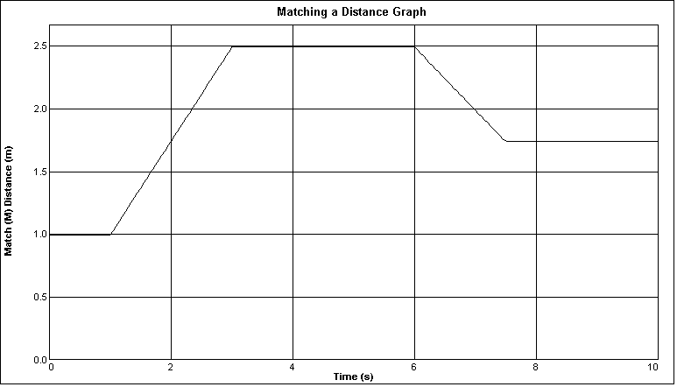

1. Describe how you would walk to produce this target graph.
2. To test your prediction, choose a starting position and stand at that point. Start data collection by clicking . When you hear the Motion Detector begin to click, walk in such a way that the graph of your motion matches the target graph on the computer screen. If you were not successful, repeat the process until your motion closely matches the graph on the screen. If a printer is attached, print the graph with your best attempt. ***If a printer is not attached, then sketch your best attempt on the figure above.***
3. Now open the experiment file Exp 01c Distance Match Two. A new graph will appear.

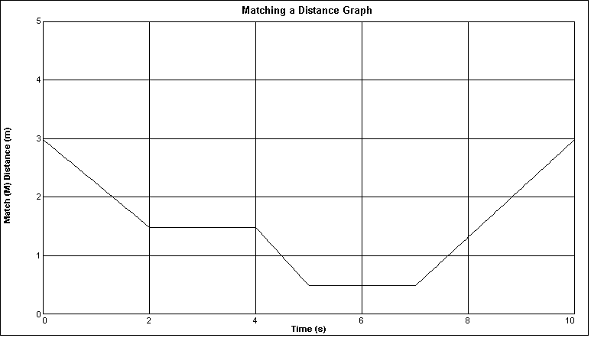

1. Describe how you would walk to produce this target graph.
2. To test your prediction, choose a starting position and stand at that point. Start data collection by clicking . When you hear the Motion Detector begin to click, walk in such a way that the graph of your motion matches the target graph on the computer screen. If you were not successful, repeat the process until your motion closely matches the graph on the screen. If a printer is attached, print the graph with your best attempt***. If a printer is not attached, then sketch your best attempt on the figure above.***
3. Answer the Analysis questions for Part II (three pages more from this page) before proceeding to Part III.

Part IIl Velocity *vs*. Time Graph Matching

1. Open the experiment file Exp 01d Velocity Match One. You will see the following velocity vs. time graph.

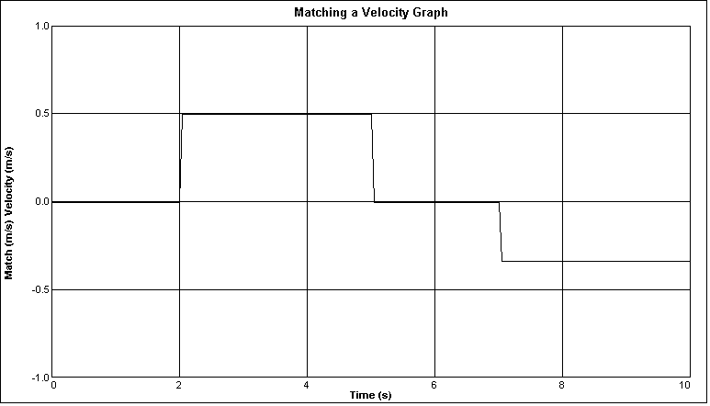

1. Describe how you would walk to produce this target graph.
2. To test your prediction, choose a starting position and stand at that point. Start Logger Pro by clicking . When you hear the Motion Detector begin to click, walk in such a way that the graph of your motion matches the target graph on the screen. It will be more difficult to match the velocity graph than it was for the distance graph. If a printer is attached, print the graph with your best attempt. ***If a printer is not attached, then sketch your best attempt on the figure above.***
3. Open the experiment file Exp 01e Velocity Match Two. You will see the following velocity vs. time graph.

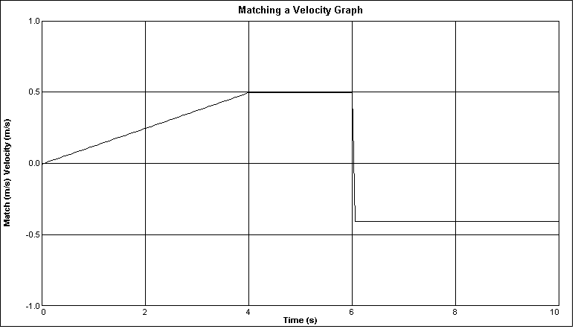

1. Describe how you would walk to produce this target graph.
2. To test your prediction, choose a starting position and stand at that point. Start Logger Pro by clicking . When you hear the Motion Detector begin to click, walk in such a way that the graph of your motion matches the target graph on the screen. It will be more difficult to match the velocity graph than it was for the distance graph. If a printer is attached, print the graph with your best attempt***. If a printer is not attached, then sketch your best attempt on the figure above.***
3. Remove the masking tape strips from the floor and answer the analysis questions.

Analysis – Part II Distance *vs*. Time Graph Matching

1. Explain the significance of the slope of a distance *vs*. time graph. Include a discussion of positive and negative slope.
2. What type of motion is occurring when the slope of a distance *vs*. time graph is zero?
3. What type of motion is occurring when the slope of a distance *vs*. time graph is constant?
4. What type of motion is occurring when the slope of a distance *vs*. time graph is changing? Test your answer to this question using the Motion Detector.

Part III Velocity *vs*. Time Graph Matching

1. What does the area under a velocity vs. time graph represent? Test your answer to this question using the Motion Detector.
2. What type of motion is occurring when the slope of a velocity vs. time graph is zero?
3. What type of motion is occurring when the slope of a velocity vs. time graph is not zero? Test your answer using the Motion Detector.

Page left intentionally blank

**Conceptual Physics Workbook**

# Vector Force Table

\_\_\_\_\_\_\_\_\_\_\_\_\_\_\_\_\_\_/\_\_\_\_\_\_\_\_\_\_\_\_\_\_\_\_\_\_/\_\_\_\_\_\_\_\_\_\_\_\_\_\_\_\_\_\_

**Names – 3 to 5 people per group,**

\_\_\_\_\_\_\_\_\_\_\_\_\_\_\_\_\_\_/\_\_\_\_\_\_\_\_\_\_\_\_\_\_\_\_\_\_**at 6 split into 2 groups**

**Class:\_\_\_\_\_\_\_\_\_\_\_\_\_\_\_\_\_\_\_Section: \_\_\_\_\_\_\_\_\_\_\_\_\_\_Date:\_\_\_\_\_\_\_\_\_\_\_\_\_\_**

**Purpose:** To determine whether forces truly behave as vectors.

**Materials:**

* Force Table
* Packet with center ring, strings, pulleys, mass hangers, and center post
* Mass Set (be sure to return mass set as you received it)
* Extra Masses (be sure to return masses to same place that you took them from)

**Definitions:**

Force Table: an apparatus used to measure and test vector quantities

Resultant: the vector sum of two or more vectors.

Equilibrant: a vector that is the same magnitude but in the opposite direction of the resultant. The equilibrant will equalize the forces so the net force is zero.

Parallelogram Method: a geometric method of calculating the resultant of two vectors. It requires that the vectors be drawn to scale. The resultant is then determined by completing a parallelogram and drawing the resultant as a diagonal of the parallelogram.

Tail-to-tip Method a second geometric method of calculating the resultant of two vectors. The first vector is drawn to scale from the origin. The vector to be added is drawn to scale starting from the tip of the first vector. The resultant is the vector from the tail of the first to the tip of the second vector.

Vector: a physical quantity that possesses both magnitude and direction.

**Procedure:**

1. For this experiment, the weight of a masses pulling on the center ring of the Force Table will be considered a force vector. The hanging masses will pull against the center ring, creating a net force and causing the center ring to move to one side. You can re-center the ring by equalizing the forces. In other words, the ring can be re-centered (and the net force acting on the ring will be zero) if the forces are balanced. The equilibrant is a vector that will be used to balance the forces.
2. Below you are given 2 vector problems. Before using the force table, convert grams to kg, calculate the weight (force in N) produced by the masses, and draw each force vector ***to scale*** (a scale of 1 cm to 1 N is recommended) on a piece of graph paper ***using a ruler and a protractor***. Use the ruler to measure the magnitude of each vector and scale it so it will fit on a sheet of paper. (HINT: It is best to draw an x-y coordinate system on a sheet of graph paper and make the center of the sheet the origin for both x and y.) Use the protractor to measure the angle of each vector on your sheet. Let the positive x-axis be 0°, and measure the angles counter-clockwise from the positive x-axis. Be sure to use a separate sheet of graph paper for each problem.
3. After having drawn the given vectors for a problem, use the parallelogram or tail-to-tip method to determine the magnitude and direction of the **resultant vector**. Measure it using the same scale and protractor, then draw and label it on your graph. Record your results for the resultant magnitude and direction in Data Table 1.
4. The **equilibrant** is a vector that has the same magnitude as the resultant but points in the opposite direction (180° away from the resultant). Measure it using the same scale and protractor, then draw and label it on your graph. Record your results for the equilibrant magnitude and direction in Data Table 1.
5. Now that you have predicted the value of the equilibrant in the step above, test whether your drawing accurately predicts the location of the equilibrant by hanging a mass at the proper angle on the Force Table. **Do NOT overlook the mass of the hangers.** The equilibrant should be the last vector you add to the force table. If your prediction was perfect, then the center ring should return to the center position when the equilibrant is added. If the center ring does not return to the center position, then by trial and error, determine what combination of equilibrant mass and angle will return the ring to the center. Record your experimental values for equilibrant magnitude and angle in Data Table 2.
6. Complete this exercise by answering the analysis questions.

**Problems:**

1. 550 gm at 0°, 350 gm at 90°
2. 450 gm at 0°, 650 gm at 140°

**Data Table 1: Predicted Resultant & Equilibrant**

|  |  |  |  |  |
| --- | --- | --- | --- | --- |
| Problem  Number | Resultant | | Equilibrant | |
| Magnitude (N) | Direction (angle) | Magnitude (N) | Direction (angle) |
| 1 |  |  |  |  |
| 2 |  |  |  |  |
| 3 |  |  |  |  |

**Data Table 2: Experimental Equilibrant**

|  |  |  |
| --- | --- | --- |
| Problem  Number | Equilibrant | |
| Magnitude (N) | Direction |
| 1 |  |  |
| 2 |  |  |
| 3 |  |  |

**Analysis Questions: Use complete sentences!**

1. Explain the relationship between the resultant force and the equilibrant force.
2. Did your experimental results match your predicted/calculated values? By how much were they different? Compare your calculated and experimental equilibrant forces by calculating a percent difference. (Show your work!) Is this a reasonable result?
$$\% Difference= \frac{\left|difference between values\right|}{average of values}*100\%$$

3. Can you think of reasons why experimental results might not match predicted/calculated values for this experiment? Name several reasons.
4. What is your conclusion? Do forces behave as vectors? (Remember – what makes a quantity a vector?) Explain your reasoning.

|  |  |  |  |  |  |  |  |  |  |  |  |  |  |  |  |  |  |  |  |  |  |  |  |  |  |  |  |  |  |  |
| --- | --- | --- | --- | --- | --- | --- | --- | --- | --- | --- | --- | --- | --- | --- | --- | --- | --- | --- | --- | --- | --- | --- | --- | --- | --- | --- | --- | --- | --- | --- |
|  |  |  |  |  |  |  |  |  |  |  |  |  |  |  |  |  |  |  |  |  |  |  |  |  |  |  |  |  |  |  |
|  |  |  |  |  |  |  |  |  |  |  |  |  |  |  |  |  |  |  |  |  |  |  |  |  |  |  |  |  |  |  |
|  |  |  |  |  |  |  |  |  |  |  |  |  |  |  |  |  |  |  |  |  |  |  |  |  |  |  |  |  |  |  |
|  |  |  |  |  |  |  |  |  |  |  |  |  |  |  |  |  |  |  |  |  |  |  |  |  |  |  |  |  |  |  |
|  |  |  |  |  |  |  |  |  |  |  |  |  |  |  |  |  |  |  |  |  |  |  |  |  |  |  |  |  |  |  |
|  |  |  |  |  |  |  |  |  |  |  |  |  |  |  |  |  |  |  |  |  |  |  |  |  |  |  |  |  |  |  |
|  |  |  |  |  |  |  |  |  |  |  |  |  |  |  |  |  |  |  |  |  |  |  |  |  |  |  |  |  |  |  |
|  |  |  |  |  |  |  |  |  |  |  |  |  |  |  |  |  |  |  |  |  |  |  |  |  |  |  |  |  |  |  |
|  |  |  |  |  |  |  |  |  |  |  |  |  |  |  |  |  |  |  |  |  |  |  |  |  |  |  |  |  |  |  |
|  |  |  |  |  |  |  |  |  |  |  |  |  |  |  |  |  |  |  |  |  |  |  |  |  |  |  |  |  |  |  |
|  |  |  |  |  |  |  |  |  |  |  |  |  |  |  |  |  |  |  |  |  |  |  |  |  |  |  |  |  |  |  |
|  |  |  |  |  |  |  |  |  |  |  |  |  |  |  |  |  |  |  |  |  |  |  |  |  |  |  |  |  |  |  |
|  |  |  |  |  |  |  |  |  |  |  |  |  |  |  |  |  |  |  |  |  |  |  |  |  |  |  |  |  |  |  |
|  |  |  |  |  |  |  |  |  |  |  |  |  |  |  |  |  |  |  |  |  |  |  |  |  |  |  |  |  |  |  |
|  |  |  |  |  |  |  |  |  |  |  |  |  |  |  |  |  |  |  |  |  |  |  |  |  |  |  |  |  |  |  |
|  |  |  |  |  |  |  |  |  |  |  |  |  |  |  |  |  |  |  |  |  |  |  |  |  |  |  |  |  |  |  |
|  |  |  |  |  |  |  |  |  |  |  |  |  |  |  |  |  |  |  |  |  |  |  |  |  |  |  |  |  |  |  |
|  |  |  |  |  |  |  |  |  |  |  |  |  |  |  |  |  |  |  |  |  |  |  |  |  |  |  |  |  |  |  |
|  |  |  |  |  |  |  |  |  |  |  |  |  |  |  |  |  |  |  |  |  |  |  |  |  |  |  |  |  |  |  |
|  |  |  |  |  |  |  |  |  |  |  |  |  |  |  |  |  |  |  |  |  |  |  |  |  |  |  |  |  |  |  |
|  |  |  |  |  |  |  |  |  |  |  |  |  |  |  |  |  |  |  |  |  |  |  |  |  |  |  |  |  |  |  |
|  |  |  |  |  |  |  |  |  |  |  |  |  |  |  |  |  |  |  |  |  |  |  |  |  |  |  |  |  |  |  |
|  |  |  |  |  |  |  |  |  |  |  |  |  |  |  |  |  |  |  |  |  |  |  |  |  |  |  |  |  |  |  |
|  |  |  |  |  |  |  |  |  |  |  |  |  |  |  |  |  |  |  |  |  |  |  |  |  |  |  |  |  |  |  |
|  |  |  |  |  |  |  |  |  |  |  |  |  |  |  |  |  |  |  |  |  |  |  |  |  |  |  |  |  |  |  |
|  |  |  |  |  |  |  |  |  |  |  |  |  |  |  |  |  |  |  |  |  |  |  |  |  |  |  |  |  |  |  |
|  |  |  |  |  |  |  |  |  |  |  |  |  |  |  |  |  |  |  |  |  |  |  |  |  |  |  |  |  |  |  |
|  |  |  |  |  |  |  |  |  |  |  |  |  |  |  |  |  |  |  |  |  |  |  |  |  |  |  |  |  |  |  |
|  |  |  |  |  |  |  |  |  |  |  |  |  |  |  |  |  |  |  |  |  |  |  |  |  |  |  |  |  |  |  |
|  |  |  |  |  |  |  |  |  |  |  |  |  |  |  |  |  |  |  |  |  |  |  |  |  |  |  |  |  |  |  |
|  |  |  |  |  |  |  |  |  |  |  |  |  |  |  |  |  |  |  |  |  |  |  |  |  |  |  |  |  |  |  |
|  |  |  |  |  |  |  |  |  |  |  |  |  |  |  |  |  |  |  |  |  |  |  |  |  |  |  |  |  |  |  |
|  |  |  |  |  |  |  |  |  |  |  |  |  |  |  |  |  |  |  |  |  |  |  |  |  |  |  |  |  |  |  |
|  |  |  |  |  |  |  |  |  |  |  |  |  |  |  |  |  |  |  |  |  |  |  |  |  |  |  |  |  |  |  |
|  |  |  |  |  |  |  |  |  |  |  |  |  |  |  |  |  |  |  |  |  |  |  |  |  |  |  |  |  |  |  |
|  |  |  |  |  |  |  |  |  |  |  |  |  |  |  |  |  |  |  |  |  |  |  |  |  |  |  |  |  |  |  |
|  |  |  |  |  |  |  |  |  |  |  |  |  |  |  |  |  |  |  |  |  |  |  |  |  |  |  |  |  |  |  |
|  |  |  |  |  |  |  |  |  |  |  |  |  |  |  |  |  |  |  |  |  |  |  |  |  |  |  |  |  |  |  |
|  |  |  |  |  |  |  |  |  |  |  |  |  |  |  |  |  |  |  |  |  |  |  |  |  |  |  |  |  |  |  |
|  |  |  |  |  |  |  |  |  |  |  |  |  |  |  |  |  |  |  |  |  |  |  |  |  |  |  |  |  |  |  |
|  |  |  |  |  |  |  |  |  |  |  |  |  |  |  |  |  |  |  |  |  |  |  |  |  |  |  |  |  |  |  |
|  |  |  |  |  |  |  |  |  |  |  |  |  |  |  |  |  |  |  |  |  |  |  |  |  |  |  |  |  |  |  |
|  |  |  |  |  |  |  |  |  |  |  |  |  |  |  |  |  |  |  |  |  |  |  |  |  |  |  |  |  |  |  |
|  |  |  |  |  |  |  |  |  |  |  |  |  |  |  |  |  |  |  |  |  |  |  |  |  |  |  |  |  |  |  |
|  |  |  |  |  |  |  |  |  |  |  |  |  |  |  |  |  |  |  |  |  |  |  |  |  |  |  |  |  |  |  |
|  |  |  |  |  |  |  |  |  |  |  |  |  |  |  |  |  |  |  |  |  |  |  |  |  |  |  |  |  |  |  |
|  |  |  |  |  |  |  |  |  |  |  |  |  |  |  |  |  |  |  |  |  |  |  |  |  |  |  |  |  |  |  |
|  |  |  |  |  |  |  |  |  |  |  |  |  |  |  |  |  |  |  |  |  |  |  |  |  |  |  |  |  |  |  |

|  |  |  |  |  |  |  |  |  |  |  |  |  |  |  |  |  |  |  |  |  |  |  |  |  |  |  |  |  |  |  |
| --- | --- | --- | --- | --- | --- | --- | --- | --- | --- | --- | --- | --- | --- | --- | --- | --- | --- | --- | --- | --- | --- | --- | --- | --- | --- | --- | --- | --- | --- | --- |
|  |  |  |  |  |  |  |  |  |  |  |  |  |  |  |  |  |  |  |  |  |  |  |  |  |  |  |  |  |  |  |
|  |  |  |  |  |  |  |  |  |  |  |  |  |  |  |  |  |  |  |  |  |  |  |  |  |  |  |  |  |  |  |
|  |  |  |  |  |  |  |  |  |  |  |  |  |  |  |  |  |  |  |  |  |  |  |  |  |  |  |  |  |  |  |
|  |  |  |  |  |  |  |  |  |  |  |  |  |  |  |  |  |  |  |  |  |  |  |  |  |  |  |  |  |  |  |
|  |  |  |  |  |  |  |  |  |  |  |  |  |  |  |  |  |  |  |  |  |  |  |  |  |  |  |  |  |  |  |
|  |  |  |  |  |  |  |  |  |  |  |  |  |  |  |  |  |  |  |  |  |  |  |  |  |  |  |  |  |  |  |
|  |  |  |  |  |  |  |  |  |  |  |  |  |  |  |  |  |  |  |  |  |  |  |  |  |  |  |  |  |  |  |
|  |  |  |  |  |  |  |  |  |  |  |  |  |  |  |  |  |  |  |  |  |  |  |  |  |  |  |  |  |  |  |
|  |  |  |  |  |  |  |  |  |  |  |  |  |  |  |  |  |  |  |  |  |  |  |  |  |  |  |  |  |  |  |
|  |  |  |  |  |  |  |  |  |  |  |  |  |  |  |  |  |  |  |  |  |  |  |  |  |  |  |  |  |  |  |
|  |  |  |  |  |  |  |  |  |  |  |  |  |  |  |  |  |  |  |  |  |  |  |  |  |  |  |  |  |  |  |
|  |  |  |  |  |  |  |  |  |  |  |  |  |  |  |  |  |  |  |  |  |  |  |  |  |  |  |  |  |  |  |
|  |  |  |  |  |  |  |  |  |  |  |  |  |  |  |  |  |  |  |  |  |  |  |  |  |  |  |  |  |  |  |
|  |  |  |  |  |  |  |  |  |  |  |  |  |  |  |  |  |  |  |  |  |  |  |  |  |  |  |  |  |  |  |
|  |  |  |  |  |  |  |  |  |  |  |  |  |  |  |  |  |  |  |  |  |  |  |  |  |  |  |  |  |  |  |
|  |  |  |  |  |  |  |  |  |  |  |  |  |  |  |  |  |  |  |  |  |  |  |  |  |  |  |  |  |  |  |
|  |  |  |  |  |  |  |  |  |  |  |  |  |  |  |  |  |  |  |  |  |  |  |  |  |  |  |  |  |  |  |
|  |  |  |  |  |  |  |  |  |  |  |  |  |  |  |  |  |  |  |  |  |  |  |  |  |  |  |  |  |  |  |
|  |  |  |  |  |  |  |  |  |  |  |  |  |  |  |  |  |  |  |  |  |  |  |  |  |  |  |  |  |  |  |
|  |  |  |  |  |  |  |  |  |  |  |  |  |  |  |  |  |  |  |  |  |  |  |  |  |  |  |  |  |  |  |
|  |  |  |  |  |  |  |  |  |  |  |  |  |  |  |  |  |  |  |  |  |  |  |  |  |  |  |  |  |  |  |
|  |  |  |  |  |  |  |  |  |  |  |  |  |  |  |  |  |  |  |  |  |  |  |  |  |  |  |  |  |  |  |
|  |  |  |  |  |  |  |  |  |  |  |  |  |  |  |  |  |  |  |  |  |  |  |  |  |  |  |  |  |  |  |
|  |  |  |  |  |  |  |  |  |  |  |  |  |  |  |  |  |  |  |  |  |  |  |  |  |  |  |  |  |  |  |
|  |  |  |  |  |  |  |  |  |  |  |  |  |  |  |  |  |  |  |  |  |  |  |  |  |  |  |  |  |  |  |
|  |  |  |  |  |  |  |  |  |  |  |  |  |  |  |  |  |  |  |  |  |  |  |  |  |  |  |  |  |  |  |
|  |  |  |  |  |  |  |  |  |  |  |  |  |  |  |  |  |  |  |  |  |  |  |  |  |  |  |  |  |  |  |
|  |  |  |  |  |  |  |  |  |  |  |  |  |  |  |  |  |  |  |  |  |  |  |  |  |  |  |  |  |  |  |
|  |  |  |  |  |  |  |  |  |  |  |  |  |  |  |  |  |  |  |  |  |  |  |  |  |  |  |  |  |  |  |
|  |  |  |  |  |  |  |  |  |  |  |  |  |  |  |  |  |  |  |  |  |  |  |  |  |  |  |  |  |  |  |
|  |  |  |  |  |  |  |  |  |  |  |  |  |  |  |  |  |  |  |  |  |  |  |  |  |  |  |  |  |  |  |
|  |  |  |  |  |  |  |  |  |  |  |  |  |  |  |  |  |  |  |  |  |  |  |  |  |  |  |  |  |  |  |
|  |  |  |  |  |  |  |  |  |  |  |  |  |  |  |  |  |  |  |  |  |  |  |  |  |  |  |  |  |  |  |
|  |  |  |  |  |  |  |  |  |  |  |  |  |  |  |  |  |  |  |  |  |  |  |  |  |  |  |  |  |  |  |
|  |  |  |  |  |  |  |  |  |  |  |  |  |  |  |  |  |  |  |  |  |  |  |  |  |  |  |  |  |  |  |
|  |  |  |  |  |  |  |  |  |  |  |  |  |  |  |  |  |  |  |  |  |  |  |  |  |  |  |  |  |  |  |
|  |  |  |  |  |  |  |  |  |  |  |  |  |  |  |  |  |  |  |  |  |  |  |  |  |  |  |  |  |  |  |
|  |  |  |  |  |  |  |  |  |  |  |  |  |  |  |  |  |  |  |  |  |  |  |  |  |  |  |  |  |  |  |
|  |  |  |  |  |  |  |  |  |  |  |  |  |  |  |  |  |  |  |  |  |  |  |  |  |  |  |  |  |  |  |
|  |  |  |  |  |  |  |  |  |  |  |  |  |  |  |  |  |  |  |  |  |  |  |  |  |  |  |  |  |  |  |
|  |  |  |  |  |  |  |  |  |  |  |  |  |  |  |  |  |  |  |  |  |  |  |  |  |  |  |  |  |  |  |
|  |  |  |  |  |  |  |  |  |  |  |  |  |  |  |  |  |  |  |  |  |  |  |  |  |  |  |  |  |  |  |
|  |  |  |  |  |  |  |  |  |  |  |  |  |  |  |  |  |  |  |  |  |  |  |  |  |  |  |  |  |  |  |
|  |  |  |  |  |  |  |  |  |  |  |  |  |  |  |  |  |  |  |  |  |  |  |  |  |  |  |  |  |  |  |
|  |  |  |  |  |  |  |  |  |  |  |  |  |  |  |  |  |  |  |  |  |  |  |  |  |  |  |  |  |  |  |
|  |  |  |  |  |  |  |  |  |  |  |  |  |  |  |  |  |  |  |  |  |  |  |  |  |  |  |  |  |  |  |
|  |  |  |  |  |  |  |  |  |  |  |  |  |  |  |  |  |  |  |  |  |  |  |  |  |  |  |  |  |  |  |
|  |  |  |  |  |  |  |  |  |  |  |  |  |  |  |  |  |  |  |  |  |  |  |  |  |  |  |  |  |  |  |

Page left intentionally blank

**Conceptual Physics Workbook**

# Free Fall

\_\_\_\_\_\_\_\_\_\_\_\_\_\_\_\_\_\_/\_\_\_\_\_\_\_\_\_\_\_\_\_\_\_\_\_\_/\_\_\_\_\_\_\_\_\_\_\_\_\_\_\_\_\_\_

**Names – 3 to 5 people per group,**

\_\_\_\_\_\_\_\_\_\_\_\_\_\_\_\_\_\_/\_\_\_\_\_\_\_\_\_\_\_\_\_\_\_\_\_\_**at 6 split into 2 groups**

**Class:\_\_\_\_\_\_\_\_\_\_\_\_\_\_\_\_\_\_\_Section: \_\_\_\_\_\_\_\_\_\_\_\_\_\_Date:\_\_\_\_\_\_\_\_\_\_\_\_\_\_**

**Introduction**

As discussed in class, an object in ***free fall*** moves toward the earth with a uniform accelerated motion due to gravity, *g*. Its speed increases at a constant rate as it falls – this rate **is** the **acceleration due to gravity**. The value of *g* varies with location on the surface of the earth – increasing with latitude, reaching a maximum value at the poles. The value of *g* also varies with elevation, decreasing with elevation at constant latitude. The average, or standard accepted value of *g*, however, is 9.80 m/s2.

We are going to measure free fall and determine g experimentally and figure out how close we get to the accepted value. The object we observe is heavy enough that it can be considered to be in free-fall and air resistance can be ignored.

Here are a few things to remember as you proceed:

* When you measure the total distance that an object moves during a certain period of time, you can calculate an **average velocity**. Average velocity is defined as



The position data given will enable you to calculate the instantaneous velocity at known time intervals. (Instantaneous velocity is found using the same equation as average velocity, but the time intervals are extremely small).

* Plotting a graph of the velocity versus the time, then finding the slope will provide an experimental value of *g*, the acceleration due to gravity.

**Purpose:** **To experimentally measure the value for *g*, the acceleration due to gravity, and compare to the accepted value for g of 9.8 m/sec2.**

**Materials:** Stopwatch, rubber ball (tennis ball), and meter stick (2 m stick preferred)

**Procedure:**

1. For the values of **Δx** in the data table, carefully measure the time it requires the ball to fall this distance. Accurately measuring the time using a stopwatch is quite difficult due to human error starting the stopwatch just as the ball is released and stopping it just as the ball hits the ground. It may require several attempts to obtain accurate time measurements. We will drop the ball from rest at various heights and record the time.
   1. *Outdoor Alternative (Preferred):*  The front, outdoor stairwell outside the Pirtle building has several opportunities to drop ball from several different heights. For instructors at colleges other than Tyler Junior College will need to find, and measure, an appropriate location at your campus. Your instructor will label the various locations, however the heights for the outdoor stairwell at Pirtle are shown in the next figure (schematic view toward south, dimensions in meters):

Railing

2.184

1.118

Railing

1.524

2.616

Railing

Railing

Railing

3.753

4.820

5.893

6.953

7.817

8.884

grass/concrete

In addition add one more measurement beyond the top railing (8.884 m). Set your meter stick vertically on the railing and reach as high as possible, for example, 0.8 m or 1.0 m. This becomes one more row of data with the extra height added to the highest railing (8.884 m). Higher is better for this experiment and this provides information as high as possible.

To clarity dimensions better, a marked photo of the stairwell is shown next.

**Photo of Pirtle Exterior Stairwell**

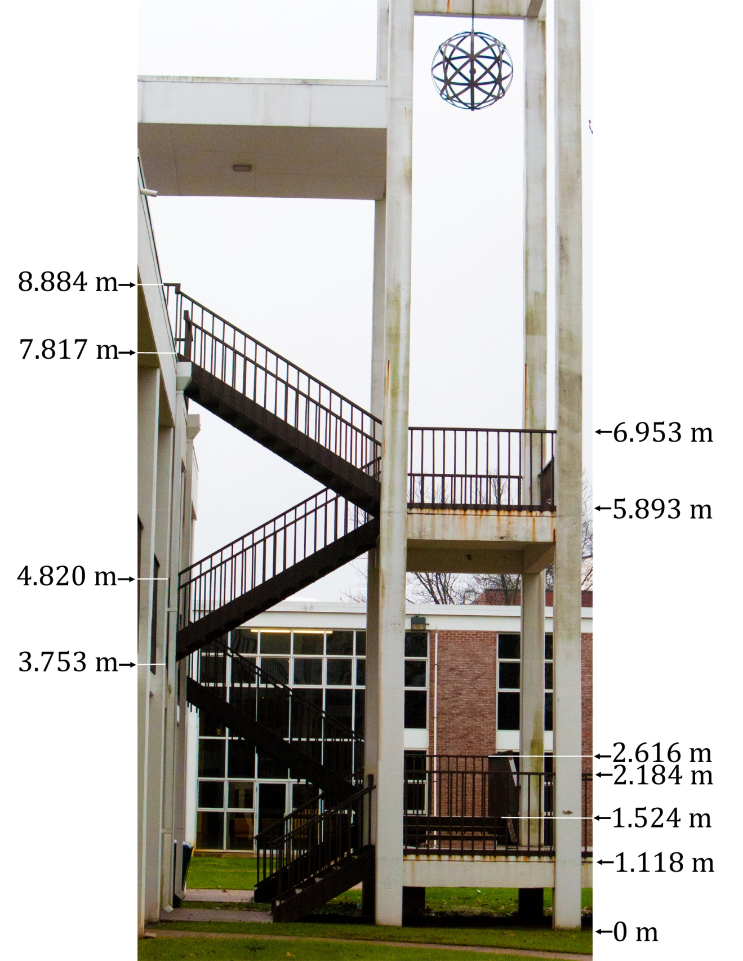

* 1. *Indoor Alternative:*  In case of inclement weather, balls may be dropped from the second floor outside G227 or inside Pirtle. A fall from the second floor to the first is 3.747 m and a fall from the second floor railing is 4.813 m. Additionally, other heights will be marked and, per the outdoor procedure, get a row of data as high above the top railing as possible. Next is a drawing of the indoor stairwell of Pirtle.

**Schematic of the indoor stairwell of Pirtle**

Landing 1.461 m

Top of Rail 2.527 m

Floor

Landing 3.759 m

Top of Rail 4.839 m

Landing 5.766 m

Top of Rail 6.820 m

Landing 7.785 m

Top of Rail 8.763 m

And, for clarity, following are photos of the indoor stairwell.

**Marked Photos of Pirtle Indoor Stairwell**

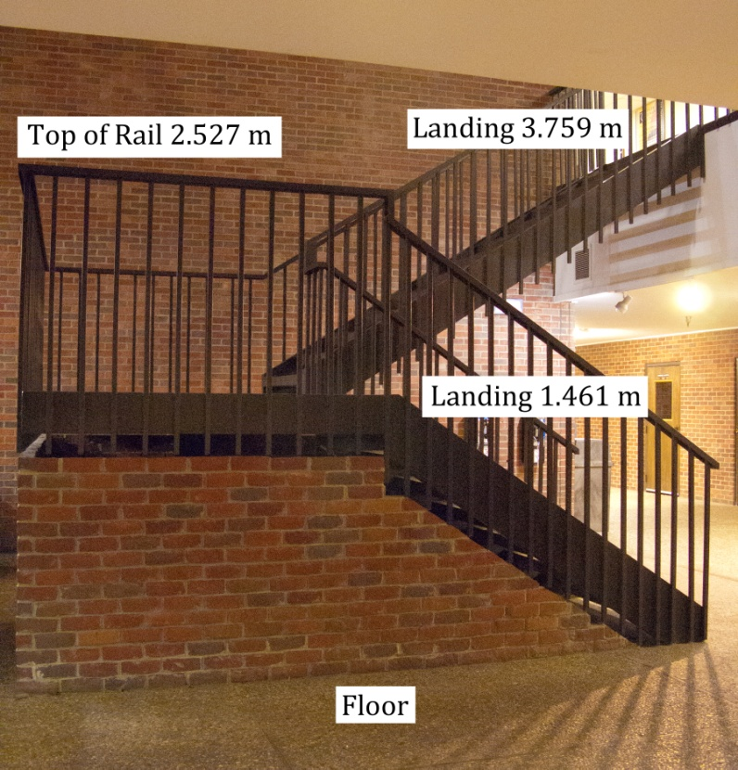

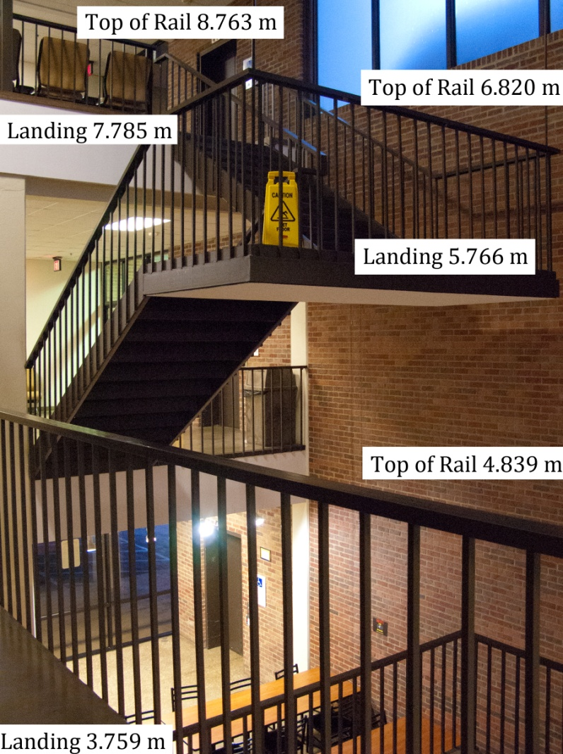

1. In the **velocity** column of the data table, record the value of the velocity of the object during each of the time intervals. Recall $v_{ave}= \frac{v_{f}+v_{i}}{2}$ and since *vi* = 0 then *vf* = 2*vave*.
2. Plot your points (time, *vf*) on the graph. Title your graph “Velocity vs. Time”.
3. Fit the best fit line straight line using a ruler through the data making sure it intersects (0, 0).
4. Find the slope of the best fit line. The slop, Δv/Δt, is equal to the acceleration of the falling object and should equal g.
5. After entering data, performing calculations, and plotting data, then answer the following questions.

**Questions:**

1. Find the acceleration *g* of the plummet using your velocity versus time graph. (Show your calculation!)
2. Compare your experimental value of *g* to the accepted value of 9.8 m/s2 by calculating the percent error.

*percent error =* 

1. What is significant about the fact that your velocity versus time graph produced a ***straight*** line? (What information does this provide about the acceleration of the object)? Would a curved line give us the same result?
2. What information does the slope of a distance versus time graph provide? Sketch the shape of the position vs. time graph for this object.

Data Table

|  |  |  |  |
| --- | --- | --- | --- |
| Time interval (sec) | Δx (m) | *vave* (m/s) | *vf* (m/s) |
| 0 | 0 |  |  |
|  |  |  |  |
|  |  |  |  |
|  |  |  |  |
|  |  |  |  |
|  |  |  |  |
|  |  |  |  |
|  |  |  |  |
|  |  |  |  |
|  |  |  |  |
|  |  |  |  |
|  |  |  |  |
|  |  |  |  |
|  |  |  |  |
|  |  |  |  |
|  |  |  |  |
|  |  |  |  |
|  |  |  |  |
|  |  |  |  |

|  |  |  |  |  |  |  |  |  |  |  |  |  |  |  |  |  |  |  |  |  |  |  |  |  |  |  |  |  |  |  |
| --- | --- | --- | --- | --- | --- | --- | --- | --- | --- | --- | --- | --- | --- | --- | --- | --- | --- | --- | --- | --- | --- | --- | --- | --- | --- | --- | --- | --- | --- | --- |
|  |  |  |  |  |  |  |  |  |  |  |  |  |  |  |  |  |  |  |  |  |  |  |  |  |  |  |  |  |  |  |
|  |  |  |  |  |  |  |  |  |  |  |  |  |  |  |  |  |  |  |  |  |  |  |  |  |  |  |  |  |  |  |
|  |  |  |  |  |  |  |  |  |  |  |  |  |  |  |  |  |  |  |  |  |  |  |  |  |  |  |  |  |  |  |
|  |  |  |  |  |  |  |  |  |  |  |  |  |  |  |  |  |  |  |  |  |  |  |  |  |  |  |  |  |  |  |
|  |  |  |  |  |  |  |  |  |  |  |  |  |  |  |  |  |  |  |  |  |  |  |  |  |  |  |  |  |  |  |
|  |  |  |  |  |  |  |  |  |  |  |  |  |  |  |  |  |  |  |  |  |  |  |  |  |  |  |  |  |  |  |
|  |  |  |  |  |  |  |  |  |  |  |  |  |  |  |  |  |  |  |  |  |  |  |  |  |  |  |  |  |  |  |
|  |  |  |  |  |  |  |  |  |  |  |  |  |  |  |  |  |  |  |  |  |  |  |  |  |  |  |  |  |  |  |
|  |  |  |  |  |  |  |  |  |  |  |  |  |  |  |  |  |  |  |  |  |  |  |  |  |  |  |  |  |  |  |
|  |  |  |  |  |  |  |  |  |  |  |  |  |  |  |  |  |  |  |  |  |  |  |  |  |  |  |  |  |  |  |
|  |  |  |  |  |  |  |  |  |  |  |  |  |  |  |  |  |  |  |  |  |  |  |  |  |  |  |  |  |  |  |
|  |  |  |  |  |  |  |  |  |  |  |  |  |  |  |  |  |  |  |  |  |  |  |  |  |  |  |  |  |  |  |
|  |  |  |  |  |  |  |  |  |  |  |  |  |  |  |  |  |  |  |  |  |  |  |  |  |  |  |  |  |  |  |
|  |  |  |  |  |  |  |  |  |  |  |  |  |  |  |  |  |  |  |  |  |  |  |  |  |  |  |  |  |  |  |
|  |  |  |  |  |  |  |  |  |  |  |  |  |  |  |  |  |  |  |  |  |  |  |  |  |  |  |  |  |  |  |
|  |  |  |  |  |  |  |  |  |  |  |  |  |  |  |  |  |  |  |  |  |  |  |  |  |  |  |  |  |  |  |
|  |  |  |  |  |  |  |  |  |  |  |  |  |  |  |  |  |  |  |  |  |  |  |  |  |  |  |  |  |  |  |
|  |  |  |  |  |  |  |  |  |  |  |  |  |  |  |  |  |  |  |  |  |  |  |  |  |  |  |  |  |  |  |
|  |  |  |  |  |  |  |  |  |  |  |  |  |  |  |  |  |  |  |  |  |  |  |  |  |  |  |  |  |  |  |
|  |  |  |  |  |  |  |  |  |  |  |  |  |  |  |  |  |  |  |  |  |  |  |  |  |  |  |  |  |  |  |
|  |  |  |  |  |  |  |  |  |  |  |  |  |  |  |  |  |  |  |  |  |  |  |  |  |  |  |  |  |  |  |
|  |  |  |  |  |  |  |  |  |  |  |  |  |  |  |  |  |  |  |  |  |  |  |  |  |  |  |  |  |  |  |
|  |  |  |  |  |  |  |  |  |  |  |  |  |  |  |  |  |  |  |  |  |  |  |  |  |  |  |  |  |  |  |
| velocity  (m/sec) |  |  |  |  |  |  |  |  |  |  |  |  |  |  |  |  |  |  |  |  |  |  |  |  |  |  |  |  |  |  |
|  |  |  |  |  |  |  |  |  |  |  |  |  |  |  |  |  |  |  |  |  |  |  |  |  |  |  |  |  |  |  |
|  |  |  |  |  |  |  |  |  |  |  |  |  |  |  |  |  |  |  |  |  |  |  |  |  |  |  |  |  |  |  |
|  |  |  |  |  |  |  |  |  |  |  |  |  |  |  |  |  |  |  |  |  |  |  |  |  |  |  |  |  |  |  |
|  |  |  |  |  |  |  |  |  |  |  |  |  |  |  |  |  |  |  |  |  |  |  |  |  |  |  |  |  |  |  |
|  |  |  |  |  |  |  |  |  |  |  |  |  |  |  |  |  |  |  |  |  |  |  |  |  |  |  |  |  |  |  |
|  |  |  |  |  |  |  |  |  |  |  |  |  |  |  |  |  |  |  |  |  |  |  |  |  |  |  |  |  |  |  |
|  |  |  |  |  |  |  |  |  |  |  |  |  |  |  |  |  |  |  |  |  |  |  |  |  |  |  |  |  |  |  |
|  |  |  |  |  |  |  |  |  |  |  |  |  |  |  |  |  |  |  |  |  |  |  |  |  |  |  |  |  |  |  |
|  |  |  |  |  |  |  |  |  |  |  |  |  |  |  |  |  |  |  |  |  |  |  |  |  |  |  |  |  |  |  |
|  |  |  |  |  |  |  |  |  |  |  |  |  |  |  |  |  |  |  |  |  |  |  |  |  |  |  |  |  |  |  |
|  |  |  |  |  |  |  |  |  |  |  |  |  |  |  |  |  |  |  |  |  |  |  |  |  |  |  |  |  |  |  |
|  |  |  |  |  |  |  |  |  |  |  |  |  |  |  |  |  |  |  |  |  |  |  |  |  |  |  |  |  |  |  |
|  |  |  |  |  |  |  |  |  |  |  |  |  |  |  |  |  |  |  |  |  |  |  |  |  |  |  |  |  |  |  |
|  |  |  |  |  |  |  |  |  |  |  |  |  |  |  |  |  |  |  |  |  |  |  |  |  |  |  |  |  |  |  |
|  |  |  |  |  |  |  |  |  |  |  |  |  |  |  |  |  |  |  |  |  |  |  |  |  |  |  |  |  |  |  |
|  |  |  |  |  |  |  |  |  |  |  |  |  |  |  |  |  |  |  |  |  |  |  |  |  |  |  |  |  |  |  |
|  |  |  |  |  |  |  |  |  |  |  |  |  |  |  |  |  |  |  |  |  |  |  |  |  |  |  |  |  |  |  |
|  |  |  |  |  |  |  |  |  |  |  |  |  |  |  |  |  |  |  |  |  |  |  |  |  |  |  |  |  |  |  |
|  |  |  |  |  |  |  |  |  |  |  |  |  |  |  |  |  |  |  |  |  |  |  |  |  |  |  |  |  |  |  |
|  |  |  |  |  |  |  |  |  |  |  |  |  |  |  |  |  |  |  |  |  |  |  |  |  |  |  |  |  |  |  |
|  |  |  |  |  |  |  |  |  |  |  |  |  |  |  |  |  |  |  |  |  |  |  |  |  |  |  |  |  |  |  |
|  |  |  |  |  |  |  |  |  |  |  |  |  |  |  |  |  |  |  |  |  |  |  |  |  |  |  |  |  |  |  |
|  |  | 0 |  |  |  |  |  |  |  |  |  |  |  |  |  |  |  |  |  |  |  |  |  |  |  |  |  |  |  |  |
|  |  |  |  |  |  | 0.2  time (s) – it may be necessary to change this time scale to fit your data |  |  |  | 0.4 |  |  |  | 0.6 |  |  |  | 0.8 |  |  |  | 1.0 |  |  |  | 1.2 |  |  |  | 1.42 |

Page left intentionally blank

**Conceptual Physics Workbook**

# Work, Power, and Conservation of Energy

\_\_\_\_\_\_\_\_\_\_\_\_\_\_\_\_\_\_/\_\_\_\_\_\_\_\_\_\_\_\_\_\_\_\_\_\_/\_\_\_\_\_\_\_\_\_\_\_\_\_\_\_\_\_\_

**Names – 3 to 5 people per group,**

\_\_\_\_\_\_\_\_\_\_\_\_\_\_\_\_\_\_/\_\_\_\_\_\_\_\_\_\_\_\_\_\_\_\_\_\_**at 6 split into 2 groups**

**Class:\_\_\_\_\_\_\_\_\_\_\_\_\_\_\_\_\_\_\_Section: \_\_\_\_\_\_\_\_\_\_\_\_\_\_Date:\_\_\_\_\_\_\_\_\_\_\_\_\_\_**

**There are two parts to this lab and your instructor may require Part I, PartII, or both. Refer to your instructor for instructions.**

**Part I**

In science, the word *work* has a meaning that is somewhat different than the everyday concept of the term. **Work** is defined as the force that acts (F) multiplied by the distance moved (d) in the direction of the force, W = Fd.

You are doing work on yourself when you walk up a stairway since you are lifting yourself through a distance. You lift your weight (F) through the vertical height of the stairs (d). Running up the stairs rather than walking is more tiring because you use up your energy at a greater rate when running. The rate at which energy is used or the rate at which work is done is called power. **Power** (P) is defined as work per unit time or energy per unit time,



When the steam engine was first invented, there was a need to describe the rate at which the engine could do work. Since people were familiar with the amount of work that horses could do, the engines were compared to the horses. James Watt, who designed a workable steam engine, defined the **horsepower** (hp) as a power rating of 550 ft lb/s. In SI units, power is measured in joules per second, or **Watts** (W). It takes 746 W to equal 1 hp.

**Procedure:**

1. Teams of two volunteers will measure the work done, the rate at which the work is done, and the horsepower rating as they move up a stairwell. Person A will measure and record the data for person B, and person B will measure and record the data for person A. An ordinary bathroom scale can be used to measure each person’s weight. Record the mass in kg in the data table. The weight is the force needed by each person to lift himself or herself up the stairs and is found by multiplying the mass times acceleration of gravity.
2. Measure the vertical height of the stairs. This is easily done by measuring the vertical height of one step and multiplying by the number of stairs to be climbed. Record this distance in meters in the data table.
3. Measure and record the time required (in seconds) for each person to walk normally up the stairs.
4. Measure and record the time required (in seconds) for each person to run up the stairs as fast as can safely be accomplished.
5. Calculate the work done, power level developed, and horsepower of each person while walking and while running up the stairs. Include the correct units on your results!

**Data Table:** Work and Power Data and Calculations

|  |  |  |
| --- | --- | --- |
|  | Volunteer A | Volunteer B |
| Mass (m)  (kg) |  |  |
| Weight (Fg)  (N) |  |  |
| Vertical height (d) of steps  (m) |  |  |
| Work  W = Fgd (J) |  |  |
| Time (tw) to walk the steps  (s) |  |  |
| Power Walking  Pw=W/tw (Watts) |  |  |
| HP Walking $$P_{w}\left(\frac{1 hp}{746 W}\right)$$ |  |  |
| Time (tr) to run the steps  (s) |  |  |
| Power Running  Pr=W/tr (Watt) |  |  |
| HP Running $$P_{r}\left(\frac{1 hp}{746 W}\right)$$ |  |  |

**Results:**

1. Explain the difference in the horsepower developed in walking and running up the stairs.

2. Could the horsepower developed by a slower-moving student ever be greater than the horsepower developed by a faster-moving student? Explain.

3.a. Work is a transfer of energy. What happens to the work done to climb a flight of stairs – where does it “go”?

b. Do you do more work or gain more energy when running up the stairs rather than walking? Explain your answer.

**Part II – Energy Conservation with a Spring: Purpose:** To experimentally test the principle of conservation of energy where gravitational and spring forces are involved.

**Theory:** When a spring is stretched a distance *d* from it’s equilibrium position, work has been done on the spring. That work is stored in the spring as elastic potential energy.

PEelastic = ½ k d2

The constant *k* is a property of the spring. It is a measure of how much force is required to stretch the spring. For these springs, the average value of *k* is about 9.5 N/m.

When the spring is hanging vertically, as in the setup for our lab today, the spring also has gravitational potential energy.

PEgrav = m g h

The height *h* will be measured as a distance above the tabletop.

When the spring in our experiment is stretched and released, it undergoes simple harmonic motion. At any point in the oscillation, if we sum all of the energy of the spring, it is a constant value.

**PEelastic + PEgrav + KE = constant = Total Energy**

But, at the top of its oscillation, it stops momentarily before it falls back down. At the bottom of its motion, it stops momentarily before it is pulled back up. Thus the kinetic energy at each of these positions is zero. The potential energies still exist at these points.

**Materials:**

* Spring
* 200 gm mass
* Meter Stick
* Stand
* Angle Bracket
* Horizontal rod

**Procedure:** Our goal today is to calculate the potential energies at the top of the oscillation and the bottom of the oscillation. We will compare them in an effort to show that the total energy is conserved.

1. Set up the apparatus as demonstrated by the instructor. Make sure the 0 cm of your meterstick is on the table. In your data table, record the position of the unstretched spring as *h0*.
2. Place a 200 g mass on the hook on the spring. Choose a position 2-3 cm below position *h0*. This will be your “drop height” – record it in your data table as *h1*. The distance (*h0 – h1*) is the distance *d1* that the spring has stretched. Record *d1* in your data table also.
3. Calculate the elastic potential energy and the gravitational potential energy at the top of the oscillation and record the values in your data table.
4. Release the mass to begin the simple harmonic motion. By careful observation and repeated trials, you can estimate the lowest point to which the mass descends before returning upward. This position will be recorded in your data table as *h2*. The distance (*h0 – h2*) is the distance *d2* that the spring has stretched at its lowest point. HINT: To measure the lowest position, you need to make your measurement on the first 2-3 oscillations. After that, the motion begins to damp out and your measurements will not be as accurate.
5. Calculate the elastic potential energy and the gravitational potential energy at the bottom of the oscillation and record the values in your data table.
6. Find the total energy at the top of the oscillation and at the bottom of the oscillation and record the totals in your data table.
7. Find the percent difference in the two total values.
8. Answer the following questions.

**Questions**

1. We can use the total energy to find the maximum kinetic energy, that is, kinetic energy at the midpoint. Assume that the total energy at the top of the oscillation is the total energy in the system, find the gravitational potential energy, the elastic potential energy, and the kinetic energy at the midpoint of the oscillation. HINT: You will not use KE = ½ mv2).

Height at midpoint (average *h1* and *h2*) = *hm* = \_\_\_\_\_\_\_\_\_ cm = \_\_\_\_\_\_\_\_\_ m

Spring stretch at midpoint = *dm* = *h0* – *hm* = \_\_\_\_\_\_\_\_\_ cm = \_\_\_\_\_\_\_\_\_ m

Midpoint spring energy = PEelastic = ½ k dm2 = \_\_\_\_\_\_\_\_\_\_\_\_\_\_\_ J

Midpoint gravitational energy = PEgrav = m g hm = \_\_\_\_\_\_\_\_\_\_\_\_J

Total Energy (average of Etop and Ebottom) = \_\_\_\_\_\_\_\_\_\_\_\_J

What must kinetic energy at midpoint be? KEm = \_\_\_\_\_\_\_\_\_\_\_\_J

1. What are some possible reasons for any error you experienced?
2. Was the purpose of this lab accomplished (In other words, how did you demonstrate that energy is conserved in this system? If not, explain why not).

**Data Table**

|  |  |  |
| --- | --- | --- |
| Unstretched spring  height *h0* | h0 = \_\_\_\_\_\_\_\_ cm = \_\_\_\_\_\_\_\_ m | Mass = 0.200 kg |
| Drop height *h1* | h1 = \_\_\_\_\_\_\_\_ cm = \_\_\_\_\_\_\_\_ m | k = 9.5 N/m |
| Distance spring stretched at the top  *d1* = *h0* – *h1* | d1 = \_\_\_\_\_\_\_\_ cm = \_\_\_\_\_\_\_\_ m |  |
| **Measured Energy at the Top:** | PEelastic = ½ k d12 = \_\_\_\_\_\_\_\_\_\_ J | PEgrav =  m g h1 = \_\_\_\_\_\_\_\_\_\_\_\_ J |
|  | **TOTAL MEASURED ENERGY AT THE TOP:** | Etop = \_\_\_\_\_\_\_\_\_\_\_\_\_\_ J |
|  |  |  |
| Lowest height *h2* | h2 = \_\_\_\_\_\_\_\_ cm = \_\_\_\_\_\_\_\_ m |  |
| Distance spring stretched at the bottom  *d2* = *h0* – *h2* | d2 = \_\_\_\_\_\_\_\_ cm = \_\_\_\_\_\_\_\_ m |  |
| **Measured Energy at the Bottom:** | PEelastic = ½ k d22 = \_\_\_\_\_\_\_\_\_\_ J | PEgrav =  m g h2 = \_\_\_\_\_\_\_\_\_\_\_\_ J |
|  | **TOTAL MEASURED ENERGY AT THE BOTTOM:** | Ebottom = \_\_\_\_\_\_\_\_\_\_\_\_ J |

Percent difference: \_\_\_\_\_\_\_\_\_\_\_\_\_\_\_\_\_\_\_\_\_\_\_\_\_\_\_\_\_ 

Page left intentionally blank

**Conceptual Physics Workbook**

# Momentum, Energy and Collisions

\_\_\_\_\_\_\_\_\_\_\_\_\_\_\_\_\_\_/\_\_\_\_\_\_\_\_\_\_\_\_\_\_\_\_\_\_/\_\_\_\_\_\_\_\_\_\_\_\_\_\_\_\_\_\_

**Names – 3 to 5 people per group,**

\_\_\_\_\_\_\_\_\_\_\_\_\_\_\_\_\_\_/\_\_\_\_\_\_\_\_\_\_\_\_\_\_\_\_\_\_**at 6 split into 2 groups**

**Class:\_\_\_\_\_\_\_\_\_\_\_\_\_\_\_\_\_\_\_Section: \_\_\_\_\_\_\_\_\_\_\_\_\_\_Date:\_\_\_\_\_\_\_\_\_\_\_\_\_\_**

**Purpose:**

1. Understand the conservation of momentum and energy.
2. Confirm or disprove the law of conservation of momentum.
3. Confirm or disprove the law of conservation of energy.
4. Classify collisions as elastic, inelastic, completely inelastic.

**Introduction:**

The collision of two carts on a track can be described in terms of momentum conservation and, in some cases, energy conservation. We use the symbol p to represent momentum and the momentum of a particle is given by:

$\vec{p}=m\vec{v}$ Equation (1)

Total momentum is found by adding up all the individual momentums of all the particles under consideration.

**INSTRUCTOR OPTION:**

BEFORE COMING TO LAB answer these questions on a separate page.:

1. Since there are no external forces acting on particles in this experiment, is the total momentum before a collision equal to the total momentum after a collision? Why or why not? Explain.
2. The following information will be used in the next several problems: Superman’s mass is 101 kg and moves to the right at 6642 m/sec, and Supergirl, whose mass is 54 kg, moves to the left at 12423 m/sec. What is Superman’s momentum?
3. What is Supergirl’s momentum?
4. What is the total momentum?
5. Superman and Supergirl collide. What is the total momentum after collision?
6. Can you determine the force Superman exerts on Supergirl and vice-versa? Why or why not?
7. What can you say about the force Superman exerts on Supergirl and vice-versa?

The kinetic energy of a particle is given by:

$ke= \frac{1}{2}mv^{2}$ Equation (2)

Total kinetic energy is found by adding up all the individual energies of all the particles under consideration. In this experiment we will only consider energy due to kinetic energy and one other form of energy.

1. What is the kinetic energy of Superman before they collide?
2. What is the kinetic energy of Supergirl before they collide?
3. What is the total kinetic energy of Superman and Supergirl before they collide?

If there is no net external force experienced by the system of two carts, then we expect the total momentum of the system to be conserved. This is true regardless of the force acting between the carts.

In contrast, energy is only conserved when certain types of forces are exerted between the carts. Collisions are elastic if kinetic energy is conserved, inelastic if not, completely inelastic if the objects stick together after collision, or super-elastic if kinetic energy is gained. In this experiment you can observe most of these types of collisions and test for the conservation of momentum and energy in each case.

1. If Superman and Supergirl collide elastically, what is the total final kinetic energy?
2. Elastic collisions are difficult, however we simplified by using the CM reference frame. Can you find the individual kinetic energies of Superman and Supergirl? Why or why not? What are the final kinetic energies of each?
3. If Superman and Supergirl collide perfectly (completely) inelastically, what is the total final kinetic energy? Hint: Consider their total momentum and individual momentums after an inelastic collision.
4. Is the total final kinetic energy after colliding inelastically the same, less than, or greater than the total kinetic energy before collision? Why or why not?
5. If the answer to Question 10 is less than or greater than, where does the “lost” kinetic energy go or where does the “gained” kinetic energy come from?

The problem posed in the preliminary questions was simplified by using the center of mass reference frame. Another simplification is equal masses and we will pose a question on this later.

If one object is at rest and another strikes it inelastically, it will move off in the same direction as the original object at reduced speed.

If Superman collides elastically with Supergirl who is originally at rest (high mass hits low mass), both will move in the same direction as Superman with Superman’s speed reduced AND (surprisingly) Supergirl’s final speed will be greater than Superman’s original speed.

If Supergirl collides elastically with Superman who is originally at rest (low mass hits high mass), Supergirl’s final velocity will be opposite to her original direction and less than her original speed. Superman’s final velocity will be in the same direction as Supergirl’s original direction and at speed less than Supergirl’s original speed.

In the experiment to follow we will measure and verify these situations.

Now, you think about what happens if equal masses collide with one originally at rest.

1. For an *inelastic* collision if Supergirl is originally at rest and her evil twin (of equal mass) is not, sketch both of their positions vs. time before and after colliding.
2. Is momentum conserved for the collision of Problem 16?
3. Is kinetic energy conserved for the collision of Problem 16?
4. Now consider the same problem except for an *elastic* collision. If Supergirl is originally at rest and her evil twin (of equal mass) is not, sketch both of their positions vs. time before and after colliding.
5. Is momentum conserved for the collision of Problem 19?
6. Is kinetic energy conserved for the collision of Problem 19?

**(End of instructor option section) TODAY’S LABORATORY Equipment:**

|  |  |
| --- | --- |
| Computers | Cart track |
| Vernier computer interface | Logger Pro |
| Two Vernier motion detectors | two low-friction dynamics carts with  magnetic and Velcro™ bumpers |
| Mass set |  |

Optionally, picket fences and photogates may be used.

**Procedure:**

* 1. Label the carts as cart 1 and cart 2 (use painter’s or masking tape and remove when experiment is complete) and measure the masses of your carts. If mass is unequal, add weights until the masses of the carts are the same. Record the masses in your data table in the columns M1 and M2. For now M1 and M2 will be equal, however we will increase M2 by 500 gm later.
  2. Set up the track so that it is horizontal. Test this by releasing a cart on the track from rest. The cart should not move.
  3. Practice creating gentle collisions by placing cart 2 at rest in the middle of the track, and release cart 1 so it rolls toward the first cart, magnetic bumper toward magnetic bumper. The carts should smoothly repel one another without physically touching.
  4. Place a Motion Detector at each end of the track, allowing for the 0.15 m minimum distance between detector and cart. Connect the Motion Detectors to the DIG/SONIC 1 and DIG/SONIC 2 channels of the interface. If the Motion Detectors have switches, set them to Track.
  5. Plug everything in, turning it on, open “Logger Pro” software, and do the experiment. This usually is best and easiest.
  6. In the software navigate to Experiment⇨Set Up Sensors⇨Show All Interfaces.
  7. Select the right motion detector⇨Reverse Direction. The left detector is already set to read positive velocity when carts move from left to right. Reversing direction on the right detector sets it to read positive velocity when carts move from left to right.
  8. OPTIONAL replace steps 6 & 7: Open the file “18 Momentum Energy Coll” from the Physics with Vernier folder.
  9. Click  to begin taking data. Repeat the collision you practiced above and use the position graphs to verify that the Motion Detectors can track each cart properly throughout the entire range of motion. You may need to adjust the position of one or both of the Motion Detectors.
  10. Place the two carts at rest in the middle of the track, with their Velcro bumpers toward one another and in contact. Keep your hands clear of the carts and click . Select both sensors and click . This procedure will establish the same coordinate system for both Motion Detectors. Verify that the zeroing was successful by clicking  and allowing the still-linked carts to roll slowly across the track. The graphs for each Motion Detector should be nearly the same. If not, repeat the zeroing process.

*Part I: Magnetic Bumpers*

* 1. Reposition the carts so the magnetic bumpers are facing one another. Click  to begin taking data and repeat the collision you practiced in Step 3. Make sure you keep your hands out of the way of the Motion Detectors after you push the cart.
  2. From the velocity graphs you can determine velocity before and after the collision for each cart. To read velocity move your cursor to the point you wish to measure and read velocity at the lower left corner. To measure the average velocity during a time interval, drag the cursor across the interval. Click the Statistics button  to read the average value. Measure the average velocity for each cart, before and after collision, and enter the four values in the data table. Column Vo1 is the original velocity of cart 1, Vo2 is original velocity of cart 2, Vf1 is final velocity of cart 1 and Vf2 is final velocity of cart 2. Delete the statistics box. **IMPORTANT – KEEP POSITIVE AND NEGATIVE SIGNS NOW AND THROUGHOUT CALCULATIONS.** If setup was correct in Steps 6 & 7, when carts move from left to right, velocity will be positive; and moving right to left velocity will be negative for both detectors.
  3. Repeat Steps 11-12 as a second run with the magnetic bumpers, recording the velocities in the data table.
  4. Add 500 gm to cart 2, use it as the cart at rest, and repeat Steps 11-12. Be sure to record the new masses of the carts.
  5. Now use the lighter cart, cart 1, as the “at rest” cart and repeat Steps 11-12.

*Part II: Velcro Bumpers*

* 1. Change the collision by turning the carts so the Velcro bumpers face one another. The carts should stick together after collision. Remove the 500 gm mass (the carts are equal mass again) and practice making the new collision, again starting with cart 2 at rest.
  2. Click  to begin taking data and repeat the new collision. Using the procedure in Steps 11-12, measure and record the cart velocities in your data table.
  3. Repeat the previous step as a second run with the Velcro bumpers.
  4. Add 500 gm to cart 2, use it as the cart at rest, and repeat Steps 11-12. Be sure to record the new masses of the carts.
  5. Now use the lighter cart, cart 1, as the “at rest” cart and repeat Steps 11-12.

**Analysis**

1. Determine the momentum (mv) of each cart before (Po1 and Po2) and after the collision (Pf1 and Pf2). Calculate the total momentum before (Pot) and after (Pft) colliding, the change in total momentum (Pt = Pft ‑ Pot), and %Diff. Enter the values in your momentum results table.
2. Determine the kinetic energy ($ke= \frac{1}{2}mv^{2}$) for each cart before (KEo1 and KEo2) and after (KEf1 and KEf2) the collision. Calculate total kinetic energy before and after (KEot and KEft) the collision, calculate the difference (KE) and %Diff between KEot and KEft. Enter the values in your data table.

**Concluding Questions**

1. If the total momentum for a system is the same before and after the collision, we say that momentum is conserved. If momentum were conserved, what would be the %Diff in momentum for a run?
2. If the total kinetic energy for a system is the same before and after the collision, we say that kinetic energy is conserved. If kinetic were conserved, what would be the %Diff in kinetic energy for a run?
3. Inspect the %Diff in the momentum results. Even if momentum is conserved for a given collision, the measured values may not be exactly the same before and after due to measurement uncertainty. The %Diff should be close to zero, however. Can you conclude momentum is conserved in your collisions? Why or why not? Explain.
4. Repeat the preceding question for the case of kinetic energy. Is kinetic energy conserved in the magnetic bumper collisions? How about the Velcro collisions? Classify your collision types as elastic, inelastic, or completely inelastic.
5. Did you accomplish the original purposes of this experiment?

**Extensions** (refer to instructions from your instructor)

1. Place the carts with the Velcro facing the magnet. What type of collision to you expect? Perform the experiments and determine if your prediction holds.
2. Using a collision cart with a spring plunger, create a super-elastic collision; that is, a collision where kinetic energy increases. The plunger spring should be compressed and locked before the collision, but then released during the collision. Measure momentum before and after the collision. Is momentum conserved in this case? Is energy conserved?

**Momentum Data and Results– blank lines in excess of your experiment are provided**

|  |  |  |  |  |  |  |  |  |  |  |  |  |  |  |  |  |  |
| --- | --- | --- | --- | --- | --- | --- | --- | --- | --- | --- | --- | --- | --- | --- | --- | --- | --- |
|  | Cart 1 Original | | | Cart 2 Original | | | Total Original Momentum | Cart 1 Final | | | Cart 2 Final | | | Total Final Momentum | Diff. | Average | Δ% |
| Run # | M1 (kg) | Vo1 (m/s) | Po1=  M1\*Vo1  (kg m/s) | M2 (kg) | Vo2 (m/s) | Po2=  M2\*Vo2  (kg m/s) | Pot=  Po1+Po2  (kg m/s) | M1 (kg) | Vf1 (m/s) | Pf1=  M1\*Vf1  (kg m/s) | M2 (kg) | Vf2 (m/s) | Pf2=  M2\*Vf2 (kg m/s) | Pft=  Pf1+Pf2 (kg m/s) | Δ=  |Pft‑Pot| | Ave=  ½\*(Pot+Pft) | Δ\*100/Ave |
| Cart 2 at rest |  |  |  |  |  |  |  |  |  |  |  |  |  |  |  |  |  |
| 2nd run Cart 2 at rest |  |  |  |  |  |  |  |  |  |  |  |  |  |  |  |  |  |
| Cart 2 + 500 gm at rest |  |  |  |  |  |  |  |  |  |  |  |  |  |  |  |  |  |
| Cart 1 at rest – Cart 2 + 500 gm |  |  |  |  |  |  |  |  |  |  |  |  |  |  |  |  |  |
| Velcro Cart 2 at rest |  |  |  |  |  |  |  |  |  |  |  |  |  |  |  |  |  |
| Velcro 2nd run Cart 2 at rest |  |  |  |  |  |  |  |  |  |  |  |  |  |  |  |  |  |
| Velcro Cart 2 + 500 gm at rest |  |  |  |  |  |  |  |  |  |  |  |  |  |  |  |  |  |
| Velcro Cart 1 at rest – Cart 2 + 500 gm |  |  |  |  |  |  |  |  |  |  |  |  |  |  |  |  |  |
| Extra row |  |  |  |  |  |  |  |  |  |  |  |  |  |  |  |  |  |
| Extra row |  |  |  |  |  |  |  |  |  |  |  |  |  |  |  |  |  |

**Energy Data and Results– blank lines in excess of your experiment are provided**

|  |  |  |  |  |  |  |  |  |  |  |  |  |  |  |  |  |  |
| --- | --- | --- | --- | --- | --- | --- | --- | --- | --- | --- | --- | --- | --- | --- | --- | --- | --- |
|  | Cart 1 Original | | | Cart 2 Original | | | Total Original Energy | Cart 1 Final | | | Cart 2 Final | | | Total Final Energy | Diff. | Avg. | Δ% |
| Run # | M1  (kg) | Vo1  (m/s) | Eo1=  M1(Vo1)2/2  (J) | M2  (kg) | Vo2  (m/s) | Eo2=  M2(Vo2)2/2  (J) | Eot=  Eo1+Eo2  (kg m/s) | M1 (kg) | Vf1 (m/s) | Ef1=  M1(Vf1)2/2  (J) | M2 (kg) | Vf2 (m/s) | Ef2=  M2(Vf2)2/2  (J) | Eft=  Ef1+Ef2  (J) | Δ=  |Eft‑Eot|  (J) | mean=  ½(Eot+Eft)  (J) | Δ\*100/Ave |
| Cart 2 at rest |  |  |  |  |  |  |  |  |  |  |  |  |  |  |  |  |  |
| 2nd run Cart 2 at rest |  |  |  |  |  |  |  |  |  |  |  |  |  |  |  |  |  |
| Cart 2 + 500 gm at rest |  |  |  |  |  |  |  |  |  |  |  |  |  |  |  |  |  |
| Cart 1 at rest – Cart 2 + 500 gm |  |  |  |  |  |  |  |  |  |  |  |  |  |  |  |  |  |
| Velcro Cart 2 at rest |  |  |  |  |  |  |  |  |  |  |  |  |  |  |  |  |  |
| Velcro 2nd run Cart 2 at rest |  |  |  |  |  |  |  |  |  |  |  |  |  |  |  |  |  |
| Velcro Cart 2 + 500 gm at rest |  |  |  |  |  |  |  |  |  |  |  |  |  |  |  |  |  |
| Velcro Cart 1 at rest – Cart 2 + 500 gm |  |  |  |  |  |  |  |  |  |  |  |  |  |  |  |  |  |
| Extra row |  |  |  |  |  |  |  |  |  |  |  |  |  |  |  |  |  |
| Extra row |  |  |  |  |  |  |  |  |  |  |  |  |  |  |  |  |  |

Page left intentionally blank

**Conceptual Physics Workbook**

# Specific Heat of Substances

\_\_\_\_\_\_\_\_\_\_\_\_\_\_\_\_\_\_/\_\_\_\_\_\_\_\_\_\_\_\_\_\_\_\_\_\_/\_\_\_\_\_\_\_\_\_\_\_\_\_\_\_\_\_\_

**Names – 3 to 5 people per group,**

\_\_\_\_\_\_\_\_\_\_\_\_\_\_\_\_\_\_/\_\_\_\_\_\_\_\_\_\_\_\_\_\_\_\_\_\_**at 6 split into 2 groups**

**Class:\_\_\_\_\_\_\_\_\_\_\_\_\_\_\_\_\_\_\_Section: \_\_\_\_\_\_\_\_\_\_\_\_\_\_Date:\_\_\_\_\_\_\_\_\_\_\_\_\_\_**

**Purpose:**

To determine the specific heat of various substances and compare to accepted values, and to understand the first law of thermodynamics and energy conservation.

**Factors to be Related**

|  |  |
| --- | --- |
| *Cs* | Specific heat of substance |
| *Cc* | Specific heat of calorimeter cup |
| *Cw* | Specific heat of water |
| *Ms* | Mass of substance |
| *Mc* | Mass of calorimeter cup |
| *Mw* | Mass of water |
| *Ts* | Original temperature of substance |
| *Tw* | Original temperature of water |
| *Tf* | Final temperature of water and substance |

**Theory**

The specific heat of a substance is the amount of heat necessary to raise the temperature of one gram of the substance one degree Celsius. The heat capacity of a substance is the amount of heat necessary to raise the temperature of a given mass of the substance one degree Celsius. The heat capacity of a substance is *MsCs*. The amount of heat lost by a mass of substance in dropping from one temperature to another is the mass of the substance multiplied by its specific heat and that result multiplied by the difference in temperatures.

To determine the specific heat of a substance, suspend a mass of the substance at a high temperature into a mass of water at a lower temperature. Then determine the final temperature of the water. Applying the law of conservation of energy, the heat lost by the substance is equal to the heat gained by its environment.

The amount of heat lost by the substance is *MsCs(Ts - Tf)*

The heat gained by the water is *MwCw(Tf - Tw)*

The amount of heat gained by the calorimeter cup is *McCc(Tf - Tw)*

The total measurable heat gained by the environment is *MwCw(Tf - Tw) + McCc(Tf - Tw)*

From the law of conservation of energy the following equation is found:

*MsCs(Ts - Tf) = MwCw(Tf - Tw) + McCc(Tf - Tw) = (Tf - Tw)(MwCw + McCc)*

We desire to find *Cs* of the substance measured. Rearranging the previous equation it is:

$C_{s}= \frac{\left(T_{f}- T_{w}\right)\left(M_{w}C_{w}+ M_{c}C_{c}\right)}{M_{s}\left(T_{s}- T_{f}\right)}$ Equation (1)

The specific heat of water is a well known constant, *Cw* = 1.00 cal/gm °K. Note that we are taking differences in temperature for Equation (1) and, therefore, it is not necessary to convert from °C to °K.

Use the reference table at the end of this lab to find the specific heat of the material the calorimeter is made of. Usually this will be Aluminum. If the calorimeter is a Styrofoam cup its specific heat may be ignored leading to the equation:

$C_{s}= \frac{\left(T_{f}- T_{w}\right)\left(M_{w}C_{w}\right)}{M_{s}\left(T_{s}- T_{f}\right)}$ Equation (2)

Note that you must measure the mass of the cup plus water and then subtract off the mass of the cup to get the mass of the water. Even though we assume the specific heat of the cup is zero, we still need the mass of the cup, *Mc*.

**Apparatus**

Calorimeter

Pot of boiling water

Substances of unknown specific heat

Thermometer

Bunsen burner & stand

**Preliminary Questions**

1. A hot metal is placed into room temperature water and the metal cools. What happens to the heat lost by the metal?
2. Can you ever really lose heat? If you “lose” heat, what happens to it? Explain.
3. Mechanical energy (GPE, SPE, KE, work, etc.) can be converted to another form, but friction causes some of it to be “wasted”. What kind of energy is “waste” energy?

**Procedure:**

1. Start water boiling in pot and bring to vigorous boil. Each lab group may have its own pot and burner OR your lab instructor may set up only one boiling pot for all groups.
2. Find the mass of the substance to be tested (*Ms*).
3. Suspend substance in boiling water for *5* minutes. Measure the temperature, *Ts*.
4. Find the mass of the calorimeter cup (*Mc*).
5. Fill the calorimeter cup half full with water and find the mass again (*Mc + Mw*). Mix cold and warm water to make it a few degrees lower than room temperature.
6. Determine the temperature of the water in the calorimeter (*Tw*).
7. Quickly remove substance from boiling water and put it into the calorimeter.
8. Find highest temperature to which calorimeter water rises (*Tf*).
9. Repeat procedure with one or more other substances.

**Data** – Be consistent, either measure all temperatures in °C or all temperatures in °K.

*Cw* = *Cc* =

(ignore if calorimeter is Styrofoam)

|  |  |  |  |  |  |  |  |
| --- | --- | --- | --- | --- | --- | --- | --- |
| Substance | *Ms* (gm) | *Ts*  (°C or °K) | *Mc* (gm) | *Mc + Mw* (gm) | *Mw* (gm) | *Tw*  (°C or °K) | *Tf*  (°C or °K) |
|  |  |  |  |  |  |  |  |
|  |  |  |  |  |  |  |  |
|  |  |  |  |  |  |  |  |

**Results**

|  |  |  |  |
| --- | --- | --- | --- |
| Substance | *Cs* measured $\left(\frac{cal}{ gm °K }\right)$ | *Cs* accepted value $\left(\frac{cal}{ gm °K }\right)$ | %Err |
|  |  |  |  |
|  |  |  |  |
|  |  |  |  |

**Conclusion**

1. What information does the %Err provide. Recall:
$$\%Err= \frac{\left|Accepted-Measured\right|}{Accepted}×100\%$$

2. How did we confirm energy is conserved? Explain.
3. How does the First Law of Thermodynamics relate to the Principle of Energy Conservation.
4. Were the purposes of this lab accomplished?

**Reference**

## Specific heats for various substances at 20 °C

|  |  |  |
| --- | --- | --- |
| Substance | c $\left(\frac{J}{ gm °K }\right) or \left(\frac{kJ}{ kg °K }\right)$ | c $\left(\frac{cal}{ gm °K }\right)$, $\left(\frac{kcal}{ kg °K }\right)$, or $\left(\frac{BTU}{ lb °F }\right)$ |
| Aluminum | 0.900 | 0.215 |
| Iron (Steel) | 0.45 | 0.108 |
| Copper | 0.386 | 0.0923 |
| Brass | 0.380 | 0.092 |
| Gold | 0.126 | 0.0301 |
| Lead | 0.128 | 0.0305 |
| Silver | 0.233 | 0.0558 |
| Glass | .84 | 0.20 |
| Water | 4.186 | 1.00 |
| Ice (-10 C) | 2.05 | 0.49 |
| Steam | 2.08 | 0.50 |
| Mercury | 0.140 | 0.033 |
| Alcohol(ethyl) | 2.4 | 0.58 |

Page left intentionally blank

**Conceptual Physics Workbook**

# Batteries, Bulbs, and Circuits

\_\_\_\_\_\_\_\_\_\_\_\_\_\_\_\_\_\_/\_\_\_\_\_\_\_\_\_\_\_\_\_\_\_\_\_\_/\_\_\_\_\_\_\_\_\_\_\_\_\_\_\_\_\_\_

**Names – 3 to 5 people per group,**

\_\_\_\_\_\_\_\_\_\_\_\_\_\_\_\_\_\_/\_\_\_\_\_\_\_\_\_\_\_\_\_\_\_\_\_\_**at 6 split into 2 groups**

**Class:\_\_\_\_\_\_\_\_\_\_\_\_\_\_\_\_\_\_\_Section: \_\_\_\_\_\_\_\_\_\_\_\_\_\_Date:\_\_\_\_\_\_\_\_\_\_\_\_\_\_**

**Part I: Light Bulb**

1. Obtain from your instructor a battery, a bulb, and a piece of wire. Carefully examine the construction of the bulb to see how the parts are arranged. A #14 bulb contains at least 9 parts. After you have determined how the bulb is constructed, try forming various arrangements which make the bulb light, being sure that you find more than one.
2. After you have an arrangement which will make the bulb light, try putting various objects (pens, coins, pencils, keys, paper, combs, etc.) between the bulb and the remaining parts of the circuit. Find and attempt a minimum of 6 objects. Note which objects allow the bulb to light (called conductors) and those which don’t (called insulators). Make a data table to show which objects you used, and the result.
3. Draw a sketch of one arrangement which will make the bulb light and describe what you think is happening. What is the fundamental principle required to make it light?
4. List some of the items that were found to be conductors and some that were found to be insulators. What property is common to those things that you found to be conductors as opposed to those which were insulators?
5. Draw an enlarged sketch of the bulb and identify those parts which must be insulators and those which must be conductors.

**Part II: Circuits**

1. Consider the circuits shown on page 2 and predict the order of brightness of the bulbs in the examples below. Use the symbols <, >, = to indicate the order of brightness. ex. A=B<C Write your answer in the space beside each example (the Prediction Column)

|  |  |  |
| --- | --- | --- |
|  | Prediction | Actual |
| 1. A, B, C in circuits 1 and 2 |  |  |
| 1. B, C in circuit 2 |  |  |
| 1. D, E in circuit 3 |  |  |
| 1. B, D in circuits 2 and 3 |  |  |
| 1. C, E in circuits 2 and 3 |  |  |
| 1. A, F, G in circuits 1 and 4 |  |  |
| 1. B, F in circuits 2 and 4 |  |  |
| 1. H, I, J in circuit 5 |  |  |
| 1. H, B in circuits 2 and 5 |  |  |
| 1. F, I in circuits 4 and 5 |  |  |

1. Construct the circuits and check the predictions you made in step 1. Grade yourself by marking correct or incorrect by each example (in the Actual column). If you were incorrect, record the correct answer.
2. Skip to the page following the schematics and answer the follow-up questions.

3.

E

D

5.

J

I

H

1.

A

4.

F

G

C

2.

B

1. What do we mean by electrical current? Is bulb brightness an indicator of electrical current?
2. Bulbs follow a relationship called Ohms Law which states that voltage equals current times resistance, that is, V = IR. So if current in a brighter bulb is more than a dim bulb, is the voltage across the bright bulb more? Explain.
3. What causes the bulbs to burn brighter? What are we measuring by measuring the brightness?
4. By using the model of flow in an electric circuit, explain why the bulbs compare as they do in examples 1, 4, 6, and 8 in step 1.

Page left intentionally blank

**Conceptual Physics Workbook**

# Electrical & Magnetic Fields

\_\_\_\_\_\_\_\_\_\_\_\_\_\_\_\_\_\_/\_\_\_\_\_\_\_\_\_\_\_\_\_\_\_\_\_\_/\_\_\_\_\_\_\_\_\_\_\_\_\_\_\_\_\_\_

**Names – 3 to 5 people per group,**

\_\_\_\_\_\_\_\_\_\_\_\_\_\_\_\_\_\_/\_\_\_\_\_\_\_\_\_\_\_\_\_\_\_\_\_\_**at 6 split into 2 groups**

**Class:\_\_\_\_\_\_\_\_\_\_\_\_\_\_\_\_\_\_\_Section: \_\_\_\_\_\_\_\_\_\_\_\_\_\_Date:\_\_\_\_\_\_\_\_\_\_\_\_\_\_**

**Purpose**

Why you have completed this lab you should: (1) understand and clearly explain the concept of a force field, (2) understand and describe why we find the concept of a field very useful, (3) understand and explain lines of force and their physical meaning, (4) understand and describe the connection between lines of force and potential, and (5) understand and explain how potentials are connected to work.

**Materials and Apparatus**

Magnets, iron filings, transparency, compass, graph paper, electromagnet, oscilloscope

**Introduction**

The electrostatic force between two point charges, q and qo, is given by Coulomb’s law:

$F= \frac{kqq_{o}}{r^{2}}$**(Eqn. 11.1)**

and the direction of the force given by “opposites attract, like repel.” We say the Coulomb force follows an inverse-square law meaning:

$F∝ \frac{1}{r^{2}}$**(Eqn. 11.2)**

or force is proportional to one divided by r squared.

The electric field, E, of q on qo is given by:

$E= \frac{F}{q_{o}}= \frac{kq}{r^{2}}$**(Eqn. 11.3)**

and the direction goes from positive charges to negative charges – E points in the same direction as the force if qo is positive.

Potential, or voltage, is how much work you must do to move a positive test charge (qo) in an electric field. This means positive charges are at higher potential than negative charges. It’s easy to see from Equation 11.3 that work, voltage, and electric field are connected as shown next:

$Ed= \frac{Fd}{q_{o}}= \frac{W}{q_{o}}=V$**(Eqn. 11.4)**

Equation 11.4 is especially useful since it’s often easier to set a voltage (with a battery, for example) and distance to create an electric field than it is to set charges and using Equation 11.1.

When we discussed work we noted that there is no work done if we move perpendicular to the electric field. The line where we don’t do any work is an equipotential line, perpendicular to field lines, and are lines of constant voltage as illustrated next (Figure 11.1).

|  |  |
| --- | --- |
|  | **Fig. 11.1** – The arrows point in the direction of the electric field, the shading of the arrow indicates the strength of the electric field (lighter arrows are smaller electric fields), and the circles are equipotential lines. The inner circle is 10 V and outer is 4 V. |

Equipotentials are like topographic maps. Here’s a topographic map of the Tyler area:

|  |
| --- |
|  |
| **Fig. 11.2** – Topographic map of area near TJC. The lines labeled with numbers are equal elevation lines/curves. Where they make a circle is the top of a hill or bottom of a depression. Note that they follow creeks – the lines roughly parallel to the creek indicate a hillside near the creek. |

Next are fields for electric dipoles, that is, one positive charge and one negative charge.

|  |
| --- |
|  |
| **Fig. 11.3** – Electric field for two charges. Arrow points in direction of field, and shading of arrow indicates strength. Lighter arrows are smaller electric fields. |

Magnets also create similar fields with one major exception. You may have lone charges, but you can’t have lone north (N) or south (S) poles – N and S ALWAYS come in pairs. You will note in Figure 11.4 that the magnetic field lines look remarkable like the fields in Figure 11.3 for two charges.

|  |
| --- |
|  |
| **Fig. 11.4** – Magnetic field lines, arrow points direction (from N to S) and shading of arrow indicates strength. Lighter arrows are smaller magnetic fields. |

Since the force on a moving charge is given by *F = qvB* (*B* is the conventional symbol for magnetic field), magnetic field can be thought of a force per the quantity charge times velocity or:

$B= \frac{F}{qv}= \frac{F}{Il}$**(Eqn. 11.5)**

Note that current times length of the wire (*Il*) equals the charge times velocity (*qv*). Also the force is perpendicular to velocity and field and therefore **magnetic forces don’t do work on moving charges** (however we can create arrangements to do work by spinning around a shaft in a motor, for example). Finally note, magnetic fields act on moving charges, not stationary, while electric fields act on charges whether they move or not.

**Procedure**

1. Insure your magnet is strong before you start by pointing N against N of another magnet, S against S, and N against S. If it doesn’t behave as expected it may be weak. Get another magnet in that case.
2. Cover a bar magnet with a sheet of cardboard with paper on top and trace the outline of the magnet. Sprinkle iron filings to obtain a pattern. Trace the pattern as accurately as possible, label properly, and staple the paper to the lab report. Comment. Do the patterns look anything like any of the Figures (11.1, 11.3, or 11.4)? Attach and properly label additional pages if needed.
3. With a compass map the magnetic field lines for your bar magnet. Sketch your map on the same page used in Step (2), include the vector direction of magnetic field, label properly, and staple to the lab report. Explain and comment. Does the compass point in the same direction as the iron filings pattern? Attach and properly label additional pages if needed.
4. Repeat the previous two procedures (Procedures 2 and 3) for a horseshoe magnet and comment as before. Attach and properly label additional pages if needed.
5. Examine the following diagram showing Earth’s magnetic field. You know that N on your compass will point toward Earth’s magnetic pole in the northern hemisphere, however the magnetism of the north pole is S. Why is this? Explain. Attach and properly label additional pages if needed.

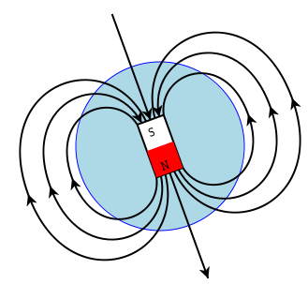

1. Note that at magnetic north the field lines are perpendicular to the ground while near the equator they are parallel. What direction will Earth’s magnetic field be at your location? Explain. If you have a Vernier magnetic probe, use the compass to discover the direction of the magnetic field in the horizontal plane, then use the Vernier probe to find out the horizontal and vertical components of magnetic field. Sketch a top down view and side view of the magnetic field vector. Attach and properly label additional pages if needed.
2. Hold the bar magnet near the current carrying coil. If you have a Vernier magnetic probe, use that plus compass and measure magnetic field, not forces. In either case find the direction of the vector force or field. Describe what happens and the direction of the force (field) when you point your magnet in different directions to the coil. That is, point your magnet along the coil’s axis, perpendicular to the axis, and parallel to the current repeating this for the top, bottom, and sides, both inside the coil and outside. Include the direction of the force (or field) at each point and explain why. Make a complete sketch of each configuration showing forces, fields, and wires in three dimensions. Attach and properly label additional pages if needed.
3. Repeat the previous step holding a magnet near a CRT type oscilloscope. Exceptions to the previous step are that current is only going in one direction and you only have access to the top and sides (12 total configurations – not 24). DO NOT PUT ANYTHING INSIDE AND/OR NEAR THE TUBE. THERE ARE DANGEROUS HIGH VOLTAGES. Attach and properly label additional pages if needed.
4. Take two magnets and verify that N repels N, S repels S, and N attracts S. Comment and explain.
5. Were you able to verify that the force equals current times length times magnetic field for the coil and that the force is perpendicular to both the magnetic field AND current? Explain your reasoning. Attach and properly label additional pages if needed.

**Questions**

1. Explain why magnetic fields don’t do work on moving charges such as the electron beam in the oscilloscope? Attach and properly label additional pages if needed.
2. We did not do an experiment on Faraday’s law. What is Faraday’s law and what kind of experiment would you devise to test it? Explain thoroughly. Attach and properly label additional pages if needed.
3. Explain how electricity and magnetism are similar and how they are different. Attach and properly label additional pages if needed.
4. Is gravity more like electrostatics or magnetism? Explain. How might we map gravitational field? Sketch the gravitational field for two point masses. Topographic maps show lines of equal elevation. What are these like in electrostatics? Explain completely and attach and properly label additional pages if needed.

Page left intentionally blank

**Conceptual Physics Workbook**

# Measuring the Speed of Sound

\_\_\_\_\_\_\_\_\_\_\_\_\_\_\_\_\_\_/\_\_\_\_\_\_\_\_\_\_\_\_\_\_\_\_\_\_/\_\_\_\_\_\_\_\_\_\_\_\_\_\_\_\_\_\_

**Names – 3 to 5 people per group,**

\_\_\_\_\_\_\_\_\_\_\_\_\_\_\_\_\_\_/\_\_\_\_\_\_\_\_\_\_\_\_\_\_\_\_\_\_**at 6 split into 2 groups**

**Class:\_\_\_\_\_\_\_\_\_\_\_\_\_\_\_\_\_\_\_Section: \_\_\_\_\_\_\_\_\_\_\_\_\_\_Date:\_\_\_\_\_\_\_\_\_\_\_\_\_\_**

**Purpose:**

To study the phenomenon of resonance and to measure the velocity of sound in air.

**Equipment:**

Glass resonance tube on lab stand with water reservoir connected; meter stick; three tuning forks; class thermometers.

**Introduction:**

The fundamental equation of wave motion is

 (eq. 1)

where *v* = velocity of propagation of the wave, *f* = frequency of the wave, λ = wavelength of the wave

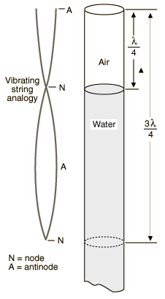If a vibrating source (such as a tuning fork) is held over an air column in a closed tube, compressions and rarefactions will travel down the tube and be reflected back upwards. If the tube length is adjusted until it is equal to one-fourth the wavelength of the tone from the fork, the returning wave will interfere with the incident wave and produce a standing wave. When this occurs, the returning wave will arrive back at the top of the tube precisely in phase with the next vibration from the fork, and a tone of unusually loud volume will be heard. This phenomenon is known as resonance, and it occurs when standing waves are set up in the tube with a node at the closed end and an antinode at the open end. This situation can only occur when the length of the tube (*L*) is any *odd number of quarter wavelengths* of the sound waves being emitted by the fork (see figure). In other words, resonance will occur when:



The apparatus used in this experiment consists of a tube, about 1.2 m long, fitted with a meter stick and a water reservoir whose level can be changed to make water rise and fall in the tube. The frequency of the tuning fork is known (stamped on the side of the fork) and λ can be calculated from measurements taken at points of resonance, the velocity of sound in air may be calculated by using eq. 1.

**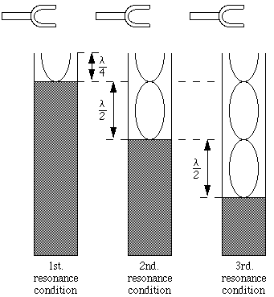Procedure:**

1. With the reservoir near the top, fill the tube nearly full of water.
2. Strike one of the tuning forks with a rubber hammer near the center (other positions will cause excitation of higher frequencies) and hold it over the water-filled tube. **DANGER**: do NOT touch the fork to the glass tube. The tube may break if you touch the rapidly moving fork to the glass.
3. While holding the vibrating fork over the tube, move the water reservoir down slowly. This will lower the level of water in the tube at the same time. Carefully listen for amplification of the tone. When a resonance point is reached, you will hear a loud tone. Move the water surface up and down several times to locate the point of maximum sound intensity. Once you have determined the point of greatest amplification, record the measurement from the meter stick in Data Table 1. This marks the point of the first one-quarter wavelength. From this measurement you should be able to estimate where the three-quarters and five-quarters wavelength resonance points should occur. Do not record the estimates.
4. Lower the water level still further to find the next resonant length. Continue in this manner as far as the length of the tube will permit. Obtain the lengths /4, 3/4, etc. in meters from your measurements. You will need to check to see if your column lengths follow the progression 1, 3, 5, 7, -- since you may have missed a resonance or counted one of the fainter spurious resonances which sometimes occur.
5. On a sheet of scrap paper, determine the wavelength from each of your resonance measurements. Average the results and record the average calculated wavelength in Data Table 1.
6. Use eq. 1 to calculate the velocity of sound using your average calculated wavelength and the frequency of the tuning fork. Record your value in Data Table 1.
7. Repeat the procedure for two other tuning forks.
8. Average your velocity results and record the average in the space provided. Record the results in meters per second.
9. Read the temperature from the two thermometers in the room. Average their values and record the value in the space provided. It is necessary to record the room temperature for reference since the velocity of sound increases with increasing air temperature. Then calculate the speed of sound from the room’s temperature and record your finding. Finally, determine the percent error.

**Data Table 1 – Tube Lengths of Resonances**

|  |  |  |  |  |  |  |
| --- | --- | --- | --- | --- | --- | --- |
| Frequency on Tuning Fork (Hz) |  | First Resonance | Second Resonance | Third Resonance | Average Calculated Wavelength (m) – show wavelength calculations below | Calculated Velocity (m/sec) |
|  | Tube Length L (m) |  |  |  |  |  |
| Wave Length  (m) |  |  |  |
|  | Tube Length L (m) |  |  |  |  |  |
| Wave Length  (m) |  |  |  |
|  | Tube Length L (m) |  |  |  |  |  |
| Wave Length  (m) |  |  |  |

Average measured speed of sound (meters/second) = \_\_\_\_\_\_\_\_\_\_\_\_\_\_\_\_\_\_\_\_\_\_\_

Room Temperature = \_\_\_\_\_\_\_\_\_\_\_\_\_\_\_\_\_\_\_\_\_\_\_\_\_\_

Calculate the speed of sound for the room’s temperature by the following equation.

, where *T* = temperature in Celsius

From this calculation of the accepted value of the speed of sound, find:

*v*accepted = \_\_\_\_\_\_\_\_\_\_\_\_\_\_\_\_\_\_\_\_\_\_\_\_\_\_\_, % error = \_\_\_\_\_\_\_\_\_\_\_\_\_\_\_\_\_\_\_\_\_\_\_\_\_\_\_

Show your work

Realize that the speed of sound formulas are approximations. A second approximation, the one your textbook uses, is:

*v* = (330 + 0.6\**T*) m/sec, where *T* = temperature in Celsius

From this second calculation of the accepted value of the speed of sound, find:

*v*accepted = \_\_\_\_\_\_\_\_\_\_\_\_\_\_\_\_\_\_\_\_\_\_\_\_\_\_\_, % error = \_\_\_\_\_\_\_\_\_\_\_\_\_\_\_\_\_\_\_\_\_\_\_\_\_\_\_

Show your work

1. The resonance conditions of an open tube are different from this closed tube. Why? Explain.
2. If the nature of sound was not wave-like, but more like the mechanics of balls, cars, etc. that we studied earlier this semester, could resonance occur? Why or why not? Explain.
3. Sir Isaac Newton thought light was particles and not waves. What kind of experiment would you devise to distinguish between the theory of light being particles and the theory light is a wave? Explain.

Page left intentionally blank

**Conceptual Physics Workbook**

# Reflection Laboratory

\_\_\_\_\_\_\_\_\_\_\_\_\_\_\_\_\_\_/\_\_\_\_\_\_\_\_\_\_\_\_\_\_\_\_\_\_/\_\_\_\_\_\_\_\_\_\_\_\_\_\_\_\_\_\_

**Names – 3 to 5 people per group,**

\_\_\_\_\_\_\_\_\_\_\_\_\_\_\_\_\_\_/\_\_\_\_\_\_\_\_\_\_\_\_\_\_\_\_\_\_**at 6 split into 2 groups**

**Class:\_\_\_\_\_\_\_\_\_\_\_\_\_\_\_\_\_\_\_Section: \_\_\_\_\_\_\_\_\_\_\_\_\_\_Date:\_\_\_\_\_\_\_\_\_\_\_\_\_\_**

**Purpose:** To practice drawing ray diagrams for image formation by a plane mirror.

Materials: Mirror, block (optional – required to keep mirror vertical), cork board (or cardboard), pins, ruler, paper, pencil

**Procedure:**

1. Hold a pencil vertically at arm’s length. In your other hand, hold a second pencil about 15 cm closer than the first. Without moving the pencils, look at them while you move your head from side to side.
   1. *Question:* Which way does the nearer pencil appear to move with respect to the one behind it when you move your head to the left?
2. Now move the pencils closer together and observe the apparent relative motion between them as you, move your head.
   1. *Question:* Where must the pencils be if there is to be no apparent relative motion, that is, no parallax, between them?
3. Now we shall use parallax to locate the image of a nail (pin) seen in a plane mirror. Place a blank paper on the cork board and support a plane mirror vertically about half way down the paper by fastening it to a wood block with rubber bands or using straight pins to hold it upright. Stand a pin on its head about 10 cm in front of the mirror. Draw the line B-B’ indicating the reflecting surface AND recall reflection occurs on the rear of the mirror. Refer to the following Figure.
   1. *Question:* Where do you think the image of the nail or pin is?
4. Move your head from side to side while looking at the nail and the image.
   1. *Question:* Where is the nail’s (pin’s) image? Describe this location. Behind the mirror or in front of the mirror, the same distance or more or less than the object, etc.
5. We can also locate the position of an object by drawing rays which show the direction in which light travels from it to our eye. Stick a pin vertically into a piece of paper resting on a sheet of soft cardboard (corkboard). If the first pin about 10 cm from the mirror is acceptable, you may use its current position. This will be the object pin. Establish the direction in which light comes to your eye from the pin by sighting along a ruler as shown in the following figure. Then firmly hold the ruler and draw a pencil line along this edge. Look at the object pin from several widely different directions and mark the new lines of sight to the object pin. Move the mirror and extend this line through the mirror boundary line BB’ and continue as far as possible. Label the point of reflection with the letter P and label the other end of the line R (Reflection).

*Questions:*

* 1. Where do these lines intersect? Explain.
  2. Record the distances of the image and object from the reflecting surface in Results Table 1. How do these distances compare? Explain.

|  |
| --- |
| **Figure Reflection 1** – Diagram of experimental arrangement studying reflection. |

* 1. Draw a line from O to I, measure the angle this line makes with the reflecting surface B-B’, and record in Results Table 1. Is that angle 90° or not? Explain.

1. Place a protractor on line BB’ with vertex at Point P and mark a point 90° from the line (label it N for Normal – perpendicular). From this point, use the ruler to draw a dashed normal (NP). Complete your ray diagram by using the ruler to draw a line from the point of reflection (P) to the source of the light ray at the pin (O for Object). Place arrows on line OP and line PR to show which way the light ray moved.
2. Using the protractor, measure the angle of incidence and angle of reflection for each of your three or more rays and record in Data Table 1.
   1. *Question:* What do you conclude about the angles, i and r, formed between the mirror surface and the light paths?
   2. *Question:* Consider your answers to 5b, 5c, and 7a. What are the set of laws that govern reflection? Explain.
3. Arrange two mirrors at right angles with an object somewhere between them. Comment on the images you observe.
   1. *Question:* How is this like and how is this unlike a single plane mirror?
   2. *Question:* Is this expected or unexpected?

**Data Table 1**

|  |  |  |  |
| --- | --- | --- | --- |
| Trial | Angle of Incidence (i) | Angle of Reflection (r) | % Difference |
| 1 |  |  |  |
| 2 |  |  |  |
| 3 |  |  |  |
| 4 |  |  |  |
| 5 |  |  |  |
| 6 |  |  |  |
| 7 |  |  |  |

**Results Table 1**

|  |  |  |  |
| --- | --- | --- | --- |
| Distance | | |  |
| Object to mirror | Image to mirror | % Difference | Angle of O-I with mirror |
|  |  |  |  |

1. Describe any pattern you found in the data between the angle of incidence and the angle of reflection.
2. What do you conclude about the position of the image and the relationship to the object?
3. At what angle does the line from the image to object intersect the plane mirror?
4. What is the fundamental principle confirmed by your answers to Questions 1 to 3? What path does the light take from the object to your eye? Can you derive this principle from algebra or geometry?
5. Was the purpose of the lab accomplished? Did you confirm or disprove the laws of reflection? Why or why not?

Page left intentionally blank

**Conceptual Physics Workbook**

# Refraction Laboratory

**Teamwork Assessment Form – Find private location to fill this out and MUST be turned in at conclusion of Refraction Lab.**

Date \_\_\_\_\_\_ Course \_\_\_\_\_\_\_\_\_\_\_ Section

Your Name

Results of this survey will be confidential and submitting your name is optional. For any credit awarded for participating in this survey, your name is required. Please be as accurate as possible.

**Please rate your teammates on the following – one teammate per column. You will check three boxes for each teammate in your lab group.**

|  |  |  |  |  |  |
| --- | --- | --- | --- | --- | --- |
| **Teammate** | **1** | **2** | **3** | **4** | **5** |
| **Contributions to Team Interaction (choose one for each teammate):** | | | | | |
| Interacts poorly, inconsistently, or not at all |  |  |  |  |  |
| Interacts with team members to accomplish the objective |  |  |  |  |  |
| Provides leadership in helping the team accomplish the objective efficiently |  |  |  |  |  |
| **Individual Contributions (choose one box for each teammate):** | | | | | |
| Is unprepared for teamwork |  |  |  |  |  |
| Is adequately prepared for working with the team |  |  |  |  |  |
| Is prepared not only for the individual contribution but has prepared more than was assigned |  |  |  |  |  |
| **Completed Team Purpose/Goal (choose one box for each teammate):** | | | | | |
| Team member did not work with others to contribute to final project or product (lab) |  |  |  |  |  |
| Completed project or product exemplifies efforts of individuals working as a team and team member adequately contributed to finished project (lab) |  |  |  |  |  |
| Completed team project or product shows superior efforts of individuals working as a team and team member made superior contribution to finished project (lab) |  |  |  |  |  |

Page left intentionally blank

**Conceptual Physics Workbook**

**Refraction Laboratory**

This lab is used for assessment and reports for this lab must be written individually even if you turned in group reports during the rest of the semester. Cooperate as a team to take measurements, collect data, and verify calculations.

Your name: \_\_\_\_\_\_\_\_\_\_\_\_\_\_\_\_\_\_\_\_\_\_\_

\_\_\_\_\_\_\_\_\_\_\_\_\_\_\_\_\_\_/\_\_\_\_\_\_\_\_\_\_\_\_\_\_\_\_\_\_/\_\_\_\_\_\_\_\_\_\_\_\_\_\_\_\_\_\_

**Names – 3 to 5 people per group,**

\_\_\_\_\_\_\_\_\_\_\_\_\_\_\_\_\_\_/\_\_\_\_\_\_\_\_\_\_\_\_\_\_\_\_\_\_**at 6 split into 2 groups**

**Class:\_\_\_\_\_\_\_\_\_\_\_\_\_\_\_\_\_\_\_Section: \_\_\_\_\_\_\_\_\_\_\_\_\_\_Date:\_\_\_\_\_\_\_\_\_\_\_\_\_\_**

**Preface:** This lab will be used to assess teaching and learning at TJC in the areas of empirical and quantitative skills, communication, critical thinking and teamwork.

**Purpose:** To investigate the refraction of light. When light encounters the interface between two optical media, part of the light will be reflected, and part of it will enter the second medium, it is refracted, and we will investigate this.

**Materials:** Glass, semicircle plastic container, cork board (or cardboard), pins, ruler, paper, pencil

**Procedure 1:**

1. We will test refraction using this half circle. You may use a rectangular prism instead, however it is much more difficult. For reference, Procedure 2 describes testing refraction using a rectangular prism. For this Procedure 1 to work properly, the light rays must go through the center of the circle as illustrated on the next page – Figure Refraction 1. Start with a fresh piece of paper and place on corkboard (or cardboard).
2. Fill semicircle with water (or other fluid as your instructor directs) and place in the middle of the paper.
3. Trace the outline of the semicircle.
4. *Very precisely*, using a ruler, measure where the middle of the semicircle is located, label this Point P (refer to Figure Refraction 1), and put a pin there.
5. Place a second pin at Point O. Choose Point O so that i ranges from small, to medium, to large angles.
6. For each *i*, sight along the ruler through the water such that the parallax between Points P and O is eliminated. Firmly hold the ruler and draw a pencil line along the edge. Be sure to label this line with the trial number.
7. Not moving Pin P, but only moving Pin O, repeat Steps 6 and 7 several (minimum 3) times recording data in Data Table 1.
8. Move the ruler to find the value of *r* where Point P is on the verge of appearing and disappearing. This is the critical angle, *c*, for total internal reflection. For *r* > *c*, total internal reflection will occur and for *r* > *c*, you will have ordinary refraction.

|  |
| --- |
| **Figure Refraction 1** – Refraction experiment using semicircle. |

1. Remove the semicircle and extend all ruler lines. They should intersect Point P. If they are far off then the experiment needs to be repeated. See your lab instructor for help.
2. Draw line N perpendicular to Point P.
3. Use the protractor to measure the incident angles and the refraction angles (*i* and *r*) for each case.
4. You will need to calculate index of refraction as follows:

Recall, *n1* = index of refraction of substance 1, *n2* = index of refraction of substance 2, *1* = angle in substance 1 (angle of light ray from normal), *2* = angle in substance 2 (angle of light ray from normal), *v1* = speed of light in substance 1, *v2* = speed of light in substance 2 and c = speed of light in vacuum, Snell’s Law states:

$$n_{1}\sin\left(θ_{1}\right)= n_{2}\sin\left(θ_{2}\right)$$

where:

$$n_{1}= \frac{c}{v_{1}} and n_{2}= \frac{c}{v_{2}}$$

For this lab, let the subscript 1 stand for values in air and the subscript 2 refer to values in glass. Therefore, *n1* = 1, the accepted value of *n2* = 1.33, we have two measurements of *1* (*i)*, and two measurements of *2* (*r*). We can find two measurements for *n* of water:

$n= \frac{\sin\left(θ_{i}\right)}{\sin\left(θ_{r}\right)}$

1. Calculate index of refraction, its reciprocal, and enter data in Data Tables 1 and 2 noting that the accepted index of refraction of water, *n*, is 1.33 (your instructor will provide the accepted values if other fluids are used).

**Data Table 1**

|  |  |  |  |
| --- | --- | --- | --- |
| Trial | *i* (degrees) | *r* (degrees) | *n* |
| 1 |  |  |  |
| 2 |  |  |  |
| 3 |  |  |  |
| 4 |  |  |  |
| 5 |  |  |  |
|  |  | Average |  |
|  |  | % Diff |  |
|  |  | % Err |  |

**Data Table 2**

|  |  |
| --- | --- |
| *c* (degrees) | sin(*c*) – measured value of 1/*n* |
|  |  |
| 1/*n* (accepted value) |  |
| % Err between sin(*c*) and 1/*n* |  |

1. **Questions:**
   1. Is Snell’s Law confirmed or disproved? Why or why not?
   2. What is the position of the image compared to the position of the object? How is this position similar or different in reflection and refraction? Explain how to correct for this if your eyes are above the water and you’re trying to catch fish in the water.
   3. In Data Table 2, how did the predicted critical angle (or the sin of the angle or 1/*n*) compare with measurements?

**Results**

1. *Assessment assignment to be turned into turnitin.com and used to evaluate critical thinking, written communication, and empirical and quantitative skills.* If we followed Procedure 2, that is, if light travels through a pane of glass per Figure Refraction 2, how will it be refracted? Will the light exit the pane of glass at the same angle as it enters or not? Is the ray exiting parallel to the ray entering the glass? Is the ray exiting on the same line as the ray entering? Show your reasoning thoroughly using geometric and algebraic reasoning. Sketch on this page and submit written explanations to turnitin.com.
2. What are the values of *r* that produce total internal reflection? Why does light reflect instead of escaping exiting? Explain thoroughly.
3. Was the purpose of the lab accomplished? Did you confirm or disprove Snell’s Law? Did you observe or not observe total internal reflection? Why or why not?

**PROCEED ONLY IF YOUR INSTRUCTOR REQUIRES Alternate Procedure 2:**

1. Place the blank paper on the cork and the rectangular piece of glass on top of that. Trace the outline of the glass on the paper. Refer to the Figure Refraction 2.
2. Place the blank paper on the cork and the rectangular piece of glass on top of that. Trace the outline of the glass on the paper.
3. Stick a pin straight up and down into the paper about 10 cm from the glass and slightly to the right (and top) as shown in the diagram. Label the location O.
4. On the left bottom side, carefully align the edge of a ruler with the refracted image as shown. Try to go to as large of angle for *i* as possible then firmly hold the ruler and draw a pencil line along this edge. Label this line “Line 1”.
5. Sight along the ruler and place a second pin straight up and down into the paper near the edge of the glass as shown in the figure. Label the location of the pin O’.
6. *Remove the front pin at Point O’ – do not move the rear pin at Point O* and repeat Step 3 at a low angle. Label the line “Line 2”.
7. Remove the glass and, using a ruler, extend the glass/air interface line on both sides. Label one AA’ and the other BB’ as shown in the figure.
8. Extend the ruler line and label the point on BB’ with the letter P. Draw a line through OO’ intersecting AA’ and label the point of intersection P’.
9. Place a protractor on line BB’ at the vertex P and mark a point 90° from BB’ (label it N for Normal – perpendicular). From this point, use the ruler to draw a dashed normal (NP). Repeat for the other side drawing a perpendicular to AA’ from P’ and label the dashed normal N’P’.
10. Complete your ray diagram by using the ruler to draw a line from P to P’. Use arrows to show the path the light is taking.
11. Use the protractor to measure the angles of incidence and the angles of refraction for both sides. Record these angles in Data Table 3.
12. Do the two calculations for *n* as described in Procedure 1, and enter in Data Table 3.

|  |
| --- |
| **Figure Refraction 2** – Diagram of experimental arrangement studying refraction. |

**Data Table 3**

|  |  |  |  |
| --- | --- | --- | --- |
| Trial | Angle of Incidence  (*i* or *i’* in degrees) | Angle of Refraction  (*r* or *r’* in degrees) | Index of Refraction (n) |
| 1 |  |  |  |
|  |  |  |
|  |  | average |  |
|  |  | % Diff |  |
|  |  | % Err |  |

1. Extend Lines 1 and 2. Where they intersect is the location of the Image I.
2. Measure the locations of Point O and Point I from Point P, record in Data Table 4, and calculate the difference, , in values.

**Data Table 4**

|  |  |  |
| --- | --- | --- |
| Point | Horizontal (x) Distance (cm) | Vertical (y) Distance (cm) |
| O |  |  |
| I |  |  |
|  |  |  |

1. *Questions:*
   1. Do you expect the rays on either side of the glass to be parallel or not? In other words, do you expect line RP to be parallel to line P’O? Explain.
   2. Determine if your rays found experimentally are parallel or not?
   3. Does the answer to Question (b) fit your expectations or not?

Page left intentionally blank

**Conceptual Physics Workbook**

# Spectroscopy Laboratory

\_\_\_\_\_\_\_\_\_\_\_\_\_\_\_\_\_\_/\_\_\_\_\_\_\_\_\_\_\_\_\_\_\_\_\_\_/\_\_\_\_\_\_\_\_\_\_\_\_\_\_\_\_\_\_

**Names – 3 to 5 people per group,**

\_\_\_\_\_\_\_\_\_\_\_\_\_\_\_\_\_\_/\_\_\_\_\_\_\_\_\_\_\_\_\_\_\_\_\_\_**at 6 split into 2 groups**

**Class:\_\_\_\_\_\_\_\_\_\_\_\_\_\_\_\_\_\_\_Section: \_\_\_\_\_\_\_\_\_\_\_\_\_\_Date:\_\_\_\_\_\_\_\_\_\_\_\_\_\_**

**Introduction:**

All of the information we learn about stars comes to us by electromagnetic radiation. Types of radiation are distinguished by wavelength; our eyes are sensitive to visible light with wavelengths from 400 nanometers (blue light) to 700 nanometers (red light). One nanometer is one billionth of a meter.

When light from a source is passed through a prism or fine grating, the light is spread out into its component colors, and *absorption* or *emission* lines can be seen. These lines provide information about the chemical composition, temperature, density, and motion of the light source. Spectroscopy is the science of spreading and analyzing light. A *spectroscope* is used to separate the component wavelengths of visible light. In this lab, you will use a convenient hand-held calibrated spectroscope called a *spectrometer* to analyze light from lamps and hot gaseous emission tubes.

**Objectives:**

1. Investigate the spectrum of a light bulb and a fluorescent light.
2. Recognize and measure the spectral lines of hydrogen, helium, and mercury.
3. Identify unknown elements by observing emission (bright line) spectra.

**Materials needed:**

1. Diffraction gratings and hand spectrometers
2. Spectral discharge tubes - Hydrogen, and at least 3-4 other elements:

*Helium, Neon, Mercury, Argon, Krypton, Oxygen, Sodium, Carbon Dioxide*

(The discharge tubes may be masked, or unlabeled, to serve as unknowns.)

1. Incandescent light bulb - a 25 or 40 watt
2. Fluorescent lights - Usually available in the ceiling of a classroom.
3. Spectral Line Positions for Various Elements Chart
4. Colored Pencils or Pens (These will significantly improve the quality of your data!)

**Background**

Using the spectrometer you will see the following scales (Note: Spectrometer models are different and your school may use a spectrometer with the slit on the left. A spectrometer with the slit at right is shown.)



Spectral emission lines

700 600 500 400

Your job will be to examine various gases and record as carefully and accurately as possible the spectral lines you see. To use the spectrometer, you must align its straight edge at the light source:

****

Your school’s spectrometers may be reversed right-to-left in the previous figure. That is, the slit the light enters may be on the left.

**Hints to do well in this activity!**

* 1. Much of science depends upon careful observation and recording of data. To use the spectrometers, look first for the overall pattern of emission lines and/or continuous colors of the rainbow. Then focus on three or four of the brightest lines, and record their approximate wavelengths.
  2. While one group member is using the spectrometer, others can use the diffraction grating slides (which are not calibrated) to help identify the colors and sequences of emission lines.
  3. Collaborate with your partners. Share the responsibility of observing the data and recording it accurately. ***Take frequent breaks away from the spectrometer to relieve eye strain.***

**Activity 1: Observing Lights and Lamps**

1. Using a diffraction grating, observe the light produced by an incandescent light bulb. Sketch the appearance of the spectrum in the appropriate space on the Spectral Record below. Use colored pencils to show the individual colors produced.

Step 1: INCANDESCENT LIGHT BULB SPECTRUM: Sketch what you see with the **diffraction grating**, and indicate different colors with colored pencils or different shading styles.



*Red End*

*Violet End*

1. Now use the plastic spectrometer to observe the light bulb. Be careful to aim the slit at the light bulb, but look straight ahead at the energy and wavelength scales. You may have to move the instrument sideways slightly until the light spectrum comes clearly through the slit onto the scales. Note that the following diagrams are reversed if the slit is on the right and the previous figure is reversed if the slit is on the left.
2. Record on the following chart the ranges of colors you detect; be careful to note where the colors begin and end according to wavelengths. Use the same shading system or colored pencils that you used in Step 1.



400 500 600 700 nm

slit

1. Record the number on the wavelength scale corresponding to the reddest light you can detect (on the right of the scale), and similarly for the bluest light you can see (at the left on the scale). Notice that the light is continuous, without any missing colors. A light bulb with a solid filament produces this kind of *continuous spectrum*.

Reddest light wavelength detected: \_\_\_\_\_\_\_\_\_\_\_ nanometers (nm)

Bluest light wavelength detected: \_\_\_\_\_\_\_\_\_\_\_ nm

1. Now look at a fluorescent light bulb with your spectrometer. Sketch what you see on the spectral record, and describe any similarities or differences from the light bulb spectrum. Carefully record the brightest bright lines you might see according to the wavelengths shown in the spectrometer. And look for any suggestion or evidence of a continuous spectrum as well.

Fluorescent Spectrum



slit

400 500 600 700 nm

1. Record the three or four brightest lines you detect. Most fluorescent lights have bright emission lines from hot Mercury gas superimposed on a continuous spectrum. Mercury emits a green emission line at a wavelength around *546 nm*. Do you see evidence of Mercury gas in your observations?

Line Approximate

Color Wavelength

\_\_\_\_\_\_\_\_\_\_\_\_\_\_\_\_\_\_\_\_\_\_\_\_\_\_\_\_\_\_\_ Evidence of Mercury Gas?

\_\_\_\_\_\_\_\_\_\_\_\_\_\_\_\_\_\_\_\_\_\_\_\_\_\_\_\_\_\_\_ \_\_\_\_\_\_\_Yes or No?

\_\_\_\_\_\_\_\_\_\_\_\_\_\_\_\_\_\_\_\_\_\_\_\_\_\_\_\_\_\_\_ Evidence of Faint Background Continuous Spectrum?

\_\_\_\_\_\_\_\_\_\_\_\_\_\_\_\_\_\_\_\_\_\_\_\_\_\_\_\_\_\_\_ \_\_\_\_\_\_\_Yes or No?

**Activity 2: Observing Emission Lines from Hot Gases**

1. Observe the spectrum of Hydrogen Gas with the diffraction grating; notice the bright colored emission lines that gas produces. Using the spectrometer, observe Hydrogen's spectrum and carefully sketch the strongest emission lines below. Be sure to note the wavelengths of the lines you detect.

Hydrogen Spectrum



slit

400 500 600 700 nm

Approximate

Color Wavelength

\_\_\_\_\_\_\_\_\_\_\_\_\_\_\_\_\_\_\_\_\_\_\_\_\_\_\_\_\_\_\_

\_\_\_\_\_\_\_\_\_\_\_\_\_\_\_\_\_\_\_\_\_\_\_\_\_\_\_\_\_\_\_

\_\_\_\_\_\_\_\_\_\_\_\_\_\_\_\_\_\_\_\_\_\_\_\_\_\_\_\_\_\_\_

\_\_\_\_\_\_\_\_\_\_\_\_\_\_\_\_\_\_\_\_\_\_\_\_\_\_\_\_\_\_\_

1. Observe the spectrum of Helium Gas with the diffraction grating; notice the bright colored emission lines that gas produces. Using the spectrometer, observe Helium’s spectrum and carefully sketch the strongest emission lines below. Be sure to note the wavelengths of the lines you detect.

Helium Spectrum



slit

400 500 600 700 nm

Approximate

Color Wavelength

\_\_\_\_\_\_\_\_\_\_\_\_\_\_\_\_\_\_\_\_\_\_\_\_\_\_\_\_\_\_\_

\_\_\_\_\_\_\_\_\_\_\_\_\_\_\_\_\_\_\_\_\_\_\_\_\_\_\_\_\_\_\_

\_\_\_\_\_\_\_\_\_\_\_\_\_\_\_\_\_\_\_\_\_\_\_\_\_\_\_\_\_\_\_

\_\_\_\_\_\_\_\_\_\_\_\_\_\_\_\_\_\_\_\_\_\_\_\_\_\_\_\_\_\_\_

1. Observe the spectrum of Mercury Gas with the diffraction grating; notice the bright colored emission lines that gas produces. Using the spectrometer, observe Mercury’s spectrum and carefully sketch the strongest emission lines below. Be sure to note the wavelengths of the lines you detect.

Mercury Spectrum



slit

400 500 600 700 nm

Approximate

Color Wavelength

\_\_\_\_\_\_\_\_\_\_\_\_\_\_\_\_\_\_\_\_\_\_\_\_\_\_\_\_\_\_\_

\_\_\_\_\_\_\_\_\_\_\_\_\_\_\_\_\_\_\_\_\_\_\_\_\_\_\_\_\_\_\_

\_\_\_\_\_\_\_\_\_\_\_\_\_\_\_\_\_\_\_\_\_\_\_\_\_\_\_\_\_\_\_

\_\_\_\_\_\_\_\_\_\_\_\_\_\_\_\_\_\_\_\_\_\_\_\_\_\_\_\_\_\_\_

1. Observe the spectrum of an UNKNOWN Gas with the diffraction grating; notice the bright colored emission lines that gas produces. Using the spectrometer, observe this spectrum and carefully sketch the strongest emission lines below. Be sure to note the wavelengths of the lines you detect.

Unknown Spectrum



slit

400 500 600 700 nm

Approximate

Color Wavelength

\_\_\_\_\_\_\_\_\_\_\_\_\_\_\_\_\_\_\_\_\_\_\_\_\_\_\_\_\_\_\_

\_\_\_\_\_\_\_\_\_\_\_\_\_\_\_\_\_\_\_\_\_\_\_\_\_\_\_\_\_\_\_

\_\_\_\_\_\_\_\_\_\_\_\_\_\_\_\_\_\_\_\_\_\_\_\_\_\_\_\_\_\_\_

\_\_\_\_\_\_\_\_\_\_\_\_\_\_\_\_\_\_\_\_\_\_\_\_\_\_\_\_\_\_\_

1. Observe the spectrum of \_\_\_\_\_\_\_\_\_\_\_\_\_\_\_\_\_\_\_ Gas with the diffraction grating; notice the bright colored emission lines that gas produces. Using the spectrometer, observe this spectrum and carefully sketch the strongest emission lines below. Be sure to note the wavelengths of the lines you detect.

\_\_\_\_\_\_\_\_\_\_\_\_\_\_\_\_\_\_\_ Spectrum



slit

400 500 600 700 nm

Approximate

Color Wavelength

\_\_\_\_\_\_\_\_\_\_\_\_\_\_\_\_\_\_\_\_\_\_\_\_\_\_\_\_\_\_\_

\_\_\_\_\_\_\_\_\_\_\_\_\_\_\_\_\_\_\_\_\_\_\_\_\_\_\_\_\_\_\_

\_\_\_\_\_\_\_\_\_\_\_\_\_\_\_\_\_\_\_\_\_\_\_\_\_\_\_\_\_\_\_

\_\_\_\_\_\_\_\_\_\_\_\_\_\_\_\_\_\_\_\_\_\_\_\_\_\_\_\_\_\_\_

*Extra Pages for Additional Gases – see your instructor*

1. Observe the spectrum of \_\_\_\_\_\_\_\_\_\_\_\_\_\_\_\_\_\_\_ Gas with the diffraction grating; notice the bright colored emission lines that gas produces. Using the spectrometer, observe this spectrum and carefully sketch the strongest emission lines below. Be sure to note the wavelengths of the lines you detect.

\_\_\_\_\_\_\_\_\_\_\_\_\_\_\_\_\_\_\_ Spectrum



slit

400 500 600 700 nm

Approximate

Color Wavelength

\_\_\_\_\_\_\_\_\_\_\_\_\_\_\_\_\_\_\_\_\_\_\_\_\_\_\_\_\_\_\_

\_\_\_\_\_\_\_\_\_\_\_\_\_\_\_\_\_\_\_\_\_\_\_\_\_\_\_\_\_\_\_

\_\_\_\_\_\_\_\_\_\_\_\_\_\_\_\_\_\_\_\_\_\_\_\_\_\_\_\_\_\_\_

\_\_\_\_\_\_\_\_\_\_\_\_\_\_\_\_\_\_\_\_\_\_\_\_\_\_\_\_\_\_\_

1. Observe the spectrum of \_\_\_\_\_\_\_\_\_\_\_\_\_\_\_\_\_\_\_ Gas with the diffraction grating; notice the bright colored emission lines that gas produces. Using the spectrometer, observe this spectrum and carefully sketch the strongest emission lines below. Be sure to note the wavelengths of the lines you detect.

\_\_\_\_\_\_\_\_\_\_\_\_\_\_\_\_\_\_\_ Spectrum



slit

400 500 600 700 nm

Approximate

Color Wavelength

\_\_\_\_\_\_\_\_\_\_\_\_\_\_\_\_\_\_\_\_\_\_\_\_\_\_\_\_\_\_\_

\_\_\_\_\_\_\_\_\_\_\_\_\_\_\_\_\_\_\_\_\_\_\_\_\_\_\_\_\_\_\_

\_\_\_\_\_\_\_\_\_\_\_\_\_\_\_\_\_\_\_\_\_\_\_\_\_\_\_\_\_\_\_

\_\_\_\_\_\_\_\_\_\_\_\_\_\_\_\_\_\_\_\_\_\_\_\_\_\_\_\_\_\_\_

*Extra Pages for Additional Gases – see your instructor*

1. Observe the spectrum of \_\_\_\_\_\_\_\_\_\_\_\_\_\_\_\_\_\_\_ Gas with the diffraction grating; notice the bright colored emission lines that gas produces. Using the spectrometer, observe this spectrum and carefully sketch the strongest emission lines below. Be sure to note the wavelengths of the lines you detect.

\_\_\_\_\_\_\_\_\_\_\_\_\_\_\_\_\_\_\_ Spectrum



slit

400 500 600 700 nm

Approximate

Color Wavelength

\_\_\_\_\_\_\_\_\_\_\_\_\_\_\_\_\_\_\_\_\_\_\_\_\_\_\_\_\_\_\_

\_\_\_\_\_\_\_\_\_\_\_\_\_\_\_\_\_\_\_\_\_\_\_\_\_\_\_\_\_\_\_

\_\_\_\_\_\_\_\_\_\_\_\_\_\_\_\_\_\_\_\_\_\_\_\_\_\_\_\_\_\_\_

\_\_\_\_\_\_\_\_\_\_\_\_\_\_\_\_\_\_\_\_\_\_\_\_\_\_\_\_\_\_\_

1. Observe the spectrum of \_\_\_\_\_\_\_\_\_\_\_\_\_\_\_\_\_\_\_ Gas with the diffraction grating; notice the bright colored emission lines that gas produces. Using the spectrometer, observe this spectrum and carefully sketch the strongest emission lines below. Be sure to note the wavelengths of the lines you detect.

\_\_\_\_\_\_\_\_\_\_\_\_\_\_\_\_\_\_\_ Spectrum



slit

400 500 600 700 nm

Approximate

Color Wavelength

\_\_\_\_\_\_\_\_\_\_\_\_\_\_\_\_\_\_\_\_\_\_\_\_\_\_\_\_\_\_\_

\_\_\_\_\_\_\_\_\_\_\_\_\_\_\_\_\_\_\_\_\_\_\_\_\_\_\_\_\_\_\_

\_\_\_\_\_\_\_\_\_\_\_\_\_\_\_\_\_\_\_\_\_\_\_\_\_\_\_\_\_\_\_

\_\_\_\_\_\_\_\_\_\_\_\_\_\_\_\_\_\_\_\_\_\_\_\_\_\_\_\_\_\_\_

*Extra Pages for Additional Gases – see your instructor*

1. Observe the spectrum of \_\_\_\_\_\_\_\_\_\_\_\_\_\_\_\_\_\_\_ Gas with the diffraction grating; notice the bright colored emission lines that gas produces. Using the spectrometer, observe this spectrum and carefully sketch the strongest emission lines below. Be sure to note the wavelengths of the lines you detect.

\_\_\_\_\_\_\_\_\_\_\_\_\_\_\_\_\_\_\_ Spectrum



slit

400 500 600 700 nm

Approximate

Color Wavelength

\_\_\_\_\_\_\_\_\_\_\_\_\_\_\_\_\_\_\_\_\_\_\_\_\_\_\_\_\_\_\_

\_\_\_\_\_\_\_\_\_\_\_\_\_\_\_\_\_\_\_\_\_\_\_\_\_\_\_\_\_\_\_

\_\_\_\_\_\_\_\_\_\_\_\_\_\_\_\_\_\_\_\_\_\_\_\_\_\_\_\_\_\_\_

\_\_\_\_\_\_\_\_\_\_\_\_\_\_\_\_\_\_\_\_\_\_\_\_\_\_\_\_\_\_\_

1. Observe the spectrum of \_\_\_\_\_\_\_\_\_\_\_\_\_\_\_\_\_\_\_ Gas with the diffraction grating; notice the bright colored emission lines that gas produces. Using the spectrometer, observe this spectrum and carefully sketch the strongest emission lines below. Be sure to note the wavelengths of the lines you detect.

\_\_\_\_\_\_\_\_\_\_\_\_\_\_\_\_\_\_\_ Spectrum



slit

400 500 600 700 nm

Approximate

Color Wavelength

\_\_\_\_\_\_\_\_\_\_\_\_\_\_\_\_\_\_\_\_\_\_\_\_\_\_\_\_\_\_\_

\_\_\_\_\_\_\_\_\_\_\_\_\_\_\_\_\_\_\_\_\_\_\_\_\_\_\_\_\_\_\_

\_\_\_\_\_\_\_\_\_\_\_\_\_\_\_\_\_\_\_\_\_\_\_\_\_\_\_\_\_\_\_

\_\_\_\_\_\_\_\_\_\_\_\_\_\_\_\_\_\_\_\_\_\_\_\_\_\_\_\_\_\_\_

*Extra Pages for Additional Gases – see your instructor*

1. Observe the spectrum of \_\_\_\_\_\_\_\_\_\_\_\_\_\_\_\_\_\_\_ Gas with the diffraction grating; notice the bright colored emission lines that gas produces. Using the spectrometer, observe this spectrum and carefully sketch the strongest emission lines below. Be sure to note the wavelengths of the lines you detect.

\_\_\_\_\_\_\_\_\_\_\_\_\_\_\_\_\_\_\_ Spectrum



slit

400 500 600 700 nm

Approximate

Color Wavelength

\_\_\_\_\_\_\_\_\_\_\_\_\_\_\_\_\_\_\_\_\_\_\_\_\_\_\_\_\_\_\_

\_\_\_\_\_\_\_\_\_\_\_\_\_\_\_\_\_\_\_\_\_\_\_\_\_\_\_\_\_\_\_

\_\_\_\_\_\_\_\_\_\_\_\_\_\_\_\_\_\_\_\_\_\_\_\_\_\_\_\_\_\_\_

\_\_\_\_\_\_\_\_\_\_\_\_\_\_\_\_\_\_\_\_\_\_\_\_\_\_\_\_\_\_\_

1. Observe the spectrum of \_\_\_\_\_\_\_\_\_\_\_\_\_\_\_\_\_\_\_ Gas with the diffraction grating; notice the bright colored emission lines that gas produces. Using the spectrometer, observe this spectrum and carefully sketch the strongest emission lines below. Be sure to note the wavelengths of the lines you detect.

\_\_\_\_\_\_\_\_\_\_\_\_\_\_\_\_\_\_\_ Spectrum



slit

400 500 600 700 nm

Approximate

Color Wavelength

\_\_\_\_\_\_\_\_\_\_\_\_\_\_\_\_\_\_\_\_\_\_\_\_\_\_\_\_\_\_\_

\_\_\_\_\_\_\_\_\_\_\_\_\_\_\_\_\_\_\_\_\_\_\_\_\_\_\_\_\_\_\_

\_\_\_\_\_\_\_\_\_\_\_\_\_\_\_\_\_\_\_\_\_\_\_\_\_\_\_\_\_\_\_

\_\_\_\_\_\_\_\_\_\_\_\_\_\_\_\_\_\_\_\_\_\_\_\_\_\_\_\_\_\_\_

***Analysis of Spectral Identification***

1. What was the most difficult part of this activity for you and your colleagues?

\_\_

1. Often in astronomy, scientists must not only identify what gas is involved, but also how dense it is, how fast it is moving, and its temperature. All of those observations depend upon very detailed observations of each spectral line. If two spectral lines were within 50 nanometers of   
     
   each other, do you think you could detect that they were separate lines?

(Yes or No) Look over your data, and notice those cases when you saw multiple lines that were within 50 nm of each other.

1. What if the lines were within 5 nm of each other?

|  |
| --- |
| **SPECTRAL LINE POSITIONS for VARIOUS ELEMENTS** |

|  |
| --- |
| Helium |

|  |
| --- |
| Mercury |

|  |
| --- |
| Neon |

|  |
| --- |
| Argon |

|  |
| --- |
| Krypton |

|  |
| --- |
| Oxygen |

|  |
| --- |
| CO2 |

|  |
| --- |
|  |

|  |
| --- |
|  |

|  |
| --- |
| brightest emission lines |

|  |
| --- |
| some emission |

|  |
| --- |
| dim emission |

|  |
| --- |
| 3.4 |

|  |
| --- |
| 3.2 |

|  |
| --- |
| 3.0 |

|  |
| --- |
| 2.8 |

|  |
| --- |
| 2.6 |

|  |
| --- |
| 2.4 |

|  |
| --- |
| 2.2 |

|  |
| --- |
| 2.0 |

|  |
| --- |
| 1.9 |

|  |
| --- |
| 1.8 |

|  |
| --- |
| 700 |

|  |
| --- |
| 600 |

|  |
| --- |
| 500 |

|  |
| --- |
| 400 |

|  |
| --- |
| eV |

|  |
| --- |
| 1.7 |

|  |
| --- |
| nm |

|  |
| --- |
| 3.4 |

|  |
| --- |
| 3.2 |

|  |
| --- |
| 3.0 |

|  |
| --- |
| 2.8 |

|  |
| --- |
| 2.6 |

|  |
| --- |
| 2.4 |

|  |
| --- |
| 2.2 |

|  |
| --- |
| 2.0 |

|  |
| --- |
| 1.9 |

|  |
| --- |
| 1.8 |

|  |
| --- |
| 700 |

|  |
| --- |
| 600 |

|  |
| --- |
| 500 |

|  |
| --- |
| 400 |

|  |
| --- |
| eV |

|  |
| --- |
| 1.7 |

|  |
| --- |
| nm |

|  |
| --- |
| 3.4 |

|  |
| --- |
| 3.2 |

|  |
| --- |
| 3.0 |

|  |
| --- |
| 2.8 |

|  |
| --- |
| 2.6 |

|  |
| --- |
| 2.4 |

|  |
| --- |
| 2.2 |

|  |
| --- |
| 2.0 |

|  |
| --- |
| 1.9 |

|  |
| --- |
| 1.8 |

|  |
| --- |
| 700 |

|  |
| --- |
| 600 |

|  |
| --- |
| 500 |

|  |
| --- |
| 400 |

|  |
| --- |
| eV |

|  |
| --- |
| 1.7 |

|  |
| --- |
| nm |

|  |
| --- |
| 3.4 |

|  |
| --- |
| 3.2 |

|  |
| --- |
| 3.0 |

|  |
| --- |
| 2.8 |

|  |
| --- |
| 2.6 |

|  |
| --- |
| 2.4 |

|  |
| --- |
| 2.2 |

|  |
| --- |
| 2.0 |

|  |
| --- |
| 1.9 |

|  |
| --- |
| 1.8 |

|  |
| --- |
| 700 |

|  |
| --- |
| 600 |

|  |
| --- |
| 500 |

|  |
| --- |
| 400 |

|  |
| --- |
| eV |

|  |
| --- |
| 1.7 |

|  |
| --- |
| nm |

|  |
| --- |
| 3.4 |

|  |
| --- |
| 3.2 |

|  |
| --- |
| 3.0 |

|  |
| --- |
| 2.8 |

|  |
| --- |
| 2.6 |

|  |
| --- |
| 2.4 |

|  |
| --- |
| 2.2 |

|  |
| --- |
| 2.0 |

|  |
| --- |
| 1.9 |

|  |
| --- |
| 1.8 |

|  |
| --- |
| 700 |

|  |
| --- |
| 600 |

|  |
| --- |
| 500 |

|  |
| --- |
| 400 |

|  |
| --- |
| eV |

|  |
| --- |
| 1.7 |

|  |
| --- |
| nm |

|  |
| --- |
| 3.4 |

|  |
| --- |
| 3.2 |

|  |
| --- |
| 3.0 |

|  |
| --- |
| 2.8 |

|  |
| --- |
| 2.6 |

|  |
| --- |
| 2.4 |

|  |
| --- |
| 2.2 |

|  |
| --- |
| 2.0 |

|  |
| --- |
| 1.9 |

|  |
| --- |
| 1.8 |

|  |
| --- |
| 700 |

|  |
| --- |
| 600 |

|  |
| --- |
| 500 |

|  |
| --- |
| 400 |

|  |
| --- |
| eV |

|  |
| --- |
| 1.7 |

|  |
| --- |
| nm |

|  |
| --- |
| 3.4 |

|  |
| --- |
| 3.2 |

|  |
| --- |
| 3.0 |

|  |
| --- |
| 2.8 |

|  |
| --- |
| 2.6 |

|  |
| --- |
| 2.4 |

|  |
| --- |
| 2.2 |

|  |
| --- |
| 2.0 |

|  |
| --- |
| 1.9 |

|  |
| --- |
| 1.8 |

|  |
| --- |
| 700 |

|  |
| --- |
| 600 |

|  |
| --- |
| 500 |

|  |
| --- |
| 400 |

|  |
| --- |
| eV |

|  |
| --- |
| 1.7 |

|  |
| --- |
| nm |

|  |
| --- |
| 3.4 |

|  |
| --- |
| 3.2 |

|  |
| --- |
| 3.0 |

|  |
| --- |
| 2.8 |

|  |
| --- |
| 2.6 |

|  |
| --- |
| 2.4 |

|  |
| --- |
| 2.2 |

|  |
| --- |
| 2.0 |

|  |
| --- |
| 1.9 |

|  |
| --- |
| 1.8 |

|  |
| --- |
| 700 |

|  |
| --- |
| 600 |

|  |
| --- |
| 500 |

|  |
| --- |
| 400 |

|  |
| --- |
| eV |

|  |
| --- |
| 1.7 |

|  |
| --- |
| nm |

Emission Spectra

Hydrogen:

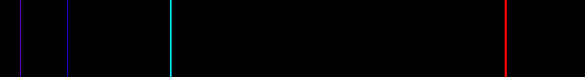

Helium:

helium_spec.gif

helium_emission.gif

\*\*NOTE: These spectra images of Helium use different scales, so their emission lines do not line up.

Mercury:

mercury-emission.gif

Neon:

neon-emission-sp.gif

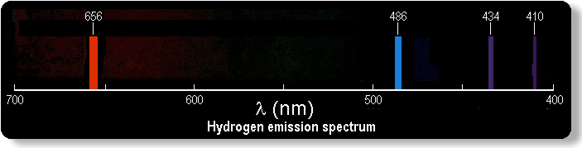

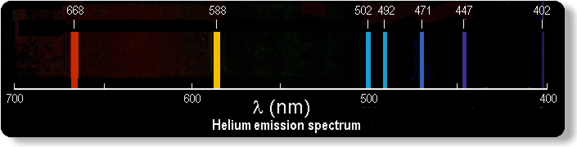

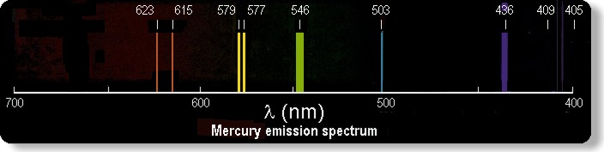

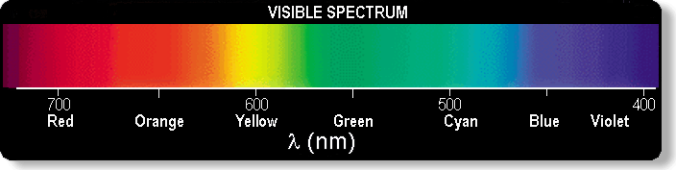



Hydrogen:



Helium:

helium.jpg

Mercury:



**Conceptual Physics Workbook**

# Appendix A: Lecture Activities

**Quick Questions**

Answer on separate page individually or in groups as instructor requires.

1. Is Creationism or Intelligent Design a valid scientific hypothesis? Remember, to be valid a measurement, observation, or experiment must be falsifiable. In other words, if untrue the experiment, measurement, or observation must be able to detect that. Can you design such an experiment? Why or why not? Explain.
2. View electric motor and Explain how it works.
3. View the high road, low road demonstration and explain the differences in average speed. Use algebraic reasoning.
4. View wave motion, measure wavelength and frequency, and calculate speed. Compare this to direct measurement of speed of wave crest.

# **Which Way Does the Moon Move?**

\_\_\_\_\_\_\_\_\_\_\_\_\_\_\_\_\_\_/\_\_\_\_\_\_\_\_\_\_\_\_\_\_\_\_\_\_/\_\_\_\_\_\_\_\_\_\_\_\_\_\_\_\_\_\_

**Names – 3 to 5 people per group,**

\_\_\_\_\_\_\_\_\_\_\_\_\_\_\_\_\_\_/\_\_\_\_\_\_\_\_\_\_\_\_\_\_\_\_\_\_**at 6 split into 2 groups**

**Class:\_\_\_\_\_\_\_\_\_\_\_\_\_\_\_\_\_\_\_Section: \_\_\_\_\_\_\_\_\_\_\_\_\_\_Date:\_\_\_\_\_\_\_\_\_\_\_\_\_\_**

The Sun and the Moon are the two astronomical objects that are most evident to us.  In this assignment we seek to answer the direction the Moon moves around the Earth.

Equipment:  Your eyes and brains and your teammates

Procedure:  Over the period of this class, observe the moon nightly (or daily).  Work as a team – if one person forgets to observe, another teammate can pick up the slack.  Discuss this with each other.  Sketch the image of the moon - be sure to label North, South, East, and West.  The four most common phases follow:

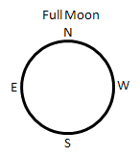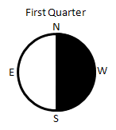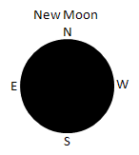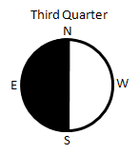

North, South, East, and West are the direction you would observe when laying on your back with your head to the North and looking UP into the sky. A regular map is the view looking DOWN at the Earth. We are flipped 180° from what we were used to.

In addition to phase, report Moon rise and Moon set. You may estimate this.  For example, if at 8 pm the moon is halfway through the sky, Moon rise was about 6 hr before that or 2 pm and Moon set is about 6 hr after that or 2 am. Fill in the table at the end for at least one full cycle. A few days before the New Moon, the Moon sets shortly before the Sun and is difficult to see near sunset, but can be seen shortly before sunrise. After the New Moon it is easy to see after sunset, but after the First Quarter it rises past midnight. You may skip days if inclement weather prohibits observation, but do the best you can.

**Required Analysis & Conclusion**: Explain, at a 5th grade level, the direction (clockwise or counter-clockwise) the Moon revolves around the Earth and how you deduced this from observation of phases and Moon rise and set. *Observations may be done as a group, but your explanations must be turned in individually.* Sketch the relationship of the Sun, Earth and Moon in for the four major phases of the Moon. Show the view looking down at the North pole, the view from Earth, the direction the Earth is rotating, and the direction the Moon is revolving.

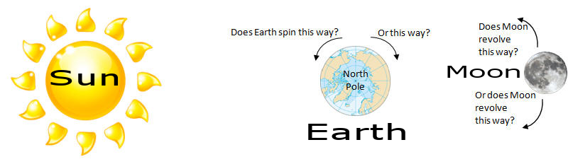

|  |  |  |  |  |  |  |
| --- | --- | --- | --- | --- | --- | --- |
| Sunday | Monday | Tuesday | Wednesday | Thursday | Friday | Saturday |
| Sketch  Moon  rise:  Moon  set: | Sketch  Moon  rise:  Moon  set: | Sketch  Moon  rise:  Moon  set: | Sketch  Moon  rise:  Moon  set: | Sketch  Moon  rise:  Moon  set: | Sketch  Moon  rise:  Moon  set: | Sketch  Moon  rise:  Moon  set: |
| Sketch  Moon  rise:  Moon  set: | Sketch  Moon  rise:  Moon  set: | Sketch  Moon  rise:  Moon  set: | Sketch  Moon  rise:  Moon  set: | Sketch  Moon  rise:  Moon  set: | Sketch  Moon  rise:  Moon  set: | Sketch  Moon  rise:  Moon  set: |
| Sketch  Moon  rise:  Moon  set: | Sketch  Moon  rise:  Moon  set: | Sketch  Moon  rise:  Moon  set: | Sketch  Moon  rise:  Moon  set: | Sketch  Moon  rise:  Moon  set: | Sketch  Moon  rise:  Moon  set: | Sketch  Moon  rise:  Moon  set: |
| Sketch  Moon  rise:  Moon  set: | Sketch  Moon  rise:  Moon  set: | Sketch  Moon  rise:  Moon  set: | Sketch  Moon  rise:  Moon  set: | Sketch  Moon  rise:  Moon  set: | Sketch  Moon  rise:  Moon  set: | Sketch  Moon  rise:  Moon  set: |
| Sketch  Moon  rise:  Moon  set: | Sketch  Moon  rise:  Moon  set: | Sketch  Moon  rise:  Moon  set: | Sketch  Moon  rise:  Moon  set: | Sketch  Moon  rise:  Moon  set: | Sketch  Moon  rise:  Moon  set: | Sketch  Moon  rise:  Moon  set: |
| Sketch  Moon  rise:  Moon  set: | Sketch  Moon  rise:  Moon  set: | Sketch  Moon  rise:  Moon  set: | Sketch  Moon  rise:  Moon  set: | Sketch  Moon  rise:  Moon  set: | Sketch  Moon  rise:  Moon  set: | Sketch  Moon  rise:  Moon  set: |

Page left intentionally blank

|  |
| --- |
| ****Project**** |

\_\_\_\_\_\_\_\_\_\_\_\_\_\_\_\_\_\_/\_\_\_\_\_\_\_\_\_\_\_\_\_\_\_\_\_\_/\_\_\_\_\_\_\_\_\_\_\_\_\_\_\_\_\_\_

**Names – 3 to 5 people per group,**

\_\_\_\_\_\_\_\_\_\_\_\_\_\_\_\_\_\_/\_\_\_\_\_\_\_\_\_\_\_\_\_\_\_\_\_\_**at 6 split into 2 groups**

**Class:\_\_\_\_\_\_\_\_\_\_\_\_\_\_\_\_\_\_\_Section: \_\_\_\_\_\_\_\_\_\_\_\_\_\_Date:\_\_\_\_\_\_\_\_\_\_\_\_\_\_**

[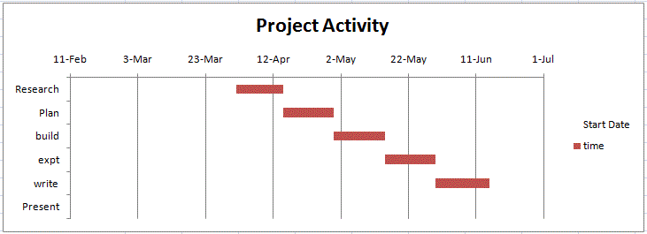](http://www.funphysicist.net/icha/excel_project_planner.xlsx) 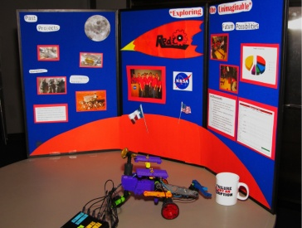

In-class groups will participate in a project and present a tri-fold display at the end of the semester.  This is very much like a K-12 high school science fair project.  Research science fair guidelines, and compare to this, to get ideas, but you will be held accountable to meet the following guidelines.

**Tri-fold, Instructable, or Maker Video Required** (see photo above right) at or prior to end of semester.  See below for [guidelines](http://www.funphysicist.net/icha/icha_project.htm#Poster_Guidelines).  Also refer to [the science poster](http://www.monash.edu.au/lls/llonline/writing/science/8.xml), [writing in science](http://www.monash.edu.au/lls/llonline/writing/science/index.xml), and [writing in engineering](http://www.monash.edu.au/lls/llonline/writing/engineering/index.xml).

**Project ideas**:  Archimede's screw (water pump), how a musical instrument works, Foucault's pendulum (no model - difficult to build), magnetic levitation, Van de Graff generator, Barkhausen effect, crystal radio (not from a kit), or CHOOSE YOUR OWN.

You may have an idea.  If you have an idea, discuss it me, your other professors, and/or contact [me](mailto:JTSizemore@tjc.edu).  I am looking for a step up from the baking soda and vinegar volcano.  But can you design a project to use baking soda and vinegar to weigh air?

Potential opportunity every semester:

* Some semesters we have disabled students who need **notetakers**.  Being a notetaker satisfies project requirement, however a tri-fold poster is still required and must have science content.

**Project requirements**:

1. **Progress Reports:**
   1. Plan:  Due about 1/3 way through semester (see syllabus).  This spreadsheet is provided as an example: [spreadsheet.](http://www.funphysicist.net/icha/excel_project_planner.xlsx)
   2. Progress Report:  Due about 2/3 way through semester (see syllabus).  Be honest - are you on track to finish.  You're grade won't depend on how your adherence to the plan, but on the honesty and accuracy of this report.
2. **Working model** if project is amenable to a working model.  Check with [me](mailto:JTSizemore@tjc.edu) if in doubt.
3. **Tri-fold Poster Guidelines**:  A Tri-fold poster is required at last day of class.  The [library](http://www.tjc.edu/Library/) or [writing lab](http://www.tjc.edu/Tutoring/Labs.php) can help AND you get ICA credit for utilizing the writing center.  Organization:
   1. **Title** (include names of group members)
   2. **Brief description** (~1 paragraphs)
   3. **Introduction** - more thorough discussion of background, history, & theory.  For trifold make these bullet points.
   4. **Experiment** - Describe equipment and procedure.  Vary factors and test the outcomes.  View labs as examples.  Ask similar questions relating to your project.  What did it do?  For example, if you build a battery, what was the voltage and how long did it run a light bulb.
   5. **Results** - Take the data, analyze it, and try to draw conclusions.  In general we report results and not raw data.
   6. **Discuss Results** - What to the results mean or imply?  Discuss cause and effect.  Did your project meet expectations or not?  What would you do differently in the future?
   7. **Brief, Key Conclusions**
   8. Cite all non-original sources using **MLA or APA style**.  Pick one or the other (MLA or APA), but be consistent.  The [library](http://www.tjc/library/) or [writing lab](http://www.tjc.edu/Tutoring/Labs.php) can help.  Remember, if you cite the source it's research, if you don't it's plagiarism.
   9. Think for yourself.  Gather research sources, however contribute your own thoughts and conclusions.  If too much of your tri-fold is citations you won't be accused of plagiarism, but the grade may suffer from lack of originality.
   10. Edit ruthlessly.  The emphasis of a tri-fold poster is on visual information & completeness yet very concise
   11. Email me an electronic version of your poster text and photos.
   12. NO FLIPPING PAGES.  Everything must be visible from the front including group member names & citations.

**Grading**:  Your grade will depend on how well you comply with these requirements.

Sometimes things don't work out as we plan.  Your grade, therefore, will not depend on whether the project works.  If it doesn't work I'll be looking for a good explanation of what went wrong; a good attempt to make a working model; a clear explanation of your project, construction, and procedures; valid testing; results and conclusions; and good tri-fold presentation.

Page left intentionally blank

|  |
| --- |
| ****Planning for College**** |

What are you going to do with the rest of your life?  How is college going to help you get there?  How are you going to finish college?  What degree are you going to get?  How will that degree help you get to the next step - finding a job or advanced degrees?

Most of you doing this assignment are just starting your career path and now is the time to think about these questions.  **Figure out what you enjoy doing, what you're good at, and what you can be paid for then target where the three intersect.**

Steps To Get There **GRADUATE! Get your two year diploma and be specific.** It will take you longer to graduate if you get a general studies diploma from community college. **Aim for a specific goal and get THAT diploma.**

**Assignment:  Plan Your Courses to Achieve Your Degree Plan**

Your mission is to map out, semester-by-semester, the courses you will need to get there.  **Plan Your Work and Work Your Plan. Failure to Plan is Planning to Fail.**

* If you have partially completed your program, starting with this semester, show how you will finish it.
* If you have not decided yet, make your best guess now. It’s easier to change your mind later than wandering aimlessly and deciding later.
* Because of work, etc., it may require more than four years. If so, show it.
* Add additional pages if needed (copy page after next).
* If you feel there is something unusual in your plans, explain those circumstances.
* Be specific.
* You have one week to complete this assignment - it is **due the first meeting of the second week of class.**
* Bug advisors and instructors for information.
* **Consult your intended four year college** – the information provided is generic and your four year college of choice may have some deviations. Do your homework now – it will save you time, energy, and money.
* Keep your assignment – we will have a one-on-one review later in the semester.

**Name:**

**Class:\_\_\_\_\_\_\_\_\_\_\_\_\_\_\_\_\_\_\_Section: \_\_\_\_\_\_\_\_\_\_\_\_\_\_Date:\_\_\_\_\_\_\_\_\_\_\_\_\_\_**

|  |  |  |  |  |  |  |  |  |  |  |
| --- | --- | --- | --- | --- | --- | --- | --- | --- | --- | --- |
| Year 1 Fall Semester | | | | |  | Year 1 Spring Semester | | | | |
| Course |  | Credits |  | What Degree Requirement? (what?, list) |  | Course |  | Credits |  | What Degree Requirement? (what?, list) |
|  |  |  |  |  |  |  |  |  |  |  |
|  |  |  |  |  |  |  |  |  |  |  |
|  |  |  |  |  |  |  |  |  |  |  |
|  |  |  |  |  |  |  |  |  |  |  |
|  |  |  |  |  |  |  |  |  |  |  |
|  |  |  |  |  |  |  |  |  |  |  |
|  |  |  |  |  |  |  |  |  |  |  |

|  |  |  |  |  |  |  |  |  |  |  |
| --- | --- | --- | --- | --- | --- | --- | --- | --- | --- | --- |
| Year 2 Fall Semester | | | | |  | Year 2 Spring Semester | | | | |
| Course |  | Credits |  | What Degree Requirement? (what?, list) |  | Course |  | Credits |  | What Degree Requirement? (what?, list) |
|  |  |  |  |  |  |  |  |  |  |  |
|  |  |  |  |  |  |  |  |  |  |  |
|  |  |  |  |  |  |  |  |  |  |  |
|  |  |  |  |  |  |  |  |  |  |  |
|  |  |  |  |  |  |  |  |  |  |  |
|  |  |  |  |  |  |  |  |  |  |  |
|  |  |  |  |  |  |  |  |  |  |  |

|  |  |  |  |  |  |  |  |  |  |  |
| --- | --- | --- | --- | --- | --- | --- | --- | --- | --- | --- |
| Year 3 Fall Semester | | | | |  | Year 3 Spring Semester | | | | |
| Course |  | Credits |  | What Degree Requirement? (what?, list) |  | Course |  | Credits |  | What Degree Requirement? (what?, list) |
|  |  |  |  |  |  |  |  |  |  |  |
|  |  |  |  |  |  |  |  |  |  |  |
|  |  |  |  |  |  |  |  |  |  |  |
|  |  |  |  |  |  |  |  |  |  |  |
|  |  |  |  |  |  |  |  |  |  |  |
|  |  |  |  |  |  |  |  |  |  |  |
|  |  |  |  |  |  |  |  |  |  |  |

|  |  |  |  |  |  |  |  |  |  |  |
| --- | --- | --- | --- | --- | --- | --- | --- | --- | --- | --- |
| Year \_\_\_\_\_\_\_\_\_\_\_ Fall Semester | | | | |  | Year \_\_\_\_\_\_\_\_\_\_\_ Spring Semester | | | | |
| Course |  | Credits |  | Degree Requirement? (what?, list) |  | Course |  | Credits |  | Degree Requirement? (what?, list) |
|  |  |  |  |  |  |  |  |  |  |  |
|  |  |  |  |  |  |  |  |  |  |  |
|  |  |  |  |  |  |  |  |  |  |  |
|  |  |  |  |  |  |  |  |  |  |  |
|  |  |  |  |  |  |  |  |  |  |  |
|  |  |  |  |  |  |  |  |  |  |  |
|  |  |  |  |  |  |  |  |  |  |  |

|  |  |  |  |  |  |  |  |  |  |  |
| --- | --- | --- | --- | --- | --- | --- | --- | --- | --- | --- |
| Year \_\_\_\_\_\_\_\_\_\_\_ Fall Semester | | | | |  | Year \_\_\_\_\_\_\_\_\_\_\_ Spring Semester | | | | |
| Course |  | Credits |  | Degree Requirement? (what?, list) |  | Course |  | Credits |  | Degree Requirement? (what?, list) |
|  |  |  |  |  |  |  |  |  |  |  |
|  |  |  |  |  |  |  |  |  |  |  |
|  |  |  |  |  |  |  |  |  |  |  |
|  |  |  |  |  |  |  |  |  |  |  |
|  |  |  |  |  |  |  |  |  |  |  |
|  |  |  |  |  |  |  |  |  |  |  |
|  |  |  |  |  |  |  |  |  |  |  |

|  |  |  |  |  |  |  |  |  |  |  |
| --- | --- | --- | --- | --- | --- | --- | --- | --- | --- | --- |
| Year \_\_\_\_\_\_\_\_\_\_\_ Fall Semester | | | | |  | Year \_\_\_\_\_\_\_\_\_\_\_ Spring Semester | | | | |
| Course |  | Credits |  | Degree Requirement? (what?, list) |  | Course |  | Credits |  | Degree Requirement? (what?, list) |
|  |  |  |  |  |  |  |  |  |  |  |
|  |  |  |  |  |  |  |  |  |  |  |
|  |  |  |  |  |  |  |  |  |  |  |
|  |  |  |  |  |  |  |  |  |  |  |
|  |  |  |  |  |  |  |  |  |  |  |
|  |  |  |  |  |  |  |  |  |  |  |
|  |  |  |  |  |  |  |  |  |  |  |

Page left intentionally blank

|  |
| --- |
| ****Philosophy of Science Debate**** |

\_\_\_\_\_\_\_\_\_\_\_\_\_\_\_\_\_\_/\_\_\_\_\_\_\_\_\_\_\_\_\_\_\_\_\_\_/\_\_\_\_\_\_\_\_\_\_\_\_\_\_\_\_\_\_

**Names – 3 to 5 people per group,**

\_\_\_\_\_\_\_\_\_\_\_\_\_\_\_\_\_\_/\_\_\_\_\_\_\_\_\_\_\_\_\_\_\_\_\_\_**at 6 split into 2 groups**

**Class:\_\_\_\_\_\_\_\_\_\_\_\_\_\_\_\_\_\_\_Section: \_\_\_\_\_\_\_\_\_\_\_\_\_\_Date:\_\_\_\_\_\_\_\_\_\_\_\_\_\_**

There are two main issues regarding the philosophy of science.  The first is, Can science really prove anything beyond a shadow of a doubt? And the second is, Does religion have a place in scientific thinking?

We will divide up into 4 teams.  Two teams will take the pro and con of the first question and the other two teams will take the pro and con of the second question.  Self select, however if teams are unbalanced people may be place on a different team by lottery.  Each team will have 15 min. to huddle to prepare.  The debate will be three minutes to each team argue their position and two minutes each for rebuttal.  Then the entire class will vote by secret ballot.  The grade will depend on respectful discussion, reasoning, critical thinking, and participation.  Since teams may of necessity be chosen by lottery, the grade will not depend on the proposition your team is defending or the outcome of the vote.

Enter bullet points of your reasoning here:

|  |  |
| --- | --- |
| Question:  Can science really prove anything beyond a shadow of a doubt? | Question:  Does religion have a place in scientific thinking? |
| Proposition:  Science can prove something beyond a shadow of a doubt: | Proposition: Religion has a place in scientific thought: |
| Proposition:  Science CANNOT prove something beyond a shadow of a doubt: | Proposition:  Religion DOES NOT have a place in scientific thought: |

For fun (and relevant to future quizzes and exams) I thought of the un-testable hypothesis of a secret world of wizards and witches who boarded a train to Hogwart's School of Witchcraft and Wizardry through an invisible portal at platform 9 3/4 at King's Cross Station in London. For more see [Flickr Group](https://www.flickr.com/groups/633663@N22/pool/).

Page left intentionally blank

|  |
| --- |
| ****Mass of a penny**** |

\_\_\_\_\_\_\_\_\_\_\_\_\_\_\_\_\_\_/\_\_\_\_\_\_\_\_\_\_\_\_\_\_\_\_\_\_/\_\_\_\_\_\_\_\_\_\_\_\_\_\_\_\_\_\_

**Names – 3 to 5 people per group,**

\_\_\_\_\_\_\_\_\_\_\_\_\_\_\_\_\_\_/\_\_\_\_\_\_\_\_\_\_\_\_\_\_\_\_\_\_**at 6 split into 2 groups**

**Class:\_\_\_\_\_\_\_\_\_\_\_\_\_\_\_\_\_\_\_Section: \_\_\_\_\_\_\_\_\_\_\_\_\_\_Date:\_\_\_\_\_\_\_\_\_\_\_\_\_\_**

Taking accurate measurement is one of the most important aspects of studying physics or, indeed, any other quantitative discipline.  You may find these results surprising.

Mass is the amount of matter in an object.  Technically, mass is a measure of the inertia of an object and inertia is how much an object resists change in velocity.  On the other hand, weight is a special type of force - the force gravity exerts on an object.  The mass is the same on the Earth and the Moon, but weight is different because the Moon's gravity attracts less.

Later we will study density.  The mass per (divided by) volume is density.  [By the way](http://en.wikipedia.org/wiki/Archimedes#The_Golden_Crown), this topic was important historically and resulted in a mad scientist streaking naked through the streets shouting "Eureka" and the loss of a goldsmith's head for cheating a king.

Equipment required - pennies, balance, Vernier caliper, micrometer, [graph paper](http://www.funphysicist.net/help/graph_fifth.htm).

Data and Results

|  |  |  |
| --- | --- | --- |
| Penny | Mass (gm) | Procedure   1. Without anything on the mass balance, adjust it so it reads zero. 2. Carefully find the mass of 10 different pennies to the nearest hundredth of a gram and record data below 3. Pennies most likely do not have identical masses.  To find patterns in data people create a type of graph called a histogram which plots the frequency of each measurement.  The vertical (y) axis on a histogram is the frequency and horizontal (x) axis is the mass (increments of a tenth of a gm).  Using the graph paper provided (or your own), create a histogram of the mass. 4. Can the pennies be divided into groups based on mass?  If so, report the center (average or mean if you prefer) of each group (3 rows are provided, but that doesn't mean pennies can be divided into 3 groups) |
| 1 |  |
| 2 |  |
| 3 |  |
| 4 |  |
| 5 |  |
| 6 |  |
| 7 |  |
| 8 |  |
| 9 |  |
| 10 |  |
| Center of Group 1 |  |
| Center of Group 2 |  |
| Center of Group 3 |  |

Analysis

1. What do you observe about the mass of the pennies (examine histograms)?
2. Do the pennies look the same?
3. If all the pennies look the same, explain why mass is different?
4. How might you analyze the information differently to provide meaningful information?

|  |  |  |  |  |  |  |  |  |  |  |  |  |  |  |  |  |  |  |  |  |  |  |  |  |  |  |  |  |  |  |
| --- | --- | --- | --- | --- | --- | --- | --- | --- | --- | --- | --- | --- | --- | --- | --- | --- | --- | --- | --- | --- | --- | --- | --- | --- | --- | --- | --- | --- | --- | --- |
|  |  |  |  |  |  |  |  |  |  |  |  |  |  |  |  |  |  |  |  |  |  |  |  |  |  |  |  |  |  |  |
|  |  |  |  |  |  |  |  |  |  |  |  |  |  |  |  |  |  |  |  |  |  |  |  |  |  |  |  |  |  |  |
|  |  |  |  |  |  |  |  |  |  |  |  |  |  |  |  |  |  |  |  |  |  |  |  |  |  |  |  |  |  |  |
|  |  |  |  |  |  |  |  |  |  |  |  |  |  |  |  |  |  |  |  |  |  |  |  |  |  |  |  |  |  |  |
|  |  |  |  |  |  |  |  |  |  |  |  |  |  |  |  |  |  |  |  |  |  |  |  |  |  |  |  |  |  |  |
|  |  |  |  |  |  |  |  |  |  |  |  |  |  |  |  |  |  |  |  |  |  |  |  |  |  |  |  |  |  |  |
|  |  |  |  |  |  |  |  |  |  |  |  |  |  |  |  |  |  |  |  |  |  |  |  |  |  |  |  |  |  |  |
|  |  |  |  |  |  |  |  |  |  |  |  |  |  |  |  |  |  |  |  |  |  |  |  |  |  |  |  |  |  |  |
|  |  |  |  |  |  |  |  |  |  |  |  |  |  |  |  |  |  |  |  |  |  |  |  |  |  |  |  |  |  |  |
|  |  |  |  |  |  |  |  |  |  |  |  |  |  |  |  |  |  |  |  |  |  |  |  |  |  |  |  |  |  |  |
|  |  |  |  |  |  |  |  |  |  |  |  |  |  |  |  |  |  |  |  |  |  |  |  |  |  |  |  |  |  |  |
|  |  |  |  |  |  |  |  |  |  |  |  |  |  |  |  |  |  |  |  |  |  |  |  |  |  |  |  |  |  |  |
|  |  |  |  |  |  |  |  |  |  |  |  |  |  |  |  |  |  |  |  |  |  |  |  |  |  |  |  |  |  |  |
|  |  |  |  |  |  |  |  |  |  |  |  |  |  |  |  |  |  |  |  |  |  |  |  |  |  |  |  |  |  |  |
|  |  |  |  |  |  |  |  |  |  |  |  |  |  |  |  |  |  |  |  |  |  |  |  |  |  |  |  |  |  |  |
|  |  |  |  |  |  |  |  |  |  |  |  |  |  |  |  |  |  |  |  |  |  |  |  |  |  |  |  |  |  |  |
|  |  |  |  |  |  |  |  |  |  |  |  |  |  |  |  |  |  |  |  |  |  |  |  |  |  |  |  |  |  |  |
|  |  |  |  |  |  |  |  |  |  |  |  |  |  |  |  |  |  |  |  |  |  |  |  |  |  |  |  |  |  |  |
|  |  |  |  |  |  |  |  |  |  |  |  |  |  |  |  |  |  |  |  |  |  |  |  |  |  |  |  |  |  |  |
|  |  |  |  |  |  |  |  |  |  |  |  |  |  |  |  |  |  |  |  |  |  |  |  |  |  |  |  |  |  |  |
|  |  |  |  |  |  |  |  |  |  |  |  |  |  |  |  |  |  |  |  |  |  |  |  |  |  |  |  |  |  |  |
|  |  |  |  |  |  |  |  |  |  |  |  |  |  |  |  |  |  |  |  |  |  |  |  |  |  |  |  |  |  |  |
|  |  |  |  |  |  |  |  |  |  |  |  |  |  |  |  |  |  |  |  |  |  |  |  |  |  |  |  |  |  |  |
|  |  |  |  |  |  |  |  |  |  |  |  |  |  |  |  |  |  |  |  |  |  |  |  |  |  |  |  |  |  |  |
|  |  |  |  |  |  |  |  |  |  |  |  |  |  |  |  |  |  |  |  |  |  |  |  |  |  |  |  |  |  |  |
|  |  |  |  |  |  |  |  |  |  |  |  |  |  |  |  |  |  |  |  |  |  |  |  |  |  |  |  |  |  |  |
|  |  |  |  |  |  |  |  |  |  |  |  |  |  |  |  |  |  |  |  |  |  |  |  |  |  |  |  |  |  |  |
|  |  |  |  |  |  |  |  |  |  |  |  |  |  |  |  |  |  |  |  |  |  |  |  |  |  |  |  |  |  |  |
|  |  |  |  |  |  |  |  |  |  |  |  |  |  |  |  |  |  |  |  |  |  |  |  |  |  |  |  |  |  |  |
|  |  |  |  |  |  |  |  |  |  |  |  |  |  |  |  |  |  |  |  |  |  |  |  |  |  |  |  |  |  |  |
|  |  |  |  |  |  |  |  |  |  |  |  |  |  |  |  |  |  |  |  |  |  |  |  |  |  |  |  |  |  |  |
|  |  |  |  |  |  |  |  |  |  |  |  |  |  |  |  |  |  |  |  |  |  |  |  |  |  |  |  |  |  |  |
|  |  |  |  |  |  |  |  |  |  |  |  |  |  |  |  |  |  |  |  |  |  |  |  |  |  |  |  |  |  |  |
|  |  |  |  |  |  |  |  |  |  |  |  |  |  |  |  |  |  |  |  |  |  |  |  |  |  |  |  |  |  |  |
|  |  |  |  |  |  |  |  |  |  |  |  |  |  |  |  |  |  |  |  |  |  |  |  |  |  |  |  |  |  |  |
|  |  |  |  |  |  |  |  |  |  |  |  |  |  |  |  |  |  |  |  |  |  |  |  |  |  |  |  |  |  |  |
|  |  |  |  |  |  |  |  |  |  |  |  |  |  |  |  |  |  |  |  |  |  |  |  |  |  |  |  |  |  |  |
|  |  |  |  |  |  |  |  |  |  |  |  |  |  |  |  |  |  |  |  |  |  |  |  |  |  |  |  |  |  |  |
|  |  |  |  |  |  |  |  |  |  |  |  |  |  |  |  |  |  |  |  |  |  |  |  |  |  |  |  |  |  |  |
|  |  |  |  |  |  |  |  |  |  |  |  |  |  |  |  |  |  |  |  |  |  |  |  |  |  |  |  |  |  |  |
|  |  |  |  |  |  |  |  |  |  |  |  |  |  |  |  |  |  |  |  |  |  |  |  |  |  |  |  |  |  |  |
|  |  |  |  |  |  |  |  |  |  |  |  |  |  |  |  |  |  |  |  |  |  |  |  |  |  |  |  |  |  |  |
|  |  |  |  |  |  |  |  |  |  |  |  |  |  |  |  |  |  |  |  |  |  |  |  |  |  |  |  |  |  |  |
|  |  |  |  |  |  |  |  |  |  |  |  |  |  |  |  |  |  |  |  |  |  |  |  |  |  |  |  |  |  |  |
|  |  |  |  |  |  |  |  |  |  |  |  |  |  |  |  |  |  |  |  |  |  |  |  |  |  |  |  |  |  |  |
|  |  |  |  |  |  |  |  |  |  |  |  |  |  |  |  |  |  |  |  |  |  |  |  |  |  |  |  |  |  |  |
|  |  |  |  |  |  |  |  |  |  |  |  |  |  |  |  |  |  |  |  |  |  |  |  |  |  |  |  |  |  |  |
|  |  |  |  |  |  |  |  |  |  |  |  |  |  |  |  |  |  |  |  |  |  |  |  |  |  |  |  |  |  |  |

|  |  |  |  |  |  |  |  |  |  |  |  |  |  |  |  |  |  |  |  |  |  |  |  |  |  |  |  |  |  |  |
| --- | --- | --- | --- | --- | --- | --- | --- | --- | --- | --- | --- | --- | --- | --- | --- | --- | --- | --- | --- | --- | --- | --- | --- | --- | --- | --- | --- | --- | --- | --- |
|  |  |  |  |  |  |  |  |  |  |  |  |  |  |  |  |  |  |  |  |  |  |  |  |  |  |  |  |  |  |  |
|  |  |  |  |  |  |  |  |  |  |  |  |  |  |  |  |  |  |  |  |  |  |  |  |  |  |  |  |  |  |  |
|  |  |  |  |  |  |  |  |  |  |  |  |  |  |  |  |  |  |  |  |  |  |  |  |  |  |  |  |  |  |  |
|  |  |  |  |  |  |  |  |  |  |  |  |  |  |  |  |  |  |  |  |  |  |  |  |  |  |  |  |  |  |  |
|  |  |  |  |  |  |  |  |  |  |  |  |  |  |  |  |  |  |  |  |  |  |  |  |  |  |  |  |  |  |  |
|  |  |  |  |  |  |  |  |  |  |  |  |  |  |  |  |  |  |  |  |  |  |  |  |  |  |  |  |  |  |  |
|  |  |  |  |  |  |  |  |  |  |  |  |  |  |  |  |  |  |  |  |  |  |  |  |  |  |  |  |  |  |  |
|  |  |  |  |  |  |  |  |  |  |  |  |  |  |  |  |  |  |  |  |  |  |  |  |  |  |  |  |  |  |  |
|  |  |  |  |  |  |  |  |  |  |  |  |  |  |  |  |  |  |  |  |  |  |  |  |  |  |  |  |  |  |  |
|  |  |  |  |  |  |  |  |  |  |  |  |  |  |  |  |  |  |  |  |  |  |  |  |  |  |  |  |  |  |  |
|  |  |  |  |  |  |  |  |  |  |  |  |  |  |  |  |  |  |  |  |  |  |  |  |  |  |  |  |  |  |  |
|  |  |  |  |  |  |  |  |  |  |  |  |  |  |  |  |  |  |  |  |  |  |  |  |  |  |  |  |  |  |  |
|  |  |  |  |  |  |  |  |  |  |  |  |  |  |  |  |  |  |  |  |  |  |  |  |  |  |  |  |  |  |  |
|  |  |  |  |  |  |  |  |  |  |  |  |  |  |  |  |  |  |  |  |  |  |  |  |  |  |  |  |  |  |  |
|  |  |  |  |  |  |  |  |  |  |  |  |  |  |  |  |  |  |  |  |  |  |  |  |  |  |  |  |  |  |  |
|  |  |  |  |  |  |  |  |  |  |  |  |  |  |  |  |  |  |  |  |  |  |  |  |  |  |  |  |  |  |  |
|  |  |  |  |  |  |  |  |  |  |  |  |  |  |  |  |  |  |  |  |  |  |  |  |  |  |  |  |  |  |  |
|  |  |  |  |  |  |  |  |  |  |  |  |  |  |  |  |  |  |  |  |  |  |  |  |  |  |  |  |  |  |  |
|  |  |  |  |  |  |  |  |  |  |  |  |  |  |  |  |  |  |  |  |  |  |  |  |  |  |  |  |  |  |  |
|  |  |  |  |  |  |  |  |  |  |  |  |  |  |  |  |  |  |  |  |  |  |  |  |  |  |  |  |  |  |  |
|  |  |  |  |  |  |  |  |  |  |  |  |  |  |  |  |  |  |  |  |  |  |  |  |  |  |  |  |  |  |  |
|  |  |  |  |  |  |  |  |  |  |  |  |  |  |  |  |  |  |  |  |  |  |  |  |  |  |  |  |  |  |  |
|  |  |  |  |  |  |  |  |  |  |  |  |  |  |  |  |  |  |  |  |  |  |  |  |  |  |  |  |  |  |  |
|  |  |  |  |  |  |  |  |  |  |  |  |  |  |  |  |  |  |  |  |  |  |  |  |  |  |  |  |  |  |  |
|  |  |  |  |  |  |  |  |  |  |  |  |  |  |  |  |  |  |  |  |  |  |  |  |  |  |  |  |  |  |  |
|  |  |  |  |  |  |  |  |  |  |  |  |  |  |  |  |  |  |  |  |  |  |  |  |  |  |  |  |  |  |  |
|  |  |  |  |  |  |  |  |  |  |  |  |  |  |  |  |  |  |  |  |  |  |  |  |  |  |  |  |  |  |  |
|  |  |  |  |  |  |  |  |  |  |  |  |  |  |  |  |  |  |  |  |  |  |  |  |  |  |  |  |  |  |  |
|  |  |  |  |  |  |  |  |  |  |  |  |  |  |  |  |  |  |  |  |  |  |  |  |  |  |  |  |  |  |  |
|  |  |  |  |  |  |  |  |  |  |  |  |  |  |  |  |  |  |  |  |  |  |  |  |  |  |  |  |  |  |  |
|  |  |  |  |  |  |  |  |  |  |  |  |  |  |  |  |  |  |  |  |  |  |  |  |  |  |  |  |  |  |  |
|  |  |  |  |  |  |  |  |  |  |  |  |  |  |  |  |  |  |  |  |  |  |  |  |  |  |  |  |  |  |  |
|  |  |  |  |  |  |  |  |  |  |  |  |  |  |  |  |  |  |  |  |  |  |  |  |  |  |  |  |  |  |  |
|  |  |  |  |  |  |  |  |  |  |  |  |  |  |  |  |  |  |  |  |  |  |  |  |  |  |  |  |  |  |  |
|  |  |  |  |  |  |  |  |  |  |  |  |  |  |  |  |  |  |  |  |  |  |  |  |  |  |  |  |  |  |  |
|  |  |  |  |  |  |  |  |  |  |  |  |  |  |  |  |  |  |  |  |  |  |  |  |  |  |  |  |  |  |  |
|  |  |  |  |  |  |  |  |  |  |  |  |  |  |  |  |  |  |  |  |  |  |  |  |  |  |  |  |  |  |  |
|  |  |  |  |  |  |  |  |  |  |  |  |  |  |  |  |  |  |  |  |  |  |  |  |  |  |  |  |  |  |  |
|  |  |  |  |  |  |  |  |  |  |  |  |  |  |  |  |  |  |  |  |  |  |  |  |  |  |  |  |  |  |  |
|  |  |  |  |  |  |  |  |  |  |  |  |  |  |  |  |  |  |  |  |  |  |  |  |  |  |  |  |  |  |  |
|  |  |  |  |  |  |  |  |  |  |  |  |  |  |  |  |  |  |  |  |  |  |  |  |  |  |  |  |  |  |  |
|  |  |  |  |  |  |  |  |  |  |  |  |  |  |  |  |  |  |  |  |  |  |  |  |  |  |  |  |  |  |  |
|  |  |  |  |  |  |  |  |  |  |  |  |  |  |  |  |  |  |  |  |  |  |  |  |  |  |  |  |  |  |  |
|  |  |  |  |  |  |  |  |  |  |  |  |  |  |  |  |  |  |  |  |  |  |  |  |  |  |  |  |  |  |  |
|  |  |  |  |  |  |  |  |  |  |  |  |  |  |  |  |  |  |  |  |  |  |  |  |  |  |  |  |  |  |  |
|  |  |  |  |  |  |  |  |  |  |  |  |  |  |  |  |  |  |  |  |  |  |  |  |  |  |  |  |  |  |  |
|  |  |  |  |  |  |  |  |  |  |  |  |  |  |  |  |  |  |  |  |  |  |  |  |  |  |  |  |  |  |  |
|  |  |  |  |  |  |  |  |  |  |  |  |  |  |  |  |  |  |  |  |  |  |  |  |  |  |  |  |  |  |  |

Page left intentionally blank

|  |
| --- |
| ****How to Weigh Air**** |

\_\_\_\_\_\_\_\_\_\_\_\_\_\_\_\_\_\_/\_\_\_\_\_\_\_\_\_\_\_\_\_\_\_\_\_\_/\_\_\_\_\_\_\_\_\_\_\_\_\_\_\_\_\_\_

**Names – 3 to 5 people per group,**

\_\_\_\_\_\_\_\_\_\_\_\_\_\_\_\_\_\_/\_\_\_\_\_\_\_\_\_\_\_\_\_\_\_\_\_\_**at 6 split into 2 groups**

**Class:\_\_\_\_\_\_\_\_\_\_\_\_\_\_\_\_\_\_\_Section: \_\_\_\_\_\_\_\_\_\_\_\_\_\_Date:\_\_\_\_\_\_\_\_\_\_\_\_\_\_**

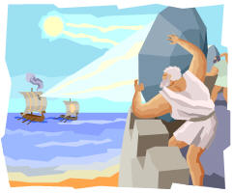Did you know Archimedes invented the raygun?  See picure at right – He did!  He also figured out how a goldsmith cheated a king.  We're going to use the same principle to weigh air.

1. We have evacuated Magdeburg hemisphere's with us today which means it doesn't have any air inside. What's the mass to the nearest tenth gm? Call this quantity mt (empty - get it) and be sure to list quantities as equations with units, for example, mt = xxx.x gm (each x represent a digit).

1. mt is NOT the true mass of the hemispheres. Remember, the mass balance actually measure FORCE exerted on the scale. So what force is exerted in N? Call this ft.

1. We'll learn more about pressure later, however it's defined as force per unit area. The weight of our entire atmosphere causes an average pressure of 101,325 N/m2 at sea level and 15°C. So the force holding the hemisphere's together is the cross-sectional area times pressure. To get a rough idea how much this is, try pulling the Madgeburg hemispere's apart. Was it easy or hard? Did it take more than one person?

1. Now that you've pulled it apart (or let the air back in), what is the mass now to the nearest tenth gm? Call this quantity ma (mass apart). Pick symbols for your quantities that mnemonically remind you of what that quantity represents.

1. What is the weight in N? Call this Fa remembering that weight is just a special type of force. The force of gravity.

1. What is the inside diameter to the nearest mm?

1. Calculate the volume of the hemisphere in m3. Do you have the volume of a sphere on the top of your head? This is such a common formula that science students should know it by heart. It is: V = 4πr3/3.

1. Archimede's Principle tells us that the bouyant force equals the weight of the fluid (in this case air) displaced. When the hemispheres are separated there is no bouyant force.  Draw force diagrams for our two cases - the hemispheres evacuated and the hemispheres pulled apart. Although Archimede's deals with fluids, which is in a later chapter, it is introduced when we discuss force because it REALLY helps you understand force balance.

1. From the force balance sketches you just made, derive a formula for the bouyant force in terms of your known quantities. It's a good idea to work things out using scratch paper and putting your final derivation here afterward.

1. Now calculate the bouyant force.

1. Knowing the bouyant force is the weight of the air displaced what, therefore, is the mass of the air in kg?

1. What is the density of air in kg/m3? The accepted value is 1.28 kg/m3.

1. The accepted value is 1.28 kg/m3. Calculate your percent difference. If you're within 30% you're doing well. Why is this measurement so inaccurate?

Page left intentionally blank

|  |
| --- |
| ****Roadrunner**** |

\_\_\_\_\_\_\_\_\_\_\_\_\_\_\_\_\_\_/\_\_\_\_\_\_\_\_\_\_\_\_\_\_\_\_\_\_/\_\_\_\_\_\_\_\_\_\_\_\_\_\_\_\_\_\_

**Names – 3 to 5 people per group,**

\_\_\_\_\_\_\_\_\_\_\_\_\_\_\_\_\_\_/\_\_\_\_\_\_\_\_\_\_\_\_\_\_\_\_\_\_**at 6 split into 2 groups**

**Class:\_\_\_\_\_\_\_\_\_\_\_\_\_\_\_\_\_\_\_Section: \_\_\_\_\_\_\_\_\_\_\_\_\_\_Date:\_\_\_\_\_\_\_\_\_\_\_\_\_\_**

Roadrunner from http://www.freeclipartnow.com/cartoons-comics/road-runner/roadrunner.gif.htmlWe will watch a Roadrunner cartoon to find physical law violations in those cartoons.  When we do, get with your ICA group, watch the cartoon with the rest of the class, then discuss and list the physical law violations observed.  You may use this form or a separate piece of paper.

|  |  |  |
| --- | --- | --- |
| Description of Scene | Name the Law Violated | How was the Law Violated? |
|  |  |  |
|  |  |  |
|  |  |  |
|  |  |  |
|  |  |  |
|  |  |  |
|  |  |  |
|  |  |  |
|  |  |  |
|  |  |  |
|  |  |  |
|  |  |  |

|  |  |  |
| --- | --- | --- |
| Description of Scene | Name the Law Violated | How was the Law Violated? |
|  |  |  |
|  |  |  |
|  |  |  |
|  |  |  |
|  |  |  |
|  |  |  |
|  |  |  |
|  |  |  |
|  |  |  |
|  |  |  |
|  |  |  |
|  |  |  |
|  |  |  |
|  |  |  |
|  |  |  |
|  |  |  |

Page left intentionally blank

|  |
| --- |
| ****Roadrunner Speed**** |

\_\_\_\_\_\_\_\_\_\_\_\_\_\_\_\_\_\_/\_\_\_\_\_\_\_\_\_\_\_\_\_\_\_\_\_\_/\_\_\_\_\_\_\_\_\_\_\_\_\_\_\_\_\_\_

**Names – 3 to 5 people per group,**

\_\_\_\_\_\_\_\_\_\_\_\_\_\_\_\_\_\_/\_\_\_\_\_\_\_\_\_\_\_\_\_\_\_\_\_\_**at 6 split into 2 groups**

**Class:\_\_\_\_\_\_\_\_\_\_\_\_\_\_\_\_\_\_\_Section: \_\_\_\_\_\_\_\_\_\_\_\_\_\_Date:\_\_\_\_\_\_\_\_\_\_\_\_\_\_**

Roadrunner from http://www.freeclipartnow.com/cartoons-comics/road-runner/roadrunner.gif.htmlIn today's Roadrunner cartoon, in addition to identifying scenes where a physical law is violated (and which law is violated and how it was violated), estimate the Roadrunner's speed.  What is your estimate?  Show calculations.

Based on your estimate, what do you think the problems might be going that fast?  Presuming the estimate is less than the speed of light it's possible for an object to go that fast, but other things happen at speeds slower than light speed, but still fast compared to, for example, a jet airplane.  What are those "other things" and what might they do to the Roadrunner?

Also get with your ICHA group, watch the rest of the cartoon, then discuss and list the physical laws and/or violations.  Use a separate piece of paper as needed.

|  |  |  |
| --- | --- | --- |
| Description of Scene | Name the Law Violated | How was the Law Violated? |
|  |  |  |
|  |  |  |
|  |  |  |
|  |  |  |
|  |  |  |
|  |  |  |
|  |  |  |
|  |  |  |

Page left intentionally blank

|  |
| --- |
| ****How Fast Must Supergirl Jump**** |

\_\_\_\_\_\_\_\_\_\_\_\_\_\_\_\_\_\_/\_\_\_\_\_\_\_\_\_\_\_\_\_\_\_\_\_\_/\_\_\_\_\_\_\_\_\_\_\_\_\_\_\_\_\_\_

**Names – 3 to 5 people per group,**

\_\_\_\_\_\_\_\_\_\_\_\_\_\_\_\_\_\_/\_\_\_\_\_\_\_\_\_\_\_\_\_\_\_\_\_\_**at 6 split into 2 groups**

**Class:\_\_\_\_\_\_\_\_\_\_\_\_\_\_\_\_\_\_\_Section: \_\_\_\_\_\_\_\_\_\_\_\_\_\_Date:\_\_\_\_\_\_\_\_\_\_\_\_\_\_**

Originally Kryptonites (people from Krypton, that is, Superman, Supergirl, etc.) could only leap - they couldn't fly.  Let's figure out how fast Supergirl must take-off to jump to the top of the steeple (21.0 m) or other local towers.  The pre-calculus and calculus based classes also have to figure out the acceleration required. 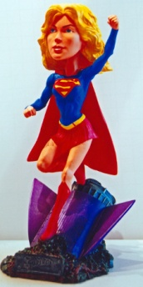

Why did I use the character of Supergirl and not Superman?  In our modern age women do everything men do including top levels of their fields in medicine, law, politics, business, etc.  Currently women comprise about half of post-graduate mathematics, but not post-graduate engineering and physics.  Certainly if women can do the math they can do physics and engineering.  So to advocate for women in physics and engineering I'll use female characters, even if fictional ones.

The first thing to do is figure out how high she must jump.  There are several methods to do this, length of shadows, a photo and application of trigonometry, an [inclinometer](http://www.exploratorium.edu/math_explorer/howHigh_makeInclino.html) (at [exploratorium](http://www.exploratorium.edu/) site - lot's of good stuff there).  Since the point of this ICA is not height measurement your instructor will help with this.

After the jump, Supergirl's vertical velocity will decrease at a constant rate (acceleration) given by g (9.8 m/sec2).  First, what is the AVERAGE vertical velocity in terms of time and distance.

Second, what is the average vertical velocity in terms of the PEAK velocity (the speed of take-off)

Third step:  Equate the answers from the first and second question and solve for time in terms of distance and take-off velocity.

Fourth step:  Using another equation, what is the time in terms of acceleration due to gravity, g, and take-off velocity?

Equate the results of Steps three and four and solve for velocity - this should give you velocity in terms of distance and g.

Finally, plug in numbers for height and g and solve for the take-off velocity.  If you used numbers before this step, you did something wrong.

Page left intentionally blank

|  |
| --- |
| ****Treasure Hunt**** |

\_\_\_\_\_\_\_\_\_\_\_\_\_\_\_\_\_\_/\_\_\_\_\_\_\_\_\_\_\_\_\_\_\_\_\_\_/\_\_\_\_\_\_\_\_\_\_\_\_\_\_\_\_\_\_

**Names – 3 to 5 people per group,**

\_\_\_\_\_\_\_\_\_\_\_\_\_\_\_\_\_\_/\_\_\_\_\_\_\_\_\_\_\_\_\_\_\_\_\_\_**at 6 split into 2 groups**

**Class:\_\_\_\_\_\_\_\_\_\_\_\_\_\_\_\_\_\_\_Section: \_\_\_\_\_\_\_\_\_\_\_\_\_\_Date:\_\_\_\_\_\_\_\_\_\_\_\_\_\_**

1. Begin at the top (north side) of the sundial.  In case of rain your instructor will provide alternative instructions. **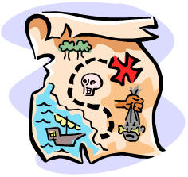**
2. Take 5 paces (10 steps, 25 ft, 7.5 m) north-east.
3. Then take 10 paces north (20 steps, 50 ft, 15 m). Have one group member point north and the other pace the distance, then figure out position at the end.
4. There should be a message at the location.  Pick it up and read it.
5. Draw the vectors to scale showing tail-to-tip addition and measure the resulting vector magnitude, angle, x coordinate, and y coordinate.





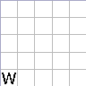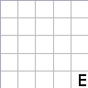





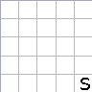

1. What is the length of the resultant vector?  The angle?  The x coordinate?  The y coordinate?  Does this come close to your sketched estimate?
2. Show your calculations.  If it matches the paper you picked up, your instructor will give you a "treasure."

Page left intentionally blank

|  |
| --- |
| ****Supergirl's Force**** |

\_\_\_\_\_\_\_\_\_\_\_\_\_\_\_\_\_\_/\_\_\_\_\_\_\_\_\_\_\_\_\_\_\_\_\_\_/\_\_\_\_\_\_\_\_\_\_\_\_\_\_\_\_\_\_

**Names – 3 to 5 people per group,**

\_\_\_\_\_\_\_\_\_\_\_\_\_\_\_\_\_\_/\_\_\_\_\_\_\_\_\_\_\_\_\_\_\_\_\_\_**at 6 split into 2 groups**

**Class:\_\_\_\_\_\_\_\_\_\_\_\_\_\_\_\_\_\_\_Section: \_\_\_\_\_\_\_\_\_\_\_\_\_\_Date:\_\_\_\_\_\_\_\_\_\_\_\_\_\_**

Originally Kryptonites (people from Krypton, that is, Superman, Supergirl, etc.) could only leap - they couldn't fly.  Let's figure out how hard Supergirl must push to jump over TJC chapel steeple (21.0 m high).  Last time you calculated how fast she must take-off.  What was that value (or recalculate it now on the back of the paper)?



When she crouches to leap and then pushes, she pushes (uniformly accelerates) over a distance of about 1 m in 0.0986 sec.  Derive or find the appropriate equation that applies to find acceleration.

What is her acceleration?  Show work.

What is the equation to find force given mass and acceleration?

Supergirl has a mass of 54 kg.  How hard does she have to push?  That is, what force does she exert to take-off?  Show work.

Superman has a mass of 101 kg.  How hard does he have to push to reach the same speed?  Show work.

According to DC Comics Supergirl is only 80% as strong as Superman, but let's make our life easier and assume they're equally strong.  If they are equally strong, who can leap higher?  Why?  Explain.

Page left intentionally blank

|  |
| --- |
| ****Rocket Report**** |

\_\_\_\_\_\_\_\_\_\_\_\_\_\_\_\_\_\_/\_\_\_\_\_\_\_\_\_\_\_\_\_\_\_\_\_\_/\_\_\_\_\_\_\_\_\_\_\_\_\_\_\_\_\_\_

**Names – 3 to 5 people per group,**

\_\_\_\_\_\_\_\_\_\_\_\_\_\_\_\_\_\_/\_\_\_\_\_\_\_\_\_\_\_\_\_\_\_\_\_\_**at 6 split into 2 groups**

**Class:\_\_\_\_\_\_\_\_\_\_\_\_\_\_\_\_\_\_\_Section: \_\_\_\_\_\_\_\_\_\_\_\_\_\_Date:\_\_\_\_\_\_\_\_\_\_\_\_\_\_**

Observe the water rockets, record the information below, and attempt to surmise how to improve the rockets performance. 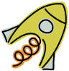

|  |  |  |  |
| --- | --- | --- | --- |
| Rocket | Characteristics | How did it perform? How high did it go? | How might it perform better? |
|  |  |  |  |
|  |  |  |  |
|  |  |  |  |
|  |  |  |  |
|  |  |  |  |
|  |  |  |  |

Page left intentionally blank

|  |
| --- |
| ****Supergirls Momentum**** |

\_\_\_\_\_\_\_\_\_\_\_\_\_\_\_\_\_\_/\_\_\_\_\_\_\_\_\_\_\_\_\_\_\_\_\_\_/\_\_\_\_\_\_\_\_\_\_\_\_\_\_\_\_\_\_

**Names – 3 to 5 people per group,**

\_\_\_\_\_\_\_\_\_\_\_\_\_\_\_\_\_\_/\_\_\_\_\_\_\_\_\_\_\_\_\_\_\_\_\_\_**at 6 split into 2 groups**

**Class:\_\_\_\_\_\_\_\_\_\_\_\_\_\_\_\_\_\_\_Section: \_\_\_\_\_\_\_\_\_\_\_\_\_\_Date:\_\_\_\_\_\_\_\_\_\_\_\_\_\_**

The original Superman couldn't fly - he could only "leap over tall buildings in a single bound."  By the time Supergirl came along he and she ould fly.  But let's go back to the original, pretend she could only jump, and, this time, figure out how much momentum she needs to jumps to the top of the CPC clock tower (or PRC tower of light, etc.)

What object is Supergirl leaping over and how tall is it?  Clock tower is 15.2 m high.

Last time you calculated how fast she must take-off.  What was that value (or recalculate it now on the back of the paper)?

What is the equation for momentum?

What is her momentum?  Her mass is 54 kg.  Show work.

what is her momentum when she reaches the top?

Why did her momentum change?  Explain.

Page left intentionally blank

## ****Supergirls Energy****

\_\_\_\_\_\_\_\_\_\_\_\_\_\_\_\_\_\_/\_\_\_\_\_\_\_\_\_\_\_\_\_\_\_\_\_\_/\_\_\_\_\_\_\_\_\_\_\_\_\_\_\_\_\_\_

**Names – 3 to 5 people per group,**

\_\_\_\_\_\_\_\_\_\_\_\_\_\_\_\_\_\_/\_\_\_\_\_\_\_\_\_\_\_\_\_\_\_\_\_\_**at 6 split into 2 groups**

**Class:\_\_\_\_\_\_\_\_\_\_\_\_\_\_\_\_\_\_\_Section: \_\_\_\_\_\_\_\_\_\_\_\_\_\_Date:\_\_\_\_\_\_\_\_\_\_\_\_\_\_**

Let's figure how much energy she needs to jump to the top of the TJC Steeple (21 m).

1. How high does Supergirl have to jump?

1. We calculated speed, but it’s easy to find it again using conservation of energy. What forms of energy does Supergirl have when she lifts off and what are the formulae?

1. What forms of energy does Supergirl have when she lands at the top and what are the formulae?

1. Now calculate her total energy at the top. Her mass is 54 kg.  Show work.

1. What MUST her energy be at the bottom?

1. Set this equal to the formula for energy at the bottom and derive a formula for velocity.

1. What is the velocity at the bottom? Is it the same as you found before?
2. Is energy conserved? Why or why not? Explain.

Page left intentionally blank

|  |
| --- |
| ****Supergirls Power**** |

\_\_\_\_\_\_\_\_\_\_\_\_\_\_\_\_\_\_/\_\_\_\_\_\_\_\_\_\_\_\_\_\_\_\_\_\_/\_\_\_\_\_\_\_\_\_\_\_\_\_\_\_\_\_\_

**Names – 3 to 5 people per group,**

\_\_\_\_\_\_\_\_\_\_\_\_\_\_\_\_\_\_/\_\_\_\_\_\_\_\_\_\_\_\_\_\_\_\_\_\_**at 6 split into 2 groups**

**Class:\_\_\_\_\_\_\_\_\_\_\_\_\_\_\_\_\_\_\_Section: \_\_\_\_\_\_\_\_\_\_\_\_\_\_Date:\_\_\_\_\_\_\_\_\_\_\_\_\_\_**

Last time you calculated the energy it takes Supergirl to jump over the CPC clock tower (or PRC tower of light, etc.). When she leaps she expends this power is a very short period of time - the time it takes to extend her legs (1 m). 

1. What object is Supergirl leaping over and how tall is it?  Steeple is 21.0 m high.

1. Last time you calculated how fast she must take-off. What was that value (or recalculate it now on the back of the paper)?

1. Either find or derive the formula for time if you know speed and distance. What is that formula?

1. Now do the calculation to find time. ALWAYS write answer in form of and equation and include units, for example, t = 10.2 sec.

1. Last time you calculated the kinetic energy. What was that value (or recalculate it now on the back of the paper)?

1. From the information in Steps 4 & 5, calculate power.

Page left intentionally blank

|  |
| --- |
| ****Rolling Races**** |

\_\_\_\_\_\_\_\_\_\_\_\_\_\_\_\_\_\_/\_\_\_\_\_\_\_\_\_\_\_\_\_\_\_\_\_\_/\_\_\_\_\_\_\_\_\_\_\_\_\_\_\_\_\_\_

**Names – 3 to 5 people per group,**

\_\_\_\_\_\_\_\_\_\_\_\_\_\_\_\_\_\_/\_\_\_\_\_\_\_\_\_\_\_\_\_\_\_\_\_\_**at 6 split into 2 groups**

**Class:\_\_\_\_\_\_\_\_\_\_\_\_\_\_\_\_\_\_\_Section: \_\_\_\_\_\_\_\_\_\_\_\_\_\_Date:\_\_\_\_\_\_\_\_\_\_\_\_\_\_**

How many of participated in a pinewood derby in Girl Scouts, Cub Scouts, Brownies, or some other organization?  In this competition you built a small model car and rolled it down a ramp.  The fastest car wins.  We're going to do something similar.  We're going to roll several objects down a ramp and see which one goes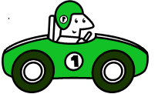 fastest.  Record the objects being raced and their characteristics.  Are they spherical, cylindrical, etc?  Solid or Hollow?  Etc.

|  |  |  |  |
| --- | --- | --- | --- |
| Object 1 & Characteristics | Object 2 & Characteristics | Which one won the race? | Why? |
|  |  |  |  |
|  |  |  |  |
|  |  |  |  |
|  |  |  |  |
|  |  |  |  |
|  |  |  |  |
|  |  |  |  |
|  |  |  |  |
|  |  |  |  |
|  |  |  |  |
|  |  |  |  |
|  |  |  |  |

1. Now let's do some physics. What was the vertical drop in m?

1. What was the horizontal travel in m?

1. What was the total distance traveled in m?

1. What type of object, sphere, cylinder, hoop, etc., was the fastest? Slowest?

1. What is the formula for the moment of inertia of the fastest object? Slowest?

1. Calculate the moment of inertias for the fastest and slowest objects.

1. What is the total energy prior to release? Use the SOLVE method, and keep 3 sig figs & units.

1. What is the total energy for the fastest and slowest object at the bottom of the ramp?

1. Solve for the velocities of the fastest and slowest objects at the bottom of the ramp?

1. What are the numerical estimates of velocities of the fastest and slowest objects at the bottom of the ramp?

Page left intentionally blank

|  |
| --- |
| ****Moon Guns**** |

\_\_\_\_\_\_\_\_\_\_\_\_\_\_\_\_\_\_/\_\_\_\_\_\_\_\_\_\_\_\_\_\_\_\_\_\_/\_\_\_\_\_\_\_\_\_\_\_\_\_\_\_\_\_\_

**Names – 3 to 5 people per group,**

\_\_\_\_\_\_\_\_\_\_\_\_\_\_\_\_\_\_/\_\_\_\_\_\_\_\_\_\_\_\_\_\_\_\_\_\_**at 6 split into 2 groups**

**Class:\_\_\_\_\_\_\_\_\_\_\_\_\_\_\_\_\_\_\_Section: \_\_\_\_\_\_\_\_\_\_\_\_\_\_Date:\_\_\_\_\_\_\_\_\_\_\_\_\_\_**

If homo sapiens (us) every get to the point of waging war on the Moon, it would only be necessary to pierce the armor of the habitats of vehicles of the enemy.  Then the occupants would die of asphyxiation. 

Armor piercing rounds have typical velocities of 1400 m/sec to 1900 m/sec.

Why would it be a bad idea to fire some of those rounds (the faster ones) on the Moon?  Hint:  Calculate the circular orbit velocity and escape velocity from the Moon.  G = 6.67428\*10-11 N m2/kg2, RMoon = 1.737\*106 m, and MMoon = 7.3477\*1022 kg.

What is the maximum velocity round you could safely fire on the Moon?  Show all your work.

Page left intentionally blank

|  |
| --- |
| ****Torque on Yo-Yo**** |

\_\_\_\_\_\_\_\_\_\_\_\_\_\_\_\_\_\_/\_\_\_\_\_\_\_\_\_\_\_\_\_\_\_\_\_\_/\_\_\_\_\_\_\_\_\_\_\_\_\_\_\_\_\_\_

**Names – 3 to 5 people per group,**

\_\_\_\_\_\_\_\_\_\_\_\_\_\_\_\_\_\_/\_\_\_\_\_\_\_\_\_\_\_\_\_\_\_\_\_\_**at 6 split into 2 groups**

**Class:\_\_\_\_\_\_\_\_\_\_\_\_\_\_\_\_\_\_\_Section: \_\_\_\_\_\_\_\_\_\_\_\_\_\_Date:\_\_\_\_\_\_\_\_\_\_\_\_\_\_**

My yo-yo has a spool diameter of \_\_\_\_\_\_\_\_\_\_\_\_\_ and outer diameter

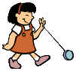

of \_\_\_\_\_\_\_\_\_\_\_\_\_\_.  What direction will it move when I pull it to the right as shown in the figure below?

|  |  |
| --- | --- |
|  | yo-yo pulled to right |

What direction will it move when I pull it to the right again, but as shown in the next figure?

|  |  |
| --- | --- |
|  | yo-yo pulled to left |

What direction will it move when I pull it up as shown in the figure below?

|  |  |
| --- | --- |
|  | yo-yo pulled up |

What the critical angle, θ, where it won't move?  What direction will it move if the angle is decreased slightly?  What direction will it move if the angle is increased slightly?

|  |  |
| --- | --- |
|  | yo-yo pulled at angle |

Page left intentionally blank

|  |
| --- |
| ****Centripetal Force on Yo-Yo**** |

\_\_\_\_\_\_\_\_\_\_\_\_\_\_\_\_\_\_/\_\_\_\_\_\_\_\_\_\_\_\_\_\_\_\_\_\_/\_\_\_\_\_\_\_\_\_\_\_\_\_\_\_\_\_\_

**Names – 3 to 5 people per group,**

\_\_\_\_\_\_\_\_\_\_\_\_\_\_\_\_\_\_/\_\_\_\_\_\_\_\_\_\_\_\_\_\_\_\_\_\_**at 6 split into 2 groups**

**Class:\_\_\_\_\_\_\_\_\_\_\_\_\_\_\_\_\_\_\_Section: \_\_\_\_\_\_\_\_\_\_\_\_\_\_Date:\_\_\_\_\_\_\_\_\_\_\_\_\_\_**

When twirling a yo-yo (or any mass on the end of a string) in a circle, there is a centripetal force - the tension in the string.  Our goal it to calculate it and compare it to the weight creating the centripetal force. 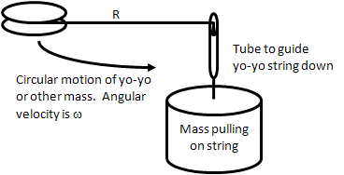

What is the formula for centripetal force?

What is the mass of the yo-yo (Instructor supplied)?  We'll call this my.

How long (R) is the string from the yo-yo (or other mass) to the center of rotation.

Use a timer to determine the angular velocity, ω, of the yo-yo.  A good way to do this is count 10 revolutions and find the time.  Enter that here:

What is the time for one revolution, T?

Remember, angular velocity is the number of ***radians*** per second and there are 2π radians per revolution.  So the formula for angular velocity is 2π / T in units of radians per second.  Calculate and enter the angular velocity in radians per second.

What is the formula for the speed the yo-yo is moving?

Calculate the speed.

Using the formula for centripetal force, calculate the centripetal force.

The mass pulling the string, mp, is what value?

What weight does mp exert?

Compare this weight to the centripetal force.  Are they close?  Why or why not?  Explain.

Page left intentionally blank

|  |
| --- |
| ****Fluids**** |

\_\_\_\_\_\_\_\_\_\_\_\_\_\_\_\_\_\_/\_\_\_\_\_\_\_\_\_\_\_\_\_\_\_\_\_\_/\_\_\_\_\_\_\_\_\_\_\_\_\_\_\_\_\_\_

**Names – 3 to 5 people per group,**

\_\_\_\_\_\_\_\_\_\_\_\_\_\_\_\_\_\_/\_\_\_\_\_\_\_\_\_\_\_\_\_\_\_\_\_\_**at 6 split into 2 groups**

**Class:\_\_\_\_\_\_\_\_\_\_\_\_\_\_\_\_\_\_\_Section: \_\_\_\_\_\_\_\_\_\_\_\_\_\_Date:\_\_\_\_\_\_\_\_\_\_\_\_\_\_**

|  |  |
| --- | --- |
| 1. Take two pieces of ordinary paper and hold them hanging down and loose.  Then blow between them as shown.  Do they attrasailingct, repel, or do nothing?  Explain what is happening.  What you are observing is called the Bernoulli effect. | Bernoulli Effect |

1. Observe a water faucet (or pouring water out of a bottle).  First, turn it on slowly so it comes out smooth (this is called laminar flow).  What happens to the flow as it speeds up from gravity?  Does it narrow or expand?  As fluids move faster they become turbulent (turbulent flow).  What changes happen as you look down the stream?  Describe and sketch this stream of water.

|  |  |
| --- | --- |
|  |  |

1. The Bernoulli effect you observe in Part 1 ignores drag, however drag is important in some fluid dynamics problems.  Due to high drag,  baseballs behave just the opposite of what the Bernoulli effect predicts as shown at right.  The cur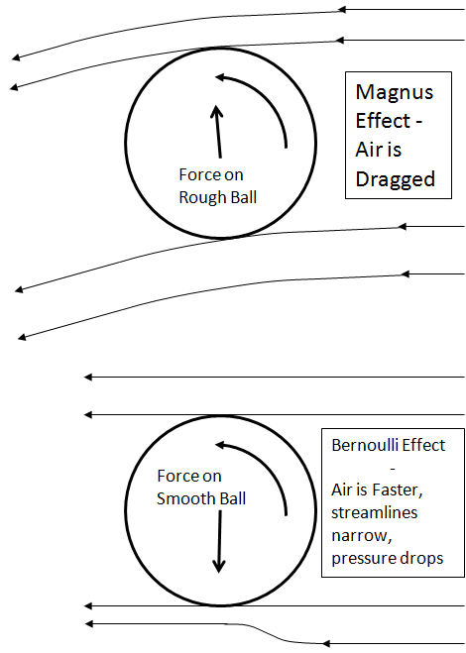ve of a baseball is due to a drag effect - the Magnus effect.   
     
   The influence of drag can be observed with eggs since raw eggs are a hard shell filled with a viscous fluid while a hard boiled egg is completely solid.  The viscous fluid interior should slow the spin of the raw egg.  Spin the two eggs, observe, and record your observations below.  At the end we will reveal which egg is hard boiled and which is raw.  Did you predict this correctly?  How did the raw egg behave?  The hard boiled egg?

At the end of this ICA you instructor will choose the hard boiled egg and a student may break it on his or her forehead to prove it is hard boiled.  While your instructor will object to breaking the raw egg on his or her forehead, you may break the raw egg in a sink to prove it is, indeed, raw.

PS - a large number of physics textbooks erroneously state the curve of a baseball is due to the Bernoulli effect.

Page left intentionally blank

|  |
| --- |
| ****Yo-yo Pendulum**** |

\_\_\_\_\_\_\_\_\_\_\_\_\_\_\_\_\_\_/\_\_\_\_\_\_\_\_\_\_\_\_\_\_\_\_\_\_/\_\_\_\_\_\_\_\_\_\_\_\_\_\_\_\_\_\_

**Names – 3 to 5 people per group,**

\_\_\_\_\_\_\_\_\_\_\_\_\_\_\_\_\_\_/\_\_\_\_\_\_\_\_\_\_\_\_\_\_\_\_\_\_**at 6 split into 2 groups**

**Class:\_\_\_\_\_\_\_\_\_\_\_\_\_\_\_\_\_\_\_Section: \_\_\_\_\_\_\_\_\_\_\_\_\_\_Date:\_\_\_\_\_\_\_\_\_\_\_\_\_\_**

We will time how long it takes my yo-yo swing back and forth and see if this fitpendulums theory.

|  |  |
| --- | --- |
| 1. | What properties of the yo-you will you need?  Name them and find their values? |

|  |  |
| --- | --- |
| 2. | Now measure the oscillation.  What is the period of one oscillation?  And easy way to find this is to time several oscillations, for example 10, then find the period of one oscillation. |

|  |  |
| --- | --- |
| 3. | What is the formula according to theory? |

|  |  |
| --- | --- |
| 4. | Calculate the theoretical value for the period of oscillation. |

|  |  |
| --- | --- |
| 5. | Theoretical period of oscillation is based on what approximation? |

|  |  |
| --- | --- |
| 6. | Let's violate this approximation and measure the period.  What is the measured period now? |

|  |  |
| --- | --- |
| 7. | How does this second measurement compare to the first and to theory?  Explain why it deviates. |

Page left intentionally blank

|  |
| --- |
| ****Slinky Wave Conceptual**** |

\_\_\_\_\_\_\_\_\_\_\_\_\_\_\_\_\_\_/\_\_\_\_\_\_\_\_\_\_\_\_\_\_\_\_\_\_/\_\_\_\_\_\_\_\_\_\_\_\_\_\_\_\_\_\_

**Names – 3 to 5 people per group,**

\_\_\_\_\_\_\_\_\_\_\_\_\_\_\_\_\_\_/\_\_\_\_\_\_\_\_\_\_\_\_\_\_\_\_\_\_**at 6 split into 2 groups**

**Class:\_\_\_\_\_\_\_\_\_\_\_\_\_\_\_\_\_\_\_Section: \_\_\_\_\_\_\_\_\_\_\_\_\_\_Date:\_\_\_\_\_\_\_\_\_\_\_\_\_\_**

|  |  |
| --- | --- |
| 1. | Use a slinky to make a transverse standing wave.  Measure Surfer (waves)the wavelength of the slinky wave.  What is it? |

|  |  |
| --- | --- |
| 2. | Use a timer to find the period of a slinky wave.  This often works well by timing 10 oscillations and then dividing by 10.  What is the period? |

|  |  |
| --- | --- |
| 3. | What formula do you use to find the wave speed given period and wavelength? |

|  |  |
| --- | --- |
| 4. | Evaluate the wave speed. |

There is another way to find speed of a transverse wave on a string (rope, slinky, etc.).  The formula is $v =\sqrt{ \frac{F_{T}}{μ} }$ where μ is mass per unit length and *FT* is the tension (force).

|  |  |
| --- | --- |
| 5. | Your instructor will provide the total mass of the slinky.  What is it? |

|  |  |
| --- | --- |
| 6. | What is the length of the slinky? |

|  |  |
| --- | --- |
| 7. | Combining Parts 5 and 6, what is μ, the mass per unit length? |

|  |  |
| --- | --- |
| 8. | You instructor is going to put a mass on the slinky or use a spring scale to stretch the slinky to find the spring constant.  What is the mass or force reading on the spring scale? |

|  |  |
| --- | --- |
| 9. | How much did the slinky elongate? |

|  |  |
| --- | --- |
| 10. | Combining Parts 8 and 9, what is the spring constant k? |

|  |  |
| --- | --- |
| 11. | How are you going to get the tension, FT, of the slinky?  Find FT. |

|  |  |
| --- | --- |
| 12. | Evaluate wave speed using the formula preceding Question 5. |

|  |  |
| --- | --- |
| 13. | How does the answer to Part 12 compare to the answer to Part 4? |

Page left intentionally blank

|  |
| --- |
| ****Wave Phenomena**** |

\_\_\_\_\_\_\_\_\_\_\_\_\_\_\_\_\_\_/\_\_\_\_\_\_\_\_\_\_\_\_\_\_\_\_\_\_/\_\_\_\_\_\_\_\_\_\_\_\_\_\_\_\_\_\_

**Names – 3 to 5 people per group,**

\_\_\_\_\_\_\_\_\_\_\_\_\_\_\_\_\_\_/\_\_\_\_\_\_\_\_\_\_\_\_\_\_\_\_\_\_**at 6 split into 2 groups**

**Class:\_\_\_\_\_\_\_\_\_\_\_\_\_\_\_\_\_\_\_Section: \_\_\_\_\_\_\_\_\_\_\_\_\_\_Date:\_\_\_\_\_\_\_\_\_\_\_\_\_\_**

The Doppler effect is so int[Society of Physics Students](http://www.spsnational.org/)imately connected to physics that the [Society of Physics Students](http://www.spsnational.org/) uses it in their logo.

We're all familiar with the fact that when a fire truck or police car goes by it starts with a high pitch sound as it approaches, then it becomes lower pitched after it passes.  This is the Doppler effect.  We will demonstrate this if possible.

|  |  |
| --- | --- |
| 1. | Draw two sketches - one for the sound source moving toward the observer and one for moving away.  From these sketches can you explain why the observer hears a higher pitch (larger frequency) when the source is moving toward you and why an observer hears a lower pitch when the source is moving away?  Explain and attach additional pages if needed. |

|  |  |
| --- | --- |
| 2. | Draw two more sketches - one for the **OBSERVER moving** (in contrast to a moving sound source) toward the stationary sound source and one for moving away.  From these sketches can you explain why the observer hears a higher pitch (larger frequency) when moving toward the source and a lower pitch when moving away?  How is this similar to the sound source moving and how is it different?  Explain and attach additional pages if necessary. |

When something goes really fast, it creates a sonic boom.  They are much like bow waves on a boat.  Many boats move faster than the slow moving water waves and create a bow wake.  It's much easier to observe bow wakes than sonic booms since aircraft regulations in the US make supersonic flight over populated areas rare.

|  |  |
| --- | --- |
| 3. | To understand sonic booms, draw a sketch of an airplane flying faster than the speed of sound overhead.  Show when the person on the ground (observer) hears the sonic boom and when the airplane emits the wave that the observer hears.  Where is the airplane when the sonic boom is heard by the oberver?  Explain and attach additional pages if necessary. |

The final wave phenomenon we will discuss today is beats. This happens when two frequencies are close to each other, but not exactly the same.  If it's two sound waves we hear the sound waver between loud (or louder) and soft, then loud again.  The "beat" frequency of the oscillation between loud and soft is the difference in frequency between the two main frequencies.  The beat frequency is most often much smaller than either main frequency.  Orchestras and bands use this phenomena to "tune" their instruments.  They tune the instrument so that no beats are heard.

Radio uses this to transmit AM radio signals.  The beats are the radio announcer's voice or record playing on the radio.  The radio receiver "beats" a frequency against the received signal to extract the "sound" coming from the radio.

\

If possible (if we have suitable demonstration equipment), we will demonstrate beats.

|  |  |
| --- | --- |
| 4. | Sketch how beats work, explain, and attach additional pages if necessary. |

These are only a few wave phenomena - there are many more such as reflection, refraction, interference, and diffraction.  We will discuss some or all of these in other assignments.

Page left intentionally blank

|  |
| --- |
| ****Sound Resonance**** |

\_\_\_\_\_\_\_\_\_\_\_\_\_\_\_\_\_\_/\_\_\_\_\_\_\_\_\_\_\_\_\_\_\_\_\_\_/\_\_\_\_\_\_\_\_\_\_\_\_\_\_\_\_\_\_

**Names – 3 to 5 people per group,**

\_\_\_\_\_\_\_\_\_\_\_\_\_\_\_\_\_\_/\_\_\_\_\_\_\_\_\_\_\_\_\_\_\_\_\_\_**at 6 split into 2 groups**

**Class:\_\_\_\_\_\_\_\_\_\_\_\_\_\_\_\_\_\_\_Section: \_\_\_\_\_\_\_\_\_\_\_\_\_\_Date:\_\_\_\_\_\_\_\_\_\_\_\_\_\_**

Today we're going to swirl a sound resonance tube and calculate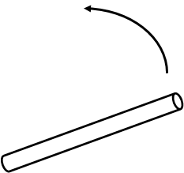 the sound resonances.

1. How long is the tube in m?

1. What are the first 4 longest wavelengths that fit in this tube for a resonating sound wave?  By this point in the semester I should not have to remind you about the SOLVE method and keeping 3 sig figs and units.

1. The speed of sound is near 340 m/sec. What are the first 4 lowest frequencies?

1. Does this make sense? Below is a list of musical notes and frequencies.

|  | Note | frequency (Hz) |
| --- | --- | --- |
|  | A | 110 |
|  | A sharp/B flat | 117 |
|  | B | 123 |
|  | C | 131 |
|  | C sharp/D flat | 139 |
|  | D | 147 |
|  | D sharp/E flat | 156 |
|  | E | 165 |
|  | F | 175 |
|  | F#/G flat | 185 |
|  | G | 196 |
|  | G#/A flat | 208 |
|  | A | 220 |
|  | A sharp/B flat | 233 |
|  | B | 247 |
| Middle | C | 262 |
|  | C sharp/D flat | 277 |
|  | D | 294 |
|  | D sharp/E flat | 311 |
|  | E | 330 |
|  | F | 349 |
|  | F#/G flat | 370 |
|  | G | 392 |
|  | G#/A flat | 415 |
| Concert | A | 440 |
|  | A sharp/B flat | 466 |
|  | B | 494 |
|  | C | 523 |
|  | C sharp/D flat | 554 |
|  | D | 587 |
|  | D sharp/E flat | 622 |
|  | E | 659 |
|  | F | 698 |
|  | F#/G flat | 740 |
|  | G | 784 |
|  | G#/A flat | 831 |
|  | A | 880 |

Page left intentionally blank

|  |
| --- |
| ****Electricity**** |

\_\_\_\_\_\_\_\_\_\_\_\_\_\_\_\_\_\_/\_\_\_\_\_\_\_\_\_\_\_\_\_\_\_\_\_\_/\_\_\_\_\_\_\_\_\_\_\_\_\_\_\_\_\_\_

**Names – 3 to 5 people per group,**

\_\_\_\_\_\_\_\_\_\_\_\_\_\_\_\_\_\_/\_\_\_\_\_\_\_\_\_\_\_\_\_\_\_\_\_\_**at 6 split into 2 groups**

**Class:\_\_\_\_\_\_\_\_\_\_\_\_\_\_\_\_\_\_\_Section: \_\_\_\_\_\_\_\_\_\_\_\_\_\_Date:\_\_\_\_\_\_\_\_\_\_\_\_\_\_**

Rub a balloon on your hair (or wool) and attempt to stick it to the wall.  Does it?  Even if it doesn't (it might not due to humidity and other factors), do you feel a force of attraction?  Why or why not?

Observe the Wimshurst machine or Van de Graff generator.  Why do they spark?  What is happening?

Tape a couple strips of paper close together on one electrode.  Do they attract or repel each other?  Why?

Hold your hand close to the paper strips. Are they attracted to or repelled by your hand? Explain.

If you have a charged object and uncharged object, how can you use this to put the opposite charge on the uncharged object? It's called electrostatic induction - [see this site](http://regentsprep.org/Regents/physics/phys03/aeleclab/induct.htm).

We will have foil leaf electroscopes with a charge on them - the instructor will inform you if it is positive or negative. Using the rods, fur, cloth, etc. place a charge on the object (the rubber, glass, or plastic rod, etc.) and determine the polarity. The place the opposite polarity on the electroscope and explain how you did it?

Page left intentionally blank

|  |
| --- |
| ****Series Circuits**** |

\_\_\_\_\_\_\_\_\_\_\_\_\_\_\_\_\_\_/\_\_\_\_\_\_\_\_\_\_\_\_\_\_\_\_\_\_/\_\_\_\_\_\_\_\_\_\_\_\_\_\_\_\_\_\_

**Names – 3 to 5 people per group,**

\_\_\_\_\_\_\_\_\_\_\_\_\_\_\_\_\_\_/\_\_\_\_\_\_\_\_\_\_\_\_\_\_\_\_\_\_**at 6 split into 2 groups**

**Class:\_\_\_\_\_\_\_\_\_\_\_\_\_\_\_\_\_\_\_Section: \_\_\_\_\_\_\_\_\_\_\_\_\_\_Date:\_\_\_\_\_\_\_\_\_\_\_\_\_\_**

|  |  |
| --- | --- |
| Take a look at the sketch at right.  The top sketch shows what happens if you hoElectrical Tower at Hoover Damok one hose to a faucet.  Lots of water flows.  Now look and the next sketch below it.  After the first hose the pressure gauge is at about half.  The pressure drop across the first hose is about half of the top picture.  Do you expect more or less water to flow when hoses are connected **IN SERIES** like this?  I think less.  There's half as much pressure so less water flows.  Electricity is like water.  Pressure is like voltage, resistors in electricity are like the hoses, and the amount of water that flows is like electrical current. | Sketch of water faucet and hoses |

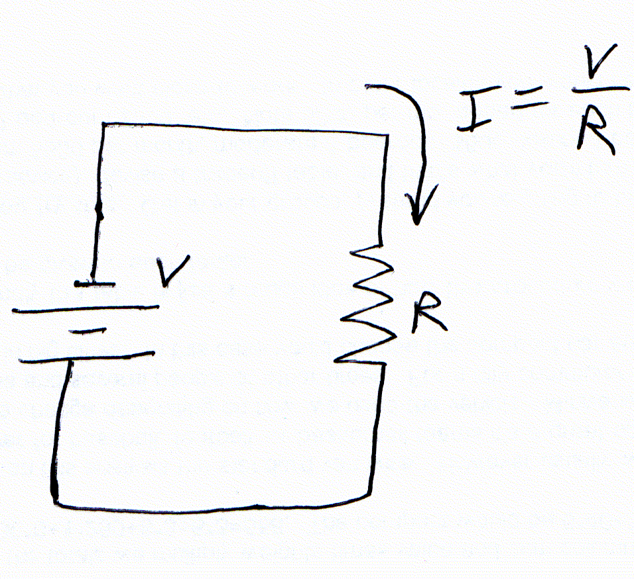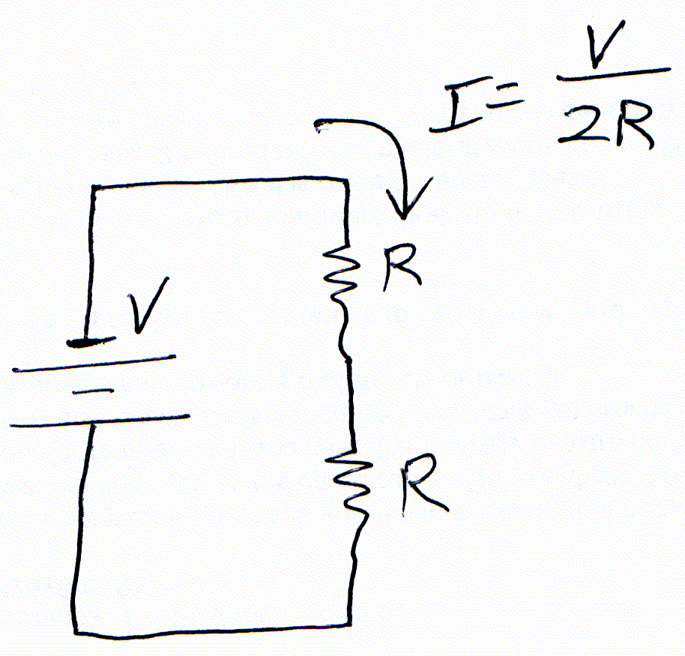The next sketch, at right, shows this.  The figure on the right is like only one hose (resistor).  The figure on the far right is like two hoses (resistors) IN SERIES.  The schematic near the letter V is a schematic of a battery - the voltage source.  R is near a resistor which, you'll remember, is like the hose.  I is the current which is like the amount of water that flows except I tells us how much electricity is going through the wires.

What is electricity?  Let's take a look at a simulator at <http://phet.colorado.edu/en/simulation/battery-resistor-circuit>.  Click the "Run Now" button.  This is just one resistor.  The blue balls coming from the negative side of the battery are electrons - they carry current like H2O molecules are what flowing water is made up of.  The greenish-beige balls are atoms - they just wiggle in place.  Finally the Amps meter tells us I - I is in units of Amps.

Let's go to another one (<http://phet.colorado.edu/en/simulation/circuit-construction-kit-dc>) - let's build a circuit.  We'll make the electrical circuit above left first.  Drag the battery and put in black end down.  Now take a resistor and stand it up and down.  Now take a wire and hook it from the top of the resistor to the top of the battery.  And do the same thing taking a wire from the bottom of the resistor to the bottom of the battery.  And voila - you've just connected this circuit.  As soon as you connect the last wire you'll see the electrons move.  Your circuit should look something like this:

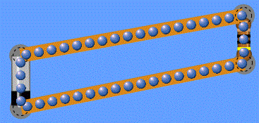 Now, let's change it to schematic.  On the far right of the simulation there's a section called **Visuals** with two buttons - "Lifelike" and "Schematic".  What you're seeing here is Likelike.  Change this to Schematic and it should look similar to the left hand sketch about of the electrical circuit.  Does it?  It should look like this (I also hid electrons): 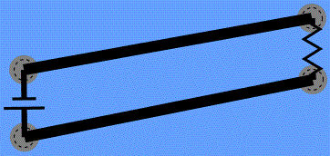

It now looks like the hand drawn schematic above.  Go ahead and change it back to Lifelike view.  Now put a second resistor in series like the next figure.

Do the electrons move faster or slower with two resistors than with one?  Why or why not?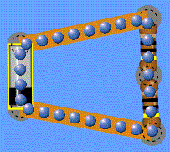

If electrons are moving faster that means there is more current, I, just like with hoses there is more water.  Slower motion through wires means less current, I.  Now before we try this with real things, replace the resistors with light bulbs. It will look like this:

Notice how much light is given off and compare it to one light bulb as shown below.

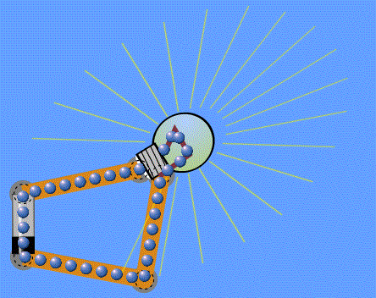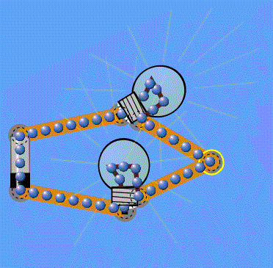

The solitary light bulb should burn brighter.  Right?  Burning brighter means more current is flowing.

OK, enough simulating.  By now you should have some understanding about what's going on.  Let's try it in real life.  Hook up you live circuit with one light bulb in series.  Then compare it to the circuit with two light bulbs in series.  Which is brighter?  Explain why it's different.  Or explain why it's the same.

What is the voltage drop across the dim light bulb(s)?  The bright light bulb(s)?  Explain why it's different.  Or explain why it's the same.

What is the current through the dim light bulb(s)?  The bright light bulb(s)?  Explain why it's different.  Or explain why it's the same.

What causes the light bulbs to be bright or dim - current or voltage?  Could it actually be both together?  Explain why.

Page left intentionally blank

|  |
| --- |
| ****Parallel Circuits**** |

\_\_\_\_\_\_\_\_\_\_\_\_\_\_\_\_\_\_/\_\_\_\_\_\_\_\_\_\_\_\_\_\_\_\_\_\_/\_\_\_\_\_\_\_\_\_\_\_\_\_\_\_\_\_\_

**Names – 3 to 5 people per group,**

\_\_\_\_\_\_\_\_\_\_\_\_\_\_\_\_\_\_/\_\_\_\_\_\_\_\_\_\_\_\_\_\_\_\_\_\_**at 6 split into 2 groups**

**Class:\_\_\_\_\_\_\_\_\_\_\_\_\_\_\_\_\_\_\_Section: \_\_\_\_\_\_\_\_\_\_\_\_\_\_Date:\_\_\_\_\_\_\_\_\_\_\_\_\_\_**

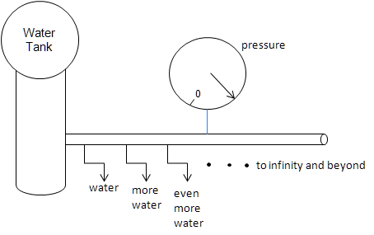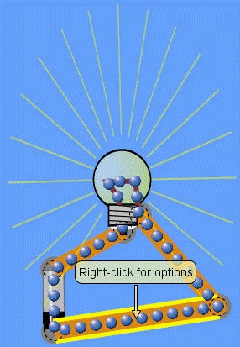When we looked at series circuits, we compare them to the flow of water ([icha series](http://www.funphysicist.net/icha/icha_series.htm)).  We do the same with parallel circuits, but since you've done this with series circuits the sketch is a little more schematic.  Take a look at the sketch above.    
  
Remember in series circuits the pressure drop across the hose dropped when a second hose was added?  It doesn't happen this way with parallel circuits - the pressure is the same.  So the first hose delivers the same quantity of water as  one hose in the series circuit.  But when we add a second hose **IN PARALLEL**, the pressure doesn't change, but twice as much water is delivered.  
  
Electricity is like water.  Pressure is like voltage, resistors in electricity are like the hoses, and the amount of water that flows is like electrical current.  We already looked at series circuits AND we put in light bulbs for resistors.  Why?  Because the brighter the light bulb shines, the more current is flowing through it.  Let's compare.

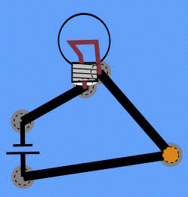Remember, just like series circuits, this is from <http://phet.colorado.edu/en/simulation/circuit-construction-kit-dc>.  The screenshot at left is "Lifelike."  The schematic looks like the figure below right.

We're going to stick with "Lifelike" (left hand figure) because it shows the brightness of the lamp.  However, we want you to get used to using schematics.

Now, what happens when we add another bulb in parallel shown next.

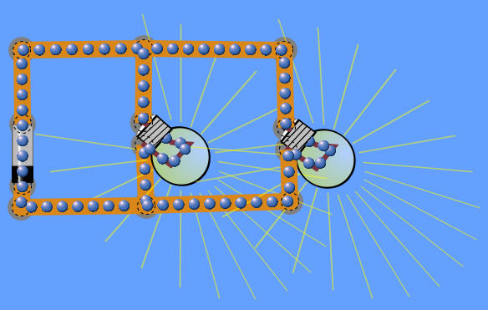Brightness doesn't change, does it?  Doesn't each bulb look the same as the single bulb above?  Compare that to a series circuit below:

Let's take another look at series and parallel circuits and measure current and voltages for each.

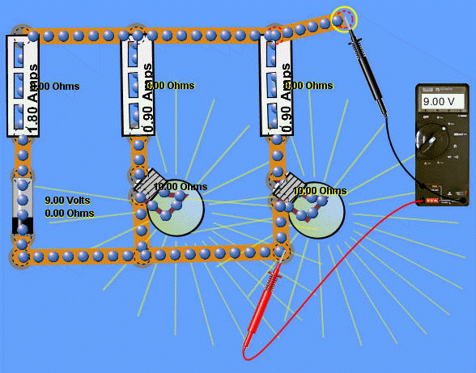Parallel: The thing to notice is that the battery is 9 V AND the voltmeter far, far away also reads 9 V.  So the wire along the positive side of the battery (red probe) is at the same potential as the wire on the negative side (black probe).  Also the current coming out of the battery is 1.8 A and it's evenly divided between the two bulbs - each has 0.9 A of current.

Now let's look at series - three pictures with three placements of the voltmeter.

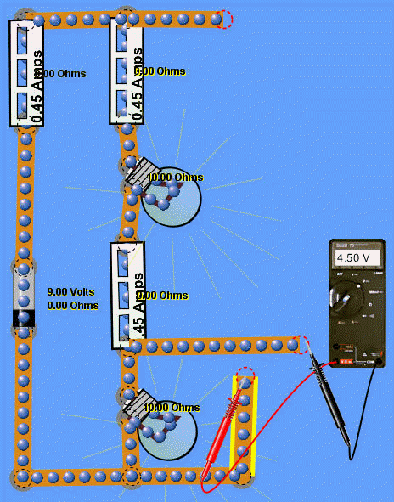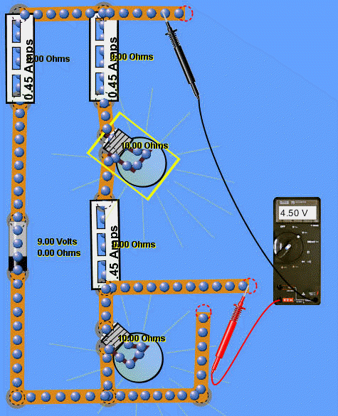

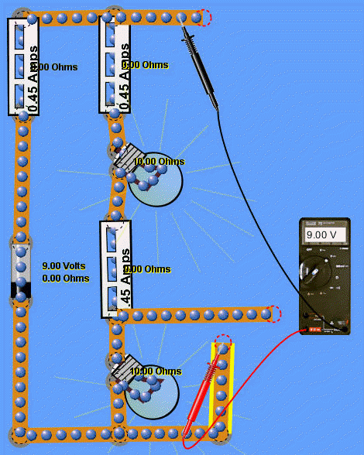In the series circuit, the voltages are different where in parallel the voltage was always the same.  In parallel circuits the 1.8 A divides between the two bulbs, but in series the voltage divides between the two bulbs.  When we measure voltage across a bulb it's 4.5 V where the total voltage is 9 V - just like parallel.  In series its current (A or amps) that stay the same and in parallel it's voltage that stays the same.

Try this at home using the simulator, but let's try it live now.  Hook up you live circuit with one light bulb and compare it to two light bulbs in parallel.  Which is brighter?  Explain.

OK, enough simulating.  By now you should have some understanding about what's going on.  Let's try it in real life.  Hook up you live circuit with one light bulb.  Then compare it to the circuit with two light bulbs in parallel.  Which is brighter?  Explain why it's different.  Or explain why it's the same.

What is the voltage drop across the solitary light bulb?  The two light bulbs?  Explain why it's different.  Or explain why it's the same.

What is the current through the single bulb?  The parallel bulbs?  Explain why it's different.  Or explain why it's the same.

What causes the light bulbs to be bright or dim - current or voltage?  Could it actually be both together?  Explain.

Page left intentionally blank

|  |
| --- |
| ****Speed of Light**** |

\_\_\_\_\_\_\_\_\_\_\_\_\_\_\_\_\_\_/\_\_\_\_\_\_\_\_\_\_\_\_\_\_\_\_\_\_/\_\_\_\_\_\_\_\_\_\_\_\_\_\_\_\_\_\_

**Names – 3 to 5 people per group,**

\_\_\_\_\_\_\_\_\_\_\_\_\_\_\_\_\_\_/\_\_\_\_\_\_\_\_\_\_\_\_\_\_\_\_\_\_**at 6 split into 2 groups**

**Class:\_\_\_\_\_\_\_\_\_\_\_\_\_\_\_\_\_\_\_Section: \_\_\_\_\_\_\_\_\_\_\_\_\_\_Date:\_\_\_\_\_\_\_\_\_\_\_\_\_\_**

|  |  |
| --- | --- |
| There are many ways to measure the speed of light.  The first attempts, including an attempt by Galileo, concluded it was infinite or extremely rapid.  An astronomer, Ole Romer circa 1670, gave us the first quantitative measurement by measuring the time discrepancy of eclipses of Io.    We're going to use a very modern method, the method used to give us our current value, which requires understanding of standing waves and is much like measuring the speed of sound where we know both the frequency and wavelength.  While easy to perform, our measurement accuracy is very imprecise while scientists refine it to great precision.  The video at the far right is our crude example.    Let's review the direct method.  It's difficult to do, but easier to understand.  It's simply the time it takes to for light to travel a certain distance.  Actually performing this measurement is difficult as the diagrams below of the Fizeau–Foucault apparatus reveals.  The next figure is my drawing showing the situation at two points in time and the bottom figure is what I felt to be a good diagram from [wikipedia](http://en.wikipedia.org/wiki/Leon_Foucault). |  |

|  |
| --- |
| Fizeau–Foucault apparatus to measure the speed of light |
| Fizeau–Foucault apparatus to measure the speed of light |

For this ICHA each group will fill out a report, however the experiment will be done as a class.

|  |  |
| --- | --- |
| 1. | Crack enough eggs or use enough marshmallow cream, chocolate syrup, etc. to cover the bottom of a glass (or microwave resistant plastic) pie plate, cake pan, or or other microwavable flat bottom cooking dish. |
| 2. | Place it in the microwave on high for a minute, then keep cooking it observing it at 1 minute intervals.  Ignore hot spots near the edges of the cooking pan.  The cooking pan absorbs the heat a little faster and cooks the edges at a higher rate.  Keep cooking (at one minute intervals) until you observe hot spots near the center of the pan. |
| 3. | What is the distance between the hot spots?  This is half the wavelength.  Write an equation. |

|  |  |
| --- | --- |
| 4. | Algebraic solve for the wavelength and write the numerical value of the solution here (write it as an equation). |

|  |  |
| --- | --- |
| 5. | Look at the back of the microwave oven.  What is the frequency?  Write an equation.  If not listed, it's probably 2450 MHz or ask your instructor. |

|  |  |
| --- | --- |
| 6. | What is the formula for the speed of a wave given frequency and wavelength? |

|  |  |
| --- | --- |
| 7. | Plug in the numbers, calculate the speed of light, and write it down as an equation below. |

|  |  |
| --- | --- |
| 8. | What is the accepted value for the speed of light?  Write that down as an equation below. |

|  |  |
| --- | --- |
| 9. | Write down the equation for percent difference, then plug in numbers and calculate the percent difference between the measured and accepted values. |

|  |  |
| --- | --- |
| 10. | Write a concluding statement. How close were you? What are the sources of error? Do you feel this is a good way to measure the speed of light? Any other thoughts? |

Page left intentionally blank

|  |
| --- |
| ****Solar Car**** |

\_\_\_\_\_\_\_\_\_\_\_\_\_\_\_\_\_\_/\_\_\_\_\_\_\_\_\_\_\_\_\_\_\_\_\_\_/\_\_\_\_\_\_\_\_\_\_\_\_\_\_\_\_\_\_

**Names – 3 to 5 people per group,**

\_\_\_\_\_\_\_\_\_\_\_\_\_\_\_\_\_\_/\_\_\_\_\_\_\_\_\_\_\_\_\_\_\_\_\_\_**at 6 split into 2 groups**

**Class:\_\_\_\_\_\_\_\_\_\_\_\_\_\_\_\_\_\_\_Section: \_\_\_\_\_\_\_\_\_\_\_\_\_\_Date:\_\_\_\_\_\_\_\_\_\_\_\_\_\_**

|  |  |
| --- | --- |
| 1. | Does this car move in the sun or is it too clocarudy, etc. for it to move at all? |

|  |  |
| --- | --- |
| 2. | How fast does it move?  Write down the distance and time, then calculate velocity. |

|  |  |
| --- | --- |
| 3. | Your instructor has the mass of the car.  What is it? |

|  |  |
| --- | --- |
| 4. | What is the car's top kinetic energy? |

|  |  |
| --- | --- |
| 5. | Now let's use a concentrator.  Is the car moving now?  Repeat Steps 2 to 4.  Show all intermediate steps. |

|  |  |
| --- | --- |
| 6. | Find the solar cell area and concentrator area.  The ratio of areas tells us how much the solar energy is concentrated.  What is that ratio?  Write down all intermediate steps. |

|  |  |
| --- | --- |
| 7. | From Steps 4 and 5 we have the kinetic energy.  What is the ratio of kinetic energies from Steps 4 and 5? |

|  |  |
| --- | --- |
| 8. | Compare the results of Step 7 to the results of Step 6.  Do we expect them to be the same?  Why or why not?  Explain. |

Page left intentionally blank

|  |
| --- |
| ****Heat**** |

\_\_\_\_\_\_\_\_\_\_\_\_\_\_\_\_\_\_/\_\_\_\_\_\_\_\_\_\_\_\_\_\_\_\_\_\_/\_\_\_\_\_\_\_\_\_\_\_\_\_\_\_\_\_\_

**Names – 3 to 5 people per group,**

\_\_\_\_\_\_\_\_\_\_\_\_\_\_\_\_\_\_/\_\_\_\_\_\_\_\_\_\_\_\_\_\_\_\_\_\_**at 6 split into 2 groups**

**Class:\_\_\_\_\_\_\_\_\_\_\_\_\_\_\_\_\_\_\_Section: \_\_\_\_\_\_\_\_\_\_\_\_\_\_Date:\_\_\_\_\_\_\_\_\_\_\_\_\_\_**

Mechanical energy is easi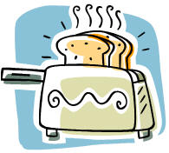ly converted to heat, but the reverse is harder.  Today we're going to use thermal probes to understand how mechanical energy is turned into heat.

1. Without touching the probe to anything, what is the temperature in °F? In °C?
2. Hold it in your hand.  What is your temperature in °F? In °C?
3. Don't put this under your tongue, however, why do doctors put the thermometer under your tongue (or elsewhere) to measure body temperature?
4. Rub your hands together then hold the thermal probe in your hand.  What is the new temperature in °F? In °C?
5. Is your hand hotter now?  Why?  Or why not?  Explain.
6. Measure and record the temperature of several things around the room.  The window, the computer, etc.  Record your observations.  Explain why one thing is warmer than another.
7. What is heat?  Why can energy be converted to heat, but not all heat can be converted back to useful energy?  Does this mean energy isn't conserved?  Why or why not?  Explain.

Page left intentionally blank

|  |
| --- |
| ****Entropy**** |

\_\_\_\_\_\_\_\_\_\_\_\_\_\_\_\_\_\_/\_\_\_\_\_\_\_\_\_\_\_\_\_\_\_\_\_\_/\_\_\_\_\_\_\_\_\_\_\_\_\_\_\_\_\_\_

**Names – 3 to 5 people per group,**

\_\_\_\_\_\_\_\_\_\_\_\_\_\_\_\_\_\_/\_\_\_\_\_\_\_\_\_\_\_\_\_\_\_\_\_\_**at 6 split into 2 groups**

**Class:\_\_\_\_\_\_\_\_\_\_\_\_\_\_\_\_\_\_\_Section: \_\_\_\_\_\_\_\_\_\_\_\_\_\_Date:\_\_\_\_\_\_\_\_\_\_\_\_\_\_**

|  |  |
| --- | --- |
| ice meltingWhen something gains heat it becomes more disordered and it's hard to get that order back.  The ice cube above, for example, gains heat and becomes a disordered puddle of water.  Going back to become an ice cube is more difficult.    Watch the video at right. |  |

|  |  |
| --- | --- |
| 1. | Can you tell when the film switches from running forward to running backward?  What finally informs you that the film was running backward?. |

|  |  |  |
| --- | --- | --- |
| 2. | Let's solve an entropy problem.  If 1 cal of heat enters the hot side of a copper heat conductor at 400°K and leaves cold side at 300°K, calculate the change in entropy.  First, how much entropy does the hot side lose? | Entropy change |
|  | |

|  |  |
| --- | --- |
| 3. | How much entropy does the cold side gain? |

|  |  |
| --- | --- |
| 4. | Add the answers from Parts 2 and 3 - What is the total entropy change? |

|  |  |
| --- | --- |
| 5. | The second law of thermodynamics says entropy increases.  Did this happen? |

Page left intentionally blank

|  |
| --- |
| ****Electrical Energy**** |

\_\_\_\_\_\_\_\_\_\_\_\_\_\_\_\_\_\_/\_\_\_\_\_\_\_\_\_\_\_\_\_\_\_\_\_\_/\_\_\_\_\_\_\_\_\_\_\_\_\_\_\_\_\_\_

**Names – 3 to 5 people per group,**

\_\_\_\_\_\_\_\_\_\_\_\_\_\_\_\_\_\_/\_\_\_\_\_\_\_\_\_\_\_\_\_\_\_\_\_\_**at 6 split into 2 groups**

**Class:\_\_\_\_\_\_\_\_\_\_\_\_\_\_\_\_\_\_\_Section: \_\_\_\_\_\_\_\_\_\_\_\_\_\_Date:\_\_\_\_\_\_\_\_\_\_\_\_\_\_**

A capacitor works a lot like a water reservoir.  Instea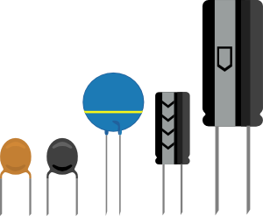d of storing water molecules, it stores electrical charges to be released whenever we want them.  We're going to compare a real capacitor to the tornado tube.

Equipment:  Tornado tube, battery or power supply, light (consistent with capacitor voltage), wires & alligator clips, ~1 F capacitor, stopwatch (a cell phone or wristwatch stopwatch works well), DMM

Turn the tornado tube over.  You can spin it if you want, or let the water glug, glug down.  Observe it and answer the questions:

1. What is the source of energy?

1. How is the energy consumed?

1. What happens, or does not happen, when the energy is entirely consumed?

1. Now we'll charge the capacitor.  When you charge a capacitor, what are you doing?

1. How is this similar to starting the tornado tube?

1. Now connect the capacitor to the light.  Sketch the circuit (first step in [SOLVE](http://www.funphysicist.net/help/solve.htm) method) and observe and describe what happens.

|  |  |
| --- | --- |
|  |  |

1. How is the behavior of the light/capacitor similar to or different than the tornado tube?

1. Measure the time it takes for the light to be about half the brightness and record it here as an equation.

1. What is the equation for this time in terms of resistance and capacitance.  Write it down, solve it symbolically for resistance of the light, and finally numerically calculate the resistance of the light.  Use [SOLVE](http://www.funphysicist.net/help/solve.htm).

1. Measure the resistance of the light, record the data (as an equation) below and calculate the percent error using the [SOLVE](http://www.funphysicist.net/help/solve.htm) method.

1. What do you conclude?  How does a capacitor work?  Compare and contrast it to the tornado tube.

1. If a 1 F capacitor is charged to -2.1 V, how much energy is it storing?

1. How much charge does this capacitor store?

1. If the spacing between plates is 10-8 m, what must the area of a 1 F capacitor be?

1. What is the electric field between the plates?

1. Pretend the charge on the capacitor is a point charge. What is voltage 1 cm from the charge?

1. Still pretending the charge is a point charge, what is the electric field 1 cm from the charge?

Page left intentionally blank

|  |
| --- |
| ****Resistance**** |

\_\_\_\_\_\_\_\_\_\_\_\_\_\_\_\_\_\_/\_\_\_\_\_\_\_\_\_\_\_\_\_\_\_\_\_\_/\_\_\_\_\_\_\_\_\_\_\_\_\_\_\_\_\_\_

**Names – 3 to 5 people per group,**

\_\_\_\_\_\_\_\_\_\_\_\_\_\_\_\_\_\_/\_\_\_\_\_\_\_\_\_\_\_\_\_\_\_\_\_\_**at 6 split into 2 groups**

**Class:\_\_\_\_\_\_\_\_\_\_\_\_\_\_\_\_\_\_\_Section: \_\_\_\_\_\_\_\_\_\_\_\_\_\_Date:\_\_\_\_\_\_\_\_\_\_\_\_\_\_**

Think of a battery (or any electrical power source) like a water pump taking w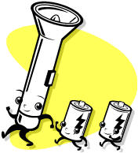ater from low to high.  A battery takes electrons from low to high energy.  A resistor is like a pipe.  A large resistor is like a long garden hose and a small resistor is like a short firehouse.  The hydraulic analog to electricity is so useful that hydraulics engineers make electrical models of rivers to understand when flooding will occur, how fast the river is moving, how much water is flowing, etc.

Equipment:  batteries (9 V are great, things with terminals that alligator clips attach to are great; AA, C, D, etc. are not so great unless wires are soldered to them), lights, electrical breadboard, wires & alligator clips, DMM

|  |  |
| --- | --- |
| 1. Take two batteries WITH DIFFERENT VOLTAGES and measure the voltages of each.  Draw the circuit to the right and write down the voltages below as equations. |  |

1. Connect the positive of one battery to the negative of the other.  Measure and write as an equation the total voltage.

1. What is your conjecture (hypothesis) about finding the total voltage if you know individual voltages?  Write your conjecture below as a symbolic equation and evaluate it.

|  |  |
| --- | --- |
| 1. Connect the positive of one battery to the POSITIVE of the other.  Draw the circuit to the right and measure and write as an equation the total voltage. |  |

1. What is your conjecture (hypothesis) about finding this new total voltage (called reverse polarity) if you know individual voltages?  Write your conjecture below as a symbolic equation, solve it symbolically using the [SOLVE](http://www.funphysicist.net/help/solve.htm) method and evaluate it.

|  |  |
| --- | --- |
| 1. Take one of the batteries matching the light bulb voltage.  Your instructor will help you pick.  Connect two lights bulbs in series to the battery.  Draw the circuit to the right and WITH THE BATTERY CONNECTED, measure the total voltage and the voltage across each light as equations.  Observe the brightness of the bulbs. |  |

|  |  |
| --- | --- |
| 1. Using the same batteries and lights, connect the lights in parallel.  Draw the circuit to the right and WITH THE BATTERY CONNECTED, measure the total voltage and the voltage across each light as equations.  Observe the brightness of the bulbs this time and compare them to Step 6. |  |

1. The bulb brightness is approximately proportional to power which is current times voltage.  How do the currents compare between Steps 6 and 7? How does the power compare?

1. What is your conjecture about how to find total voltage given individual voltages across the lights in both the series and parallel configuration.  Express values as equations and use the [SOLVE](http://www.funphysicist.net/help/solve.htm) method.  How close are the theoretical values compared to measured values?

1. Write a conclusion comparing and contrasting currents for light bulbs in the series vs. parallel configurations.

1. Provide a summary (headline) conclusions for this experiment.  How do battery voltages add?  How do you combine voltages in circuits?  How do you combine currents in circuits?

Page left intentionally blank

|  |
| --- |
| ****Magnetism**** |

\_\_\_\_\_\_\_\_\_\_\_\_\_\_\_\_\_\_/\_\_\_\_\_\_\_\_\_\_\_\_\_\_\_\_\_\_/\_\_\_\_\_\_\_\_\_\_\_\_\_\_\_\_\_\_

**Names – 3 to 5 people per group,**

\_\_\_\_\_\_\_\_\_\_\_\_\_\_\_\_\_\_/\_\_\_\_\_\_\_\_\_\_\_\_\_\_\_\_\_\_**at 6 split into 2 groups**

**Class:\_\_\_\_\_\_\_\_\_\_\_\_\_\_\_\_\_\_\_Section: \_\_\_\_\_\_\_\_\_\_\_\_\_\_Date:\_\_\_\_\_\_\_\_\_\_\_\_\_\_**

Look at the pattern of iron filings over a bar magnet.  How m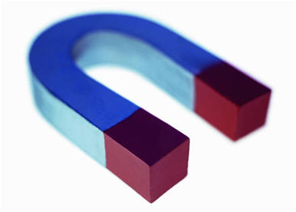any concentrations are there?  These are called magnetic poles.  How is this different from electricity?  Explain.

Does a permanent magnet pick up nails?  How about an electromagnet?  What are the similarities between a permanent and electromagnet?

What causes the CRT-TV picture to get messed up by magnets?

Explain what causes magnetism.

Page left intentionally blank

|  |
| --- |
| ****Electrical Oscillation**** |

\_\_\_\_\_\_\_\_\_\_\_\_\_\_\_\_\_\_/\_\_\_\_\_\_\_\_\_\_\_\_\_\_\_\_\_\_/\_\_\_\_\_\_\_\_\_\_\_\_\_\_\_\_\_\_

**Names – 3 to 5 people per group,**

\_\_\_\_\_\_\_\_\_\_\_\_\_\_\_\_\_\_/\_\_\_\_\_\_\_\_\_\_\_\_\_\_\_\_\_\_**at 6 split into 2 groups**

**Class:\_\_\_\_\_\_\_\_\_\_\_\_\_\_\_\_\_\_\_Section: \_\_\_\_\_\_\_\_\_\_\_\_\_\_Date:\_\_\_\_\_\_\_\_\_\_\_\_\_\_**

When size is 6 or more split into 2 or more groups.

Radios, TV, cell phones, blackberries, etc. all use a tuner and ALL have to work with alternating current signals.  A crystal radio is the easiest to understand.

Inductor

Antenna

Variable capacitor to tune radio (arrow tells you it’s variable)

•

•

•

•

•

•

Diode – only lets current flow one way

Capacitor to smooth out signal and let through only signals you can hear

High impedance, high efficiency earphone

The inductor has lots of energy when the capacitor is empty and vice versa.  Charges slosh back and forth like a swing and the radio signal from the antenna "pumps" the swing.  Only the exact right frequency, which is tuned using the variable capacitor, will pump this circuit.

The diode takes some of the AC current and, along with the capacitor, smoothes it out.  So we hear the AMPLITUDE of the AC signal and the amplitude changes in a way we can hear it.  That's why this type of radio is called AM - Amplitude Modulation.  Adding transistors to the circuit amplifies the signal from the earphone on, however we start with the inductor/capacitor "tank" circuit - like a tank of water where the water sloshes back and forth.  Here are a couple good sites (<http://www.transistor.org/FAQ/two-transistor.html> & <http://sound.westhost.com/articles/am-radio.htm>).  Here's an interesting [link](http://www.funphysicist.net/icha/icha_oscillator.pdf) - Texas Instrument's/Regency 4 transistor radio patent.  But, they all have the initial stage inductor/capacitor "tank" circuit.

Equipment:  Old style (transistorized) portable radio, for example, National Panasonic R-104A or crystal radio; variable resistor, DMM

Open the back of the radio.  Draw a sketch of the major components:  Antenna, variable tuning capacitor, variable volume resistor, circuit board, battery pack, and speaker.

1. Turn it on and tune in a few stations.  Observe how it is tuned.  What does the tuning?  Draw a sketch and explain how this device works.

1. What device changes the volume?  What is it called?  Draw a sketch and explain how this device might work.  You can't actually see it working so you may need the instructor to help you.  Or a larger version of a variable resistor may be set up.

1. It is not necessary to use a variable capacitor for tuning - you may use a variable inductor.  A variable inductor has a sliding conductor moving across wire much like a variable resistor.  Why do you think the variable capacitor is the component of choice for tuning?  Why is a variable resistor acceptable for volume?

1. What is the formula for the frequency of an LC circuit?  A typical value of C is 10-9 F and frequency of an AM signal is 1 MHz.  Using the [SOLVE](http://www.funphysicist.net/help/solve.htm) method, determine the value of L.

1. Explain what AC (Alternating Current) is and draw a sketch of voltage (or current) vs. time.

Page left intentionally blank

|  |
| --- |
| ****AM Radio Antenna**** |

\_\_\_\_\_\_\_\_\_\_\_\_\_\_\_\_\_\_/\_\_\_\_\_\_\_\_\_\_\_\_\_\_\_\_\_\_/\_\_\_\_\_\_\_\_\_\_\_\_\_\_\_\_\_\_

**Names – 3 to 5 people per group,**

\_\_\_\_\_\_\_\_\_\_\_\_\_\_\_\_\_\_/\_\_\_\_\_\_\_\_\_\_\_\_\_\_\_\_\_\_**at 6 split into 2 groups**

**Class:\_\_\_\_\_\_\_\_\_\_\_\_\_\_\_\_\_\_\_Section: \_\_\_\_\_\_\_\_\_\_\_\_\_\_Date:\_\_\_\_\_\_\_\_\_\_\_\_\_\_**

Radio antennas can sense either electrical or magnetic fields.  TV and FM a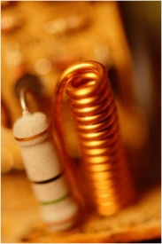ntennas sense electrical field while AM radios typically (not always) use an inductor coil as an antenna.

Equipment:  Old style (transistorized) portable radio, for example, National Panasonic R-104A.

Open the back of the radio.  Draw a sketch of the major components:  Antenna, variable tuning capacitor, variable volume resistor, circuit board, battery pack, and speaker.

1. Tune in a station.  What do you think the orientation of the antenna must be to the transmitting station?  Draw a sketch.

1. Change the orientation of the radio to determine the orientation when the radio best receives the signal.  In AM radio this is when volume is loudest.  FM and TV is different and you can't figure out the strongest signal from volume.  Sketch the orientation when the signal is best.

1. Did this match your original expected orientation?  From the actual orientation, do you have a conjecture about why the signal is strongest?  Sketch the EM wave and how it interacts with the radio, elaborate and explain.

Page left intentionally blank

|  |
| --- |
| ****Optics**** |

\_\_\_\_\_\_\_\_\_\_\_\_\_\_\_\_\_\_/\_\_\_\_\_\_\_\_\_\_\_\_\_\_\_\_\_\_/\_\_\_\_\_\_\_\_\_\_\_\_\_\_\_\_\_\_

**Names – 3 to 5 people per group,**

\_\_\_\_\_\_\_\_\_\_\_\_\_\_\_\_\_\_/\_\_\_\_\_\_\_\_\_\_\_\_\_\_\_\_\_\_**at 6 split into 2 groups**

**Class:\_\_\_\_\_\_\_\_\_\_\_\_\_\_\_\_\_\_\_Section: \_\_\_\_\_\_\_\_\_\_\_\_\_\_Date:\_\_\_\_\_\_\_\_\_\_\_\_\_\_**

Look through the lens close up (like the picture above).  How do objects appear?  Larger?  Smaller?  Normal?  Inverted?

Hold the lens far from you.  How do objects appear now?  Larger?  Smaller?  Normal?  Inverted?

Can you explain this from the laws of refraction?

Observe the ray diagrams below.  Which one do you believe shows the situation when objects are close?  Which one shows when objects are far away?  Which one would be used in a camera?

FYI - Rays always go straight through the center of a lens and parallel rays converge at the focal length.

|  |  |
| --- | --- |
| Ray Diagram A  Ray diagram for far objects | Ray Diagram B  Ray diagram for near objects |

Page left intentionally blank

|  |
| --- |
| ****Interference**** |

\_\_\_\_\_\_\_\_\_\_\_\_\_\_\_\_\_\_/\_\_\_\_\_\_\_\_\_\_\_\_\_\_\_\_\_\_/\_\_\_\_\_\_\_\_\_\_\_\_\_\_\_\_\_\_

**Names – 3 to 5 people per group,**

\_\_\_\_\_\_\_\_\_\_\_\_\_\_\_\_\_\_/\_\_\_\_\_\_\_\_\_\_\_\_\_\_\_\_\_\_**at 6 split into 2 groups**

**Class:\_\_\_\_\_\_\_\_\_\_\_\_\_\_\_\_\_\_\_Section: \_\_\_\_\_\_\_\_\_\_\_\_\_\_Date:\_\_\_\_\_\_\_\_\_\_\_\_\_\_**

In this activity we will bounce a la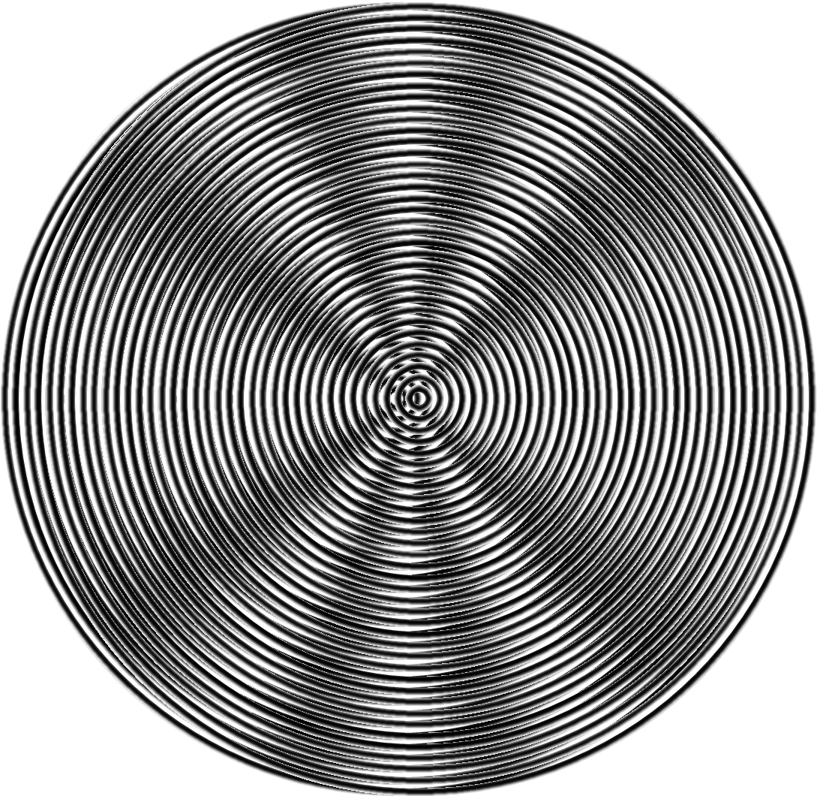ser beam (670 n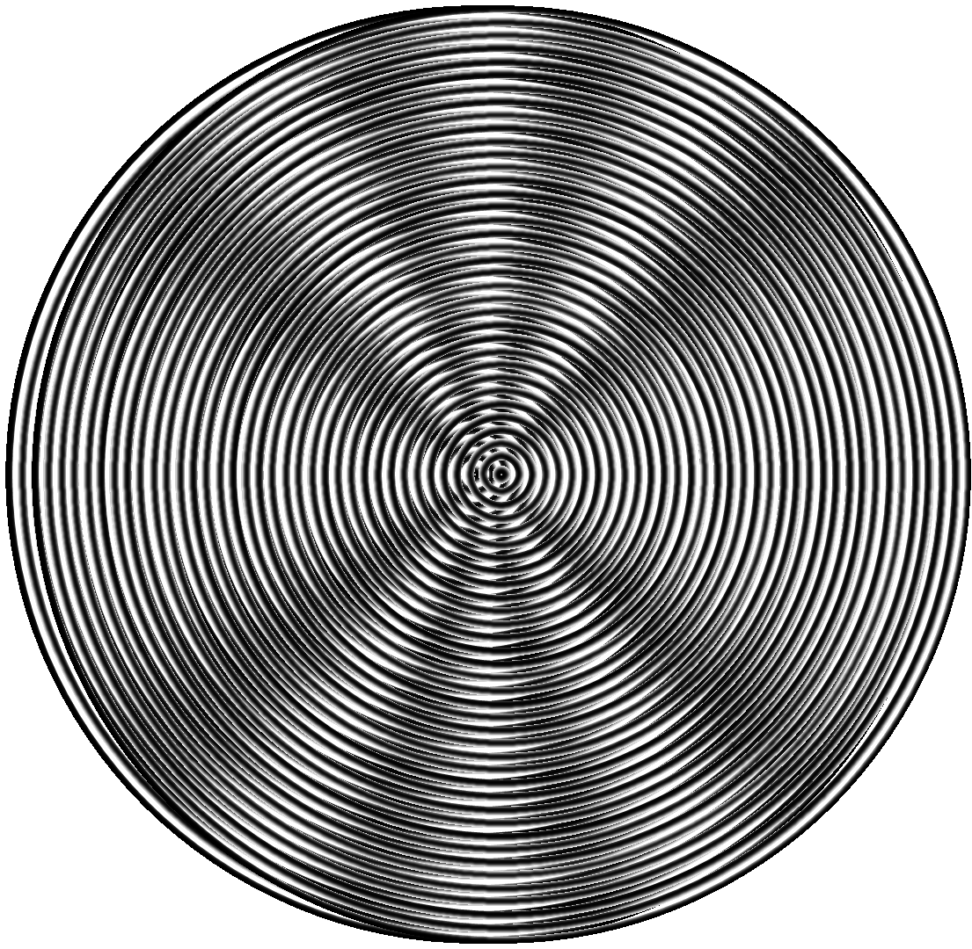m) at a blank CD and determine the spacing of tracks on a CD.

The two images above are like a snapshot of a ripple tank where two wave emitters are two wavelengths apart (the emitters are horizontal) and 180° out of phase. This is like a CD with a spacing of twice the wavelength of the light. Each stripe acts like the wave generator in a ripple tank. Unlike the above image a CD has thousands in a row. But the angle where light waves are reinforced are the same. The light areas are crests of the wave and these are where the wave is reinforced. Your instructor may show what happens with a laser striking a CD, but let's look at the wave pattern first and try to decide what we expect before we measure the CD.

The first thing to notice is that the right and left pattern above appear identical, but they are not.  The waves are 180° out of phase.  In the image at left the center is a crest.  In the image at right the center is a trough.  But reinforcement occurs at the same angles either way.

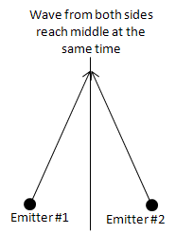Why reinforcement occurs in the center should be obvious (see figure at right).  At any point on a vertical line halfway between the two emitters the wave emanating from each emitter is going to reach that middle line at the same time.  So the perpendicular from the line connecting the emitters is going to be where constructive interference occurs.

It's the other angles that are a little bit more difficult to figure out, but not really that hard.  The first angle (other than straight ahead) where constructive interference occurs is where there is exactly one wavelength difference between the path lengths as sh 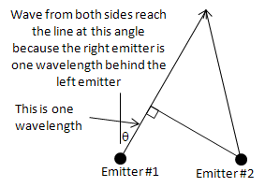own in the next figure.  The other, larger, angles occur where the path length difference is 2, 3, 4, etc. wavelength difference.  The figure at right shows the angle for the first order (1 wavelength difference).  The angle, θ, from the center is found from simple trigonometry.

On the last page the left hand top figure is expanded.  We'll analyze the first order.

|  |  |
| --- | --- |
| 1. | Using a protractor (or ruler and trigonometry), find the angle of the first order.  What is it? |

|  |  |
| --- | --- |
| 2. | Use d to represent the distance between emitters and use trigonometry to solve for this angle (first order).  What is the formula? |

|  |  |
| --- | --- |
| 3. | If d is two wavelengths, evaluate this formula.  What is θ? |

|  |  |
| --- | --- |
| 4. | Compare the results of Part 1 and 3.  Are they close to each other? |

|  |  |
| --- | --- |
| 5. | Now consider the CD.  How far from the screen was the CD? |

|  |  |
| --- | --- |
| 6. | How far from the central spot was the first order spot? |

|  |  |
| --- | --- |
| 7. | Using trigonometry, what is the formula for θ given the results of Parts 5 and 6? |

|  |  |
| --- | --- |
| 8. | Evaluate θ.  What is it? |

|  |  |
| --- | --- |
| 9. | The formula is the same as the formula for Part 2, but you need to solve for d this time.  Symbolically solve the formula in Part 2 for d and write it here. |

|  |  |
| --- | --- |
| 10. | Evaluate the formula in Part 9.   This is the spacing of tracks in a CD. |

Blow up of interference pattern follows:



Page left intentionally blank

|  |
| --- |
| ****X-ray Vision**** |

\_\_\_\_\_\_\_\_\_\_\_\_\_\_\_\_\_\_/\_\_\_\_\_\_\_\_\_\_\_\_\_\_\_\_\_\_/\_\_\_\_\_\_\_\_\_\_\_\_\_\_\_\_\_\_

**Names – 3 to 5 people per group,**

\_\_\_\_\_\_\_\_\_\_\_\_\_\_\_\_\_\_/\_\_\_\_\_\_\_\_\_\_\_\_\_\_\_\_\_\_**at 6 split into 2 groups**

**Class:\_\_\_\_\_\_\_\_\_\_\_\_\_\_\_\_\_\_\_Section: \_\_\_\_\_\_\_\_\_\_\_\_\_\_Date:\_\_\_\_\_\_\_\_\_\_\_\_\_\_**

1. Using the spectrometer, look at fluorescent ligh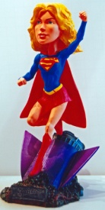ts, an incandesc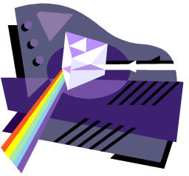ent light, and LEDs.  Sketch your observations below.

|  |  |  |  |  |  |  |  |  |  |  |  |  |  |  |  |  |
| --- | --- | --- | --- | --- | --- | --- | --- | --- | --- | --- | --- | --- | --- | --- | --- | --- |
| Wavelength in nm (1 nm = 10 Å) | | | | | | | | | | | | | | | | |
|  | 350 | | 400 | | 450 | | 500 | | 550 | | 600 | | 650 | |  |  |
|  | |  | |  | |  | |  | |  | |  | |  | | Fluorescent Light |
|  | |  | |  | |  | |  | |  | |  | |  | | Incandescent Light |
|  | |  | |  | |  | |  | |  | |  | |  | | Red LED |
|  | |  | |  | |  | |  | |  | |  | |  | | Green LED |
|  | |  | |  | |  | |  | |  | |  | |  | | Blue LED |

1. What is the formula relating wavelength, frequency, and speed of light?

1. What is the formula relating frequency and photon energy?

1. For the LED data and using these formulas, calculate and fill in the table below.

|  |  |  |  |  |
| --- | --- | --- | --- | --- |
|  | Color | Wavelength | Frequency | Energy |
| Red LED |  |  |  |  |
| Green LED |  |  |  |  |
| Blue LED |  |  |  |  |

1. What is the highest energy light? Lowest energy? Highest wavelength? Lowest wavelength?

1. Supergirl can see through ordinary materials except lead. What light might she be seeing?

Page left intentionally blank

|  |
| --- |
| ****Relativity**** |

\_\_\_\_\_\_\_\_\_\_\_\_\_\_\_\_\_\_/\_\_\_\_\_\_\_\_\_\_\_\_\_\_\_\_\_\_/\_\_\_\_\_\_\_\_\_\_\_\_\_\_\_\_\_\_

**Names – 3 to 5 people per group,**

\_\_\_\_\_\_\_\_\_\_\_\_\_\_\_\_\_\_/\_\_\_\_\_\_\_\_\_\_\_\_\_\_\_\_\_\_**at 6 split into 2 groups**

**Class:\_\_\_\_\_\_\_\_\_\_\_\_\_\_\_\_\_\_\_Section: \_\_\_\_\_\_\_\_\_\_\_\_\_\_Date:\_\_\_\_\_\_\_\_\_\_\_\_\_\_**

We can start to understand relativity by thinking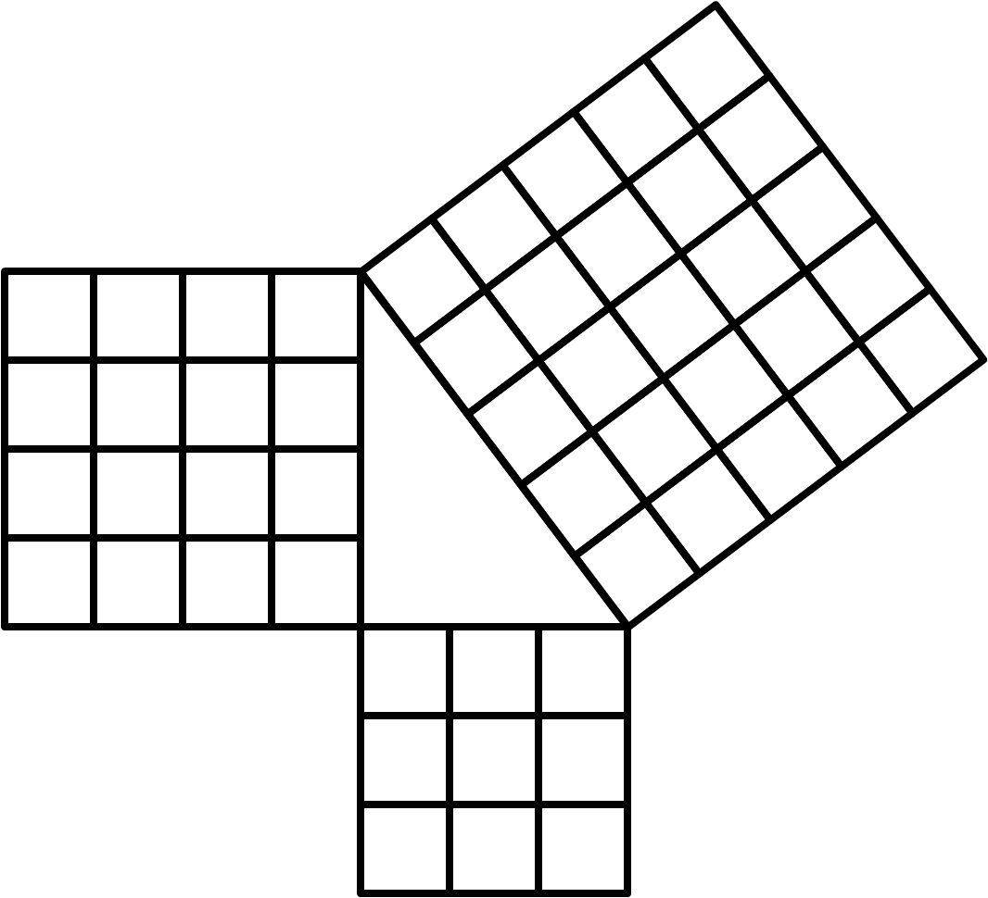 about a speed boat crossing a river compared to going downstream and back.  The boat is like a light beam and the speed of the river is like the speed Earth is traveling through space.  The river is 1500 m wide (must be the Amazon), the boat's speed is 30 m/sec, and the river's current is 3 m/sec.

First consider how long it takes the boat to travel to a point exactly across the river and back.  The answer is not 100 sec.  The boat has to aim upstream a bit both directions.

1. What is the equation for the boat's upstream speed (relative to the water) need to be to exactly cancel the current so the boat's upstream speed relative to shore is zero?

1. Draw a picture and label the components of the boat's velocity relative to the water.

1. What is the equation for the boat's speed perpendicular to the shore (relative to the shore)?  Use the variables v for the speed of the river's current, c for the speed of the boat, x for the distance across the river and back, and t for the time it takes to cross the river and come back.

1. 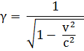What is the equation for the time it takes for the boat to go across the river and back?  Express this in terms of .

1. Now plug in numbers - how long does it take to go back and forth?  Keep 6 sig figs.

1. We're going to compare the answer to Part 5 to the time it takes to go 1500 m downstream and back.  Derive the equation for the time it takes to go 1500 m downstream?

1. Now derive the equation for the time it takes to go 1500 m back upstream?

1. Derive the equation for the total time it takes to go 1500 m downstream and back?  Express this in terms of γ per Part 4 and call this total time t'.

1. Compare the equation of Part 8 to Part 4.  Are they the same?  By what multiplying factor are they different?

1. Plug in numbers and calculate t' keeping 6 sig figs.

1. Compare t to t'.  Are they the same?

1. Instead of a boat let's say you had a light beam and instead of a river let's be on a rocket ship traveling through space.  Do you expect your equations of Part 8 and Part 4 to vary?  Why or why not?

1. In publications between 1861 and 1873 discussing the theory of electromagnetism, James Maxwell predicted the equations in Parts 4 & 8 would be the same.  This surprised physicists because, as you just got done figuring out, it should be different.  What would you propose to settle this?

As good scientists do when there is an apparent contradiction, they perform an experiment.  American scientists Albert Michelson and Edward Morley tested this in 1887 proving Maxwell correct.   t and t' WERE the same.   Hendrik Lorentz introduced the fudge factor, γ, in 1904 without really understanding the physical significance.  It was just a mathematical convenience.  The next year Albert Einstein published his work on special relativity explaining why t and t' should be the same.

What is weird and amazing about Albert Einstein's explanation is that for the speed of light to be a constant, time itself will be different.  Even if we made perfect clocks, they would run at different rates depending on their frame of reference.  We will discuss this in detail in class.

Page left intentionally blank

|  |
| --- |
| ****Supergirl's Photons**** |

\_\_\_\_\_\_\_\_\_\_\_\_\_\_\_\_\_\_/\_\_\_\_\_\_\_\_\_\_\_\_\_\_\_\_\_\_/\_\_\_\_\_\_\_\_\_\_\_\_\_\_\_\_\_\_

**Names – 3 to 5 people per group,**

\_\_\_\_\_\_\_\_\_\_\_\_\_\_\_\_\_\_/\_\_\_\_\_\_\_\_\_\_\_\_\_\_\_\_\_\_**at 6 split into 2 groups**

**Class:\_\_\_\_\_\_\_\_\_\_\_\_\_\_\_\_\_\_\_Section: \_\_\_\_\_\_\_\_\_\_\_\_\_\_Date:\_\_\_\_\_\_\_\_\_\_\_\_\_\_**

According to DC comics, Kryptonians (former inhabitants of Kryp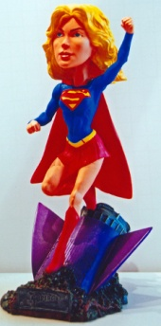ton) gained their super powers from our yellow sun.  Earlier you calculated how much energy, 11113 J, it took for Supergirl to leap over the 21.0 m TJC chapel steeple.  Now lets figure out how many photons she needs from our sun to accomplish this.  Since solar radiation is about 1000 W/m2 (watts per meter squared are units of irradiance) on a sunny day we can also calculate how long it would require for her to gain this energy and how much mass in the sun is converted to energy.

|  |  |
| --- | --- |
| 1. | Lets figure out how long it takes first.  What is the formula relating power, energy and time? |

|  |  |
| --- | --- |
| 2. | Solve this formula for time and write the working equation here. |

|  |  |
| --- | --- |
| 3. | Let's assume the super cape is 100% efficient capturing the solar radiation, channeling it to the Kryptonians, and the cape area is 2 m2.  Power per area is called irradiance and is a common way to specify how "bright" a beam of light is.  The formula is I = P/A.  Solve this formula for power and write it here: |

|  |  |
| --- | --- |
| 4. | Substitute the expression for power in Part 3 into the equation of Part 2 to get the formula for time in terms of I, A, and E. |

|  |  |
| --- | --- |
| 5. | Now plug in numbers and calculate the time. |

|  |  |
| --- | --- |
| 6. | Next we'll figure out how many photons are in 11113 J of light. Nature is truly strange.  Remember how we discussed why light is a wave?  Both Max Plank and Albert Einstein showed light comes in units of energy called quanta.  In other words, light is BOTH a particle AND a wave.  The "wave-icle" of light is called a photon.  This photon is like a piece of vibrating string thus making it act like both a wave and particle.  Later we'll learn ordinary matter behaves similarily.  The energy of each photon is given by the formula Ep = hf where h = 6.63\*10-34 J sec and f is frequency.  But before we can calculate Ep, we need to know f.  Recall for a wave the wavelength, λ, and f are related by λf = c = 3\*108 m/sec.  Yellow light has a wavelength of 600 nm (recall nm = 10-9 m).  Solve the formula λf = c for f and write down the working equation here: |

|  |  |
| --- | --- |
| 7. | Substitute this equation for f into Ep = hf and write that down here: |

|  |  |
| --- | --- |
| 8. | We know total energy, E, is 11113 J and we got a formula for the energy of each photon, Ep, in Part 7.  What is the formula for the number of photons?  Write that here: |

|  |  |
| --- | --- |
| 9. | Substitute the formula for Ep from Part 7 into the equation from Part 8 and write the formula here: |

|  |  |
| --- | --- |
| 10. | Now plug in numbers and calculate the number of photons. |

|  |  |
| --- | --- |
| 11. | Now we'll calculate how much solar mass is consumed doing this using the formula E = mc2.  Rearrange this formula to obtain m and write the new formula here: |

|  |  |
| --- | --- |
| 12. | Now plug in numbers and calculate the mass lost by the Sun. |

|  |  |
| --- | --- |
| 13. | Is this a lot of mass or a little?  Nuclear power comes from a tiny amount of matter converted to energy.  Why do you only need a tiny amount of matter? |

|  |  |
| --- | --- |
| 14. | Think of the time required from Part 5.  If it requires this amount of time to absorb enough energy to leap over the  TJC chapel steeple, how can Supergirl perform her bigger superhuman feats.  Do you have a hypothesis?  Explain. |

Page left intentionally blank

|  |
| --- |
| ****Sun’s Energy**** |

\_\_\_\_\_\_\_\_\_\_\_\_\_\_\_\_\_\_/\_\_\_\_\_\_\_\_\_\_\_\_\_\_\_\_\_\_/\_\_\_\_\_\_\_\_\_\_\_\_\_\_\_\_\_\_

**Names – 3 to 5 people per group,**

\_\_\_\_\_\_\_\_\_\_\_\_\_\_\_\_\_\_/\_\_\_\_\_\_\_\_\_\_\_\_\_\_\_\_\_\_**at 6 split into 2 groups**

**Class:\_\_\_\_\_\_\_\_\_\_\_\_\_\_\_\_\_\_\_Section: \_\_\_\_\_\_\_\_\_\_\_\_\_\_Date:\_\_\_\_\_\_\_\_\_\_\_\_\_\_**

The sun is mostly hydrogen (one proton) with a little deuterium (an isotope of hydrogen with a proton and neutron), helium-3, and helium-4.  In hydrogen fusion it doesn't just jam 4 hydrogens together to get helium-4.  There are a series of process from hydrogen to helium-4 and in this ICHA we will model the process believed to be responsible for solar energy using beans.

Start with a black (or pinto, i.e., colored) bean.  This will be hydrogen-1 or a proton (pinto, get it?) - the most abundant element in stars.  Because the lower right subscript is reserved for chemical formulas, in nuclear physics we write the number of protons (atomic number) as a lower left subscript and the nucleon (or mass) number as a left or right superscript.  Hydrogen-1 would therefore be 1H1 or .  The 1H1 notation works better for web sites since computer tools are not sophisticated enough to make the ${}_{1}^{1}H$ notation.

Let's add a couple of these together.  We can't lose protons or neutrons so we expect to get 2He2.  But we won't get 2He2 because protons repel so greatly.  What we will get is a positron (like an electron except positively charged) which has zero for a nucleon number and 1 for the charge (the same as a proton)?  In our bean model, making a positron changes a black (or pinto) bean to a white bean (neutron).  So we add two black beans (protons) together and get a black (proton) and a white (neutron) stuck together.  What element is this?  Note, we are ignoring neutrinos and gamma rays, however gamma rays in particular are important because that's where the energy comes from.  Complete the following reaction.

1H1 + 1H1 = 1e0 +  \_\_\_\_\_\_\_\_\_\_\_\_\_\_\_\_\_\_\_\_\_\_\_\_\_\_\_\_\_\_\_\_

This is how deuterium (1H2) is formed.  The positron doesn't just disappear, but it does go away in a manner we don't model.  For every two hydrogen nuclei are two electrons.  An electron will combine with the positron to making gamma rays leaving just one electron to match up with the solitary proton in 1H2.  Charge neutrality is maintained.  Now let's add our deuterium to another hydrogen-1.  Complete the following reaction.

1H1 + 1H2 = \_\_\_\_\_\_\_\_\_\_\_\_\_\_\_\_\_\_\_\_\_\_\_\_\_\_\_\_\_\_\_\_

2He3 is stable and some escapes from the sun, but it's not completely happy.  The two proton's repel each other and it would like an extra neutron to balance things out.  Now, where can we get that extra neutron?  Try adding a couple 2He3 together, then we can work something out.  First we need another 2He3 so do the previous two steps again.

How many hydrogen-1 have you used so far? \_\_\_\_\_\_\_\_\_\_\_\_\_\_\_\_\_\_\_\_\_\_\_\_\_\_\_\_\_\_\_\_

Now lets add two 2He3 get together and make two 1H1 and what else?

2He3 + 2He3 = 1H1 + 1H1 + \_\_\_\_\_\_\_\_\_\_\_\_\_\_\_\_\_\_\_\_\_\_\_\_\_\_\_\_\_\_\_\_

Voila!  Combine several hydrogens and get a helium-4 and lots of solar energy (26.7 MeV or 4.23\*10-12 J per helium-4 produced).

How many hydrogen-1 nuclei did it take to do this? \_\_\_\_\_\_\_\_\_\_\_\_\_\_\_\_\_\_\_\_\_\_\_\_\_\_\_\_\_\_\_\_

How many hydrogen-1 nuclei do you have at the end? \_\_\_\_\_\_\_\_\_\_\_\_\_\_\_\_\_\_\_\_\_\_\_\_\_\_\_\_\_\_\_\_

How many net hydrogen-1 nuclei were consumed? \_\_\_\_\_\_\_\_\_\_\_\_\_\_\_\_\_\_\_\_\_\_\_\_\_\_\_\_\_\_\_\_

How many net helium-4 nuclei were created? \_\_\_\_\_\_\_\_\_\_\_\_\_\_\_\_\_\_\_\_\_\_\_\_\_\_\_\_\_\_\_\_

Was charge conserved? \_\_\_\_\_\_\_\_\_\_\_\_\_\_\_\_\_\_\_\_\_\_\_\_\_\_\_\_\_\_\_\_

Was the number of nucleons conserved? \_\_\_\_\_\_\_\_\_\_\_\_\_\_\_\_\_\_\_\_\_\_\_\_\_\_\_\_\_\_\_\_

Mass was not conserved.  Some was lost.  What happened to it?  Remember, Einstein developed a new principle - that the sum of mc2 and energy was conserved?  Does this new principle hold?  Explain.

Page left intentionally blank

**Conceptual Physics**

# Appendix B: SOLVE Method

|  |
| --- |
| **SOLVE & Teamwork** |

In a modern work environment, we do not work in isolation.  We must interact and get along.  Here are a few pointers.  Also see [7 Habits of Effective Science Students](http://www.funphysicist.net/help/success.htm) and [How to Flunk](http://www.funphysicist.net/4fun/solitaire.htm).

Individual Problem Solving:

For individual problem solving we strongly, strongly encourage the use of the [SOLVE 5-Step Problem Solving method](http://www.funphysicist.net/help/fivestep.htm).  See the [SOLVE](http://www.funphysicist.net/help/fivestep.htm) page, but in summary:

|  |  |  |  |
| --- | --- | --- | --- |
| Picture of Obi wan Kenobi telling Luke to use the 5-Steps | 1. | **S – Sketch** | Sketch, draw a picture, understand the problem |
| 2. | **O – Organize** | Organize, write down known and unknown quantities |
| 3. | **L – List** | List relevant equations, determine which are applicable |
| 4. | **V – Vary** | Vary, rewrite, and transform equations to express unknown quantity in terms of known quantities |
| 5. | **E -- Evaluate** | Evaluate expressions, Plug in Numbers, evaluate to determine if answer makes |

We will be using this throughout the course.

**Group Problem Solving:** This also works for group problems solving.  The same reason the [SOLVE 5-Steps](http://www.funphysicist.net/help/fivestep.htm) help individuals wrap their heads around a problem, it helps communicate your reasoning to others.

**Tolerating Frustration:** Quantitative reasoning can be frustrating.  A large number of steps and if you make a mistake on any one step you will get a wrong result.  That's why we need to tolerate frustration to succeed in quantitative disciplines.

**Working with Others:** There are many classes on working together offered by our college and other colleges.  All of these help defuse emotional tensions and help us work with other, disparate people.  Everybody has a unique and valuable perspective we need to appreciate to come to the best answers.  We need to respect others opinions and interact civilly in order to WORK together.

**Brainstorming:** One (and there are many) technique is brainstorming.  List ideas, any idea.  Don't tease people for bad ideas - bad ideas are OK, we'll eliminate them later.  Get everything on the table so we can sort through them and find the good ideas.  We want the team members to feel comfortable saying something.

**Labs as practice for team building:** We will do labs throughout the quarter.  Research has established that groups of 3 or 4 work best and sometimes it is necessary to make a pragmatic decision.  If we have eight sets of lab equipment and 32 students, it's clear that we will have lab groups of four people.  Part of the purpose of labs is practicing productive, respectful, supportive group interaction.  Here are a few guidelines:

1. Be on time!
2. Study the lab before arriving at class!
3. Have all group members practice doing all portions of the lab.  If you're doing a measurement, have all group members practice doing the measurement.  When assembling equipment, have all group members participate in assembly so everybody understands how the experiment was set up.
4. Avoid one or two people dominating the group.  It's important everybody participates.
5. If your group decides to assign "jobs," rotate those jobs each week.  For example, avoid having the same person always being the data recorder.

**Explain your reasoning:** You really learn something when you can explain it to somebody else.  I expect the stronger students to explain their reasoning to students who don't understand.  And I expect students who don't understand something to ask.  And I expect respect for those questions.  We close the cycle of learning when you can explain your reasoning.