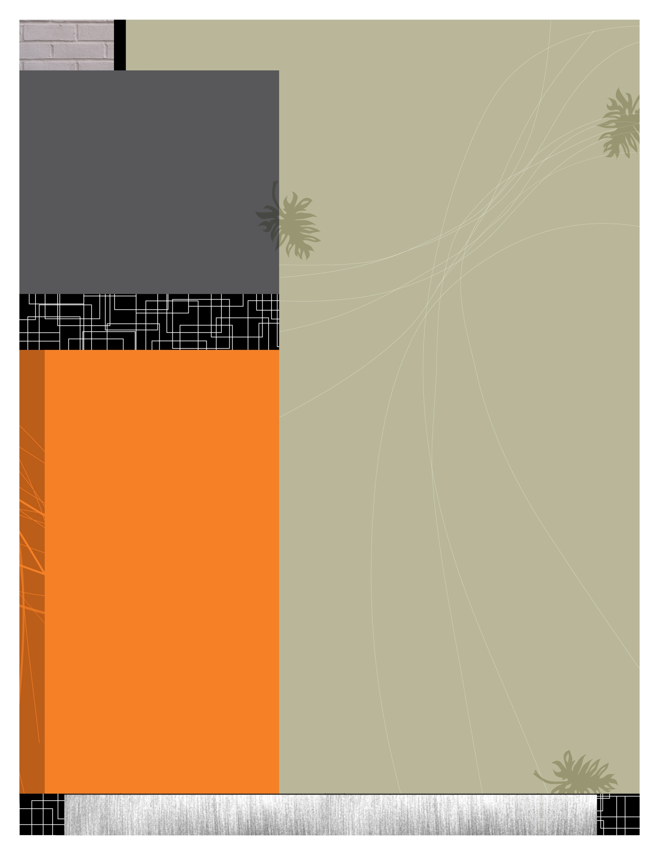

http://www.tjc.edu/WritingCenter

facebook.com/TJCWritingCenter

TJC Writing CENTER

“A Place For Writers”

* **Located in Jenkins 1108**
* **Open:**

**8:00 a.m. to 6:00 p.m.**

**Monday through Friday**

* **By appointment only, except during specified walk-in hours.**

**Walk-in hours:**

MONDAY: 8:00 to 10:00

TUESDAY: 8:00 to 10:00; 12:00 to 2:00

WEDNESDAY: 8:00 to 10:00; 4:00 to 6:00

THURSDAY: 8:00 to 10:00; 12:00 to 2:00

FRIDAY: 8:00 to 10:00

**Contact Us:**

Coordinator: Kristen Jackson

Phone: (903) 510-3200

Email: [kjac1@tjc.edu](mailto:kjac1@tjc.edu)

**FREE WRITING WORKSHOPS**

Feb. 8: The Writing Process & Writing Forms (2-3)

Feb. 15: Grammar and Usage (3-5)

Mar. 1: Grammar for ESL Students (9-10:30)

Mar 22: Critical Thinking & Rhetoric (4:30-6)

Apr.5,12,19: Research & MLA (3-4:30)

The Writing Center @ TJC

The Writing Center offers free writing consultations for all students. Writer’s block can strike anywhere at any time, or you might need extra help in order to conquer organization or grammar concerns. This is how the Writing Center might benefit you:

* We offer brainstorming sessions with trained composition tutors.
* Helpful feedback on your rough drafts.
* Assistance with resume writing, college application essays, etc.
* Help learning proofreading skills and eradicating repetitive grammar and usage errors.
* Advice about research and formatting (such as MLA, APA, and Turabian styles).

Regardless of your major or assignment, the composition process can often be confusing, so we welcome students from all majors with any writing concerns.

We do not guarantee a certain grade for an assignment, and students are always expected to take responsibility for their writing (We do not write your papers for you).

* **Make an appointment as soon as you know you will be using the Writing Center. Appointment slots can fill up very quickly. Specified walk-in hours are listed to the left.**

